**Type slowly or else just after 20 minutes you get hand pain you can’t even study**

#. **I referred youtube code 2 years old code within that if I download and run youtube code for this blog-app from github it doesn’t run there are lot of changes happened mysql2, using credentials for setting cookies. Without loosing patience you have to do Research search in stackoverflow,chatgpt google other blogs try all possible ways without quit**

**Code package version they keep updating so 1 year old code will not work today either check documents or stackoverflow blos**

project link

#. Split vs code for jsx on left side style.scss file on right

#. stop npm run start

#. While creating react app latest version was there I asked chatgpt to install packages of same version to another project to avoid error while doing same project.

#. Shortcut command “rafce” to create function in a jsx file

#. Reactrouter.com helps naviage b/w pages

#. Creating some common components

#. Outlet is from reactrouter you have to import it separately

**#. Changing function app inside app.js**

**#. Applying and creating style file for css**

**#. He told he’ll do same thing as login page for register page also**

**#. Next we do change in navbar.jsx file**

**#. Next we move to footer tab**

#. Next we go to home page home.jsx file

**Type slowly or else just after 20 minutes you get hand pain you can’t even study**

#. Home page style

**#. Handling when you click on post title redirect to single page**

**#. Our index.js file is like middleware where all request comes first there we use cors etc..**

**#. Another component for menu inside single page**

**#. Next we’ll change write page.**

#. **We start our back end from now with node application**

**#. Starting server using nodemon and other things**

#. **Using file index.js**

**#. Installing mysql good link**

**#. Creating mysql connection**

#. Create routes folder

**#. Inside routes folder posts.js file**

**#. Again separating controller operation using inside controller folder**

*. Save password encrypted using bcryptjs

#. Handling input from frontend to pass it to back end

**#. Register page ui issue**

#. Checking in browser console print when we enter name email password

*. Why do we use e.preventDefault

*. When you’ll use async that time you’ll have to use **await**

*. Mentioning api url inside package.json file

*. Browser making api request inside register.jsx file for register click button

#. **Make test post request using express**

#. Above using express for test api post request

*. I’m testing in different way to solve post issue from axios express

#. Try to solve axios post request error

*. Chatgpt told we can’t use express package in our frontend app to make post request

*. Fetch-api lot of errors solved

#. Fetch api post request worked in dummy test react app without any error great

#. Redirect other page localhost post request with axios

**#. Main error could be because of my wrong folder structure**

*. It’s very important how you run your react app: first run back end with port 8800

*. Using mysql for creating connection and for sql select stamt doesn’t work use mysql2

*. Next issue facing is not able to send error response with express to my client

#. Handle user login error client side

#. User already exists then redirect to login page using react-router-dom usenaviagate hook

**#. Do the same for login page as we did in register page frontend client**

**. **He told why to use jwt json web token he told to watch his video on it**

#. Using jwt jsonwebtoken for signin

**#. Our index.js file is like middleware where all request comes first there we use cors etc..**

#. Some credentials test data here: name and passwords

#. **Sending cookies to browser issue solved with test application**

#. Store userinfo in localstorage using state manage tools

**#. Using currentuser info we update navbar**

#. **Logout from backend and frontend**

**#. Click on post title to see detailed post and recommended post**

**. Another issue: express js you can’t write multiline sql query by concat gives error

#. **Handle delete for single post, usenaviage for navigate to home page**

#. **Single.jsx page: show recommended post according to main page category**

#. **Next we take care of write page**

#. **File uploading:**

**#. After 3 years if you want to run this project use npm ci command**

**#. While pushing code to github don’t push node_modules folder add it to gitignore**

#. project link

<https://www.youtube.com/watch?v=0aPLk2e2Z3g>

#. While creating react app latest version was there I asked chatgpt to install packages of same version to another project to avoid error while doing same project.

#. Split vs code for jsx on left side style.scss file on right

At top right click on file name select split right it moves to right

#. stop npm run start

#. While creating react app latest version was there I asked chatgpt to install packages of same version to another project to avoid error while doing same project.

i have already created react app using this command npx create-react-app blog-app --use-npm now there is a file in another project with package.json file in that dependencies some version of packages are mentioned i want to install same version of packages in my app also how to do this using npm

ChatGPT

ChatGPT

To install the same versions of packages listed in the dependencies section of another project's package.json file into your own React app, you can follow these steps:

Copy the Dependencies: Open the package.json file of the other project and locate the dependencies section. Copy the entire dependencies object, including all packages and their corresponding versions.

Paste into Your Project: Open the package.json file of your React app (blog-app in your case) and locate the dependencies section. Replace the existing dependencies object with the one you copied from the other project.

Install Dependencies: After updating your package.json file, you need to run the npm install command to install the dependencies listed in the updated package.json. Navigate to your project directory in the terminal and run:

Copy code

npm install

This command will read the dependencies section of your package.json file and install all the packages listed there, along with their specified versions.

Verify Installation: Once the installation process completes, npm will have installed the dependencies specified in the package.json file of your project with the exact versions specified. You can verify this by checking the node_modules directory in your project to see if the required packages are present.

By following these steps, you can ensure that your React app has the same versions of packages installed as the other project. This helps maintain consistency and ensures compatibility with the dependencies used in that project.

By following these steps, you can ensure that your React app has the same versions of packages installed as the other project. This helps maintain consistency and ensures compatibility with the dependencies used in that project.

Top of Form

#. stop npm run start

ChatGPT!

**ChatGPT**

To stop an npm script that's currently running, you generally have to go to the terminal or command prompt where you initiated the script and use a keyboard shortcut to stop it.

Here's how you can do it:

1. **Windows**:
   * Press **Ctrl + C** in the terminal or command prompt window where the **npm run start** command is running. This will send a SIGINT signal to the running process, effectively stopping it.
2. **macOS/Linux**:
   * Press **Ctrl + C** in the terminal where the **npm run start** command is running. Similar to Windows, this will send a SIGINT signal to stop the process.

#. Reactrouter.com helps naviage b/w pages

You’ve already installed initially using npm install

<https://reactrouter.com/en/main/start/tutorial>

npm install react-router-dom localforage match-sorter sort-by

npm run dev

in tuto itself they mentioned how to route by giving proper path

const router = createBrowserRouter([

{

path: "/",

element: <div>Hello world!</div>,

},

]);

Copy this

import {

createBrowserRouter,

RouterProvider,

} from "react-router-dom";

Paste it inside app.js

Next inside app.js we create our router

Using this below code

const router = createBrowserRouter([

{

path: "/",

element: <div>Hello world!</div>,

},

]);

Now below changes we did

const router = createBrowserRouter([

{

path: "/",

element: <div>This is home</div>,

},

]);

function App() {

return (

<div >

<RouterProvider router={router}></RouterProvider>

</div>

);

}

Inside function app added <RouterProvider router={router}></RouterProvider>

For element of router variable we pasted This is home

Now if you save and see in browser you see text “This is home”

Before

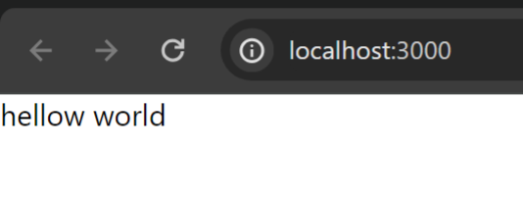

After

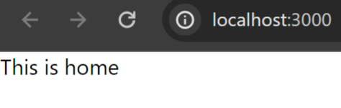

We can add as many key value pair for **router**

const router = createBrowserRouter([

{

path: "/",

element: <div>This is home</div>,

},

{

path: "/test",

element: <div>This is test</div>,

},

]);

New /test added now if you go to browser url and type /test you see this is test

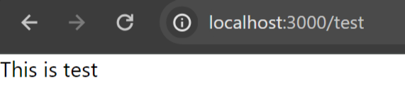

Now we create router for login register home single write jsx file or pages

import Home from "./pages/Home"

import Login from "./pages/Login"

import Register from "./pages/Register"

import Single from "./pages/Single"

import Write from "./pages/Write"

const router = createBrowserRouter([

  {

    path: "/",

    element: <div>This is home</div>,

  },

  {

    path: "/home",

    element: <Home/>,

  },

  {

    path: "/login",

    element: <Login/>,

  },

  {

    path: "/register",

    element: <Register/>,

  },

  {

    path: "/singe",

    element: <Single/>,

  },

  {

    path: "/write",

    element: <Write/>,

  },

]);

R

Like above we also do import

Also we do add as key value pair

import Write from "./pages/Write"

import like above

{

    path: "/write",

    element: <Write/>,

  },

Like above

If you go to browser now and type

<http://localhost:3000/login>

you’ll see login text

for the register and login page we don’t need navbar or footer

for the write and single page we’re gonna show navbar

time: 7:11

#. Creating some common components

Created components folder inside src

Added footer and navbar files inside it

Now also import them into our App.js file

import Navbar from "./components/Navbar";

import Footer from "./components/Footer";

Now instead of coming to app.js file and

const router = createBrowserRouter([

{

path: "/",

element: <div>This is home</div>,

},

Writing above we write like below

const router = createBrowserRouter([

{

path: "/",

element: <div>

<Navbar/>

<Home/>

<Footer/>

</div>,

Now if you goto

#. Using outlet

He told if we have many pages then using like below is not good idea

const router = createBrowserRouter([

{

path: "/",

element: <div>

<Navbar/>

<Home/>

<Footer/>

</div>,

So we use outlet

<https://reactrouter.com/en/main/components/outlet>

An <Outlet> should be used **in parent route elements to render their child route elements.** This allows nested UI to show up when child routes are rendered. If the parent route matched exactly, it will render a child index route or nothing if there is no index route.

function Dashboard() {

return (

<div>

<h1>Dashboard</h1>

{/* This element will render either <DashboardMessages> when the URL is

"/messages", <DashboardTasks> at "/tasks", or null if it is "/"

*/}

<Outlet />

</div>

);

}

Above Dashboard is a component where dashboard is navbar

Inside outlet we can use many child after that we use footer

function App() {

return (

<Routes>

<Route path="/" element={<Dashboard />}>

<Route

path="messages"

element={<DashboardMessages />}

/>

<Route path="tasks" element={<DashboardTasks />} />

</Route>

</Routes>

);

}

So in our app.js also we create layout inside that itself we write our navbar and footer

8:30

We have to put our **Layout** above **router** page

const Layout = () => {

  return (

    <>

      <Navbar />

      <Outlet />

      <Footer />

    </>

  );

};

We use layout like above inside app.js

Next inside our app.js inside **router** we use above **layout**

**After** writing our Layout in place of this

<div>

    this is home

    </div>

For element we put Layout

That is my element will be Layout component

Also we add our **children**  component to our **router**

In **children is** like our key value pair where we provide all of our child pages

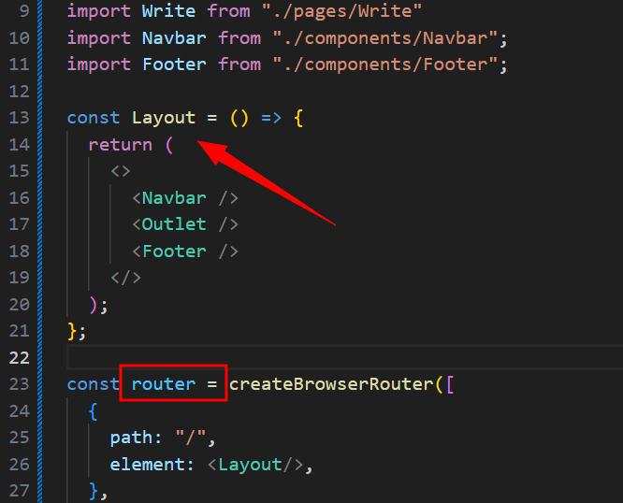

Layout should be before router

#. Outlet is from reactrouter you have to import it separately

const Layout = () => {

  return (

    <>

      <Navbar />

      <Outlet />

      <Footer />

    </>

  );

};

Above

If we want to use **outlet you have** to import it as package

9:55

import {

  createBrowserRouter,

  RouterProvider,

  Outlet,

} from "react-router-dom";

Like above

After adding outlet inside layout

And after adding layout inside router

Now If we run in browser

When you enter below url **middle text will change**

<http://localhost:3000/>

if we run above we see Home

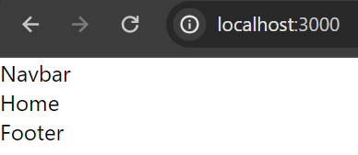

<http://localhost:3000/single>

we see single

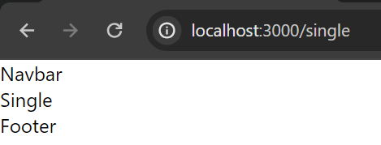

<http://localhost:3000/write>

we see write in browser

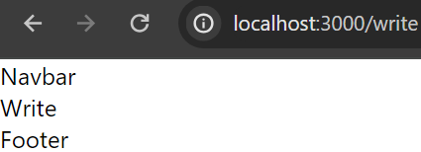

above are screenshots

10:08

<http://localhost:3000/single> single page url as well as path in code we will change it to post with id

<http://localhost:3000/post/:1234>

children:[

      {

        path: "/",

        element: <Home/>,

      },

**{**

**path:** /post/:id**",**

**element: <Single/>,**

**},**

      {

        path: "/write",

        element: <Write/>,

      }

    ]

like above check single It’s path

in browser if you type now as this:

<http://localhost:3000/post/1234>

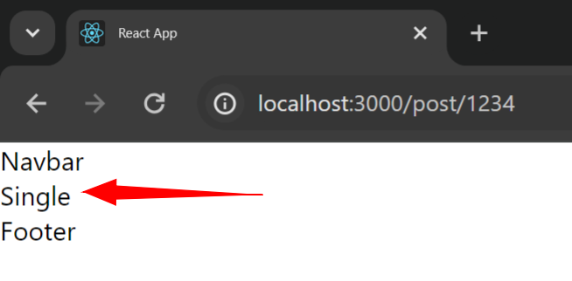

we get above

**#. Changing function app inside app.js**

function App() {

  return (

    <div className="app">

      <div className="container">

      <RouterProvider router={router}></RouterProvider>

      </div>

    </div>

  );

}

We do above change like give classname app and container because we’re gonna give **width for that** container

He told we can give individual style for each **components folder and pages folder**

But he told he’s not gonna do he’s gonna create one css file and he’s gonna write all style inside it

Because this app is very simple app we don’t have many components and pages

**#. Applying and creating style file for css**

**Uses sass package I think it’s for style**

**He** installed using yarn you can install it using npm

Later inside **src folder he created file** name called **style.scss**

**Inside** this file we add **.app{}**

**Inside** our app we add container

He told inside **our container we’re gonna have login and register page**

**Next** we go to our login page

For our div we add

className='authentication'

above class also we add form

const Login = () => {

  return (

    <div className='authentication'>

      <h1>Login</h1>

      <form>

        <input type='text' placeholder='userName'></input>

        <input type='password' placeholder='password'></input>

        <button>Login</button>

      </form>

    </div>

  )

}

we added above code for login.jsx file

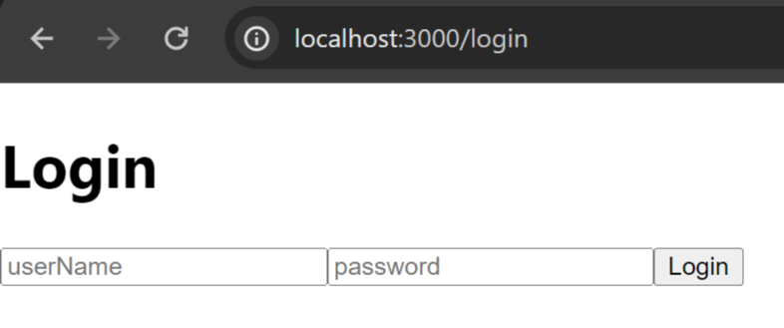

now our login page looks like above

he told he’s gonna put everything to center for that he’ll use **flexbox**

**see h**ow he used style in react this is very important

.app{

    .container{

        //login and register

        .authentication{

            display: flex;

            align-items: center;

            justify-content: center;

        }

    }

}

above code is inside style.scss file

after adding above styles we need to import this css file **into our app.jsx file** if we don’t import then css will not work

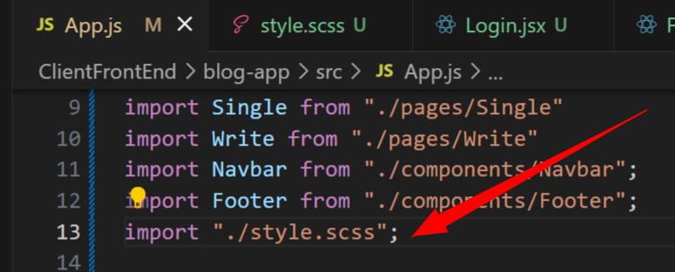

Like above we imported our style file in app.js

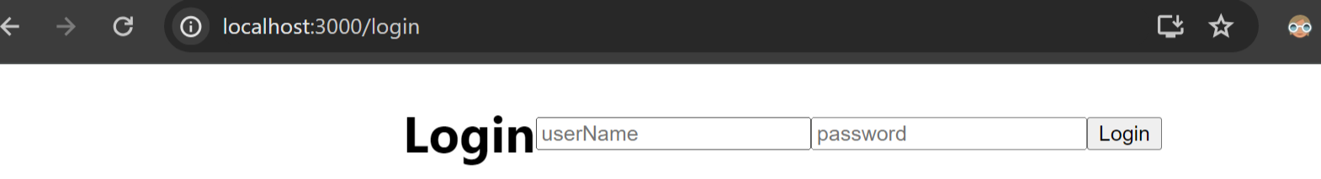

Now our web page will look like this

Now it’s not centered vertically it’s actually centered horizontally because we don’t have height

height: 100vh;

I added above height now it’s centered vertically

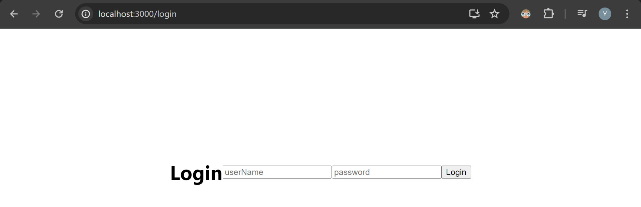

Above

So we give background color for that

background color will be common color so we create one variable

this will be background color for our entire page so we create a common variable and assign color to it

$lightGreen:#dbe7b9;

.app{

    .container{

        //login and register

        .authentication{

            display: flex;

            align-items: center;

            justify-content: center;

            height: 100vh;

            background-color: $lightGreen;

        }

    }

}

style.scss code above after adding background

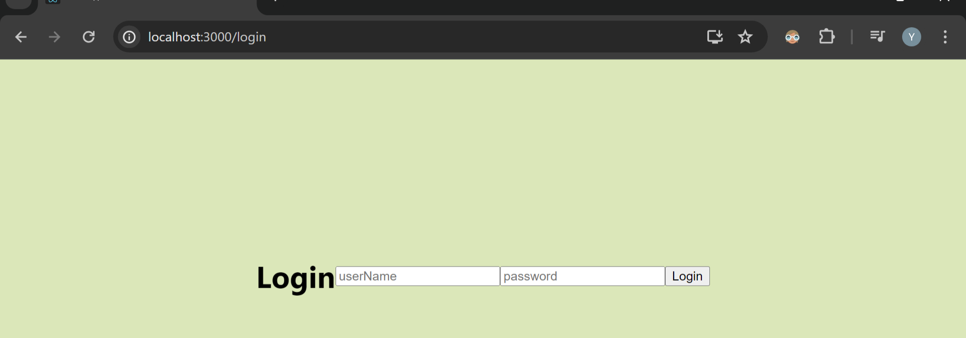

Above

I’ll change login page style after completing this app

flex-direction: column;

Next give **flex:**

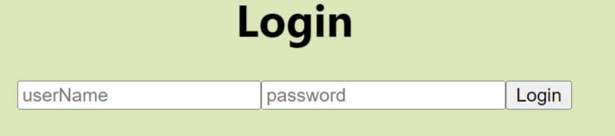

**Because** of this login page now looks like above

h1{

                font-size: 20px;

                color: rgb(128, 105, 0);

                margin-bottom: 20px;

            }

Now we gave style to font above style

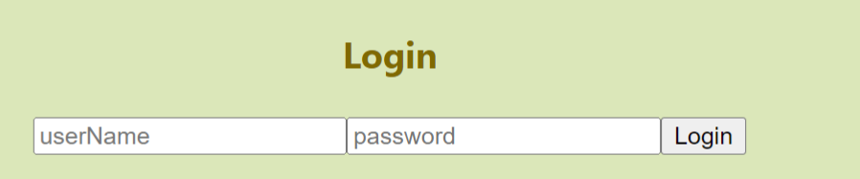

Change above

Next we make or give style to our **form**

With this our **input** textboxes and **and also our button will look one below one**

form{

                display: flex;

                flex-direction: column;

                padding: 10px;

                background-color: white;

                width: 200px;

                gap:20px;

            }

**Style for them above**

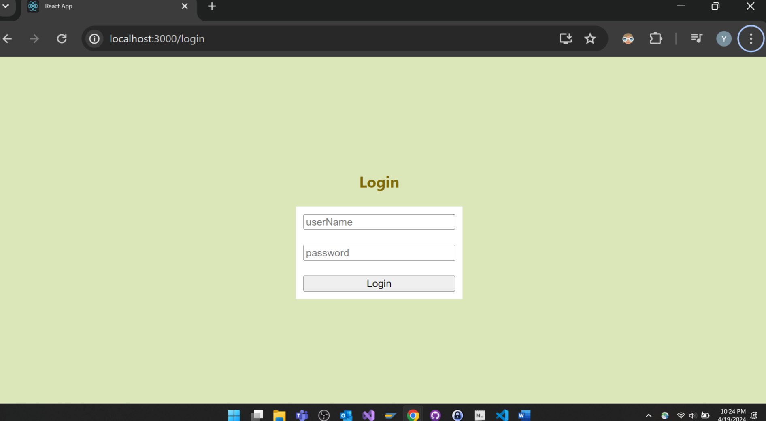

**With** this our page looks like above

  input{

                padding: 10px;

                border:none;

                border-bottom: 1px solid gray;

            }

With above style our textbox border will be removed and single line will be displayed for entering text

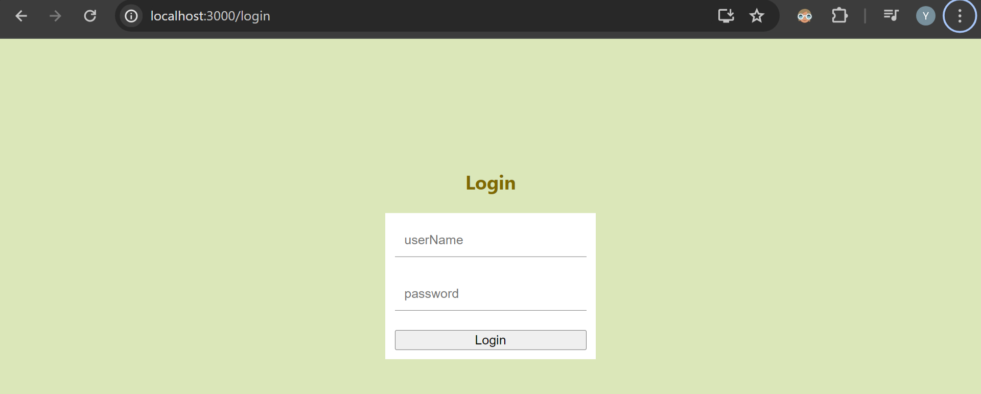

Above

Next increased padding of form from 10px to 50px it became bigger

We give style to button also

We keep style of input and button inside form itself

form{

                display: flex;

                flex-direction: column;

                padding: 50px;

                background-color: white;

                width: 200px;

                gap:20px;

                input{

                    padding: 10px;

                    border:none;

                    border-bottom: 1px solid gray;

                }

                button{

                    padding: 10px;

                    border: none;

                    background-color: teal;

                    cursor: pointer; //will show cursor on hover button

                    color: white;

                }

            }

All style of form above

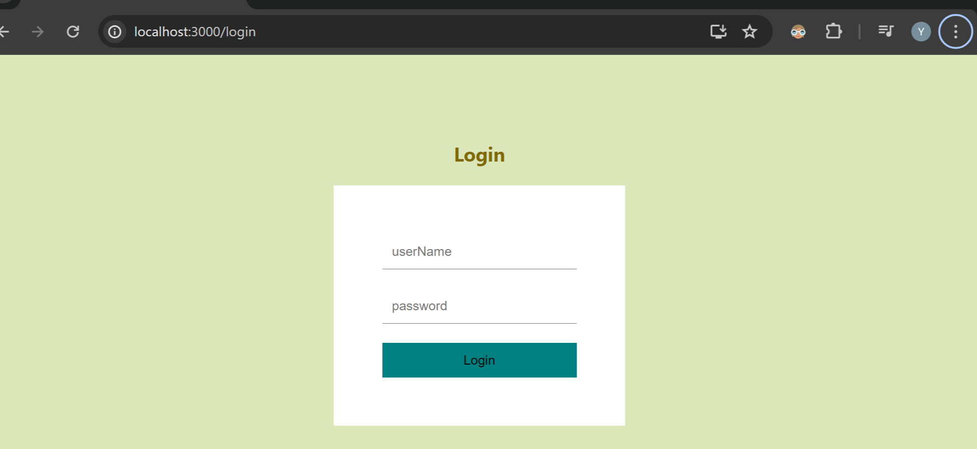

Page look

15:25

Next we create one link: if user is not a registered user link to register user

So go to login.jsx file

 <span>Don't you have an account? <Link to="/register">Register</Link>

        </span>

Add above code

If you’re using **Link** then you’ve to also import it **in that file also**

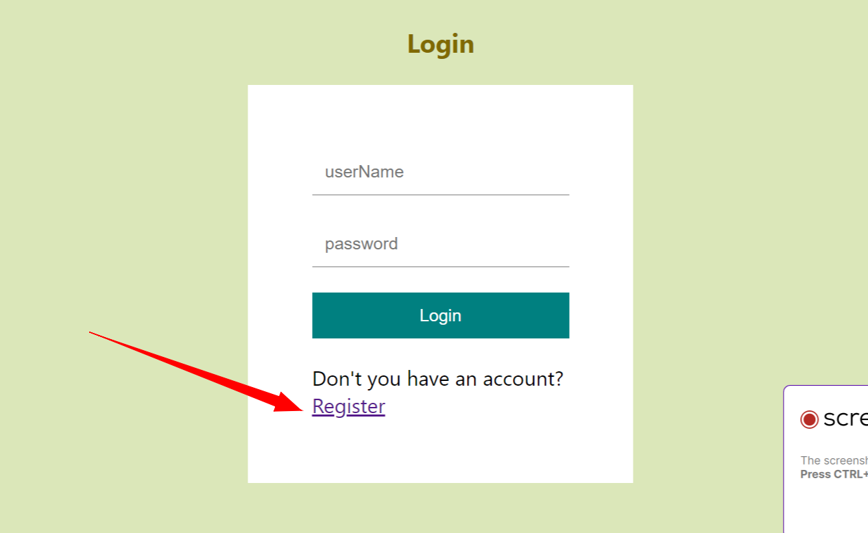

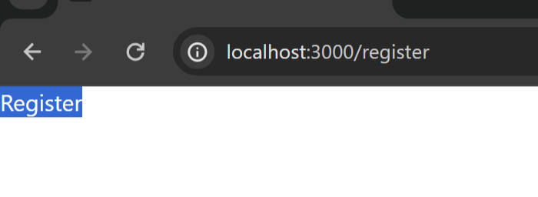

**Now** in browser when you click on **register** button you’ll be redirected to **register** page

Don't you have an account?

For above text inside span also we give style

 span{

                    font-size: 12px;

                    text-align: center;

                }

Above style for span

Next we add **p tag with** error message. Also p tag style we add

**#. He told he’ll do same thing as login page for register page also**

We copy and paste same code of login into register page and change text from login to register

Above

In register page one more thing we need is **input for email**

**Now** for input text fields add another attribute **required**

import React from 'react'

import {Link} from 'react-router-dom'

const Register = () => {

  return (

    <div className='authentication'>

      <h1>Register</h1>

      <form>

        <input type='text' placeholder='userName'></input>

        <input type='email' placeholder='email'></input>

        <input type='password' placeholder='password'></input>

        <button>Register</button>

        <p>This is an error</p>

        <span>Do you have an account? <Link to="/login">Login</Link>

        </span>

      </form>

    </div>

  )

}

export default Register

Above is register page code

Codes are same as login page

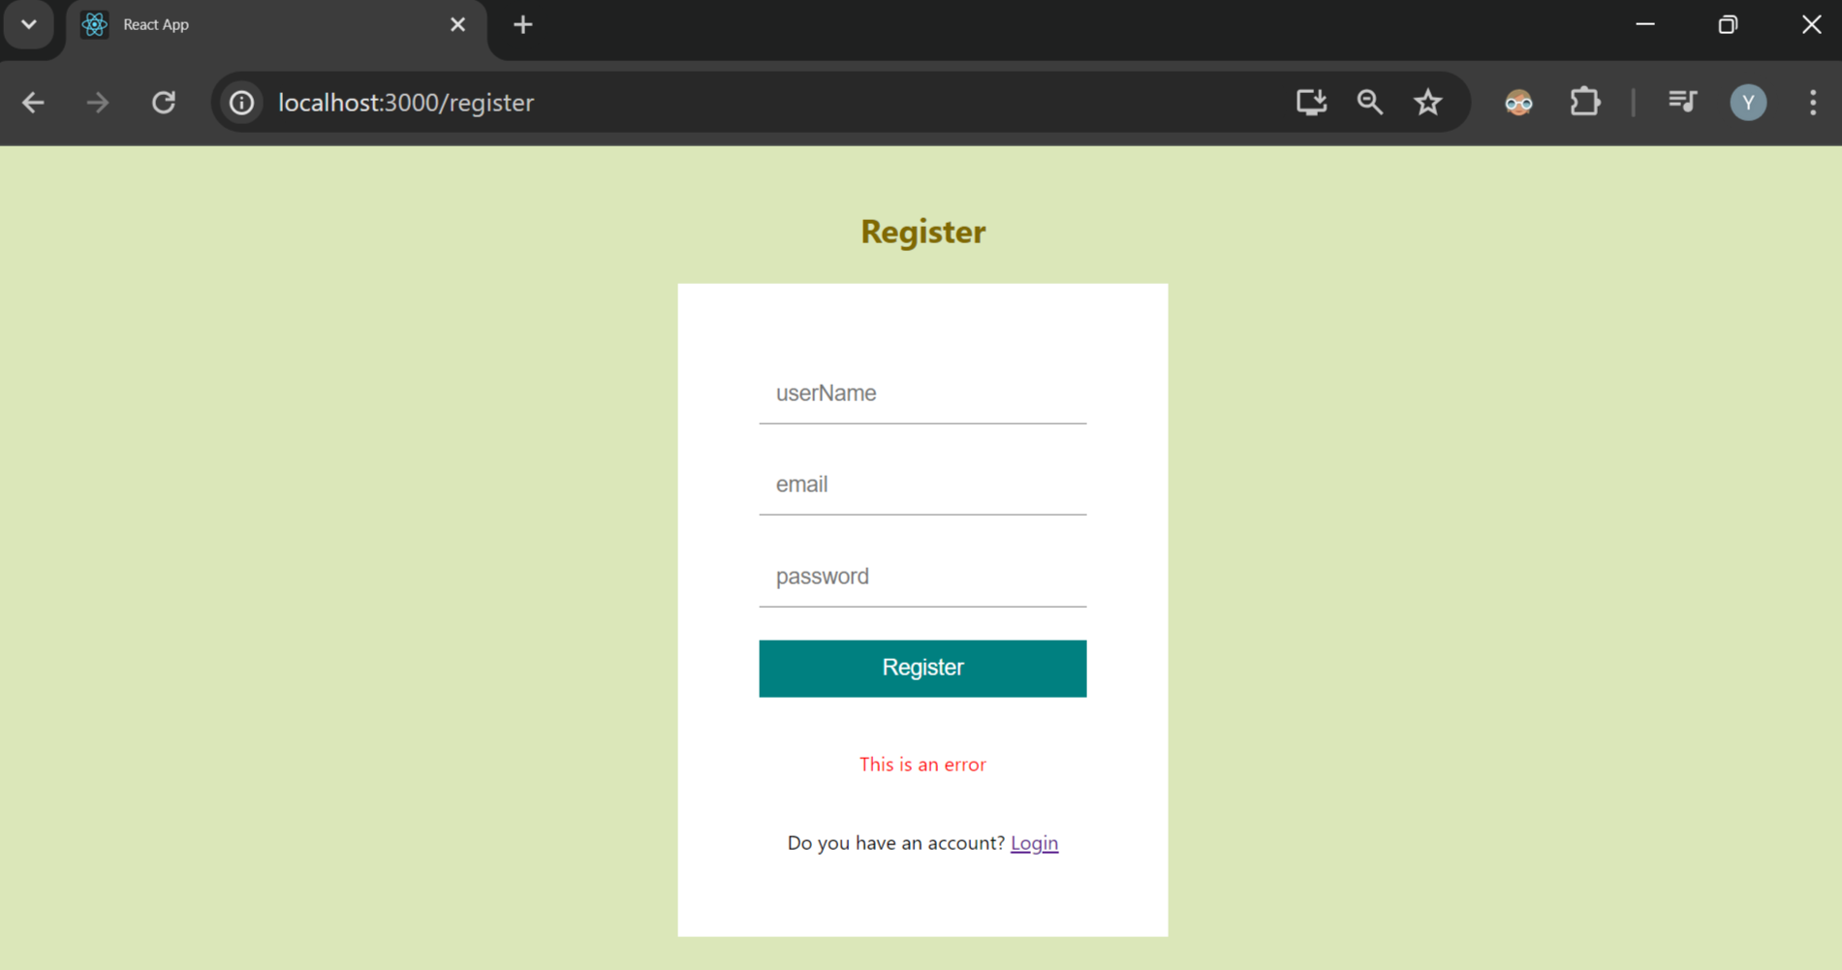

Above is the page

**#. Next we do change in navbar.jsx file**

**Add navbar c**lassname **navbar** for this class itself in our style file inside that we keep adding all other styles

He makes very good navbar check now

<div className='navbar'>Navbar</div>

Above

Inside this navbar itself we’ll have categories some different links

Create another div with **container** which in style file we keep inside our **navbar you can c**heck style.scss file for this

**Imp: inside vscode: if you type .container and press enter automatically it creates div for you**

Inside container we’ll have **logo and links**

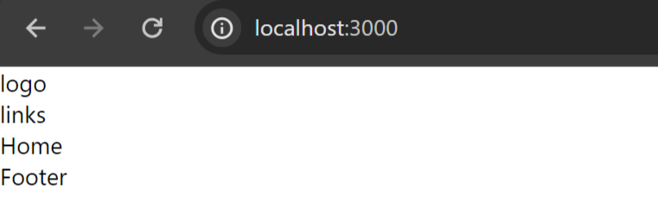

It looks like above with html code

import React from 'react'

const Navbar = () => {

  return (

    <div className='navbar'>

      <div className="container">

        <div className="logo">logo</div>

        <div className="links">links</div>

      </div>

    </div>

  )

}

export default Navbar

above

he kept visual studio in dual mode to see like one side navbar.jsx file on another side he kept open style.scss file

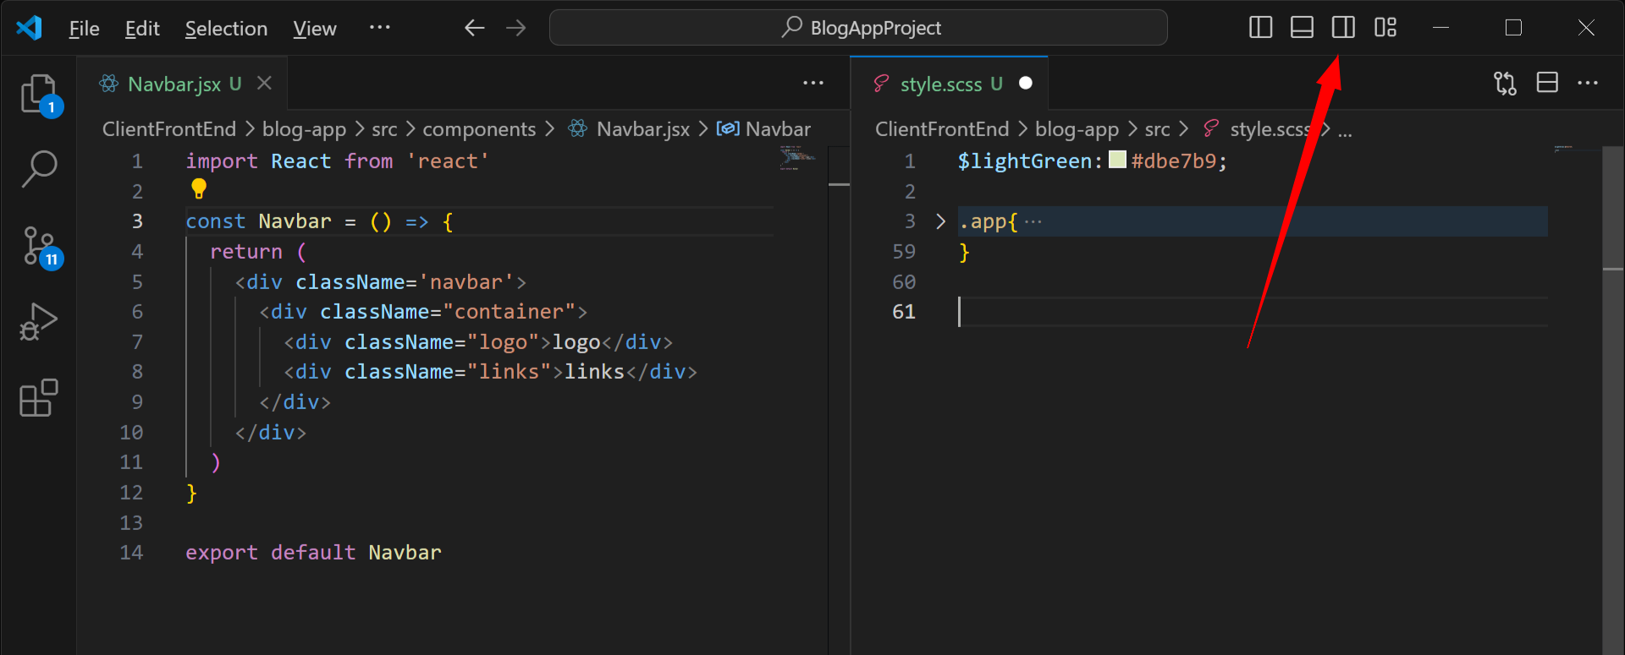

**I think we need click on above or directly from left side drag one file and drop it on right side**

He told he’ll give some specific width for **app container**

.app{

    display:flex;

    justify-content: center;

    .container{

        width: 1024px;

Now inside style.scss for app also we added some style which is to look vertical our content

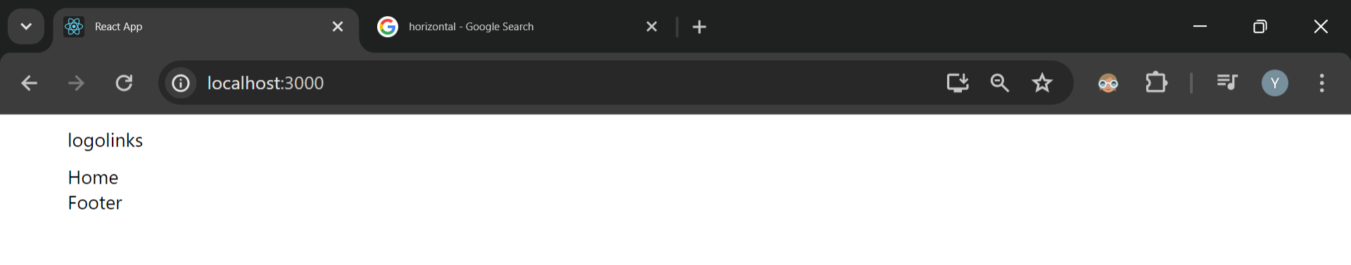

After above style our page looks

Above you can see **logolinks** are looking together because when you give

.navbar{

        .container{

            padding: 10px 0px; //top 10 bottom 0

            display: flex; //making container item horizontal

            justify-content: space-between;

Above style to navbar container they’ll look separately

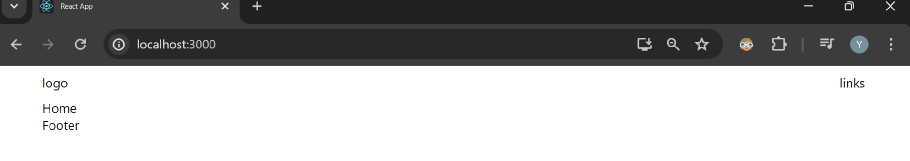

Now logo and links will look in left and right

Next we’re gonna put **logo for our web app**

To do that inside **src** create folder **img** and move all your images into that

It’s like open vs code and image containing folder left and right side and from folder select images drag and drop to vscode images folder

Once we add images to **src->img** folder we need to import them into our file with import command

import React from 'react'

import Logo from '../img/logo.png'

const Navbar = () => {

return (

<div className='navbar'>

<div className="container">

<div className="logo">

<img src={Logo} alt=''/>

</div>

<div className="links">links</div>

</div>

</div>

)

}

export default Navbar

with above with importing logo now our website looks like this

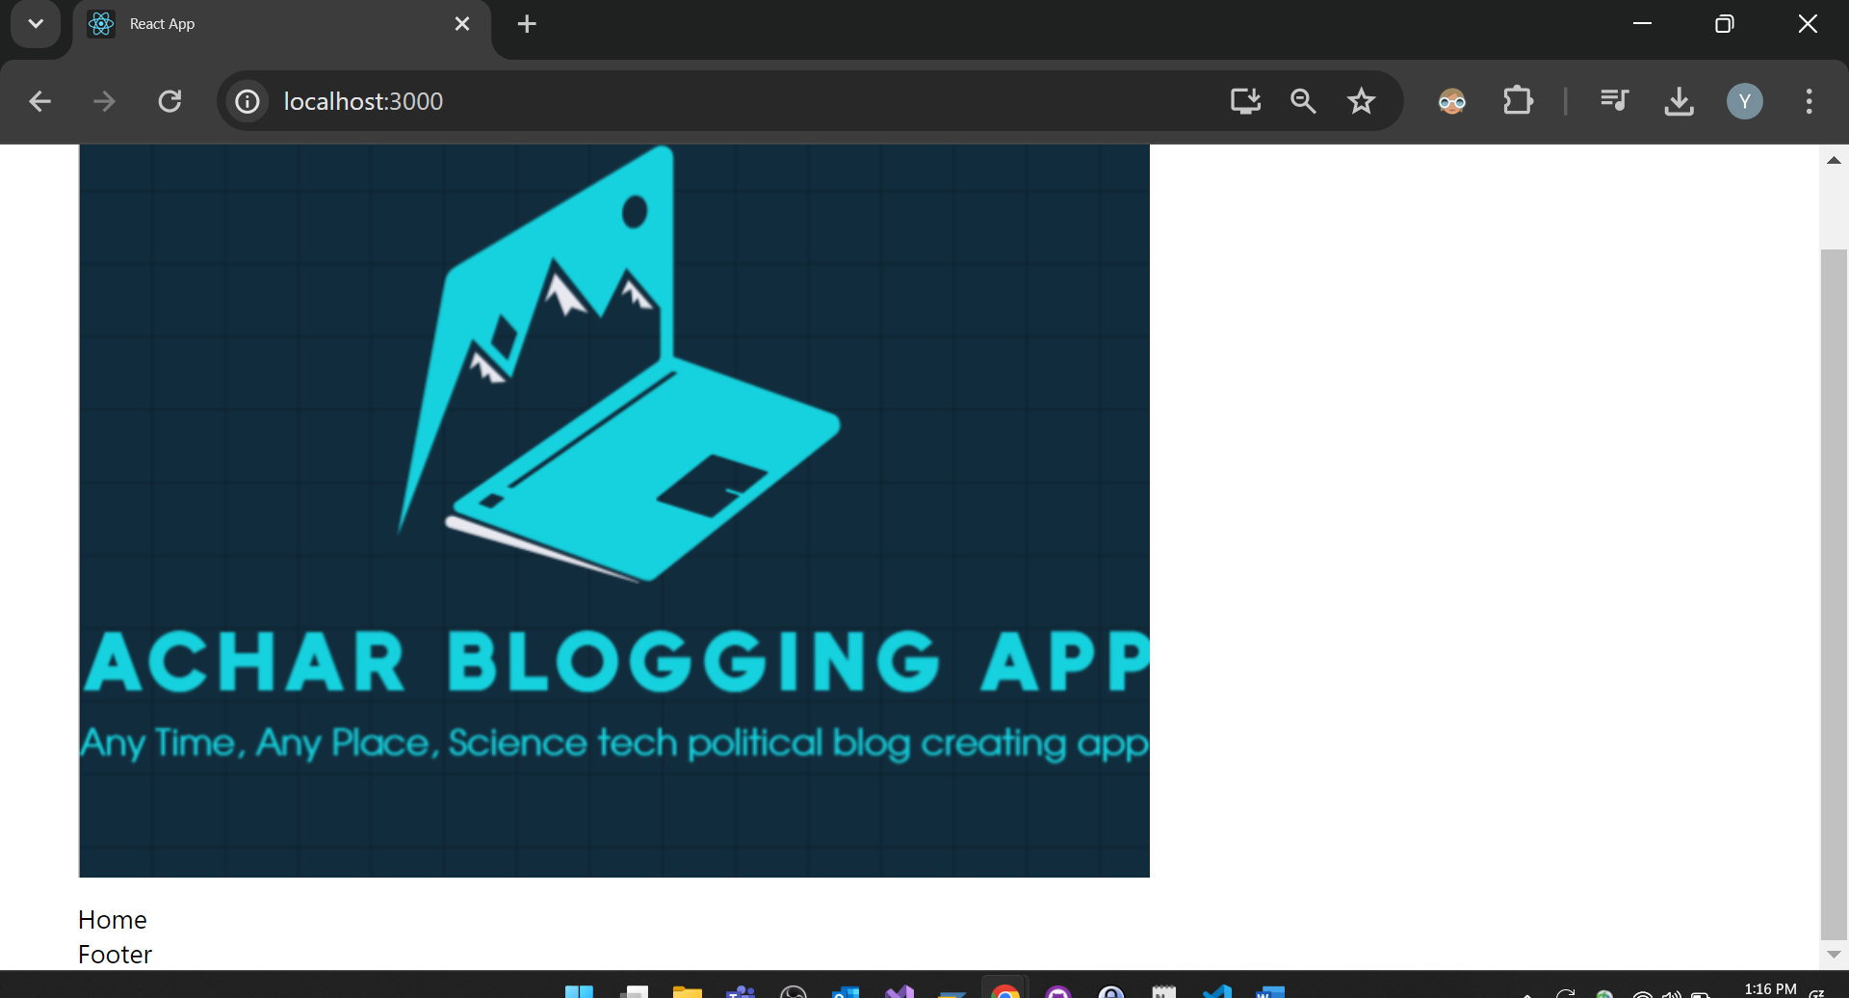

Above you’ve to give proper width and height

Next we’re gonnna create links inside navbar file itself

For link we **use Link from react-router dom we** import that at the beginning

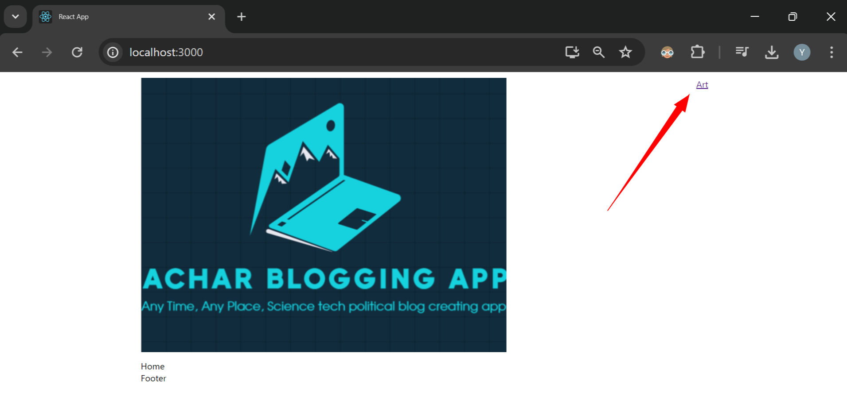

Now we can see when used <Link> we see Art as hyperlink but we don’t want to see “**Art”** with hyperlink we want to see as normal text

 <Link className='link'>Art</Link>

So now Link we give class link

And inside Style.scss file we globally give style to class link because all other place we want to see link as plain text

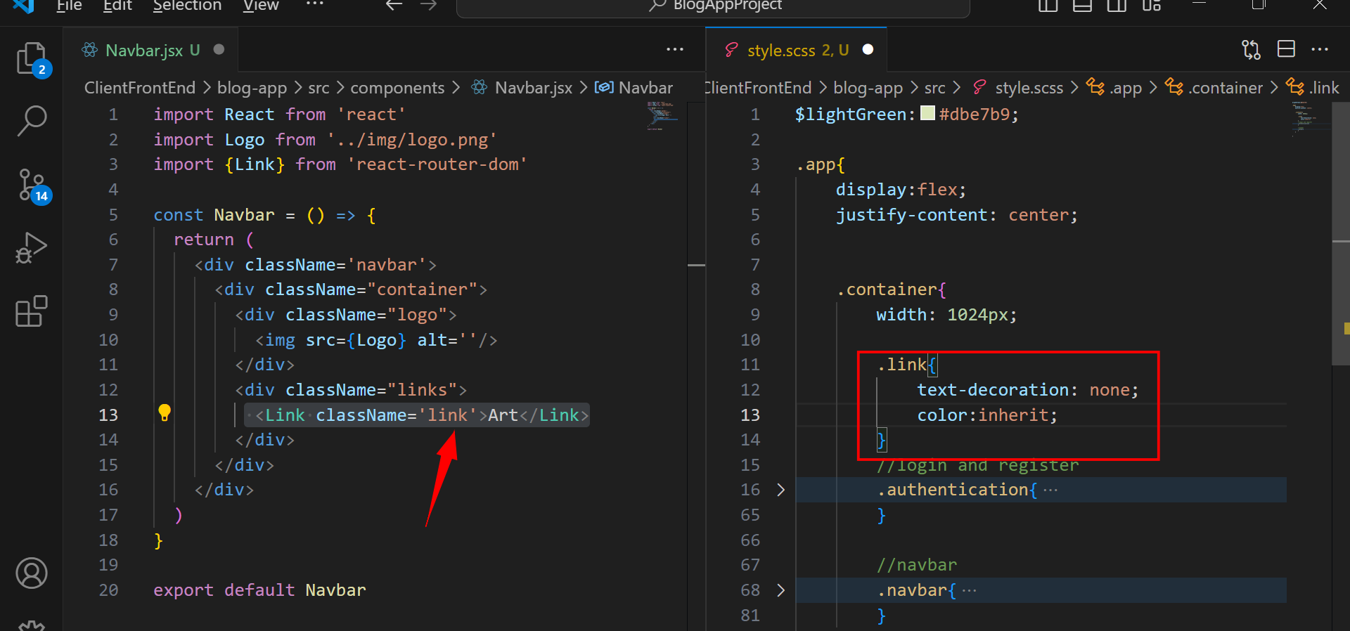

Above you can see we gave style for link globally inside container

You can see your navbar class is also present inside .app=> .container class

Now

<Link className='link' to="/?category=art">

            <h6>Art</h6>

          </Link>

Above we can see **to=”/?categroy=art** means when we click on **art** on browser it’ll redirect to something category

You can see change in url

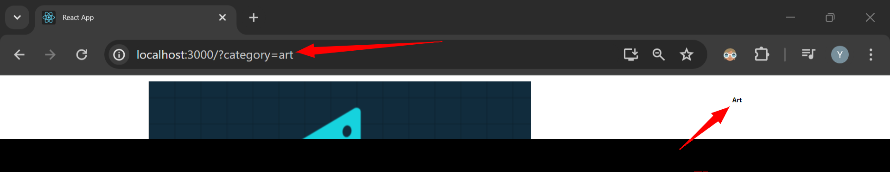

Above url changed

Now like **Art many** links we will add

Just select art and press ctrl+d it copies and pastes to next line later change text

 <div className="links">

          <Link className='link' to="/?category=art">

            <h6>Art</h6>

          </Link>

          <Link className='link' to="/?category=science">

            <h6>Science</h6>

          </Link>

          <Link className='link' to="/?category=technology">

            <h6>Technology</h6>

          </Link>

          <Link className='link' to="/?category=cinema">

            <h6>Cinema</h6>

          </Link>

          <Link className='link' to="/?category=design">

            <h6>Design</h6>

          </Link>

          <Link className='link' to="/?category=food">

            <h6>Food</h6>

          </Link>

        </div>

Above all links are displaying vertically we want to see them horizontally



He again uses same style

Display:flex, gap:10px **with this style**

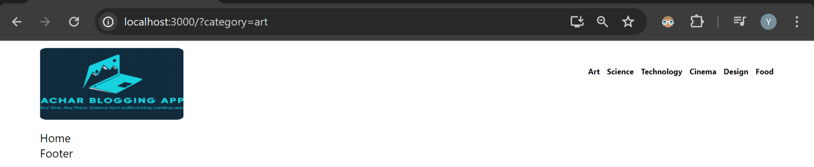

**\*.** Next we add loggedin username, logout these are spans

Another span with link inside it which is to **Write** a new blog

On clicking **Write** page will go to **Write** page.

For this **write** classname we give separate style

  .links {

                    display: flex;

                    gap:10px;

                    align-items: center;

                }

With above all our navbar links will look in single line or else “yadu and logout” they were looking above the navbar line

Next we give style for h6 we give font-size16px and fontweight:300

Also for entire span we give style like cursor:pointer

.links {

                    display: flex;

                    gap: 10px;

                    align-items: center;

                    h6 {

                        font-size: 16px;

                        font-weight: 300;

                    }

                    span {

                        cursor: pointer;

                    }

                }

All style for entire **Link above**

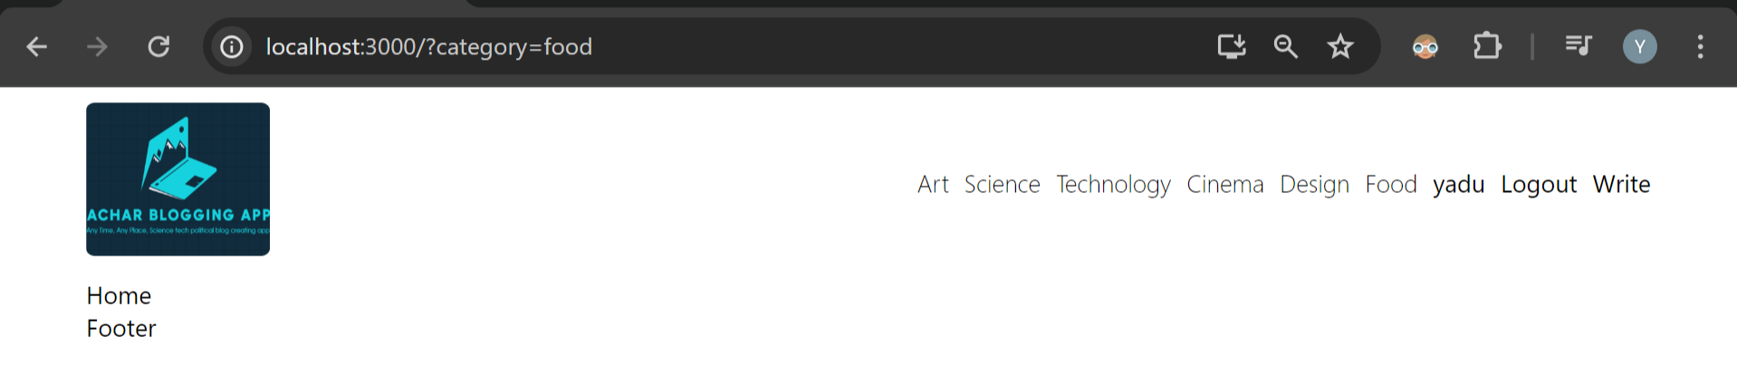

Now our website looks very good

Also in html code inside navbar for Link add classname=link with this **write** text will not be visible as hyperlink

<span className='write'>

            <Link className='link' to="/write"></Link>

          </span>

Next

We create one circle with background color blue for **this write**

**You can** make circle mainly using one thing **border-radius**

Style for below

 <span className='write'>

            <Link className='link' to="/write">Write</Link>

          </span>

.write{

background-color: lightgreen;

height: 50px;

width: 50px;

border-radius: 50%;

}

 .write{

background-color: lightgreen;

             height: 50px;                        width: 50px;

                        border-radius: 50%;

                    }

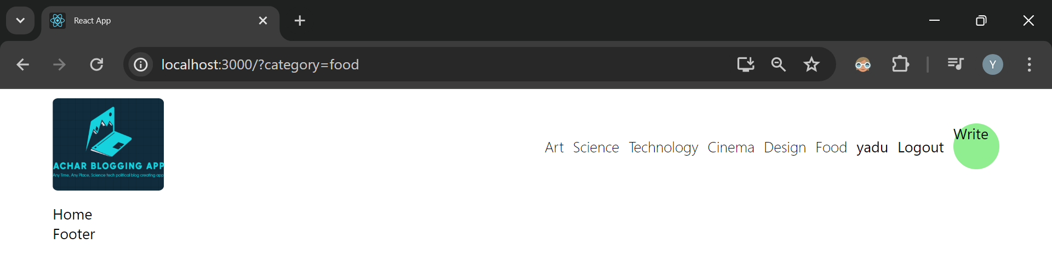

So now write looks like above

But we need to keep **write in center** of circle so we add center in our style also

display: flex;

                        align-items: center;

                        justify-content: center;

This above style we used many place to adjust position

 .write{

                        background-color: lightgreen;

                        height: 50px;

                        width: 50px;

                        border-radius: 50%;

                        display: flex;

                        align-items: center;

                        justify-content: center;

                    }

                }

Now style for write

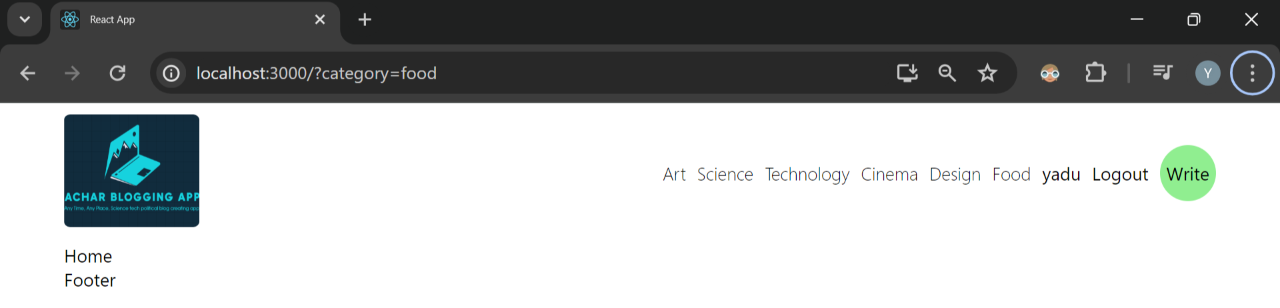

In page it looks like above

*. **Change hover effect on hovering on write text with circle**

When we hover on write we want to see changed color like white with circle

.write{

                        background-color: lightgreen;

                        height: 50px;

                        width: 50px;

                        border-radius: 50%;

                        display: flex;

                        align-items: center;

                        justify-content: center;

                        &:hover{

                            color: teal;

                            background-color: white;

                            border: 1px solid teal;

                        }

                    }

Above is style for hovering effect inside write

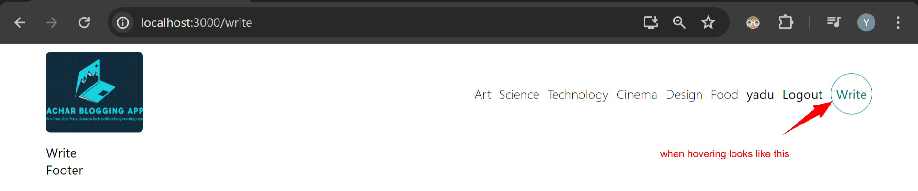

See in page while hover over **write** we see white color background

Observer very carefully when hover on **write our entire navbar itself is moving this is an issue**

So we have to prevent it

 &:hover{

                            color: teal;

                            background-color: white;

                            //border: 1px solid teal;

                        }

He told this is happening because we have added **border 1px** b/w because of this reason itself

You can comment and check all navbar link item won’t move when you comment border

So to avoid this issue means we also need border also our navbar item shouldn’ t move

 border: 1px solid white;

He told we need to also add above **style for our write class with that our all navbar items will not move**

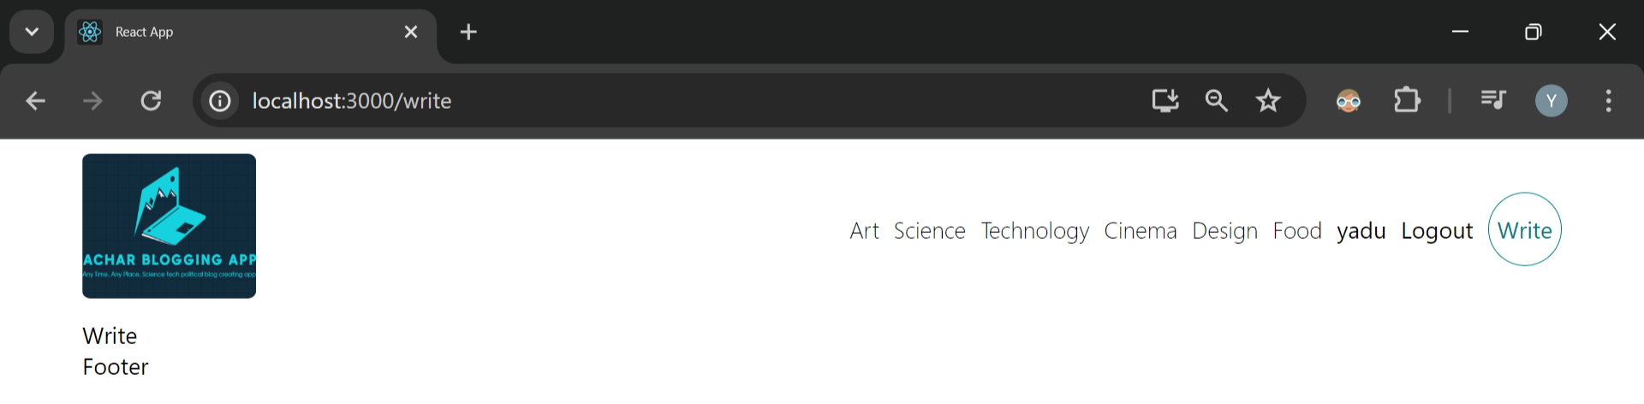

**After above** style when I hovered over **write none of navbar items moved**

**#. Next we move to footer tab**

Go to footer.jsx file start doing your changes

For footer also we add same logo as we added navbar

import React from 'react'

import Logo from '../img/logo.png'

const Footer = () => {

  return (

    <footer>

      <img  src={Logo} alt=""/>

      <span>Made with ❤️ and <b>by Achar</b>.</span>

    </footer>

  )

}

export default Footer

We added above code in footer here also we added logo

 footer{

            img{

                height: 50px;

            }

        }

When we gave above footer style

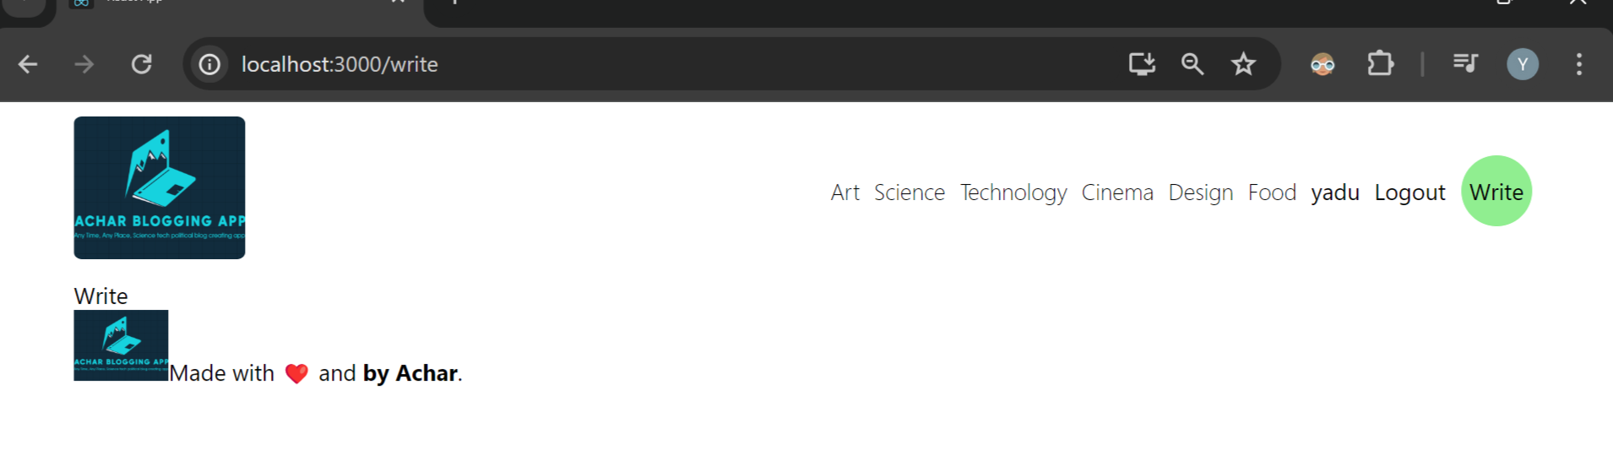

Our page looks like above

But we need to give large space b/w navbar and footer

So we add margin-top padding

 footer{

            margin-top: 100px;

            padding: 20px;

            background-color: lightgreen;

            display: flex;

            align-items: center;

            justify-content: space-between;

            font-size: 12px;

            img{

                height: 50px;

            }

        }

    }

Above is footer style

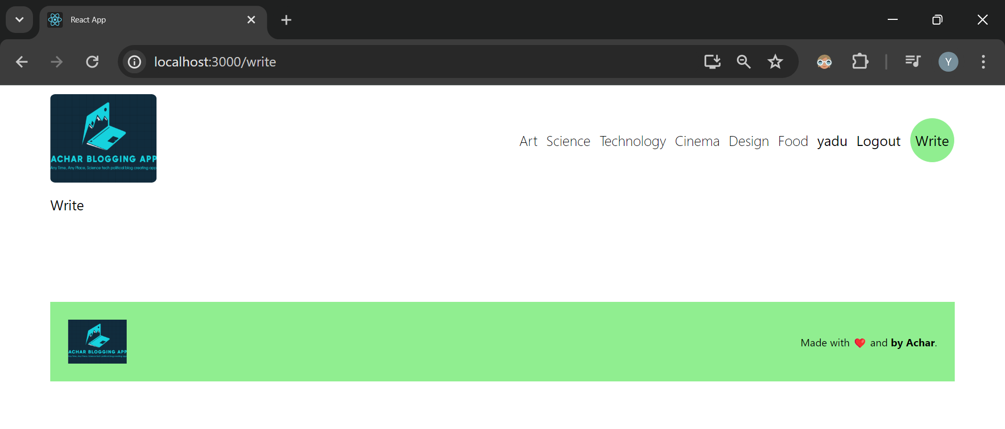

Our page looks like above

Just with html css he created entire page you have to work on html css from w3schools

#. Next we go to home page home.jsx file

For in home.jsx div we add class home

He told he’ll post some posts in home page

We’re gonna fetch post from api but as of now we’ll put some dummy data

Copied from github his dummy data and pasted in home.jsx file

We use this dummy data to check our design

For each post we will have separate div

Each post will have it’s unique key it’s post.id

We write lambda function to generate div for each post

const Home = () => {

  return (

    <div className='home'>

      <div className='posts'>

        {posts.map((post)=>(

          <div className='post' key={post.id}>

          </div>

        ))}

      </div>

    </div>

  )

}

Now inside div with class post we write another div that will be created from **map**

That div is for post

Inside div containing map: One div we create for **image**

Another **div we** create for **content which has link** inside this **content** we’ll have **title of post I think** on clicking it, it’ll show us details of content

When we click on title link we go to post page but as we remember **we’ve to specify post id**

 <div className='content'>

                <Link to={`/post/${post.id}`}>

                <h1>{post.title}</h1>

                </Link>

              </div>

**Above** is code for it when clicked on link we go to post page also we pass post.id

Also we add post description with p tag

import React from 'react'

import {Link} from 'react-router-dom'

const Home = () => {

  const posts = [

    {

      id: 1,

      title: "Lorem ipsum dolor sit amet consectetur adipisicing elit",

      desc: "Lorem, ipsum dolor sit amet consectetur adipisicing elit. A possimus excepturi aliquid nihil cumque ipsam facere aperiam at! Ea dolorem ratione sit debitis deserunt repellendus numquam ab vel perspiciatis corporis!",

      img: "https://images.pexels.com/photos/7008010/pexels-photo-7008010.jpeg?auto=compress&cs=tinysrgb&w=1260&h=750&dpr=2",

    },

    {

      id: 2,

      title: "Lorem ipsum dolor sit amet consectetur adipisicing elit",

      desc: "Lorem, ipsum dolor sit amet consectetur adipisicing elit. A possimus excepturi aliquid nihil cumque ipsam facere aperiam at! Ea dolorem ratione sit debitis deserunt repellendus numquam ab vel perspiciatis corporis!",

      img: "https://images.pexels.com/photos/6489663/pexels-photo-6489663.jpeg?auto=compress&cs=tinysrgb&w=1260&h=750&dpr=2",

    },

    {

      id: 3,

      title: "Lorem ipsum dolor sit amet consectetur adipisicing elit",

      desc: "Lorem, ipsum dolor sit amet consectetur adipisicing elit. A possimus excepturi aliquid nihil cumque ipsam facere aperiam at! Ea dolorem ratione sit debitis deserunt repellendus numquam ab vel perspiciatis corporis!",

      img: "https://images.pexels.com/photos/4230630/pexels-photo-4230630.jpeg?auto=compress&cs=tinysrgb&w=1260&h=750&dpr=2",

    },

    {

      id: 4,

      title: "Lorem ipsum dolor sit amet consectetur adipisicing elit",

      desc: "Lorem, ipsum dolor sit amet consectetur adipisicing elit. A possimus excepturi aliquid nihil cumque ipsam facere aperiam at! Ea dolorem ratione sit debitis deserunt repellendus numquam ab vel perspiciatis corporis!",

      img: "https://images.pexels.com/photos/6157049/pexels-photo-6157049.jpeg?auto=compress&cs=tinysrgb&w=1260&h=750&dpr=2",

    },

  ];

  return (

    <div className='home'>

      <div className='posts'>

        {posts.map(post=>(

          <div className='post' key={post.id}>

              <div className='img'>

                <img src={post.img} alt='' />

              </div>

              <div className='content'>

                <Link to={`/post/${post.id}`}>

                <h1>{post.title}</h1>

                <p>{post.desc}</p>

                <button>Read more</button>

                </Link>

              </div>

          </div>

        ))}

      </div>

    </div>

  )

}

export default Home

above is the code for home.jsx

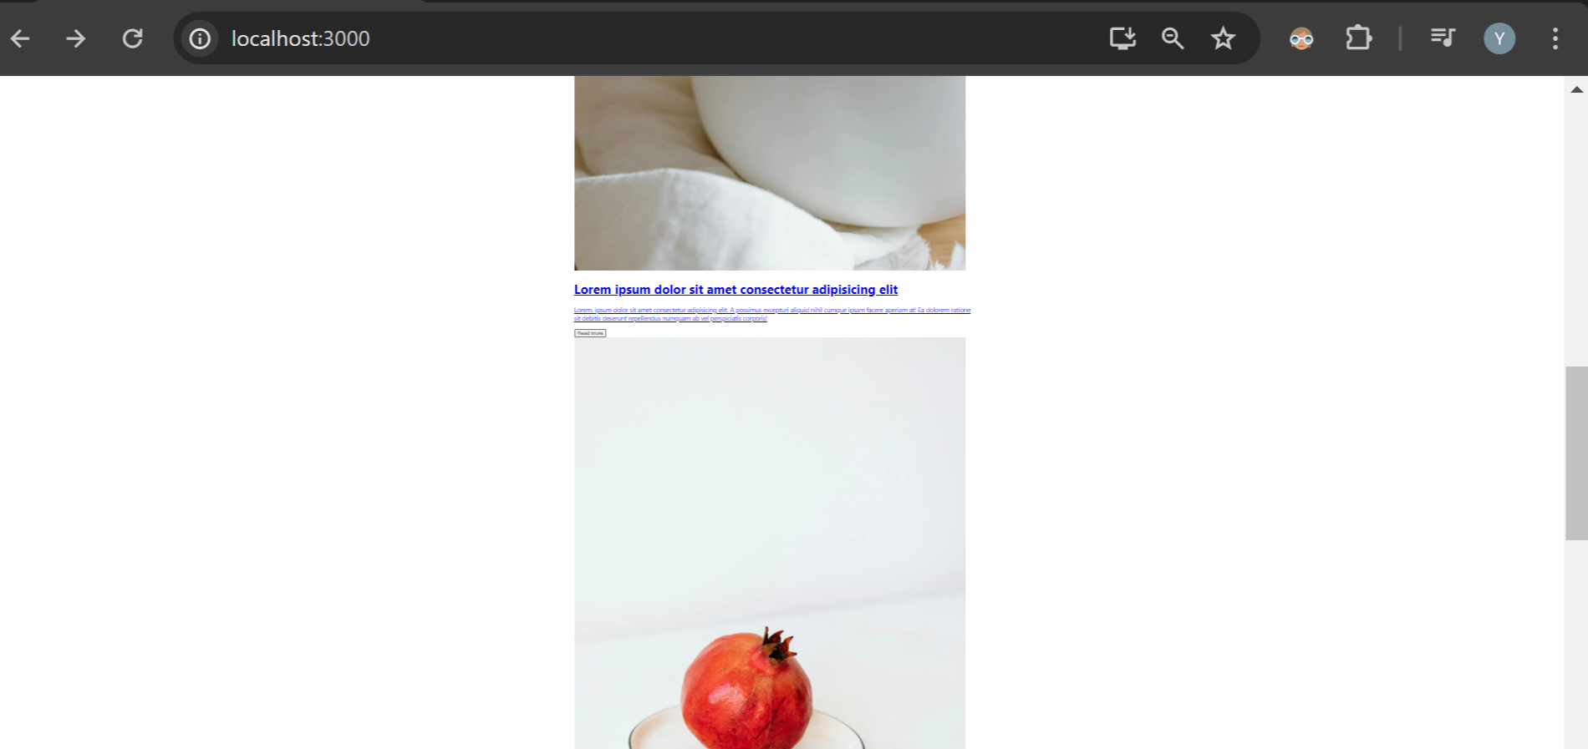

now if you go and see your page there will be lot of post 4 posts will be there

next we add style we move p tag and button out of link

in page our link is visible with hyperlink so we add class link

<div className='home'>

      <div className='posts'>

        {posts.map(post=>(

          <div className='post' key={post.id}>

              <div className='img'>

                <img src={post.img} alt='' />

              </div>

              <div className='content'>

                <Link className='link' to={`/post/${post.id}`}>

                <h1>{post.title}</h1>

                </Link>

                <p>{post.desc}</p>

                <button>Read more</button>

              </div>

          </div>

        ))}

      </div>

    </div>

Above we can see for Link tag we added class link with that hyperlink is removed



Page looks above with above text

Next we add style to entire home page inside our style.css after footer

**#. Home page style**

**Home** page class .home inside that class .posts we put in our style file

 margin-top: 50px;

b/w navbar and posts content we give marging 50px

next we wish to show our image and it’s content as column so again we use display flex

.home{

            .posts{

                margin-top: 50px;

                display: flex;

                flex-direction: column;

                gap: 150px;

            }

        }

Above is style for it gap 150 means gap b/w each post is 150px

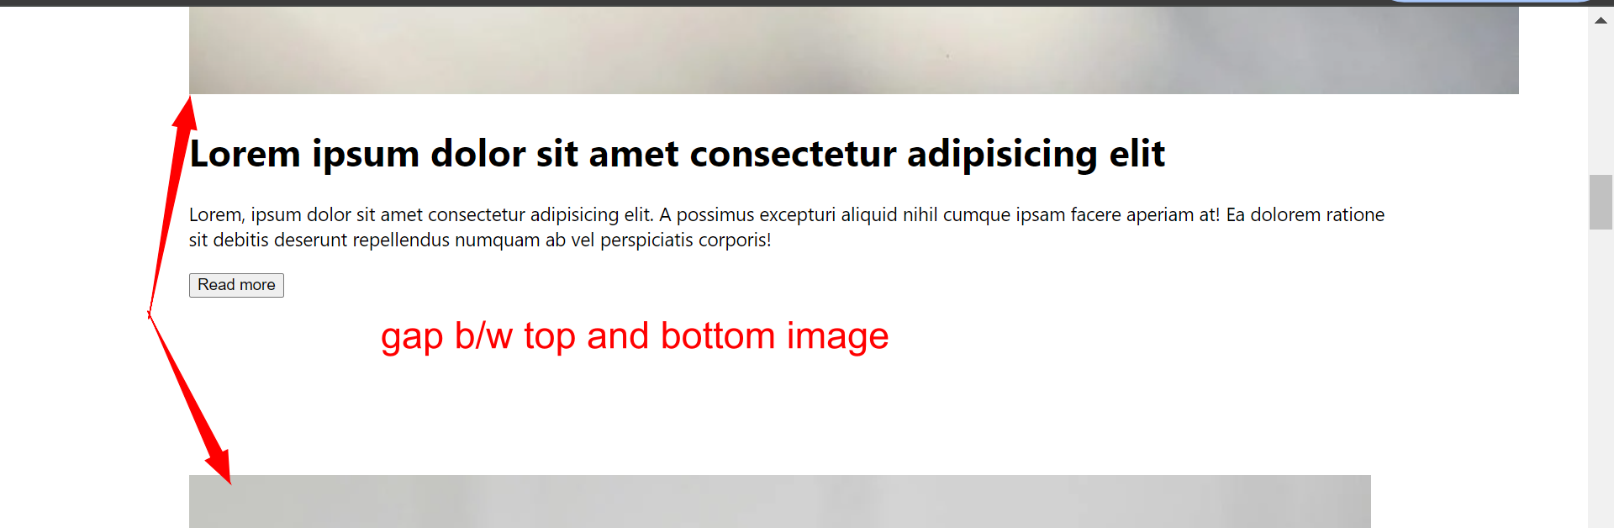

You can see gap now

Next for each post we define fixed size

For that we use display:flex this will make image horizontal next we decrease image size

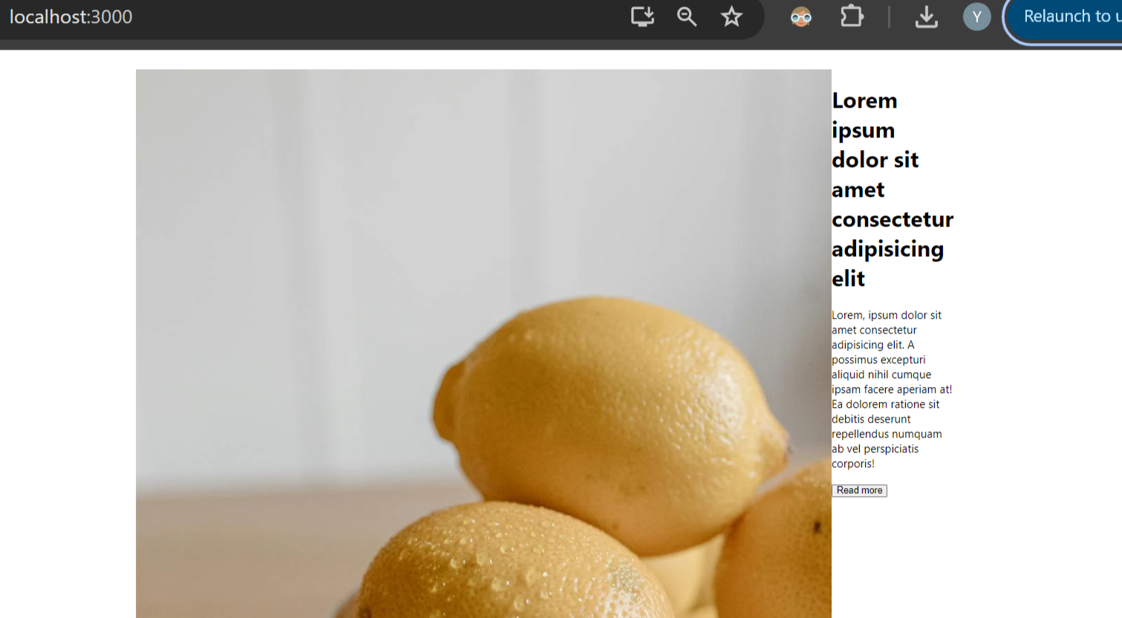

Above you can see display flex made image horizontal

Next for img class he gave **flex:1 and for content he gave flex:2**

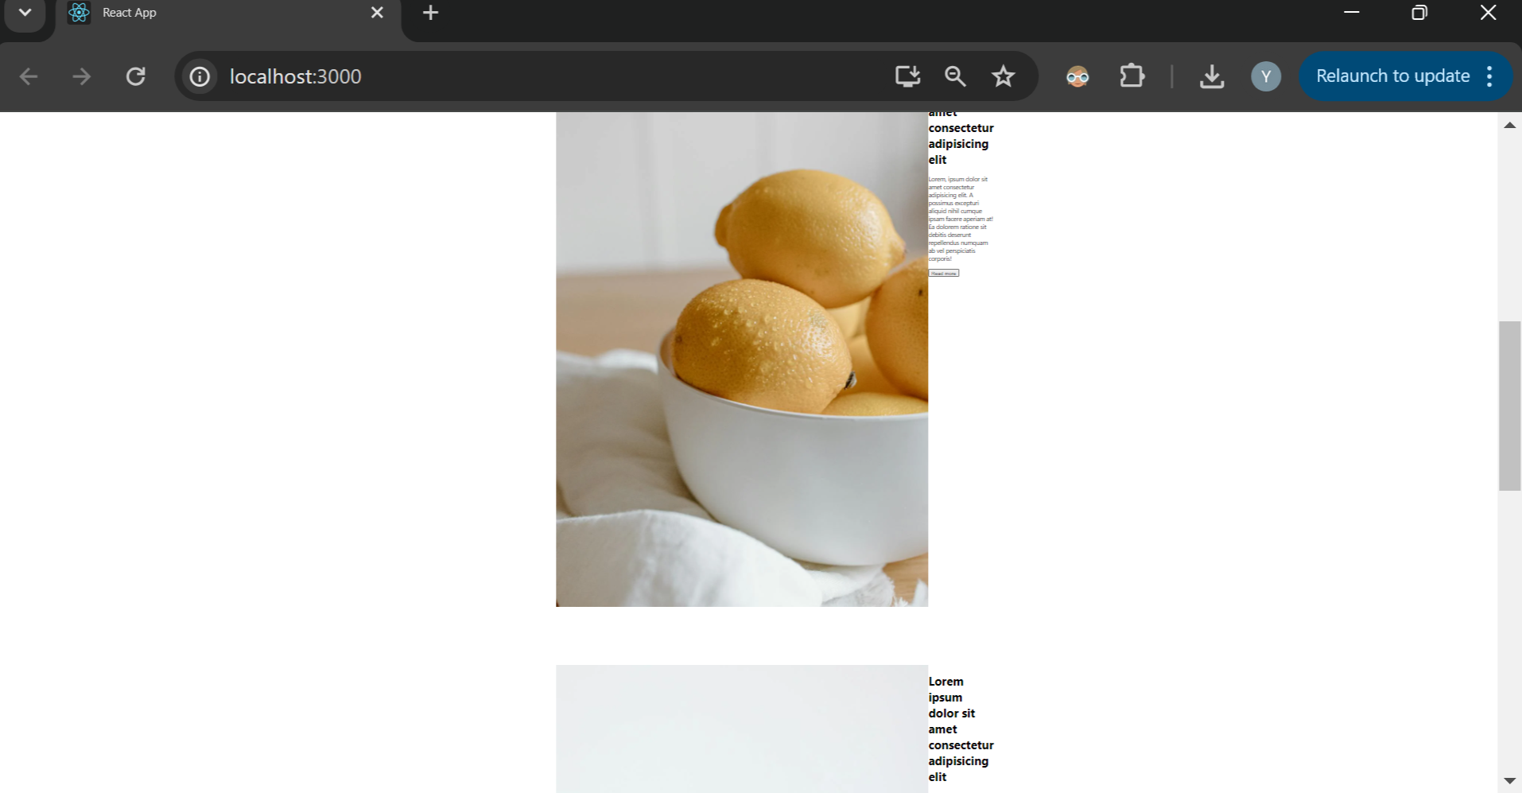

**Changes in web page** I didn’t see much difference from earlier

Now inside img class again he added img class and defined width as 100%

For testing I checked like

.img{

                flex:1;

                width: 100%;

                // img{

                //     width: 100%;

                // }

            }



Above with above image and contents overlapped

   .img{

                flex:1;

                img{

                    width: 100%;

                }

            }

But when I kept as he told like above

Img inside img for this told **width will be of parent div**

**He** told f**ont size will be 2 units a**nd size of **image will be 1 unit**

**Flex:2** we use for increasing size of image or contents inside that div

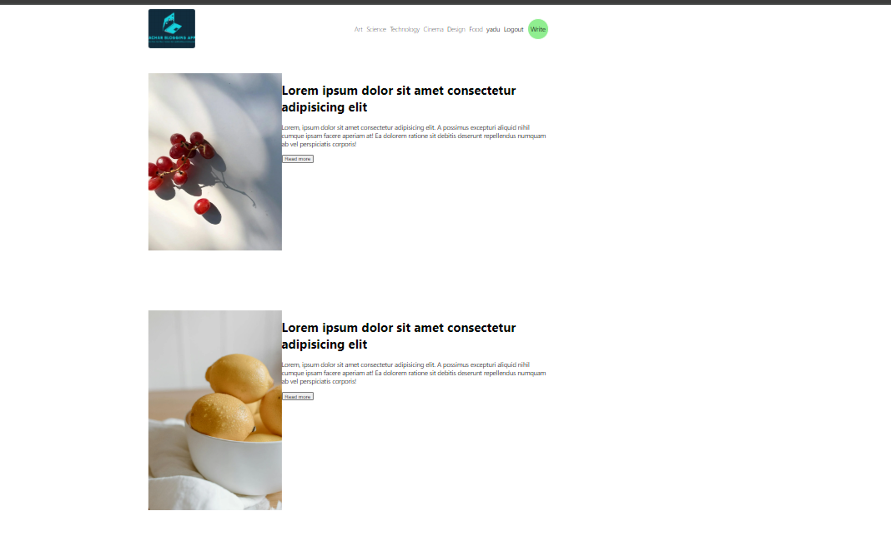

Image and text looks like this

Ask with all doubts in **chatgpt quick solution you get**

Try by giving flex:5 for image and flex:1 for text of that posts content you’ll see difference

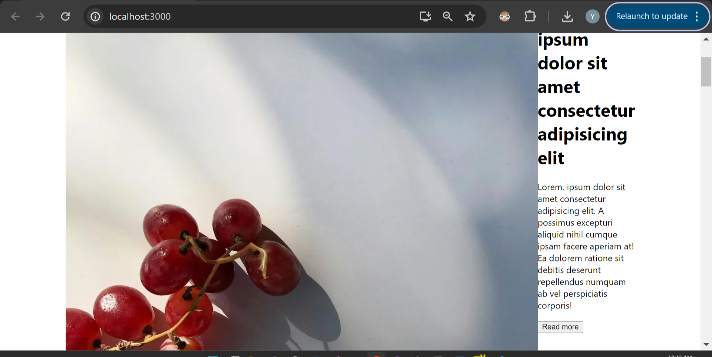

At 80% zoom it looks like above large image with **flex=5 for image**

Next we need gap b/w image and text content of that post so

For .post after display:flex add gap:100px

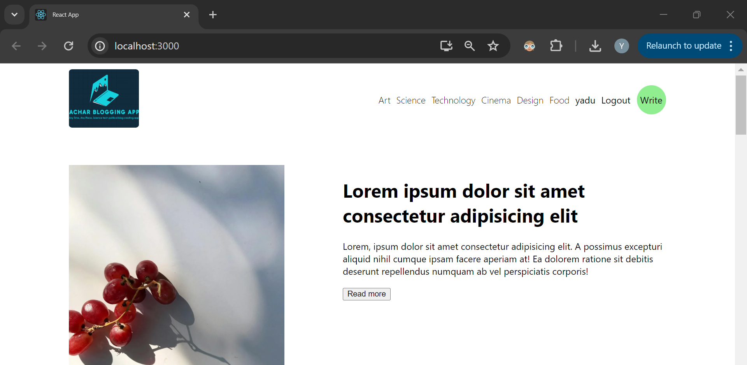

At 80% zoom page looks like above

 .post{

                display: flex;

                gap: 100px;

                .img{

                    flex:2;

                    img{

                        width: 100%;

                    }

                }

                .content{

                    flex:3;

                }

            }

With latest style

Img inside .img class max-height:400px

He also gave object-fit: cover for image

29:00 time

Now best styling he’s going to do:

If the **item number** odd put image on the right content on the left or else when item number is even put image on the left content on the right even number item we keep it as it is

Style for it:

&:nth-child(2n+1){

Flex-direction:row-reverse;

}

Above 2n+1 means for odd number item just do contents of that row reverse

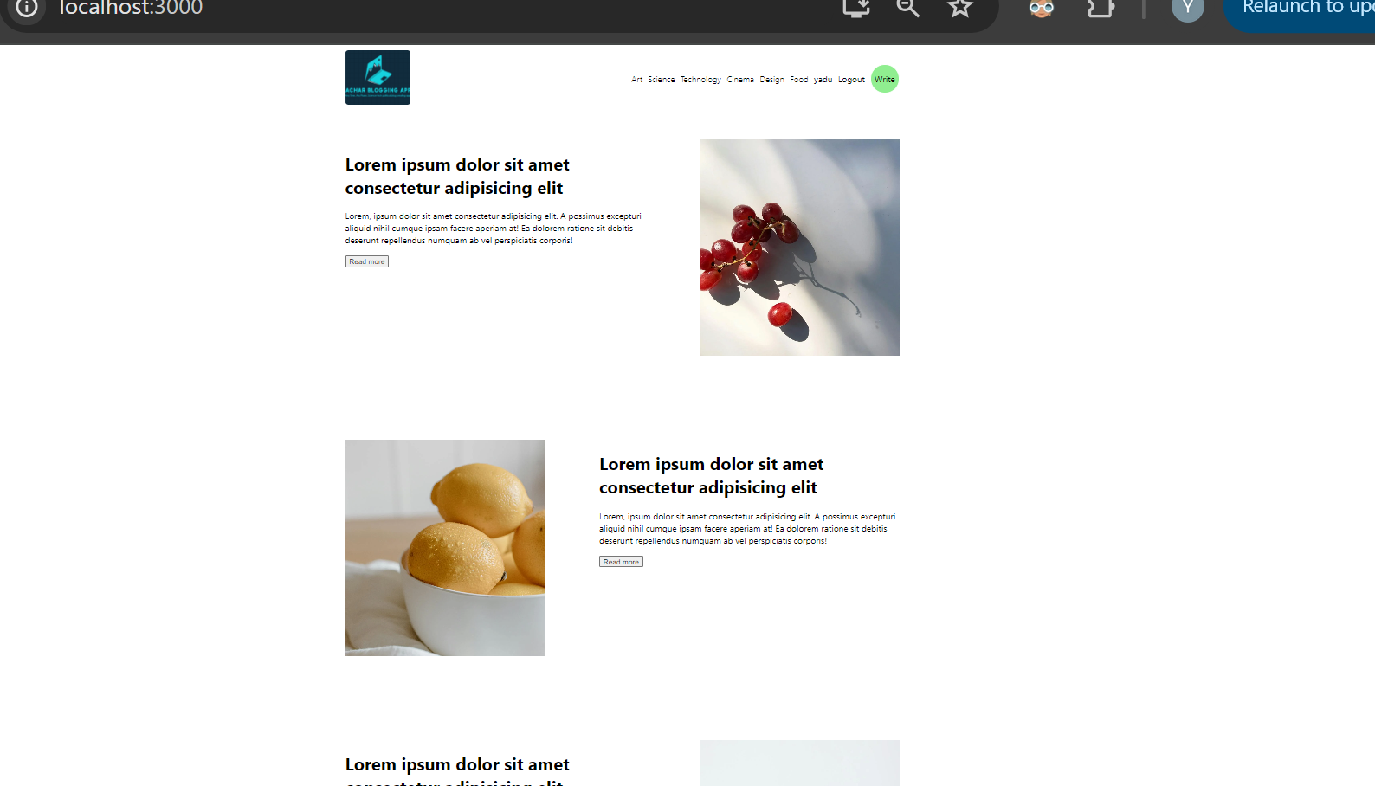

With above style becomes like this

odd row image right side, even row image left side

*. Now for image we’ll give background rectangle box **using after in csss**

This we do inside **img** class for img class it’s important to give **position:relative**

.img{

                    flex:2;

                    position: relative;

                    &::after{

                        content: "";

                        width: 100%;

                        height: 100%;

                        background-color: lightgreen;

                        position: absolute;

                        top:20px;

                        left: -20px;

                    }

With above style

We see rectangle background above our image

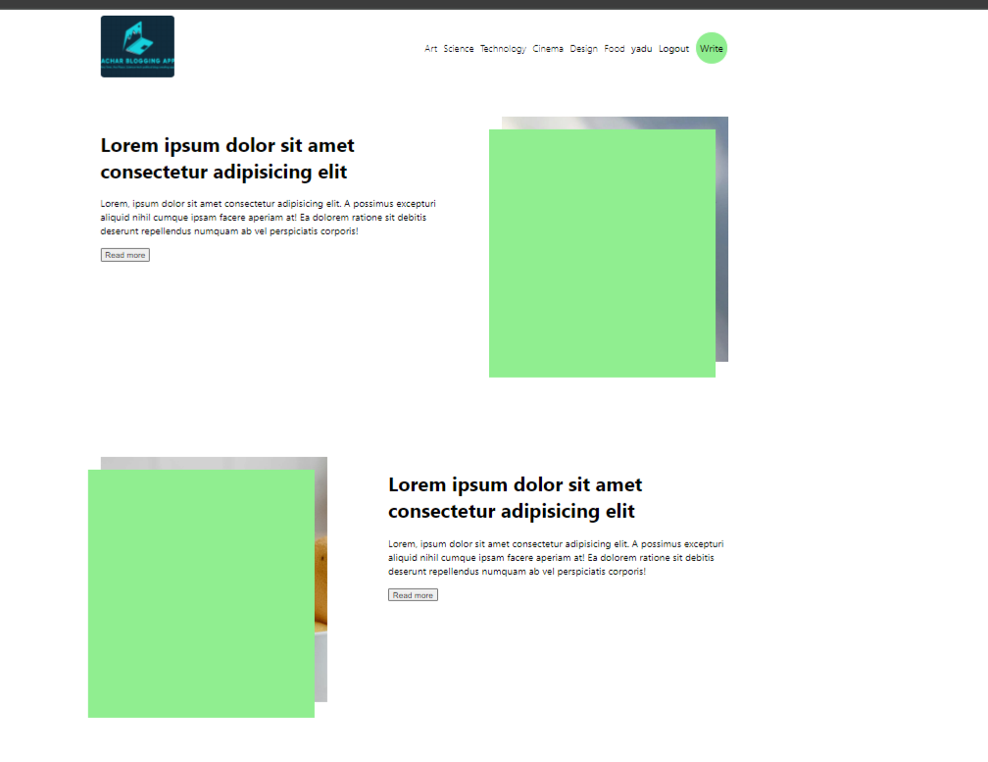

 top:20px;

 left: -20px;

because of above style you see them like background overlapped on one another

now we have one problem background visible front our image visible at back he to it’s easy to fix

we use z-index=-1;

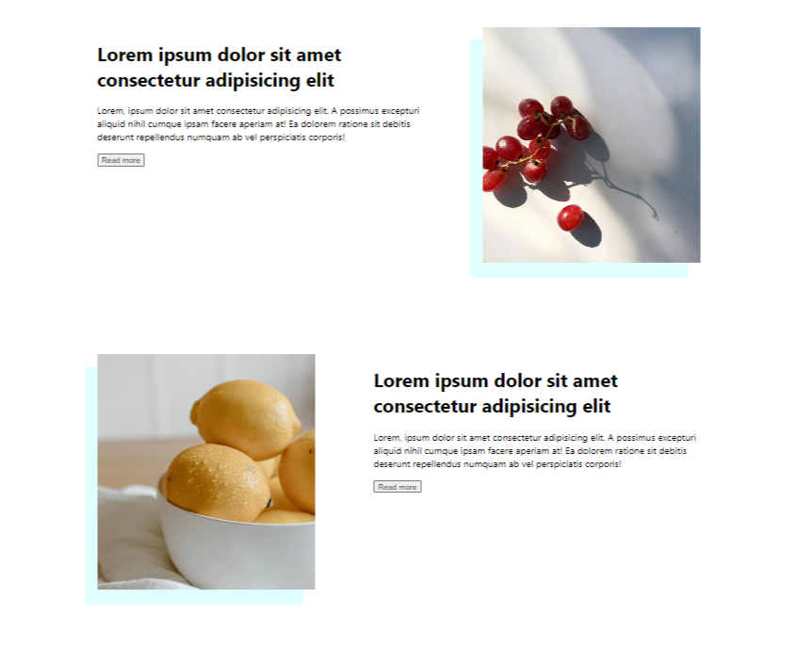

now our background with image looks

I have changed the color

*. Now if you see content: has content title, actual content and read more button

We will separate all 3 of them

For that we give style

.content{

                    flex:3;

                    display: flex;

                    flex-direction: column;

                    justify-content: space-between;

                }

So now with above style page looks

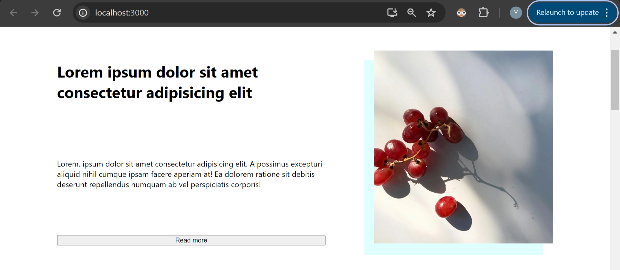

Like above all are stretched

After this we give style for h1 and p tag and read more button



After giving style for h1,p1 button page looks like above

.content{

                    flex:3;

                    display: flex;

                    flex-direction: column;

                    justify-content: space-between;

                    h1{

                        font-size: 48px;

                    }

                    p{

                        font-size: 18px;

                    }

                    button{

                        width: max-content;

                    }

                }

Above

Next for button we give background color padding

Padding numbers: top bottom left right

 button{

                        width: max-content;

                        padding: 10px 20px;

                        border: none;

                        cursor: pointer;

                        background-color: white;

                        border: 1px solid teal;

                        color: teal; //text color

                    }

Button color and all styles



**Button** will look like this

For button we also add hover effect on hover over button

When you hover over button background color changes to lightgreen or some other

Also border color we change on hover also text color we change on hover

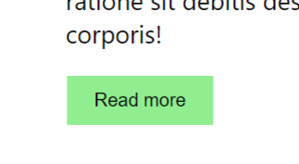

This is how button looks on hover

  button{

                        width: max-content;

                        padding: 10px 20px;

                        border: none;

                        cursor: pointer;

                        background-color: white;

                        border: 1px solid teal;

                        color: teal; //text color

                        &:hover{

                            border: 1px solid white;

                            background-color: lightgreen;

                            color: black;

                        }

                    }

Style of them

**#. Handling when you click on post title redirect to single page**

34:23

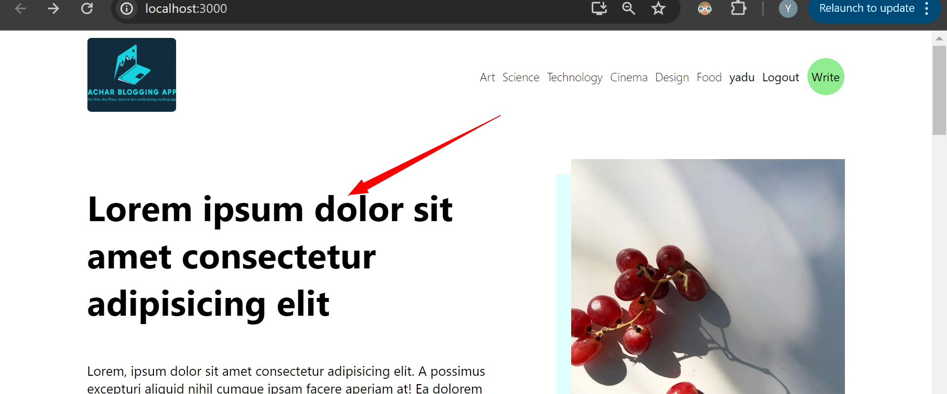

Click on above title redirect to single page

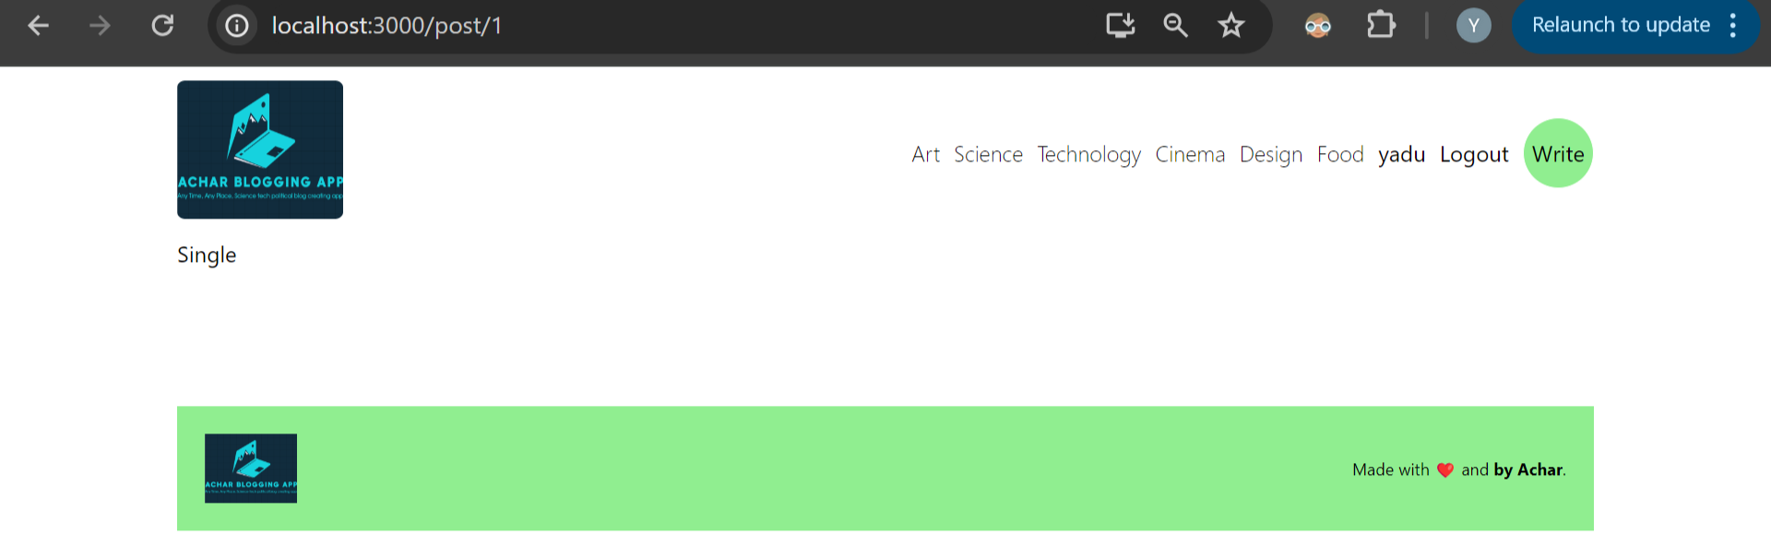

Comes here

**To single page**

<http://localhost:3000/post/1>

above will be url

we’ll have our post number 1

next we go to single page

add class single

inside single class div we’ll have 2 items

some will be our content: including post image content and description

and 2nd item will be **menu**

 .single{

            display: flex;

            gap:50px;

            .content{

                flex:5; //this is for size

            }

            .menu{

                flex:2; //this is for size

            }

        }

Now after giving style

  <div className='single'>

      <div className='content'>c</div>

      <div className='menu'>m</div>

    </div>

For content and c and menu m

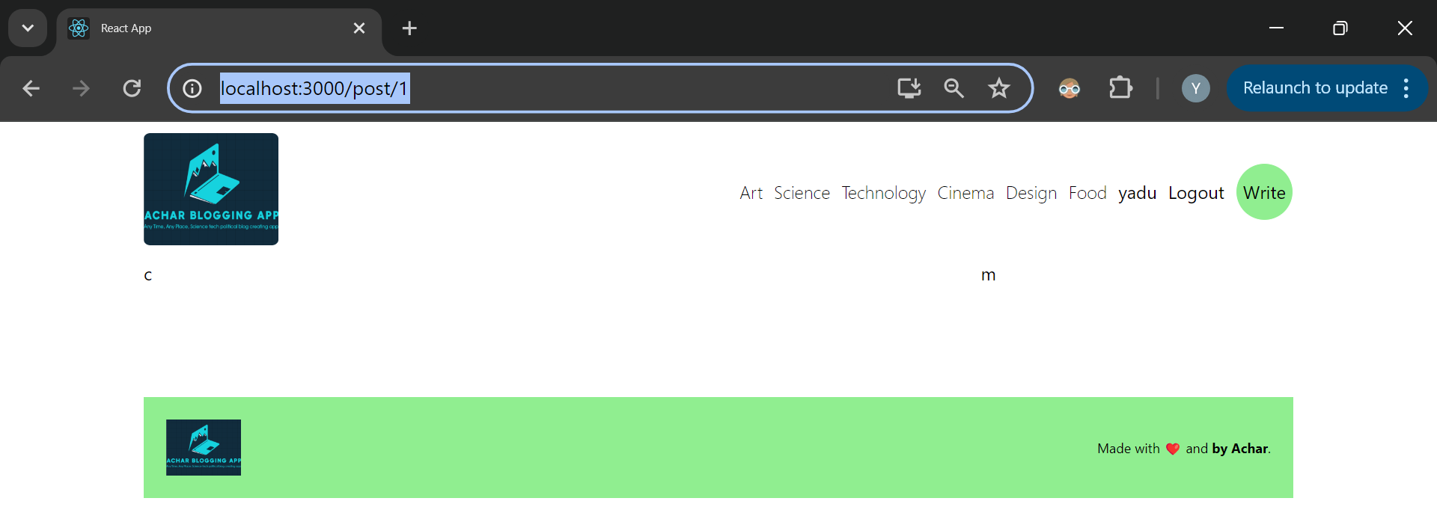

Our page looks like this with also display flex our c and m will look like above

Firstly we’re gonna insert image inside our div content

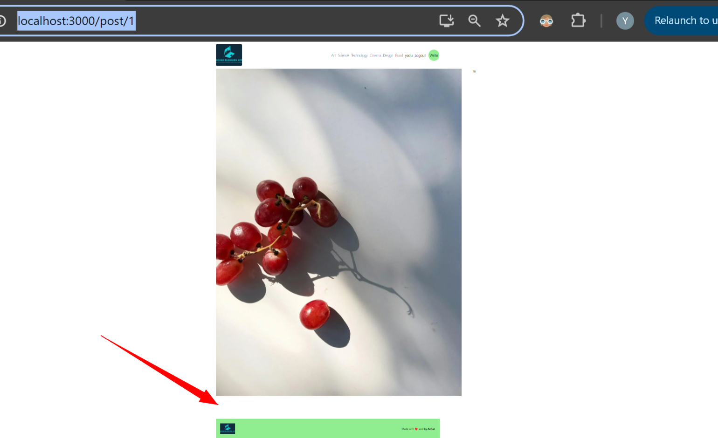

This is dummy image we’ve put

After image we create user div we want to put **user image, user name , date posted**

**After** that we put our post title

const Single = () => {

  return (

    <div className='single'>

      <div className='content'>

        <img src='https://images.pexels.com/photos/7008010/pexels-photo-7008010.jpeg?auto=compress&cs=tinysrgb&w=1260&h=750&dpr=2' alt=''/>

        <div className="user">

        <img src='https://images.pexels.com/photos/7008010/pexels-photo-7008010.jpeg?auto=compress&cs=tinysrgb&w=1260&h=750&dpr=2' alt=''/>

        <div className="info">

          <span>Ramesh</span>

          <p>Posted 2 days ago</p>

          </div>

        </div>

      </div>

      <div className='menu'>m</div>

    </div>

  )

}

Above is html code our images are so big

Now we add style for them

.user{

                    img{

                        width: 50px;

                        height: 50px;

                        border-radius: 50%;

                        object-fit: cover;

                    }

                }

Style for img inside user class



With above user image looks in circle

Next we give style for outer image related to particular post

I got to know why we’ll use style **object-fit:cover you** can comment on this style and check changes in the image if we don’t use our image looks like stretched with quality of image reduced

But when you use object-fit cover original clarity quality of image will be displayed

Below image without object-fit



And below image after using object-fit



**This is** image with good clarity

 .content{

                flex:5; //this is for size

                img{

                    width: 100%;

                    height: 300px;

                    object-fit: cover;

                }

With above style our main post image

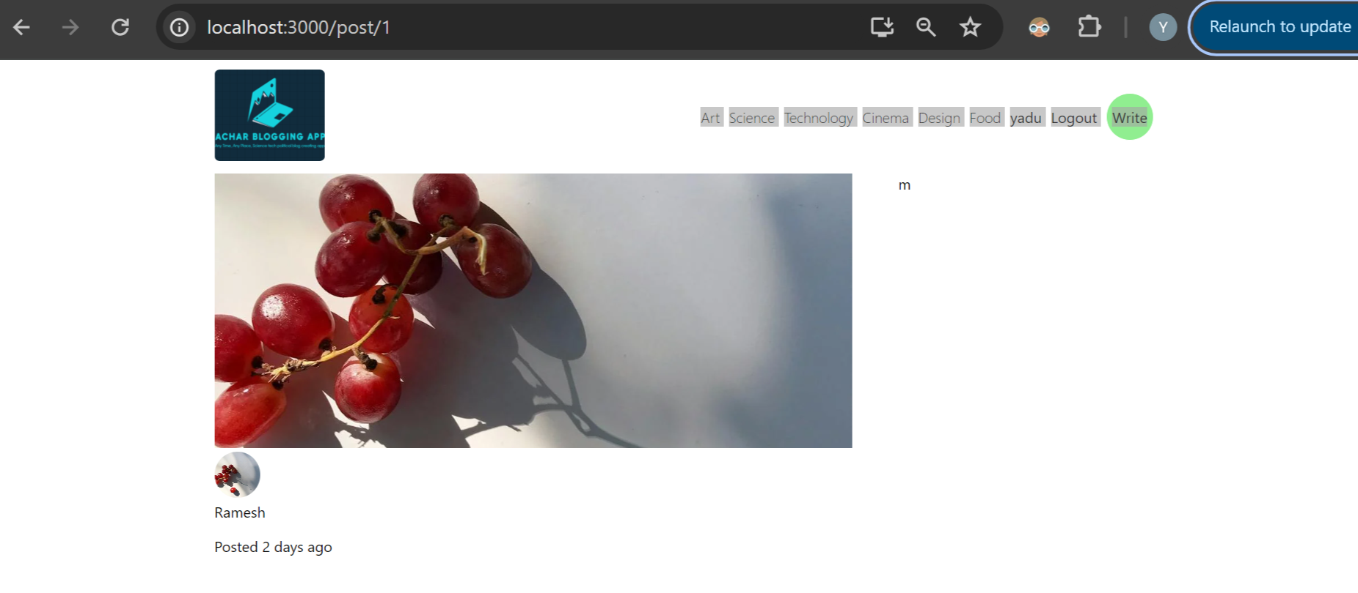

Image looks like this

Next we make **info div** horizontal

Where user name and posted date is present

For making horizontal or vertical we always use display:flex align-items center

.user{

                    display: flex;

                    align-items: center;

                    gap: 10px;

Above style for below user info

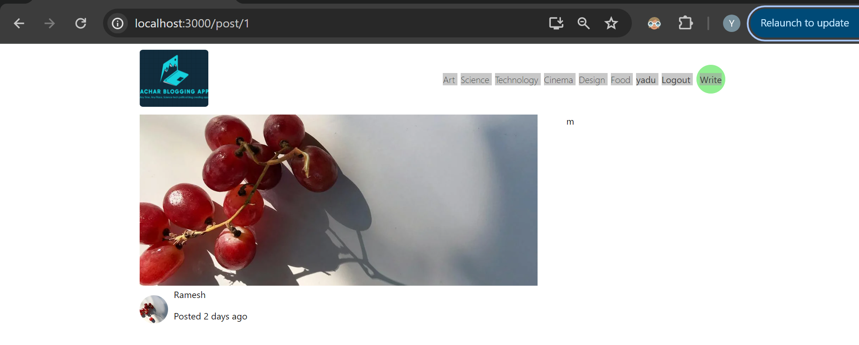

Above user info

 span{

                        font-weight: bold;

                    }

Next we show username in bold for that we apply style for span itself’

Now if we’re owner of that post we’ll be able edit or delete that post so we give 2 buttons on right side of user info

After info div in html code add 2 buttons

We add both **edit and delete** button inside **Link** so on clicking buttons we can do some actions

<div className='edit'>

            <Link to={`/write?edit=2`}>

            <img src={Edit} alt="" />

            </Link>

            <Link>

            <img src={Delete} alt="" />

            </Link>

          </div>

Above is html code for edit and delete

/write?edit=2 means we’re gonna go to write page **? mark means query over there**

**Where 2 is** our post number

We’ll change 2 later with actual post id or some thing

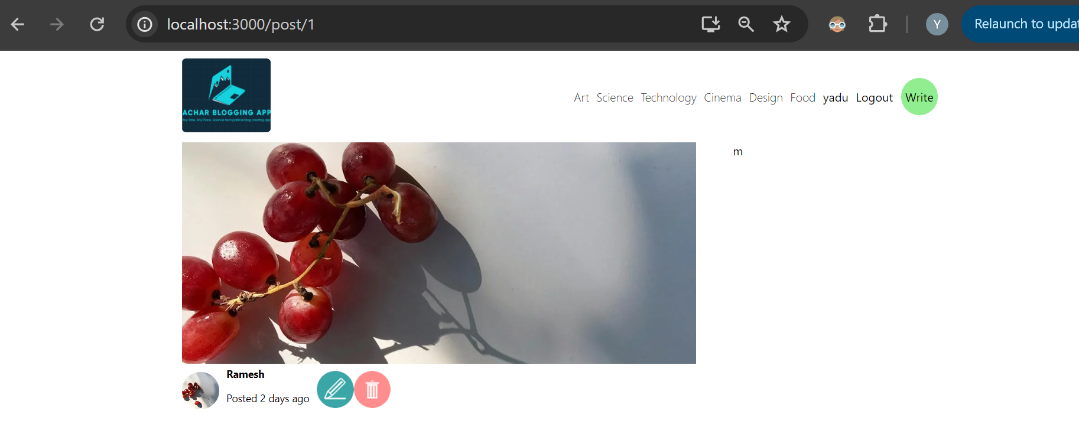

Until now

Now adding style to buttons

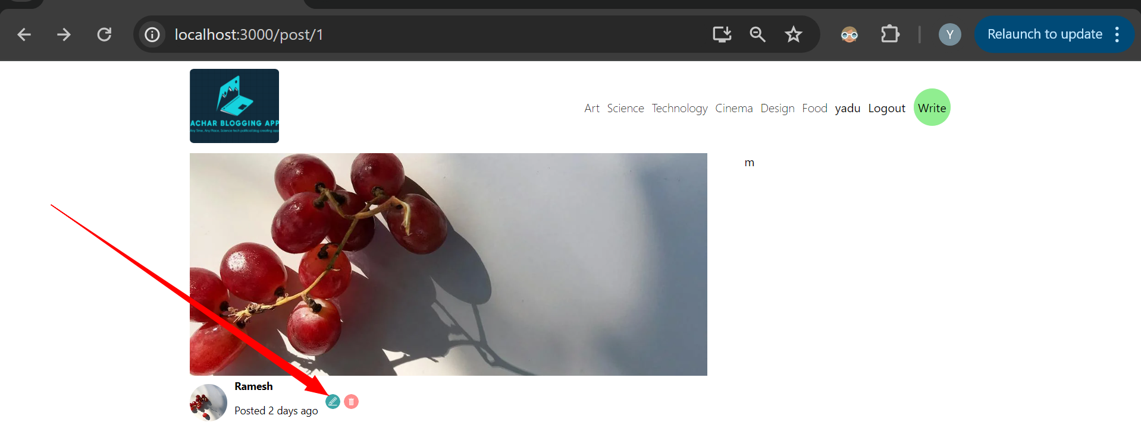

Now if you click on edit you’ll go to next page

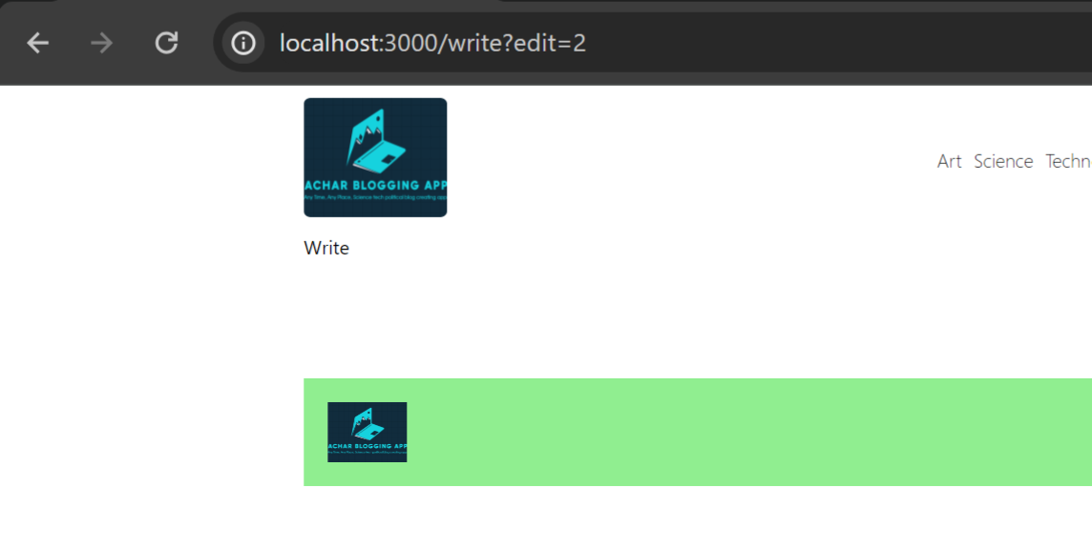

above

 .edit{

                    display: flex;

                    gap: 5px;

                    img{

                        width: 20px;

                        height: 20px;

                        cursor: pointer;

                    }

                }

style for above

and on deleting we delete that post

*. Next we take care of title and description

Add h1 tag

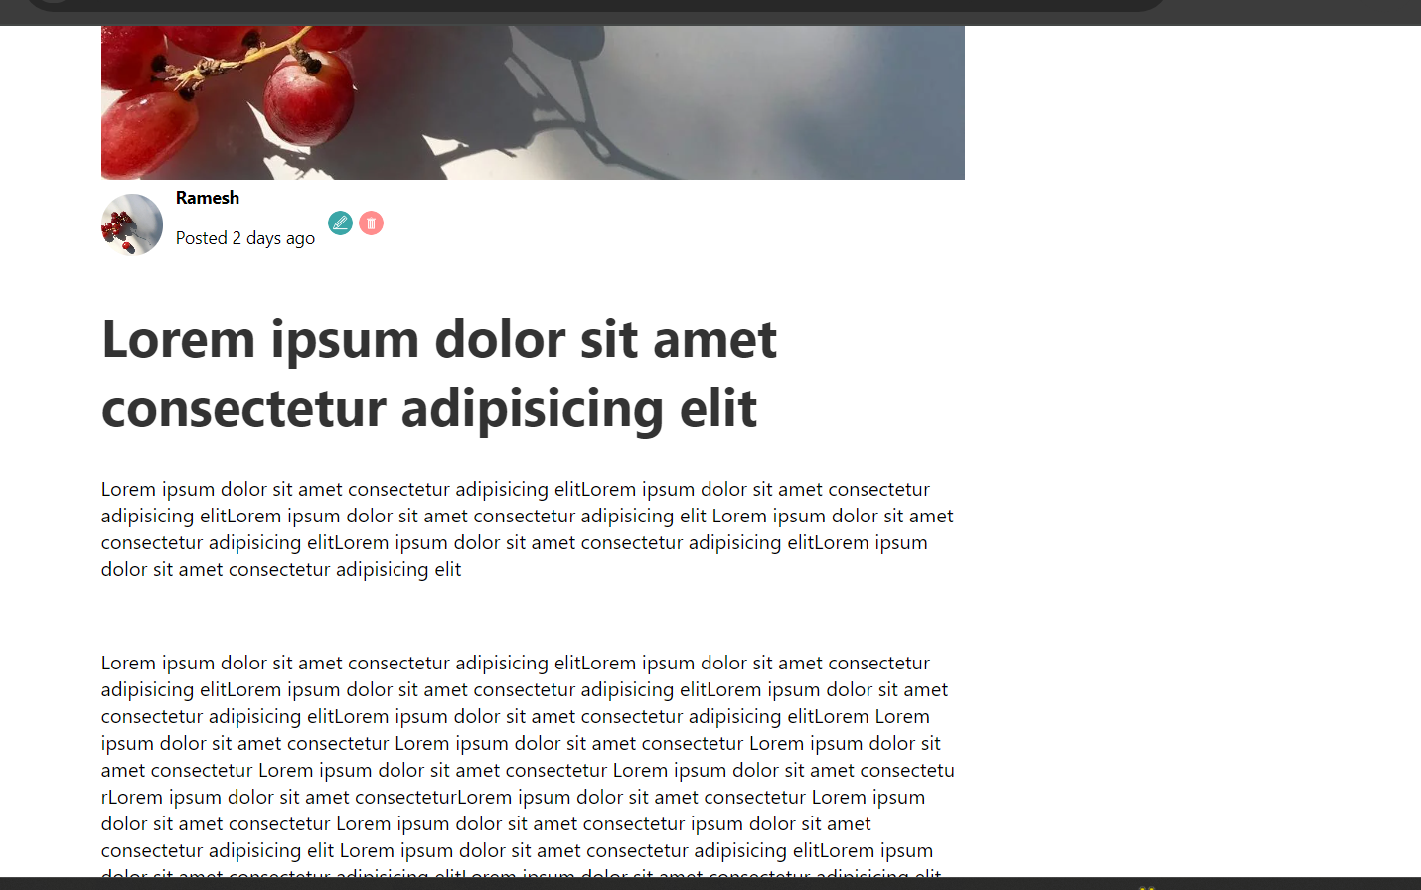

Now above Is style before giving justify content style

Now for p tag we give **text-align:justify**

 h1{

                    font-size: 42px;

                    color: #333;

                }

                p{

                    text-align: justify;

                }

**Code**



You can now see the difference

Words on the right and left are coming in the same line

So now above see compressed so we add line-height:30px for p tag

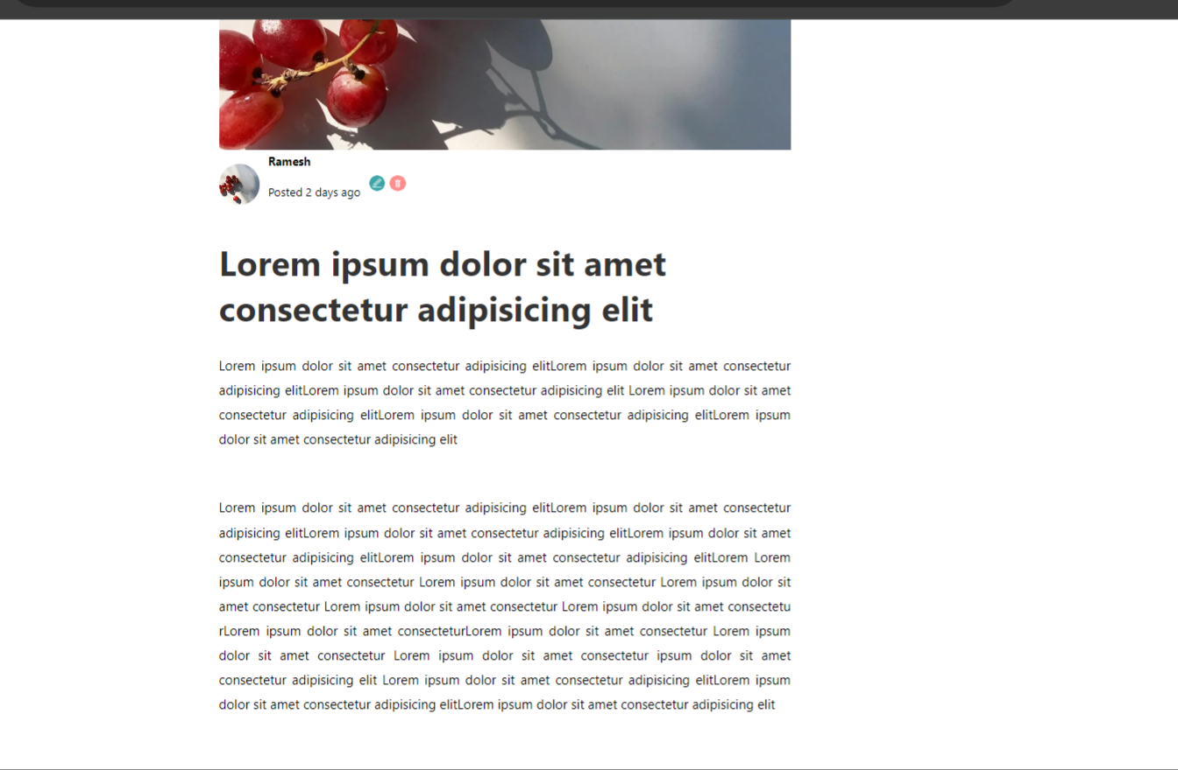

With this it looks much better

 p{

                    text-align: justify;

                    line-height: 30px;

                }

Above style

Now he added display:flex for .content class itself related to single.jsx file

.content{

                flex:5; //this is for size

                display: flex;

                flex-direction: column;

                gap: 30px;

because of above style now you see lot of gap b/w post title and post actual content

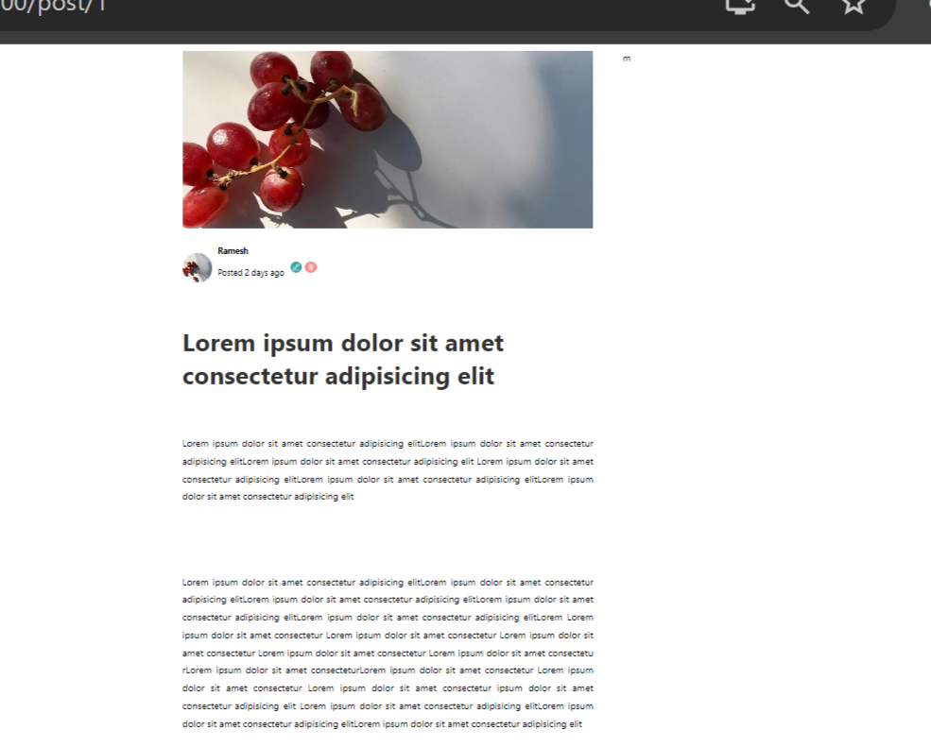

Like this

**#. Another component for menu inside single page**

Create menu.jsx inside components folder

It’s ike in menu.jsx file we keep all other components but this **menu** itself we call it inside **single.jsx file**

**We define style for menu inside single.jsx file itself these style will be applied properly**



Above you’re seeing menu from single page

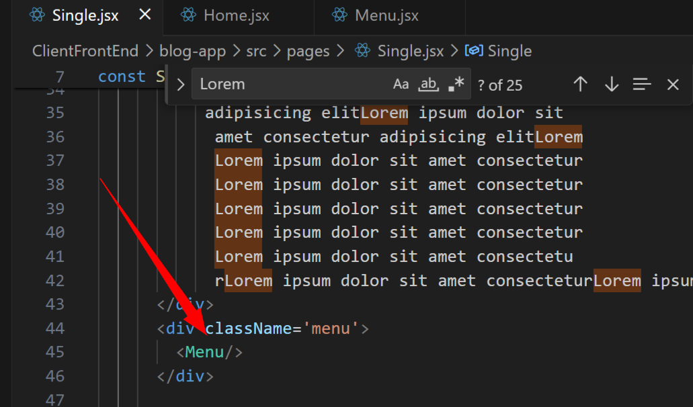

Inside single.jsx page we have imported Menu and used it now inside new file Menu.jsx we have text as menu

<div className='menu'>

        <h1>Other posts you may like</h1>

    </div>

Inside menu.jsx

Now from home.jsx copy and paste all posts in menu.jsx file also

Before return we paste all posts

As like home page we loop through posts using map and for each post create post div whee key will be post.id

And inside that div post image, post title and button for read more

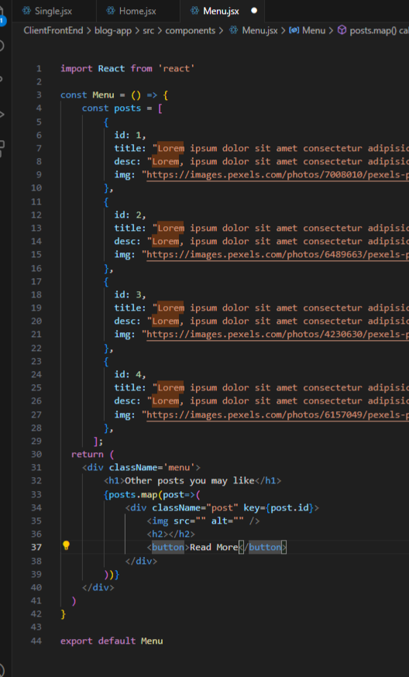

Code is above

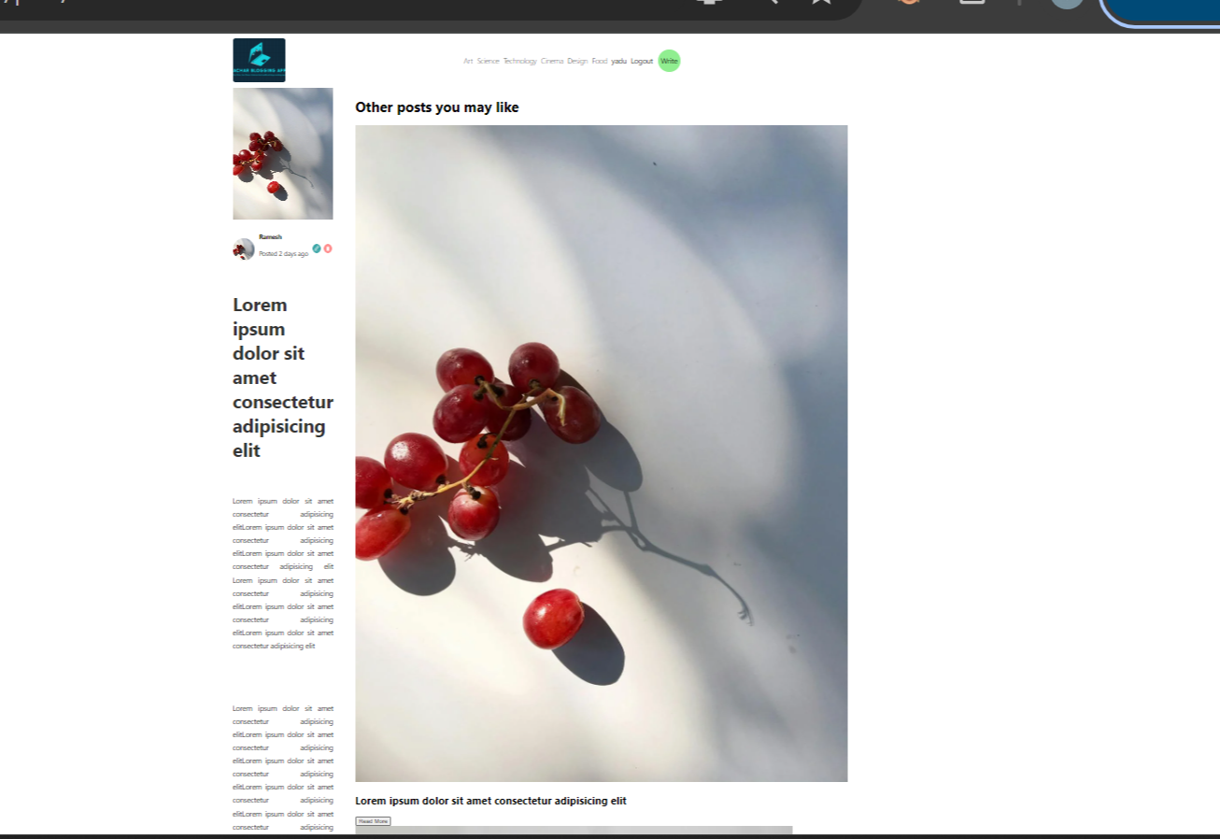

As I’ve not given style

.menu{

                flex:2; //this is for size

                display: flex;

                flex-direction: column;

                gap: 25px;

            }

Above gap 25px means gap b/w each posts on right side will be 25px they also look in column way

.post{

                    display: flex;

                    flex-direction: column;

                    gap: 10px;

                }

Above inside menu for individual post we define style here we give gap b/w post and readmore button and all that gap

                .post{

                    display: flex;

                    flex-direction: column;

                    gap: 10px;

                    img{

                        width: 100%;

                        height: 200px;

                        object-fit: cover;

                    }

                }

Next above we give style for img of each post object-fit cover is imp without it image look stretched with less clarity



Our page **“other posts you may like”** will be displayed like above

Next for h2 inside menu’s post we change color to #555

41:53

For read more button in <http://localhost:3000/> this home page we have done design for button same thing we use it here

button{

                        width: max-content;

                        padding: 10px 20px;

                        border: none;

                        cursor: pointer;

                        background-color: white;

                        border: 1px solid teal;

                        color: teal; //text color

                        &:hover{

                            border: 1px solid white;

                            background-color: lightgreen;

                            color: black;

                        }

                    }

We have above for button style inside .home that is class home same paste for menu file also

Inside .menu

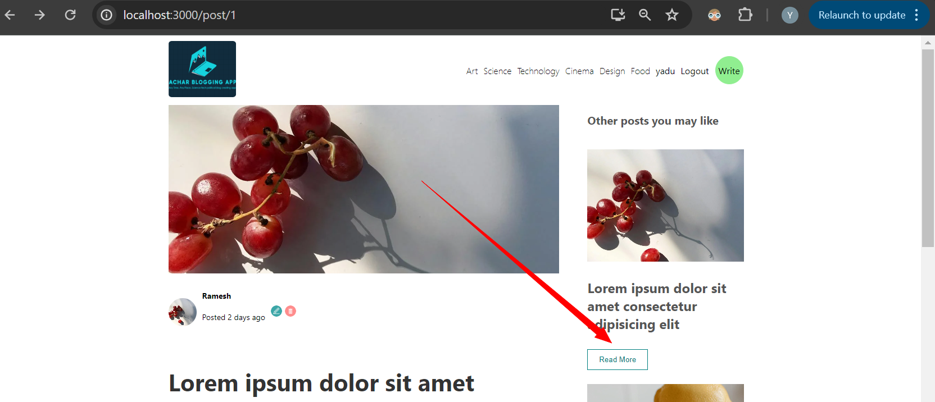

With this in our menu page “other posts you may like” we see button like this

But padding only he changed to 7.5px 15px

Other posts you may like from menu page here we only display posts based on category if post is related to science you’re seeing in single page then in “other posts you may like” also you’ll see all posts related to **science itself.**

**#. Next we’ll change write page.**

He told write page will have 2 pieces

Out content which includes inputs

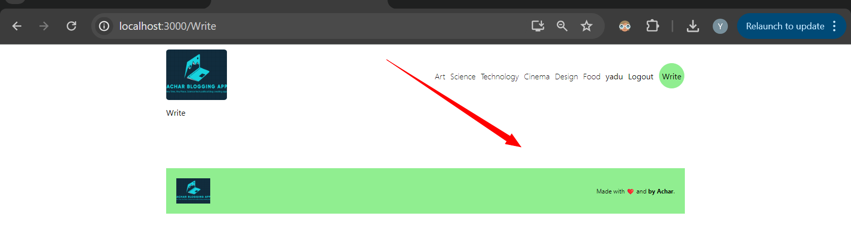

And on the right side of **write page we’ll have** publish and upload button

Also categories which we can choose

const Write = () => {

  return (

    <div className='write'>

      <div className="content">content</div>

      <div className="menu">

        <div className="item">i1</div>

        <div className="item">i2</div>

      </div>

    </div>

  )

}

Html code

We work on style now

Above gap:20px is gap b/w menu and content

Margin is margin b/w navbar and page

 .write{

            margin-top: 20px;

            display: flex;

            gap: 20px;

            .content{

                flex:5; //size of page content

            }

            .menu{

                flex: 2;

                display: flex;

                flex-direction: column;

                gap: 20px;

            }

        }

Above style display flex used mostly every where

Flex:5 is for size

Flex-direction column if we define our data displayed in column format

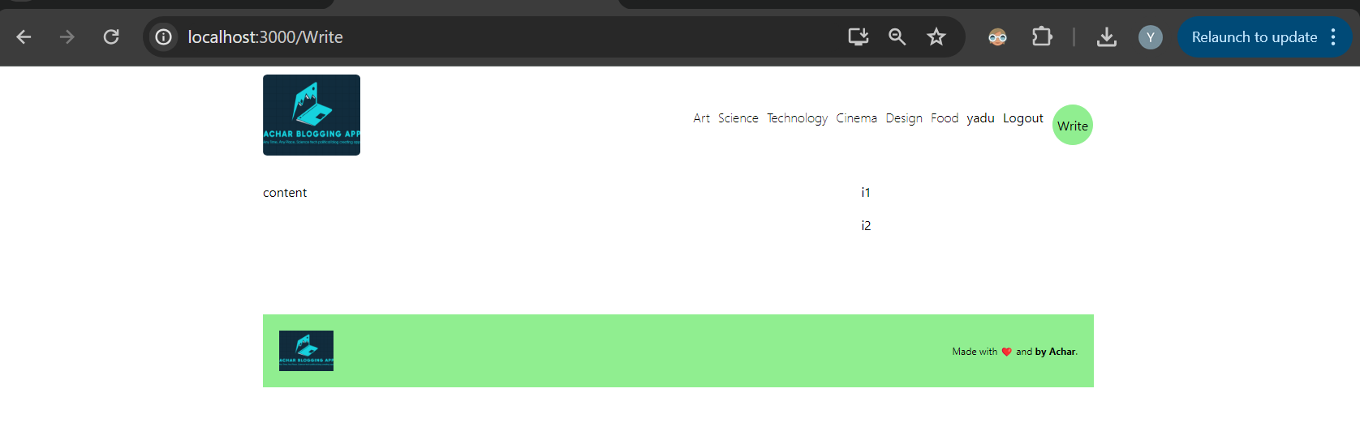

Now our write page will look like this

You can see content and on the right side i1 i2

There is one small issue: class name of above **write with circle on top right we** have given same class name for our **write page so inside write page**  we change class name to **.writeAdd**

When I gave same name for both write.jsx page and write circle when I hovered over write circle border color was black instead of green or peal

After changing class name of write page it worked

Next inside content div we add input

<div className="content">

        <input type='text' placeholder='Title'/>

      </div>

Above html code for that

Next we need textarea for our description

But for that he told he’ll use **rich text**

**He uses** library **react-quill which will** give more and more spaces in our page

With react-quill we can adjust size of font, change bold, increase font size we can give some links

**We use reqct-quill library**

**Npm install react-quill**

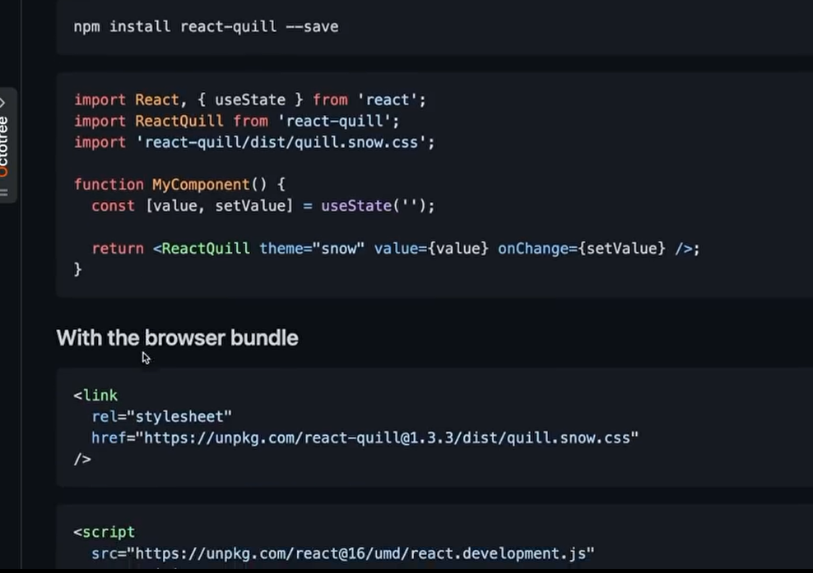

Github link of react-quill

In above image we can see, we’ll have useState

import ReactQuill from 'react-quill';

import 'react-quill/dist/quill.snow.css';

As we see in documents we import both of 2 libraries

return <ReactQuill theme="snow" value={value} onChange={setValue} />;

Whenever we change value in above he told it as editor

const [value, setValue] = useState('');

It’s gonna change our value also

import ReactQuill from 'react-quill';

import 'react-quill/dist/quill.snow.css';

So now we import them in our write.jsx file

Now in our html code after title we create container div

**<ReactQuill theme="snow" value={value} onChange={setValue} />;**

And we add he told some thing like editor for this above

Next before return in our write method we use **useState**

const Write = () => {

**const [value, setValue] = useState('');**

  console.log(value);

  return (

    <div className='writeAdd'>

      <div className="content">

        <input type='text' placeholder='Title' />

        <div className="editorContainer">

        //for below he told it's editor

**<ReactQuill theme="snow" value={value} onChange={setValue} />;**

        </div>

      </div>

      <div className="menu">

        <div className="item">i1</div>

        <div className="item">i2</div>

      </div>

    </div>

  )

}Above after using reactquill library

useState

For useState to work you’ve to import it at the beginning

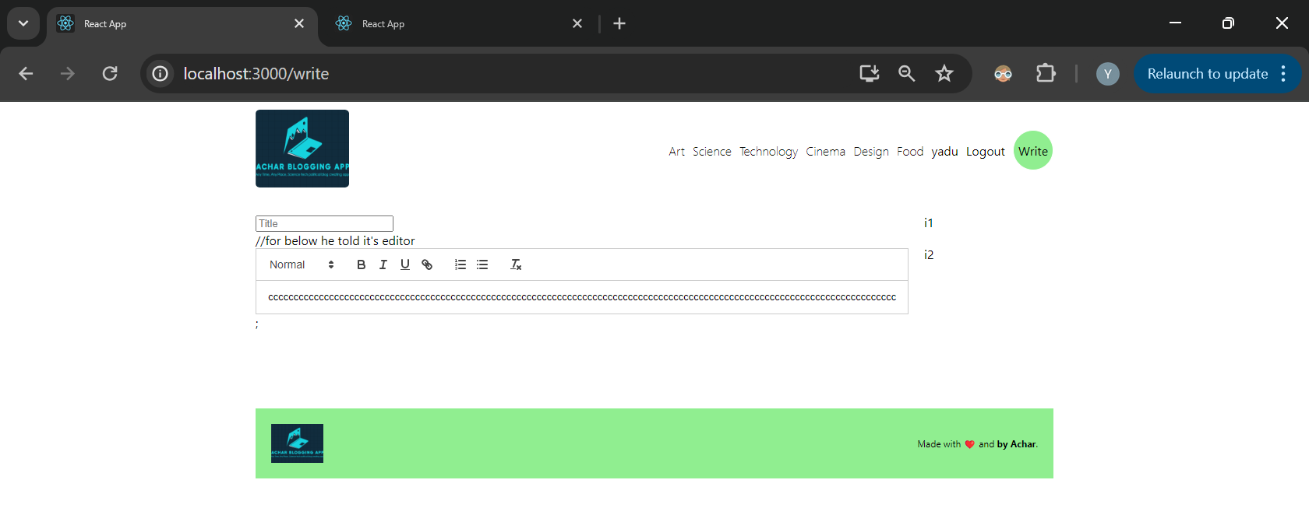

We got our text area like above

Our page now looks like

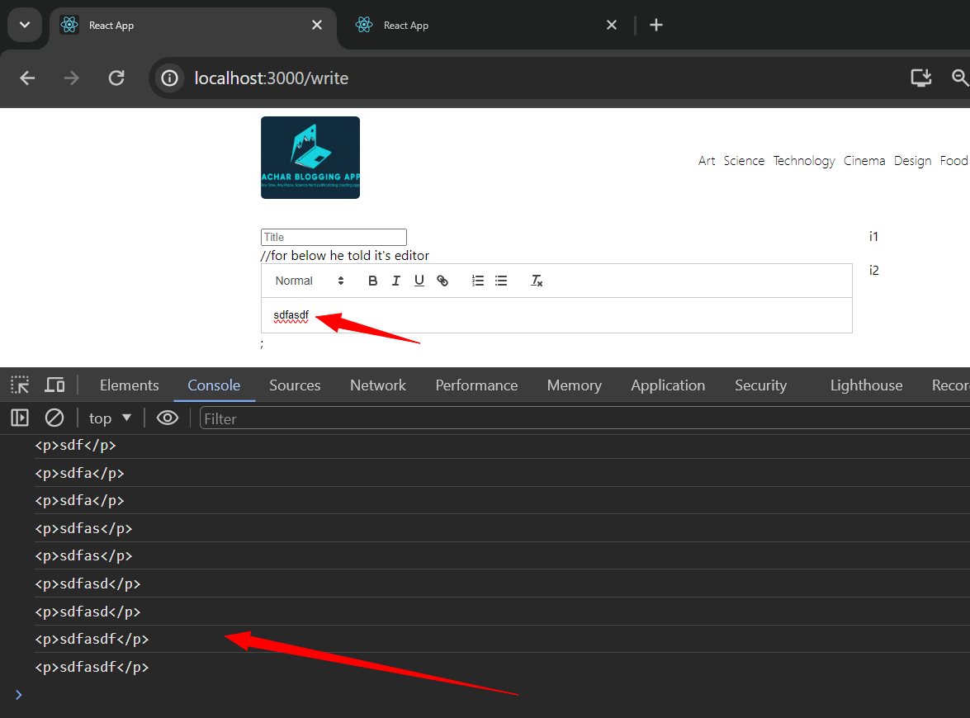

As soon as you type something in text area we can see our usestate will ge those values and in console we printed them

Next inside our div menu we create things like **publish button** and **status and**

<div className="menu">

        <div className="item">

          <h1>Publish</h1>

          <span>

            <b>Status:</b> Draft

          </span>

          <span>

            <b>Visibility:</b> Public

          </span>

          <input type='file' name="" id=""></input>

        </div>

        <div className="item">i2</div>

      </div>

Above is html code for button and for upload and all

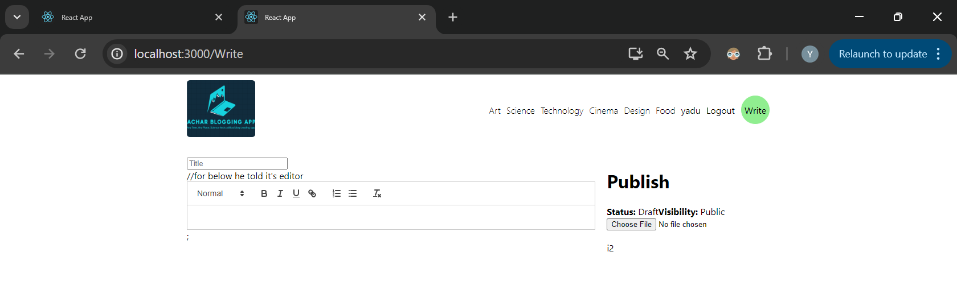

It looks like above

But we don’t want to give or we don’t want to see “”**choose file”” button**

<input style={{display:"none"}} type='file' name="" id="file"></input>

          <label htmlFor="file">Upload Image</label>

So above we have added label and none style

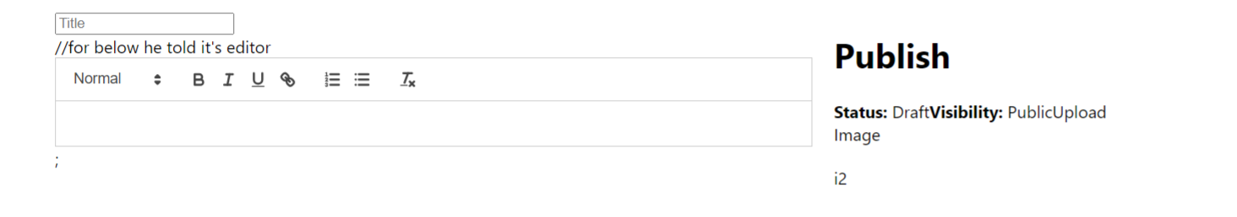

Now that button is removed but still if you click on **Upload** it prompts you to upload image or etc

Next we add div for buttons

<div className="item">

          <h1>Publish</h1>

          <span>

            <b>Status:</b> Draft

          </span>

          <span>

            <b>Visibility:</b> Public

          </span>

          <input style={{display:"none"}} type='file' name="" id="file"></input>

          <label htmlFor="file">Upload Image</label>

          <div className="buttons">

            <button>Save as a draft</button>

            <button>Update</button>

          </div>

        </div>

above

we can see buttons

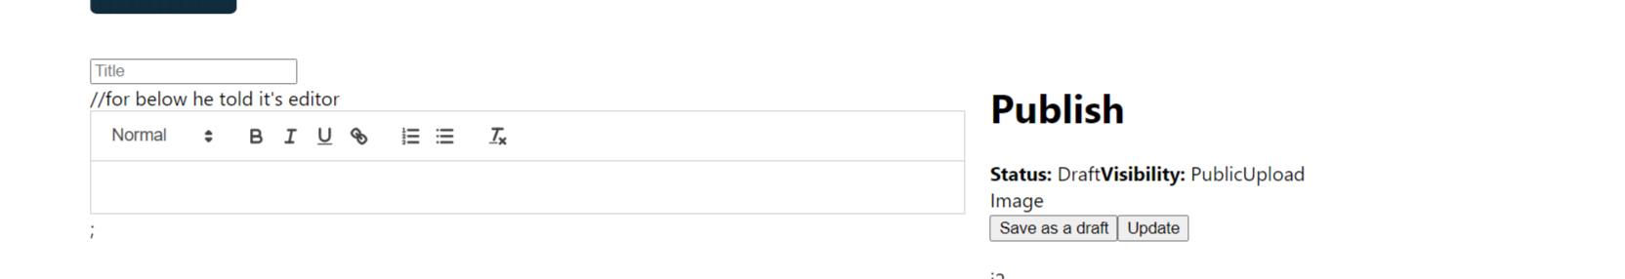

See 2 buttons

Next we add code for i2 second item

In our navbar we have many categories

Those we put as radio buttons inside category

 <div className="item">

          <h1>Category</h1>

          <input type='radio' name='cat' value='art' id='art' />

          <label htmlFor='art'>Art</label>

        </div>

Above is one of it

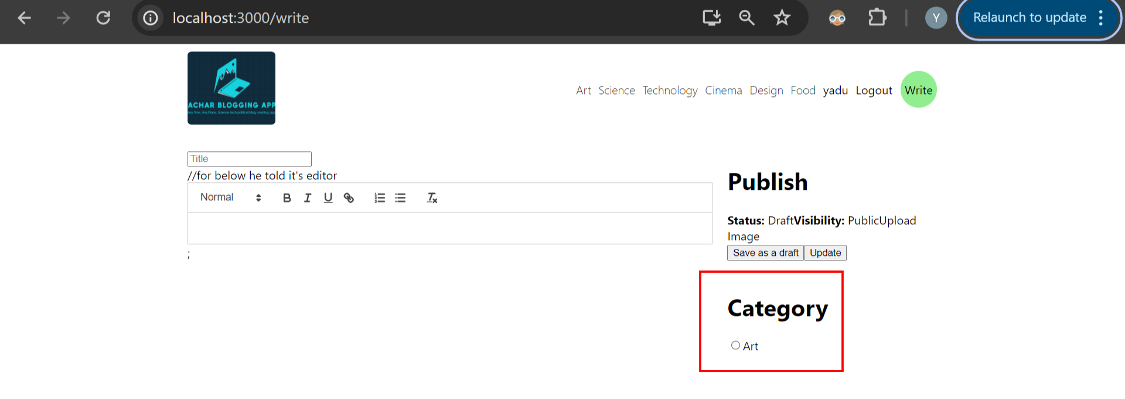

It looks like above

Like this all other categories we add

<div className="item">

          <h1>Category</h1>

          <input type='radio' name='catego' value='art' id='art' />

          <label htmlFor='art'>Art</label>

          <input type='radio' name='catego' value='science' id='science' />

          <label htmlFor='art'>Science</label>

          <input type='radio' name='catego' value='technology' id='technology' />

          <label htmlFor='art'>Technology</label>

          <input type='radio' name='catego' value='cinema' id='cinema' />

          <label htmlFor='art'>Cinema</label>

          <input type='radio' name='catego' value='design' id='design' />

          <label htmlFor='art'>Design</label>

          <input type='radio' name='catego' value='design' id='design' />

          <label htmlFor='art'>Design</label>

        </div>

Above

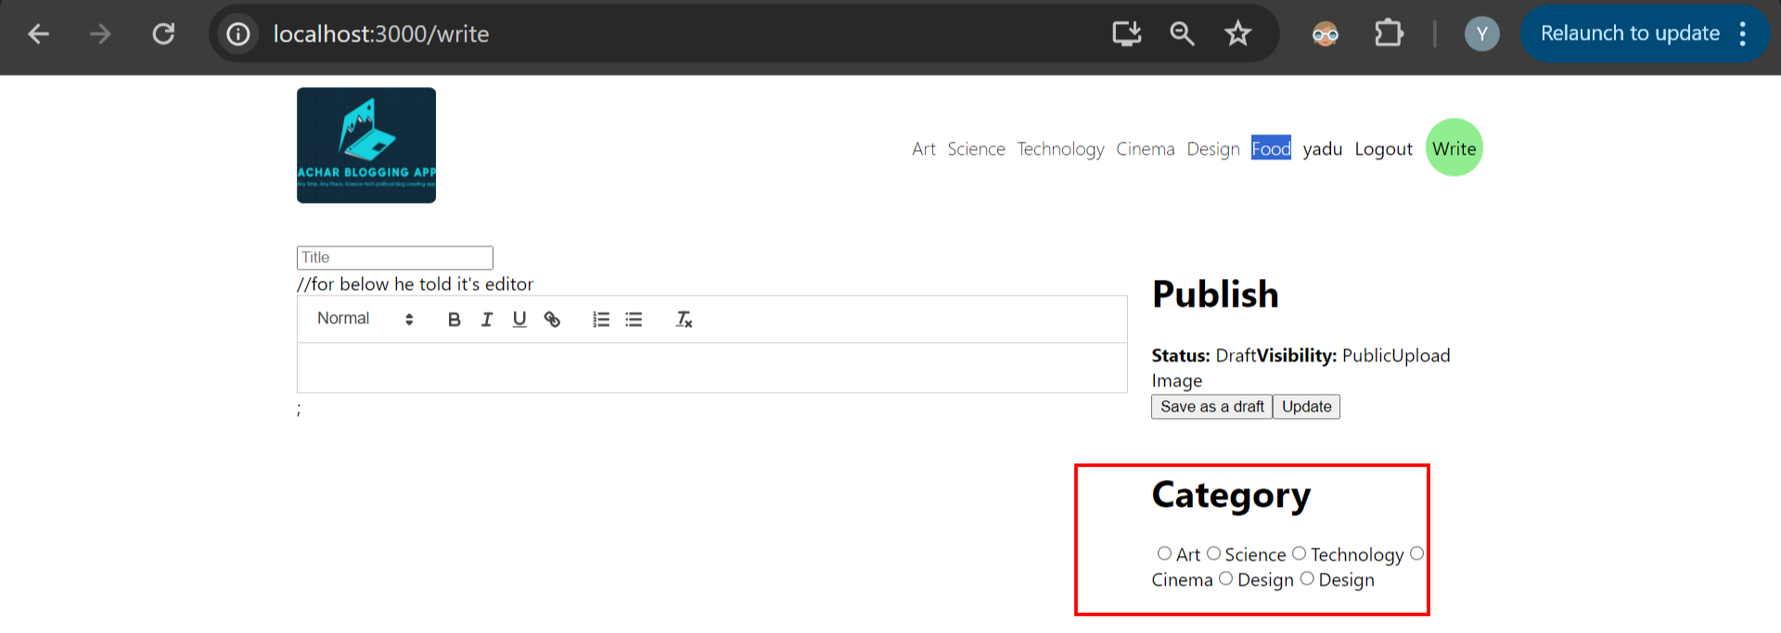

We see category like above

Next we addd style inside content for above text area and next for our category

Content global style is for entiirepage write.jsx file

.content{

                flex:5; //size of page content

                display: flex;

                flex-direction: column;

                gap: 20px;

above for entire content

input{

                    padding: 10px;

                    border: 1px solid lightgray;

                }

next we have input textbox title for that we give some padding

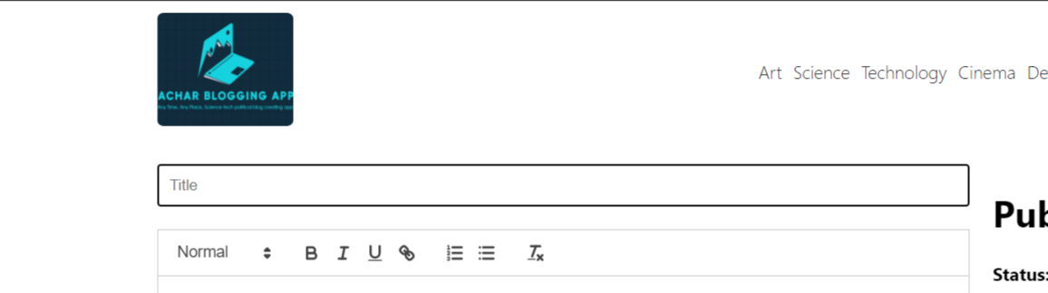

For title we gave border and color

Next for text area we do styling

editorContainer

That is for class

For ReactQuill we give class ‘editor’

<div className="content">

        <input type='text' placeholder='Title' />

        <div className="editorContainer">

        {/* for below he told it's editor */}

          <ReactQuill className='editor' theme="snow" value={value} onChange={setValue} />;

        </div>

Html code above

.editorContainer{

                    height: 300px;

                    overflow: scroll;

                    border: 1px solid;

                    .editor{

                        height: 100%;

                        border: none;

                    }

                }

Css style above these are all inside class content

Imp: because of overflow:scroll we got scrollbar

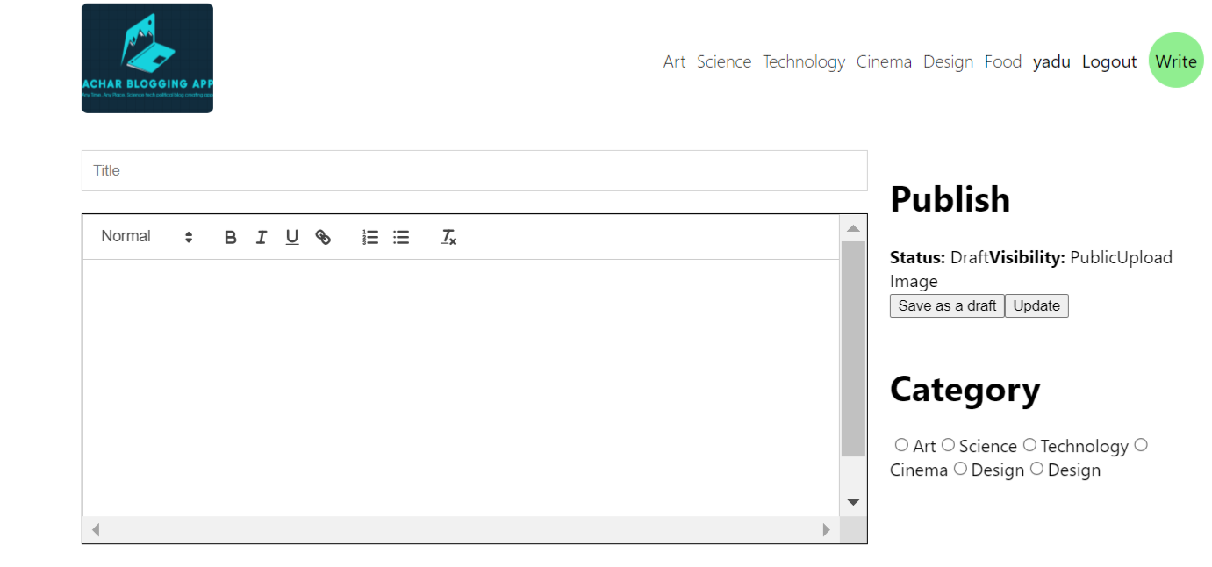

Our text area

Now for our menu items also we give same border

Inside .menu we have 2 separate class with .item so

50:00b

  .item{

                    border: 1px solid lightgrey;

                    padding: 10px;

                }

When we apply above style we see 2 boxes for our items

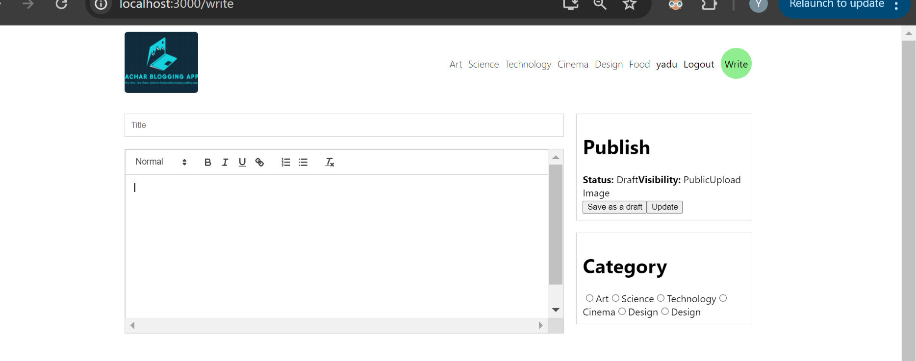

Like above

But publish and category box their height Is not same I want to make their height same

Before it has display as flex box

So now inside item we give as flex:1 for class item

 .item{

                    border: 1px solid lightgrey;

                    padding: 10px;

                    flex: 1;

                }

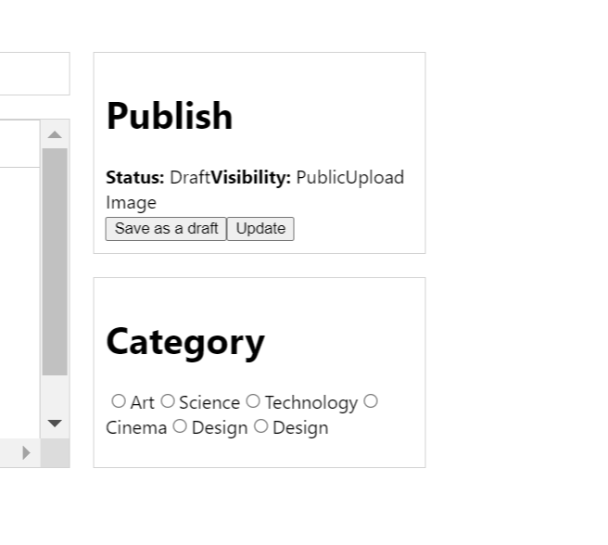

So above we can see height became same with flex 1

Next we make item present inside .item class as vertical with display flex and flex direction column style

.item{

                    border: 1px solid lightgrey;

                    padding: 10px;

                    flex: 1;

                    display: flex;

                    flex-direction: column;

                    justify-content: space-between;

                }

After adding above all categories will look column wise

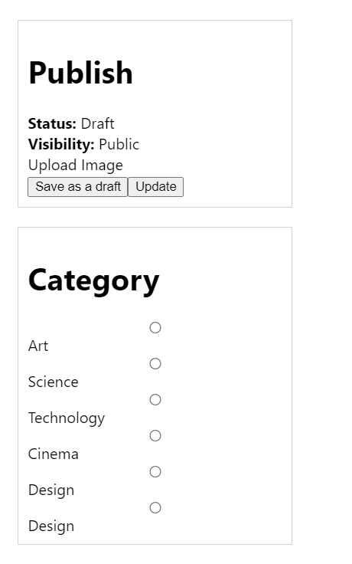

But radio buttons lookin on right side

If you want to see **radio button and it’s label on single line for that you’ve** to put them inside a single div

Below all those styles preset

 .item{

                    border: 1px solid lightgrey;

                    padding: 10px;

                    flex: 1;

                    display: flex;

                    flex-direction: column;

                    justify-content: space-between;

                    font-size: 12px;

                    color: #555;

                }

Above style for font-size and color for item

h1{

                    font-size: 20px;

                }

Next for h1 tag we give style

<label htmlFor="file">Upload Image</label>

For above labelonly we’ve to give style

Now for entire label if we give style it’ll be wrong it applies for radio button labels also

So for above label add class

 <label className='lblFile' htmlFor="file">Upload Image</label>

Above is label for file

.lblFile{

                    text-decoration: underline;

                    cursor: pointer;

                }

Now style for it

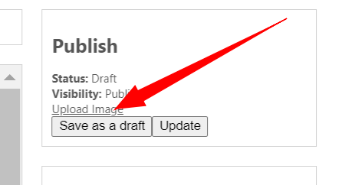

With this our **upload image gets underline**

**Above** we can see buttons don’t have space so we again use display flex

.buttons{

                    display: flex;

                    justify-content: space-between;

                }

With above style

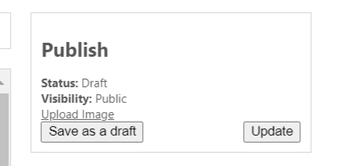

We got gap

Now above we have 2 buttons I want to give different style for first button and 2nd button how to do this

We can do it by giving different class name but

But we use concept of first and last child

.buttons{

                    display: flex;

                    justify-content: space-between;

                    :first-child{

                        cursor: pointer;

                        color: teal;

                        background-color: white;

                        border: 1px solid teal;

                        padding: 3px 5px;

                    }

                    :last-child{

                        cursor: pointer;

                        color: white;

                        background-color: teal;

                        border: 1px solid teal;

                        padding: 3px 5px;

                    }

                }

Like above we do

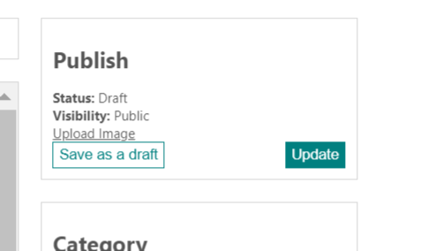

Page now looks like this

Next we add style to categories

Now we put each input radio and label into another separate div itself

<div className="item">

          <h1>Category</h1>

          <div className='category'>

            <input type='radio' name='catego' value='art' id='art' />

            <label htmlFor='art'>Art</label>

          </div>

          <div className='category'>

            <input type='radio' name='catego' value='science' id='science' />

            <label htmlFor='art'>Science</label>

          </div>

          <div className='category'>

            <input type='radio' name='catego' value='technology' id='technology' />

            <label htmlFor='art'>Technology</label>

          </div>

          <div className='category'>

            <input type='radio' name='catego' value='cinema' id='cinema' />

            <label htmlFor='art'>Cinema</label>

          </div>

          <div className='category'>

            <input type='radio' name='catego' value='design' id='design' />

            <label htmlFor='art'>Design</label>

          </div>

          <div className='category'>

            <input type='radio' name='catego' value='design' id='design' />

            <label htmlFor='art'>Design</label>

          </div >

        </div >

Above we can see we put each

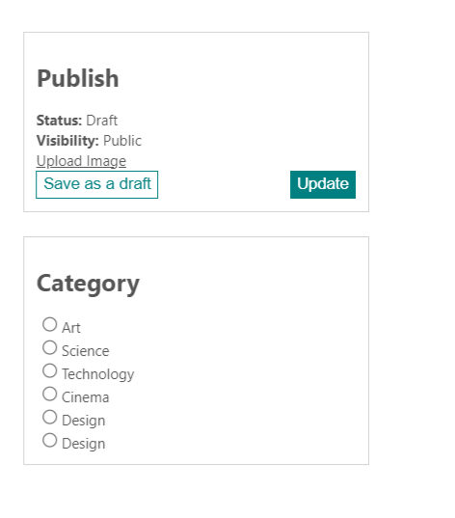

Now our categories lookmuch better

Next apply style for category div class

 .category{

                    display: flex;

                    align-items: center;

                    gap: 2px;

                    color: teal;

                }

With above style our categories will look like

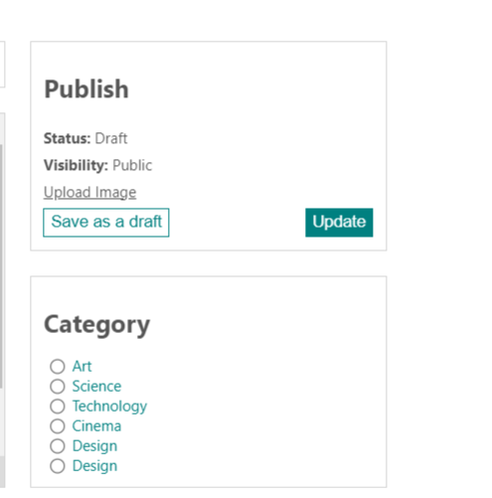

Above

#. **We start our back end from now with node application**

**In** terminal go to api folder using cd

To start or initialize node application:

Node init -y

Above command will not work as you have not reference npm to use as command node

So use

**Npm init -y**

above command will create package.json file inside our **ApiBackEnd** folder

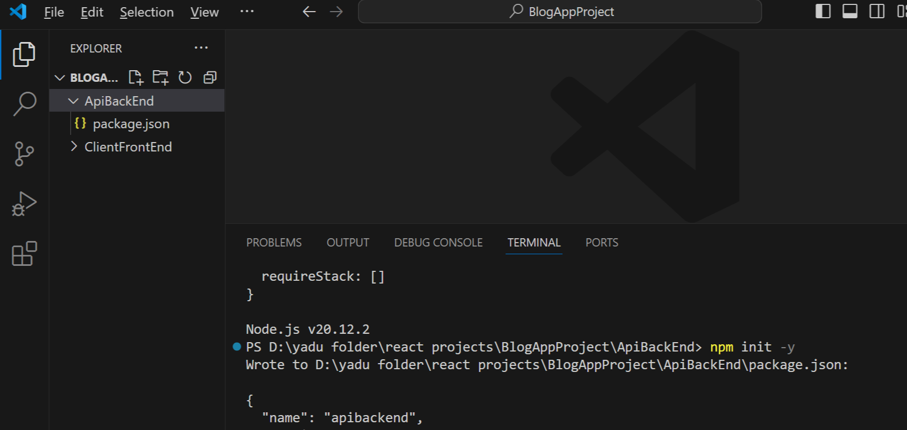

yarn add express mysql nodemon

Next installing some packages above is his command but I don’t use yarn so use

Now npm

**npm install express mysql nodemon --save**

use above

**#. Starting server using nodemon and other things**

Package.json file inside **ApiBackEnd** here we have **scripts start** there **we write**

"scripts": {

    "start": "nodemon index.js"

  },

**Like above**

"type": "module",

Also added above you can see package.json file

#. **Using file index.js**

**Import express**

Start express app with one port number

55:32

import express from 'express'

const app = express();

app.listen(8800, ()=>{

    console.log('first app');

})

As above code we listen or run at port number 8800

app.use(express.json());

he told we need to use express.json function

he told or else we won’t be able to send data to db

PS D:\yadu folder\react projects\BlogAppProject\ApiBackEnd> npm start

In console we type npm start and enter our app will start running

[nodemon] watching path(s): *.*

[nodemon] watching extensions: js,mjs,cjs,json

[nodemon] starting `node index.js`

first app connected

[nodemon] restarting due to changes...

[nodemon] starting `node index.js`

first app connected

our nodemon will run whenever we save any file it refreshes every time

**#. Installing mysql good link**

[**https://www.youtube.com/watch?v=uj4OYk5nKCg**](https://www.youtube.com/watch?v=uj4OYk5nKCg)

My localhost root password while creating or installing mysql is

Password: pass123

Even it is weak I have created it

**#. Creating mysql connection**

Create db.js file for that

We create connection separaely inside db.js which is a good way

Because this connection we’re gonna use every where

import mysql from 'mysql'

export const db= mysql.createConnection({

})

Above for create connection

We’re gonna create connection locally in local laptop

[MySQL :: Download MySQL Installer](https://dev.mysql.com/downloads/installer/)

I directly installed mysql from above link

import mysql from 'mysql'

export const db= mysql.createConnection({

    host:"localhost",

    user:"root",

    password:"pass123",

    database:"blogApp"

})

Above code write it inside db.js

Now creating schema in mysql

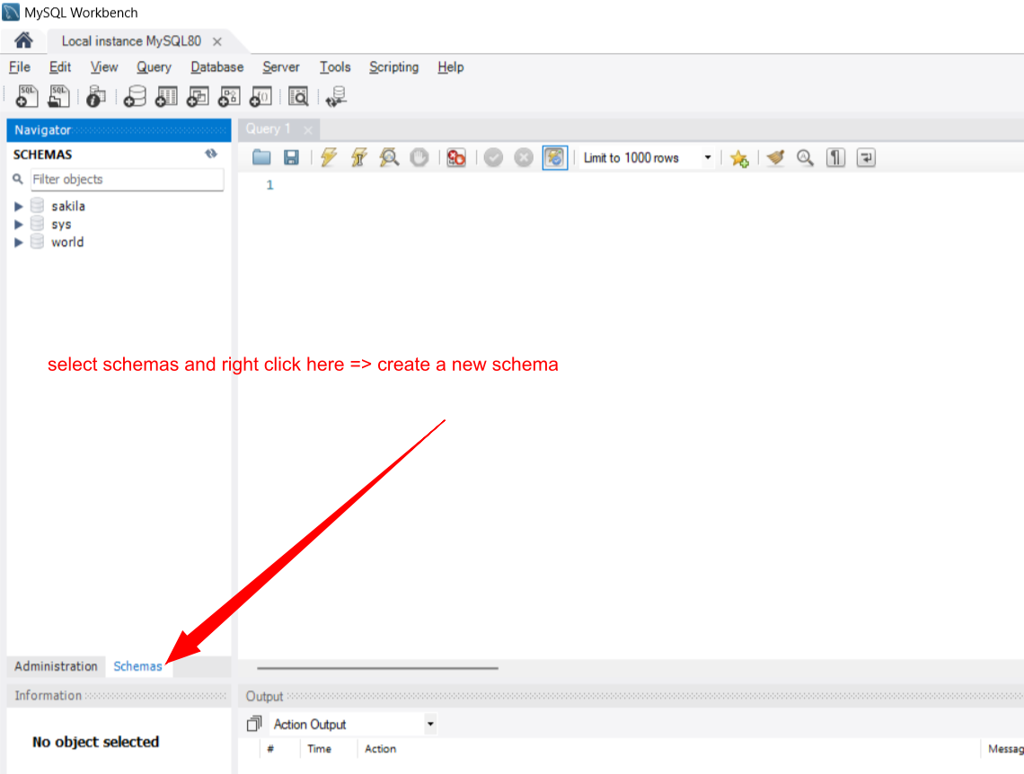

I gave schema name as blog_app

Next click on apply->

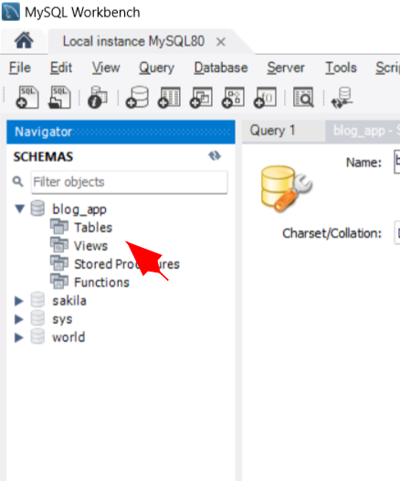

**Above** right click on tables create table

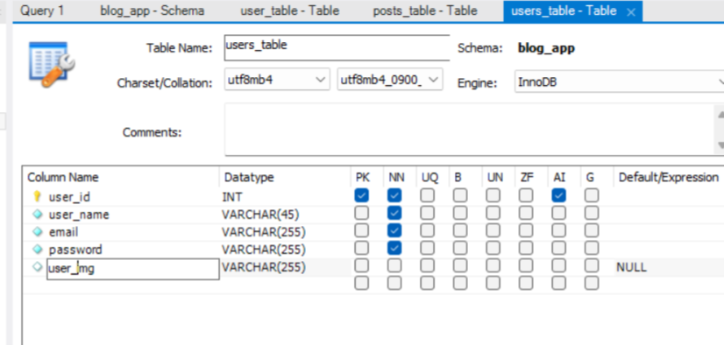

Above is my table structure

Next we create posts table

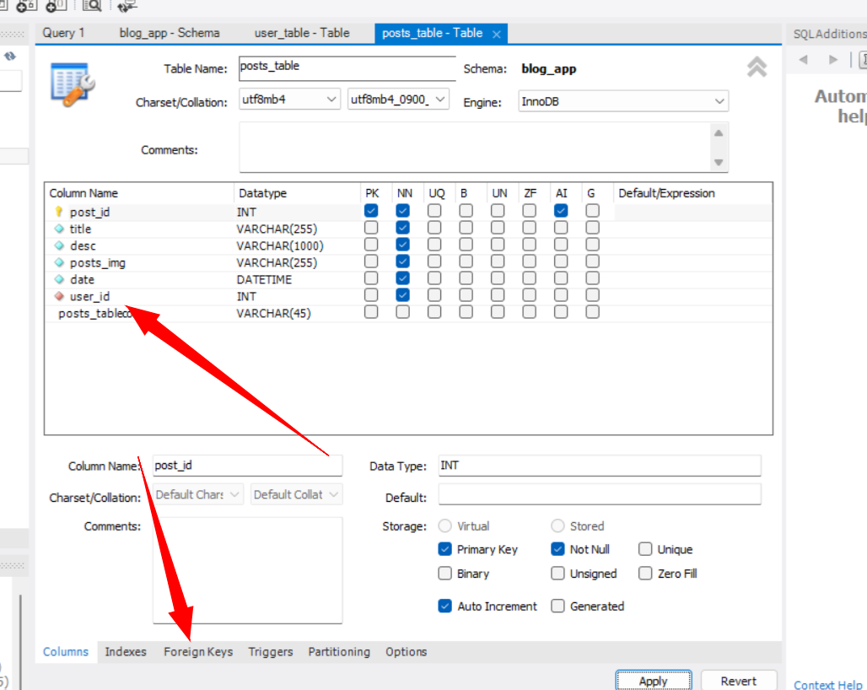

User id is our foreign key so click on foreign key tab

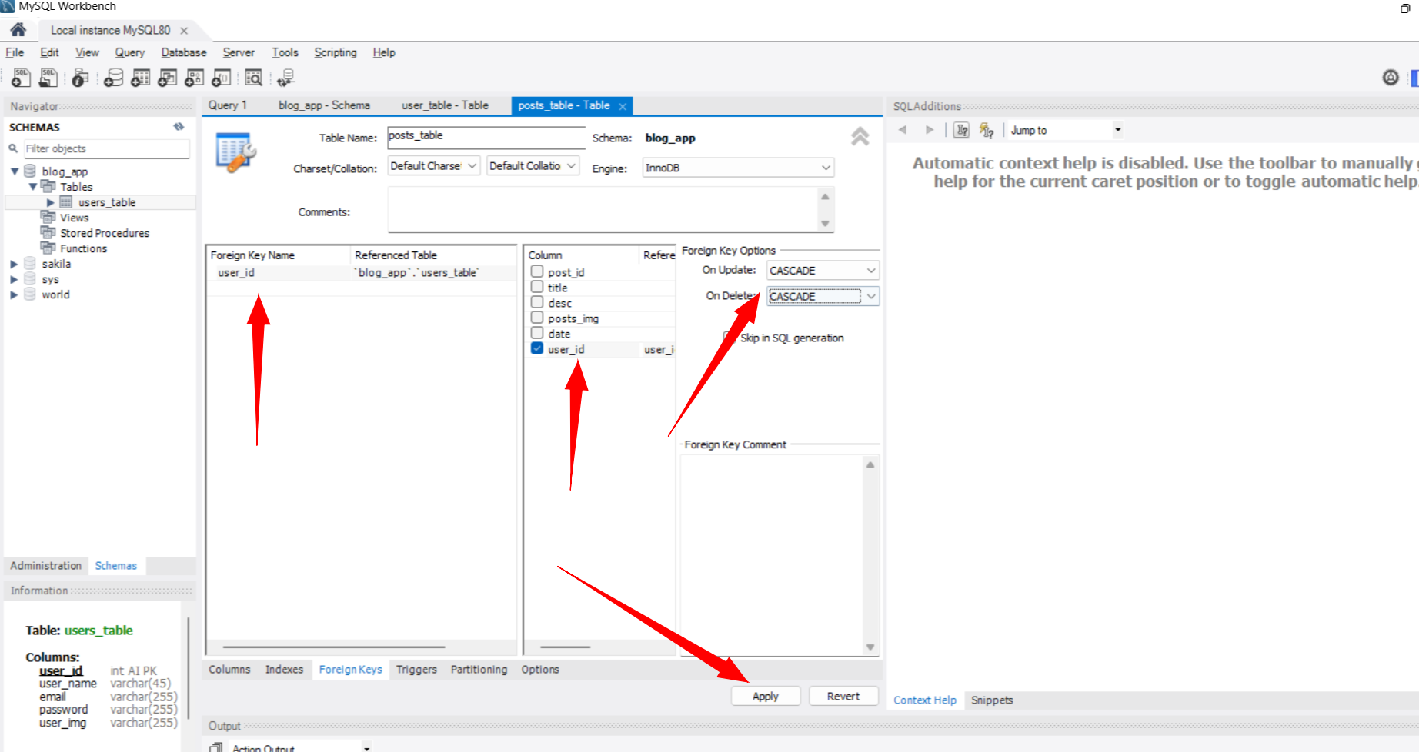

Above see arrows this is how we referenced foreign key

Click apply

Next we add users to users table

I inserted records to both posts and user table

import mysql from 'mysql'

export const db= mysql.createConnection({

    host:"localhost",

    user:"root",

    password:"pass123",

    database:"blog_app"

})

Above is db.js file

#. Create routes folder

At first we’re gonna have authentication routes that is auth.js file we create

It’s for login and register

Next create users.js this is for **users. Route**

We can make api requests using app.get there we were taking req response and we were sending response to the user

Next we do api testing inside our index.js file

app.get("/test",(req,res)=>{

    res.json("It works!")

})

app.listen(8800, ()=>{

    console.log('first app connected');

})

With above code

We’re trying to listen at port 8800 and we try to make request for endpoint test

Api port number 8800

Now if we go to brosewr and enter api url with localhost

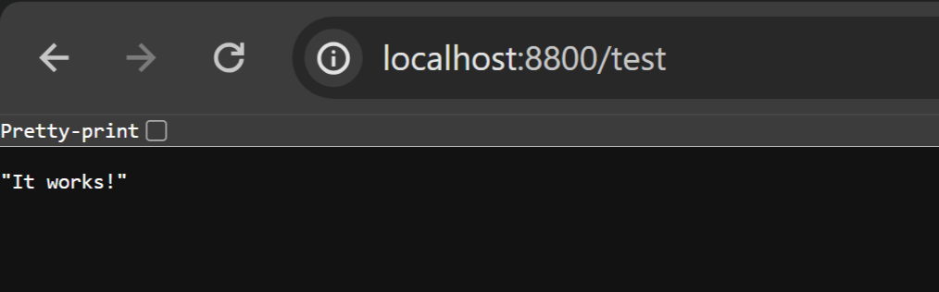

We see our response which we printe using console

He suggested instead of writing all routes inside **index.js**  file we’re gonna separate them using **routes folder with different different files**

**If we have** to do post request we can use post.js file

**#. Inside routes folder posts.js file**

import express from 'express'

const router = express.Router();

above we used router function

and using router function we can make any requests

example for the main url we make get req with req response and we’re gonna send

“this is post”

Imp: **we have to export our router**

import express from 'express'

const router = express.Router();

router.get("/",(req,res)=>{

    res.json("this is post")

})

export default router

Whole code

And also I want to use my **router inside index page**

Post router we use inside index.js page

Go to **index.js page import post routes over there**

import postRoutes from './routes/posts.js'

above is importing code

app.use(express.json());

app.use("api/posts", postRoutes)

I wrote above inside index.js

Where writing api/posts is writing an end point and **postRoutes is my routes**

Basically if I go to **localhost:8800/api/posts**

That time for home page of posts that time we’re gonna see message

“this is post”

We change little bit

router.get("/testPost",(req,res)=>{

    res.json("this is post")

})

Inside posts.js we write **/testPost**

So we go to browser

app.use("api/posts", postRoutes) this is wrong / is missing

app.use("/api/posts", postRoutes) correct

I made some mistakes

import express from 'express'

const router = express.Router();

router.get("/test",(req,res)=>{

    res.json("this is post")

})

export default router

express.Router();

Mistake in posts.js file

<http://localhost:8800/api/posts/testPost>

Now if I go to browser and type above

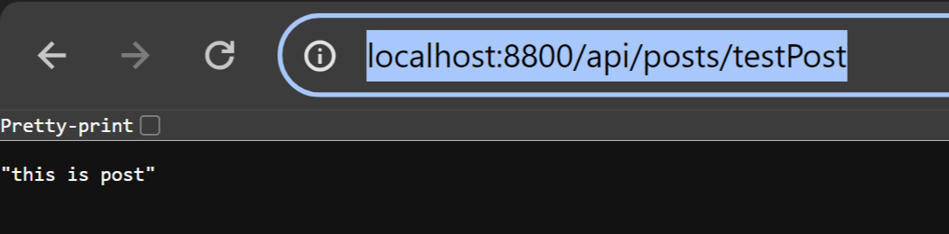

It shows above

router.get("/testPost",(req,res)=>{

    res.json("this is post")

})

He told he doesn’t want to write all above code inside posts.js file

He wants to write them separate so we create

**Controller folder for them**

Inside controller create files: auth.js is like auth controller,

Post.js is like post controller

User.js is like user controller

He told he’s gonna make all **CRUD operation** inside controller

**#. Again separating controller operation using inside controller folder**

**We have** auth.js post.js user.js

**So now** inside controller we create post.js file and auth.

export const addPost = (req,res)=>{

    res.json("from post controller: this is post")

}

Post.js file we write above method addPost

And next this **addPost method** we call inside => **routes=>posts.js file**

router.get("/testPost",(req,res)=>{

    res.json("this is post")

})

**Above code will change to**

router.get("/testPost",addPost)

After calling it becomes above

But if we want to call addpost method inside **routes=>posts.js file** then we’ve to import them inside routes.js file also

import {addPost} from "../controllers/post.js"

like above we import them

import express from 'express'

import {addPost} from "../controllers/post.js"

const router = express.Router();

router.get("/testPost",addPost)

export default router

above is our posts.js file from routes

don’t get confused with above code

import express from 'express'

import {addPost} from "../controllers/post.js"

const router = express.Router();

//remove later

router.get("/",(req,res)=>{

    res.json("this is post")

})

router.get("/addPost",addPost)

//remove later

export default router

above for addpost I make get request it’ll call controller folder post.js and print

"from post controller: this is post"

above

<http://localhost:8800/api/posts/testPost>

now if we go to browser and type above

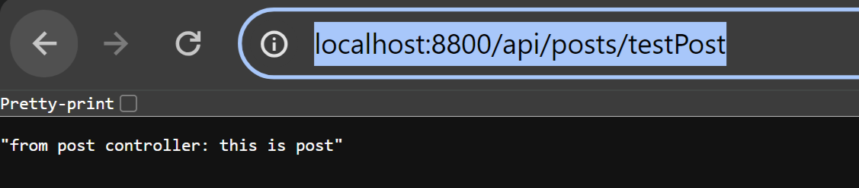

we see this text

this Is how folder structure we create

**routes, controllers** and we manage all of them inside index.js file

time:

1:04

We do same thing for others

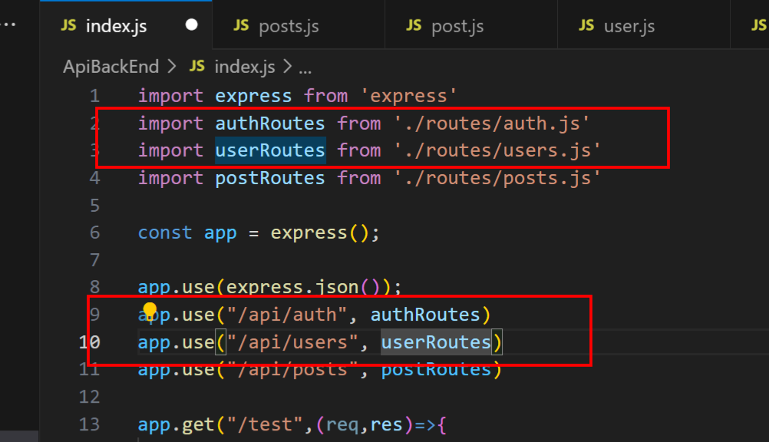

In index.js file we add above things

Just for example if you do like below inside index.js file

import express from 'express'

import authRoutes from './routes/auth.js'

import userRoutes from './routes/users.js'

import postRoutes from './routes/posts.js'

const app = express();

app.use(express.json());

app.use("/api/auth", authRoutes)

app.use("/api/users", userRoutes)

app.use("/api/posts", postRoutes)

app.get("/test",(req,res)=>{

    res.json("It works!")

})

**app.get("/api/posts",(req,res)=>{**

**res.json("It worksdddddddd!")**

**})**

app.listen(8800, ()=>{

    console.log('first app connected');

})

It’ll also make api request

**app.get("/api/posts",(req,res)=>{**

**res.json("It worksdddddddd!")**

**})**

With above code in browser if you enter them

[localhost:8800/api/posts](http://localhost:8800/api/posts)

"It worksdddddddd!"

You get above result

Next we go to **routes folder** **post.js file**

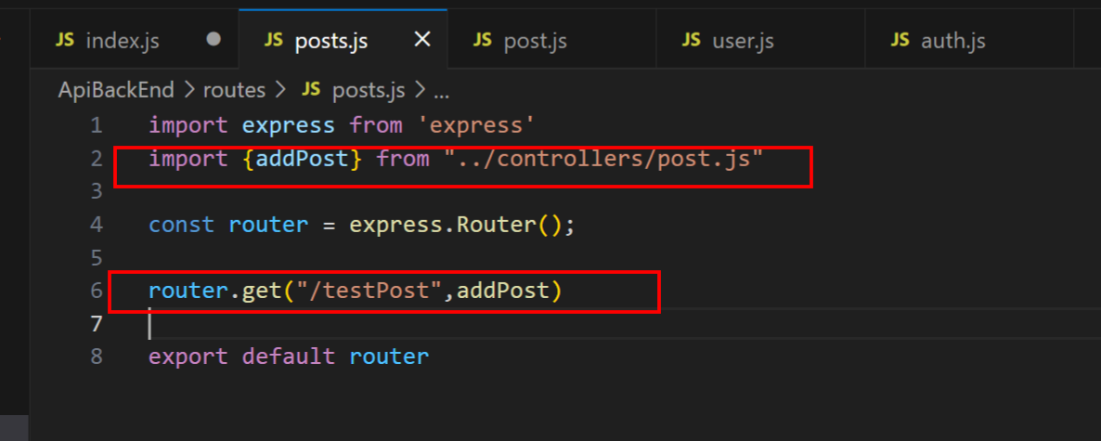

We delete red boxed items in posts.js file

import express from 'express'

const router = express.Router();

export default router

So you’re now remaining with above

Copy this same code to all other files present inside **routes folder**

Now

First we should able to register to our app

So now in our controller=> auth.js we write our req res for reg**ister and for login** **logout**

He told we do register **login and logout in** backend **server because we’re gonna use cookies**

export const register = (req,res) =>{

}

export const login = (req,res) =>{

}

export const logout = (req,res) =>{

}

Above inside **controller-> auth.js file**

Next go to below

Inside routes-> auth.js file

import express from 'express'

import { register,login,logout } from '../controllers/auth.js';

const router = express.Router();

router.post("/register", register)

router.post("/login", login)

router.post("/logout", logout)

export default router

We type above

That is first importing const method 3 register,login,logout after that passing them to router.post to make api post request

Now we go to our controller folder file methods

#. **Make test post request using express**

We simply pass title with titlename to our post request

For testing we use postman where we use body -> raw -> json

// POST request handler for creating a new post

app.post("/api/posts", (req, res) => {

    // Assuming you're expecting JSON data with a 'title' property

    const { title } = req.body;

    res.send('created');

    // You can do something with the received data, like saving it to a database

    // For this example, let's just send a response acknowledging the creation

    res.status(201).json({ message: `New post created with title: ${title}` });

});

Above code we add inside **index.js**

**Where app is from express**

Now we go to post don’t use existing old request in postman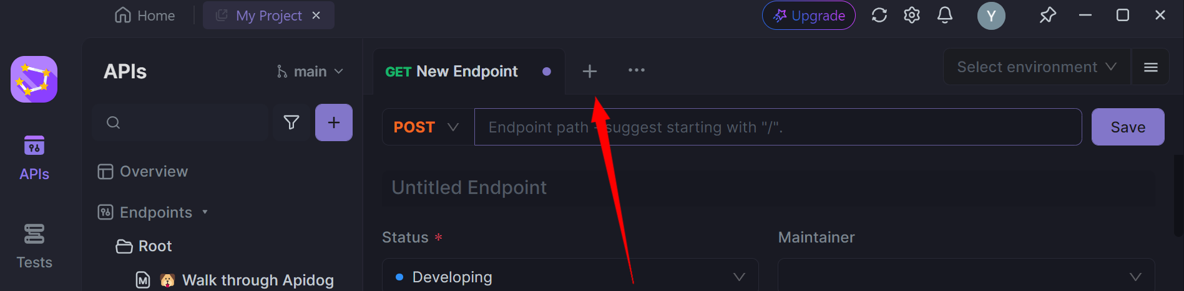

Every time make new endpoint in that do your post request

If you don’t do like this, if you use it in old request then it won’t work properly it won’t give proper response

In our react-node backend index.js file our api method is running so it’s api is available for our entire localhost

Apidog -> new endpoint

<http://localhost:8800/api/posts>

above url -> select body -> in that select **raw**

**{**

**"title":"hi"**

**}**

In box type above means it’s json object

**Now click on send** button

I got a proper response which I mentioned in vscode also

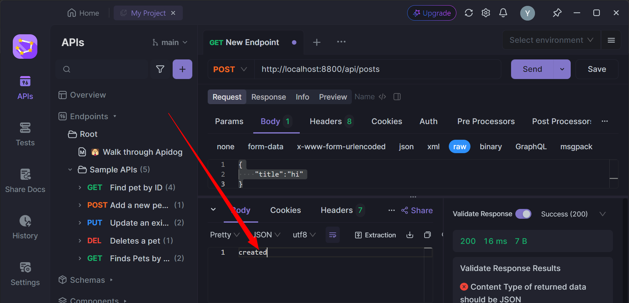

Like above I got

#. Above using express for test api post request

#. For api post request testing I used apidog alternative of postman

<https://apidog.com/compare/apidog-vs-postman/?utm_source=google_Ia&utm_campaign=20846090569&utm_content=154812052445&utm_term=postman%20free%20alternative&gclid=Cj0KCQjwir2xBhC_ARIsAMTXk864TEn_EBNg7P44w-YFsyit-ASNeEp-x6S0tdUr0_7dgHtiQETUCOoaAlF9EALw_wcB>

**\*. So for register**: we first check whether we have **user with the same email and with name**

For that we write our query

*. INSIDE controller=>auth.js

const query = "SELECT * FROM users_table WHERE EMAIL= ? OR USER_NAME=?"

We write above query

Next we import **db itself** because there we have our connection string

db.query(query, [req.body.email,req.body.name])

next for query we pass our query and once user tries to register his email and name we pass it to query using req.body

he told we directly pass input when user tries to register

next we pass arrow or callback function to same query

 db.query(query, [req.body.email,req.body.name],(err,data)=>{

    })

Above

],(err,data)=>{

    })

This is arrow or call back function

Inside that if we have error we’ll return that or else it means that everything is okay then we already have user inside db

So we’ll not allow to create new one

res.status(409)

above status means user is already exists

 db.query(query, [req.body.email,req.body.name],(err,data)=>{

        if(err) return res.json(err);

        if(data.length) return res.status(409).json("User already exists");

    })

our query look like this now

next inside that itself we need to check if user is not already in db then we’ve to insert

but he told one more thing to consider

*. Save password encrypted using bcryptjs

We shouldn’t write password in db table directly not store as plain text

So we’ve to encrypt our password

**Npm install bcryptjs**

He shown documentation there they given code snippets

**Usage - Sync**

To hash a password:

var bcrypt **=** require('bcryptjs');

var salt **=** bcrypt.genSaltSync(10);

var hash **=** bcrypt.hashSync("B4c0/\/", salt);

*// Store hash in your password DB.*

<https://www.npmjs.com/package/bcryptjs>

Above is code from documentation that is how we encrypt our password

var hash **=** bcrypt.hashSync("B4c0/\/", salt);

above B4c0 is password typed by user which will be returned as hash password

copy paste same code in auth.js

   const salt = bcrypt.genSaltSync(10);

    const hash = bcrypt.hashSync(req.body.password, salt);

we added above lines in our code before that imported **bcryptjs**

import {db} from "../db.js"

import bcrypt from "bcryptjs"

export const register = (req,res) =>{

    //check user exists: with mail and name

    const query = "SELECT * FROM users_table WHERE EMAIL= ? OR USER_NAME=?"

    db.query(query, [req.body.email,req.body.name],(err,data)=>{

        if(err) return res.json(err);

        if(data.length) return res.status(409).json("User already exists");

    })

    //hash the password and create a user

    const salt = bcrypt.genSaltSync(10);

    const hash = bcrypt.hashSync(req.body.password, salt);

}

export const login = (req,res) =>{

}

export const logout = (req,res) =>{

}

Codes until now while importing “../db” gave error here .js extension is very important

“../db.js” it should be

After this we’re gonna insert user to db

For that as we did for select we do the same for insert also write query

So if there is error return error

Or else return response with status code **200 means successful**

 const queryInsert = "INSERT INTO users_table('user_name','email','password')"

    const values = [req.body.username,

    req.body.email, hash]

    db.query(queryInsert,[values],(err,data)=>{

        if(err) return res.json(err);

        return res.status(200).json("User has been created");

    })

Code now we test this he told

**#. Handling input from frontend to pass it to back end**

1:11

Go to register.asx file

We’re gonna use **useState** hook

Inside usestate hook we’re gonna store user information

import React, { useState } from 'react'

This will get imported automatically when you press on intellisense while typing **useS..**

const [inputs,setInputs] = useState({

    userName:"",

    email:"",

    passWord:"",

  })

Above we’ve added inside Register.jsx file initially we define username email password as empty

We use usestate hook inside it we store our user information

With all empty

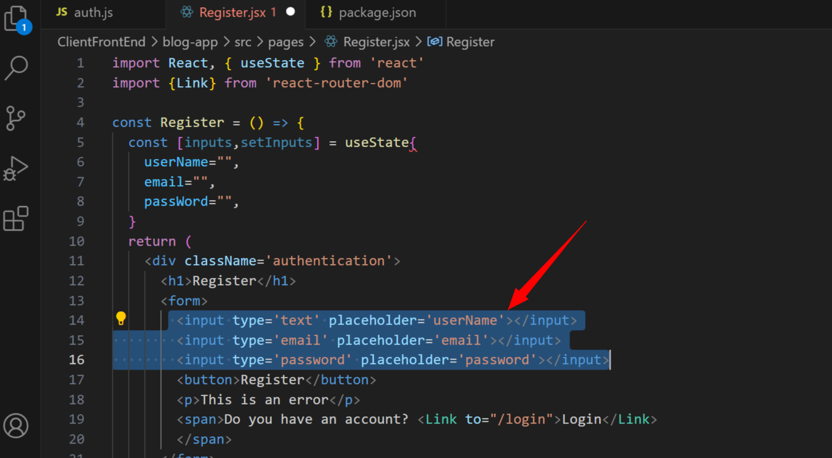

**This is important : whenever we change our inputs above** we set out use states again

To do that we create another function

This will be our common function **handleChange which is onchange method**

above<input type='text' placeholder='userName' onChange={handleChange}></input>

        <input type='email' placeholder='email' onChange={handleChange}></input>

        <input type='password' placeholder='password' onChange={handleChange}></input>

Above for all our input function we add it

Next how are we gonna setinputs

He told to watch **useState video** he told it’s really important you’ll atleast check document or blog

File=> register.jsx file

Inside **handleChange** metod: call setinput method

Next we create arrow function with setInputs

  const handleChange = e =>{

    setInputs(prev=>({...prev,[e.target.name]: e.target.value}))

  }

Until above e is also arrow function

For setinputs also with prev we write arrow function

Target.name: target.value looks like key value pair

Next for our inputs we add input names

That is **name=’userName’** like that for others

  <input type='text' placeholder='userName' name='userName' onChange={handleChange}></input>

        <input type='email' placeholder='email' name='email' onChange={handleChange}></input>

        <input type='password' placeholder='password' name='passWord' onChange={handleChange}></input>

Above we’ve added input names

We try to print inputs to see what will come

Npm run start to run frontend app

Npm start command to run backedn

Now our browser is opened

**#. Register page ui issue**

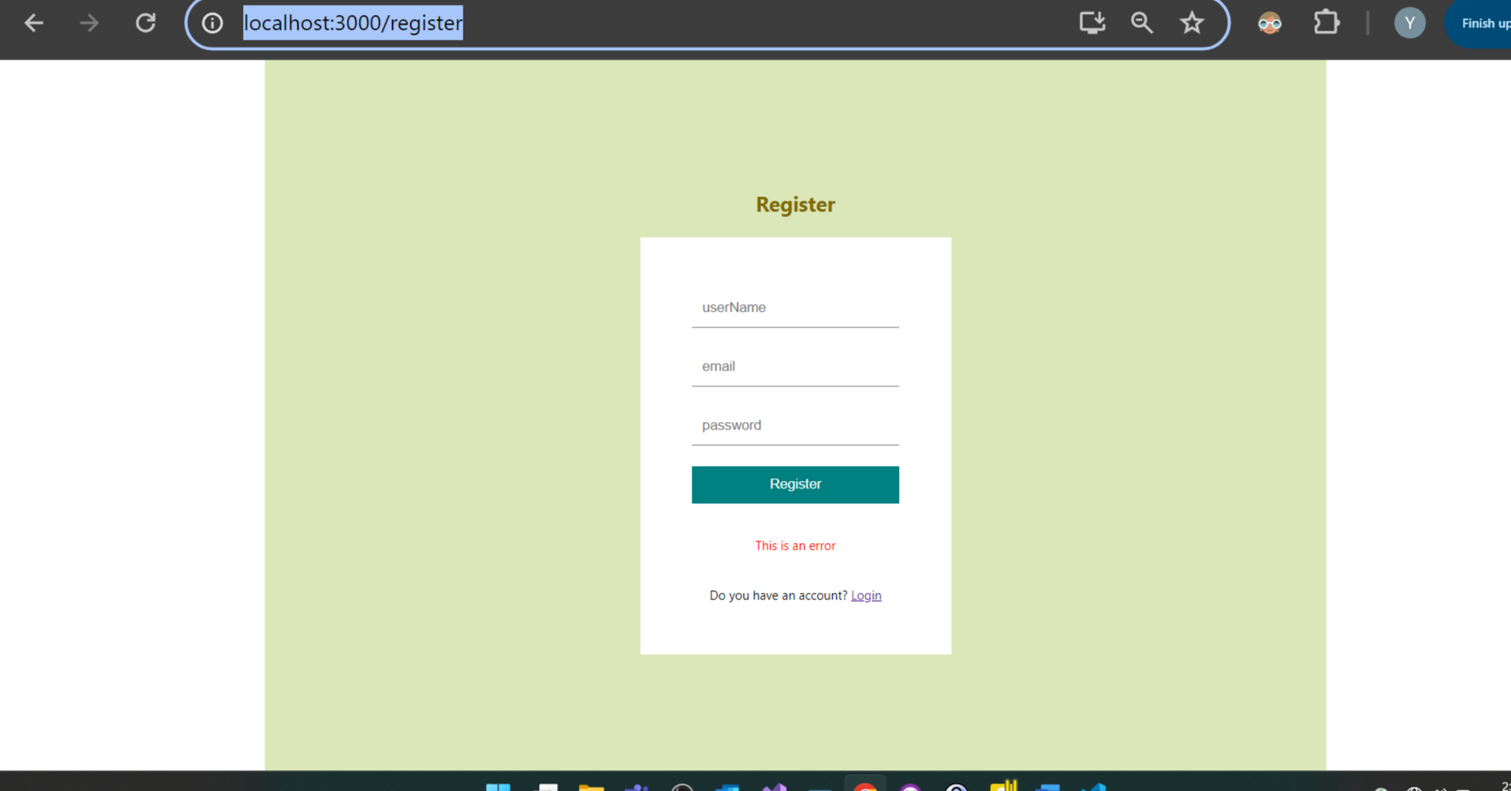

**As** our register form should come inside light green box it’s looking wrong

He told we check this issue later.

#. Checking in browser console print when we enter name email password

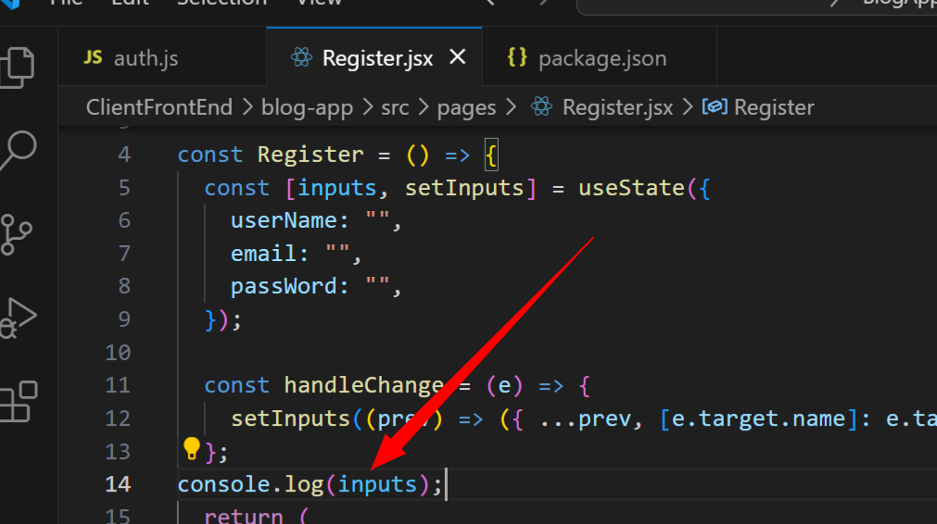

Above inputs is an object you’ll see it in broser

Now if you enter anything in textbox

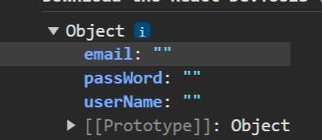

You’ll see them printed in console also

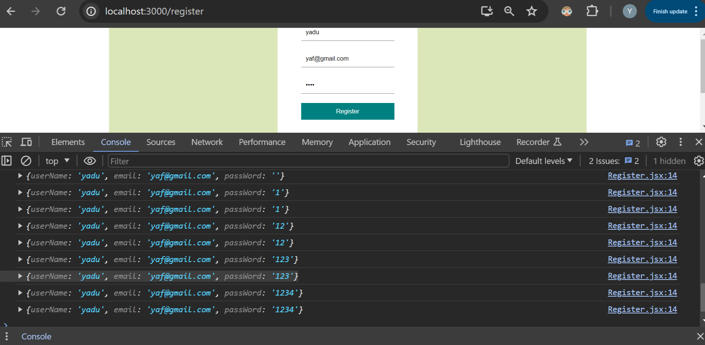

Above you can see every single char you type it’s keep printing

Now we’ve our input and we’re ready to send them to end point now

Next for register button I’ll add **onclick event**

Method will be **handleSubmit** for button click

const handleSubmit = e =>{

  e.preventDefault =

};

*. Why do we use e.preventDefault

it’ll stop page from refreshing when we click on register button

he told handleSubmit will be **asynchronous function** as we’re doing api request

so make api async request we need one more library

package is **axios**

*. When you’ll use async that time you’ll have to use **await**

**Await means** he told he’ll wait for that occasion

And for axios.post we pass our api url

Localhost:8800/auth/ etc…etc

But he told writing same url again and again is also not good idea

*. Mentioning api url inside package.json file

Inside package.json file we creatr json key as proxy as a value we put our api url

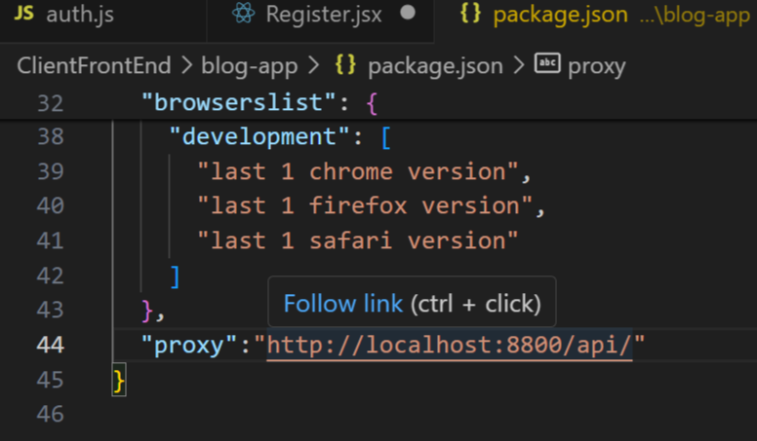

Above our package.json file

As **we mentioned it as proxy** here now inside our post or get request we don’t have to write all url part we can just mention our next **apir url things**

const handleSubmit = async e =>{

  e.preventDefault()

  const response = await axios.post("/auth/register");

};

**Above axios.post** we have put after part of api url

Or else every time we’ll have to type all long url

For that post we pass input as 2nd parameter

We put this entire response inside our try catch block

In catch block we handle error

const handleSubmit = async e =>{

  e.preventDefault()

  try{

    const response = await axios.post("/auth/register", inputs);

    console.log(response);

  }

  catch(err){

    console.log(err)

  }

};

Above is our method async for api call

*. Browser making api request inside register.jsx file for register click button

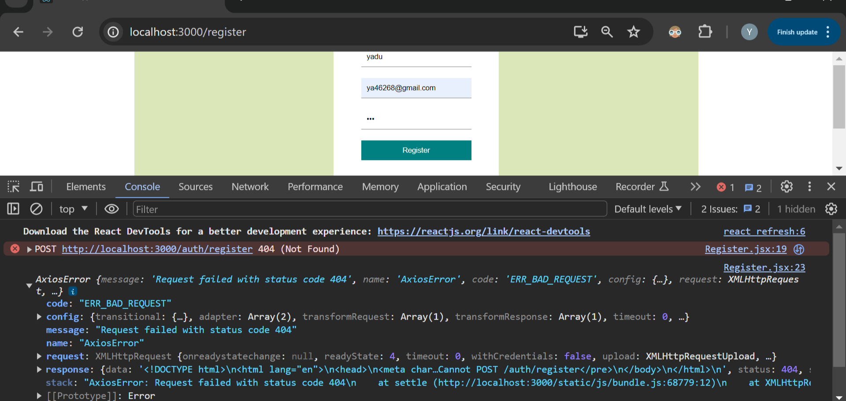

May be because of some mistake I got above error

1:16

When I make above api request inside register.jsx to insert new data which will go to auth.js file I’m getting error

So to debug this I’ll go to that part of video where he has started adding back end codes and also started running back end codes and api also

,

   "proxy": "http://localhost:8800/api/"

**Clientfrontend: package.json file**  because of putting above code as told in video my api was not working

*. I’m testing in different way to solve post issue from axios express

So within my back end app I started debugging with help of google and chatgpt

That is 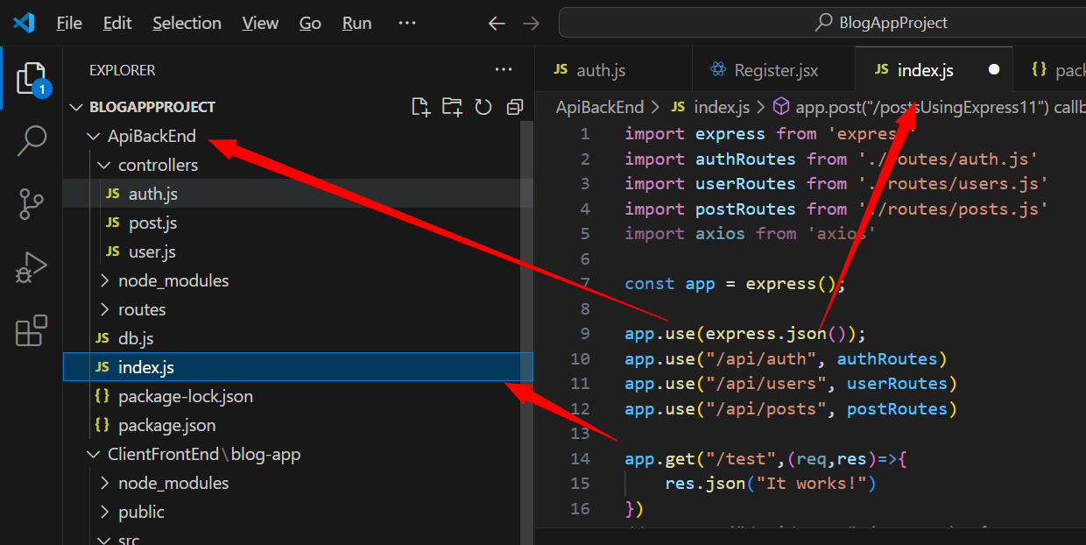

Above is **apibackend file** there itself I’m using **express post request for testing post request**

But during debugging I made many post request with postman it was giving same error

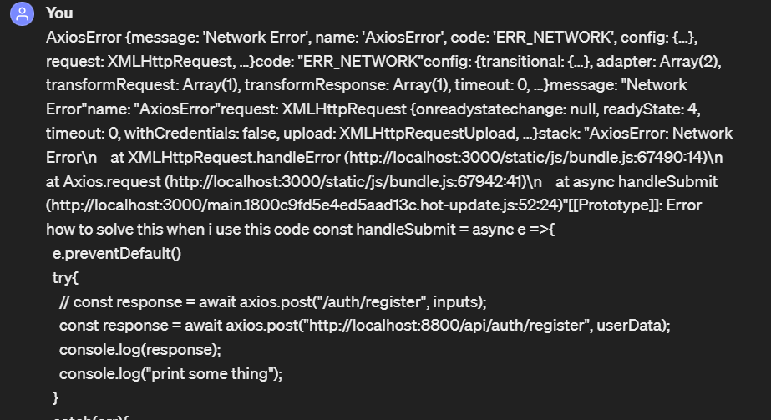

Like above is error from axios while making post request from front end register.jsx file

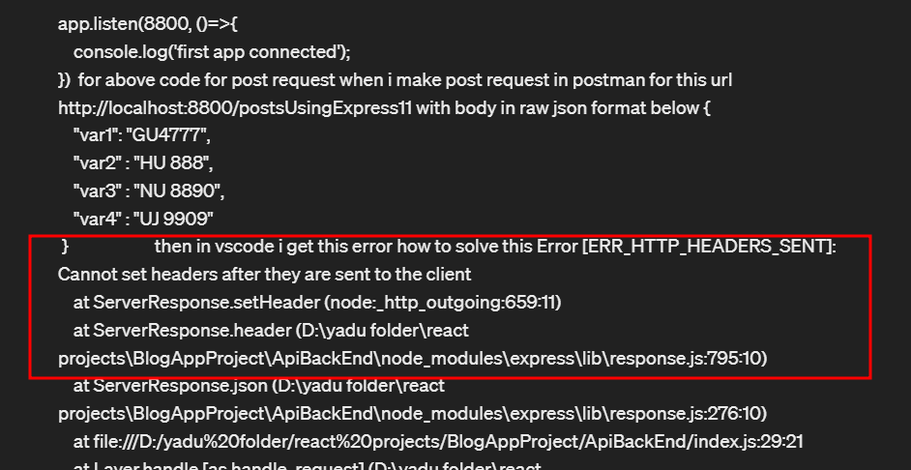

But later while doing post request from express I got above error

I got to know one thing

Inside post request if we print res.send 2 times we get above error when we do post request from postman

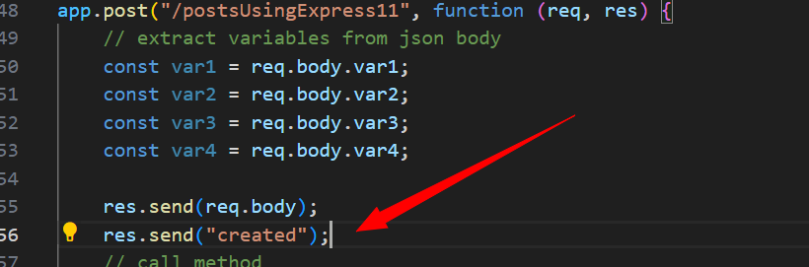

Example

With above code it gives error as res.send used 2 times

So while doing post request it throws error

So final error solved using chatgpt:

app.post("/postsUsingExpress11", function (req, res) {

    // extract variables from json body

    const var1 = req.body.var1;

    const var2 = req.body.var2;

    const var3 = req.body.var3;

    const var4 = req.body.var4;

    res.send(req.body);

I did above code to print res.body for debugging

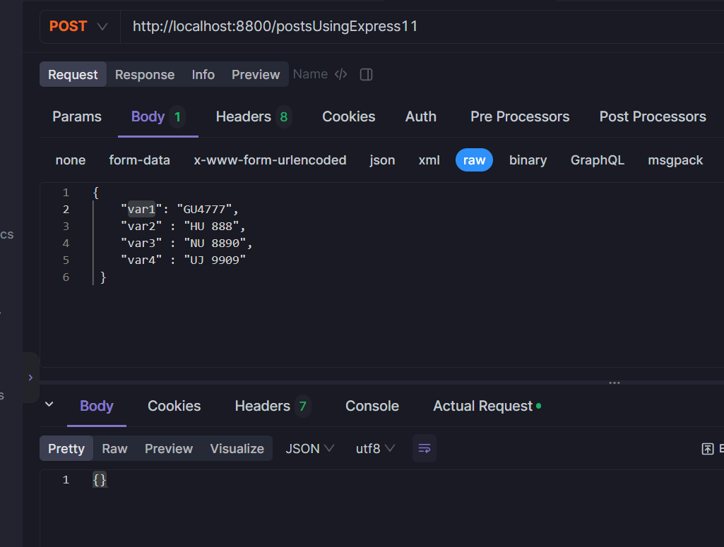

And in postman I did post request like above which gave me response as {}

So I checked the same in chatgpt

{} this is printed on doing console.log

ChatGPT

**ChatGPT**

If **req.body** is printing as **{}** (an empty object), it means that the JSON body is not being parsed correctly by Express. This could be due to a few reasons:

1. **Missing Body Parser Middleware**: Ensure that you have included **express.json()** middleware before your route handler. This middleware is necessary for parsing JSON bodies.
2. **Content-Type Header**: When sending JSON data with Postman, ensure that you set the **Content-Type** header to **application/json**. This informs Express that the incoming request contains JSON data.
3. **Postman Configuration**: Verify that your Postman request is sending the JSON data correctly in the request body. Double-check for any syntax errors or missing fields.

Above is **prompt from** chatgpt it told me to check

**Content-type header** added in apidog alternative to postman

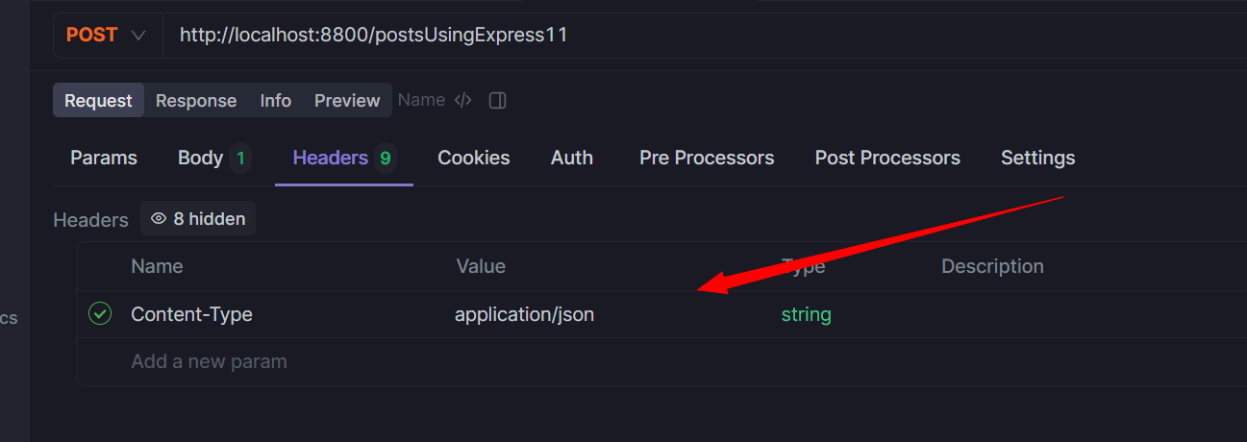

Above **Content-Type application/json**

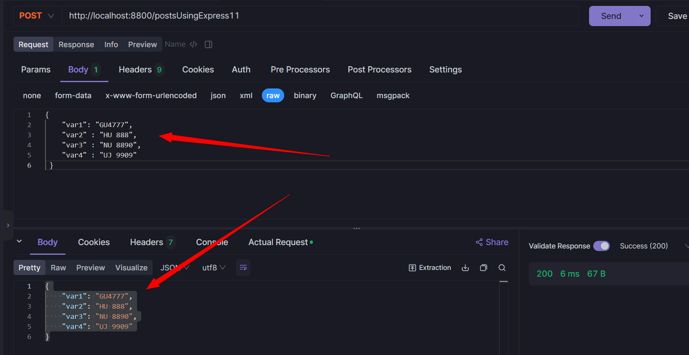

So post request error is solved with express

app.post("/postsUsingExpress11", function (req, res) {

    // extract variables from json body

    const var1 = req.body.var1;

    const var2 = req.body.var2;

    const var3 = req.body.var3;

    const var4 = req.body.var4;

    res.send(req.body);

    console.log(req.body);

});

{ var1: 'GU4777', var2: 'HU 888', var3: 'NU 8890', var4: 'UJ 9909' }

Above is output

Post: <http://localhost:8800/postsUsingExpress11>

Body raw: {

"var1": "GU4777",

"var2" : "HU 888",

"var3" : "NU 8890",

"var4" : "UJ 9909"

}

Headers: Content-Type application/json

Above index.js all code

import express from 'express'

import authRoutes from './routes/auth.js'

import userRoutes from './routes/users.js'

import postRoutes from './routes/posts.js'

import axios from 'axios'

const app = express();

app.use(express.json());

app.use("/api/auth", authRoutes)

app.use("/api/users", userRoutes)

app.use("/api/posts", postRoutes)

app.get("/test",(req,res)=>{

    res.json("It works!")

})

app.get("/api/posts",(req,res)=>{

    res.json("It worksdddddddd!")

})

// POST request handler for creating a new post

app.post("/api/posts", (req, res) => {

    // Assuming you're expecting JSON data with a 'title' property

    const { title } = req.body;

    res.send(req.body);

    res.status(201).json({ message: `New post created with title: ${title}` });

});

const userData = {

    username: 'John Doe',

    email: 'john@example.com',

    password: 'password123'

  };

app.post("/postsUsingExpress", (req, res) => {

    // Assuming you're expecting JSON data with a 'title' property

    const username = req.body.username

    const email = req.body.email

    const password = req.body.password

    // res.status(201).json({ message: `New post created with title: ${title}` });

    console.log(req.body.username)

    res.status(200).send({

        "message": `Executed name() with var1 = ${username}, var2 = ${email}, var4 = ${password}`

    });

});

app.post("/postsUsingExpress11", function (req, res) {

    // extract variables from json body

    const var1 = req.body.var1;

    const var2 = req.body.var2;

    const var3 = req.body.var3;

    const var4 = req.body.var4;

    res.send(req.body);

    console.log(req.body);

});

app.listen(8800, ()=>{

    console.log('first app connected');

})

It’s very important to pass header as Headers: Content-Type application/json

While making post request

#. Try to solve axios post request error

app.post("/postsUsingExpress", (req, res) => {

    // Assuming you're expecting JSON data with a 'title' property

    const username = req.body.username

    const email = req.body.email

    const password = req.body.password

    // res.status(201).json({ message: `New post created with title: ${title}` });

    console.log(req.body.username)

    res.status(200).send({

        "message": `Executed name() with var1 = ${username}, var2 = ${email}, var4 = ${password}`

    });

});

Above code I made post request with apidog with body and header

<http://localhost:8800/postsUsingExpress>

body: raw: {"username": "John Doe","email": "john@example.com","password": "password123"}

as Headers: Content-Type application/json

output: in postman: {

    "message": "Executed name() with var1 = John Doe, var2 = john@example.com, var4 = password123"

}

There is code generation option in api dog I spent little time on apidog and found it

var axios = require('axios');

var data = JSON.stringify({

   "username": "John Doe",

   "email": "john@example.com",

   "password": "password123"

});

var config = {

   method: 'post',

   url: 'http://localhost:8800/postsUsingExpress',

   headers: {

      'User-Agent': 'Apidog/1.0.0 (https://apidog.com)',

      'Content-Type': 'application/json',

      'Accept': '*/*',

      'Host': 'localhost:8800',

      'Connection': 'keep-alive'

   },

   data : data

};

axios(config)

.then(function (response) {

   console.log(JSON.stringify(response.data));

})

.catch(function (error) {

   console.log(error);

});

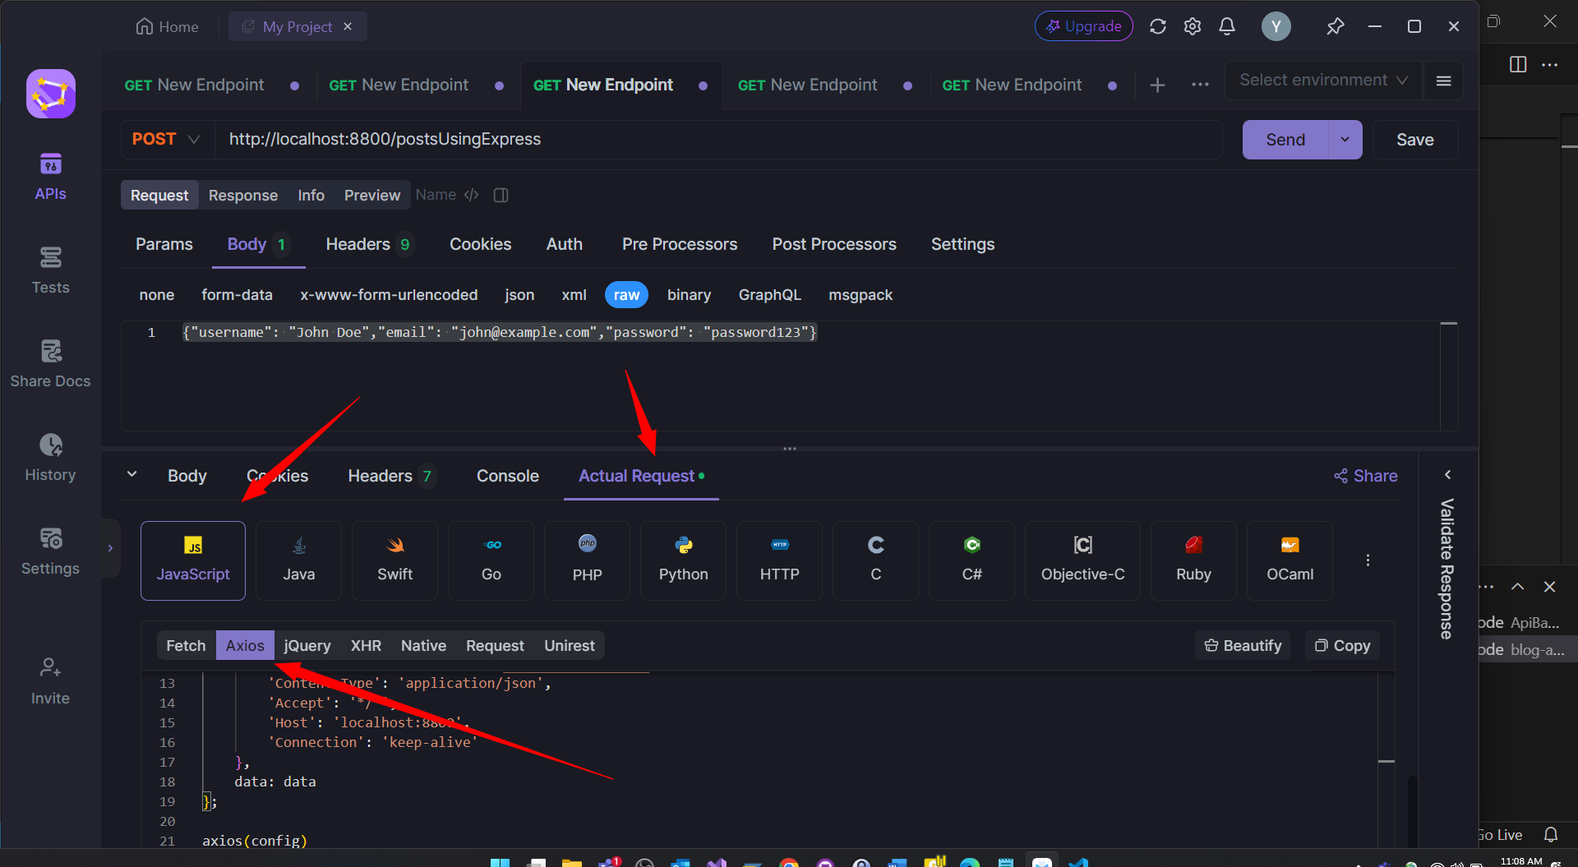

<https://stackoverflow.com/questions/53667206/mock-postman-request-into-axios>

in his github code itself axios doesn’t work so I need to look for alternative for axios

*. Chatgpt told we can’t use express package in our frontend app to make post request

1. **Check Environment**: Ensure that you are using Express in the correct environment. Express is primarily designed to run on the server side with Node.js, not in a browser environment. If you're trying to use Express in a client-side JavaScript application, consider using alternative solutions more suitable for client-side development, such as Axios or Fetch API for making HTTP requests.

Above

*. Fetch-api lot of errors solved

<https://stackoverflow.com/questions/71041521/unhandledschemeerror-what-is-this-nodebuffer-error-and-how-do-i-solve-it>

Simply downgrading it to "node-fetch": "2.6.1" or any other 2.x.x version will fix this issue.

I downloaded latest version of fetch from node-fetch package into my clientfrontend app version number was above 3

So when I imported it to Register.jsx file and saved and npm start it gave lot of errors nodebuffer, http,https,path stream, fs

So in stack overflow they told to downgrade version to 2.6.1 which solved my error

#. Fetch api post request worked in dummy test react app without any error great

When I used fetch api in my blog-app it gave lot of errors now I understood they’re all due to packages are not compativle each other

I created separate node react app inside that imported fetch-api

Made get and post request tested them with api-dog alternative of postman worked without any error

Now same I’ll try to add it to my react blog-app step by step I’ll try to solve error also step by step

Also in that test fetch app for post I’ll also try to use axios and try to test it using apidog

<https://github.com/node-fetch/node-fetch/issues/1624>

this link says that localhost post request does not work on nodejs latest versions

only on nodejs 16 localhost post request will work

above message is very important

I experience the same issue,

I use nvm for Windows and same code works properly for 16.17.0

#. Life saving video which solved axios localhost issue

<https://www.youtube.com/watch?v=llE5_0m0r_E>

from this video I understood that you can’t check post request when your server is running in nodejs client and from localhost you’re doing post request

here when you try with react axios for making post request you can send post request from client front end and test it within server you can’t test this request in postman I tried lot of ways testing post request in postman but all of them gave error even with google and chatgpt also I couldn’t solve it.

Finally one youtube video told that I need to use cors in in my backend or server side code to read response of post request with that itself it’ll work

One more thing I simple created a test app I tested within test app it worked fine over there

Code below

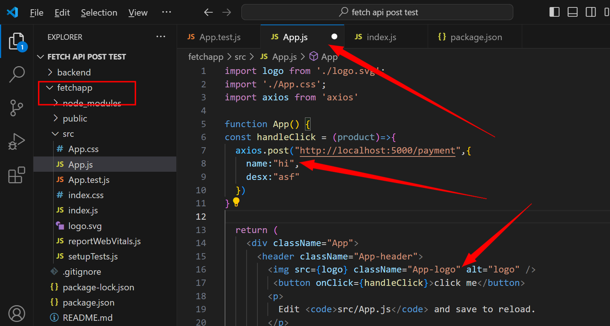

Client side code

import logo from './logo.svg';

import './App.css';

import axios from 'axios'

function App() {

const handleClick = (product)=>{

  axios.post("http://localhost:5000/payment",{

    name:"hi",

    desx:"asf"

  })

}

  return (

    <div className="App">

      <header className="App-header">

        <img src={logo} className="App-logo" alt="logo" />

         <button onClick={handleClick}>click me</button>

        <p>

          Edit <code>src/App.js</code> and save to reload.

        </p>

        <a

          className="App-link"

          href="https://reactjs.org"

          target="_blank"

          rel="noopener noreferrer"

        >

          Learn React

        </a>

      </header>

    </div>

  );

}

export default App;

above is client side code to make post request using axios

now important thing: in backend code I have index.js file in that itself I’m reading post request

but to run index.js file from backend you **have to make one important change that is type**

**type:module in package.json file** if you don’t do this you’ll get module not found error it’ll tell like inside index.js file you’ll import express you get error like

cannot import outside module

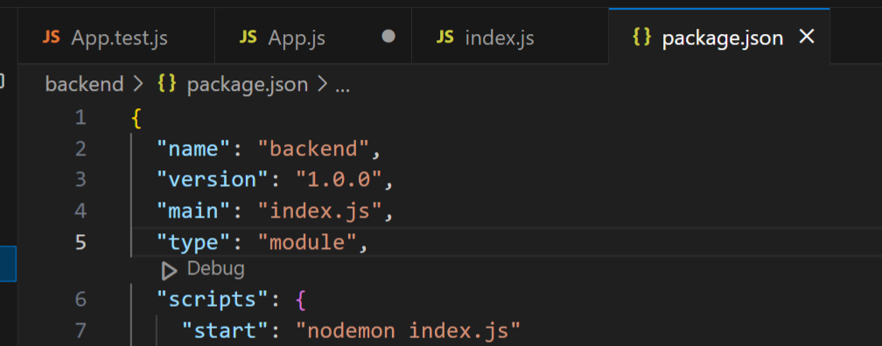

And my server side code

import express from 'express'

import cors from 'cors'

const app = express();

app.use(cors())

app.use(express.json())

app.post("/payment",(req,res)=>{

    const body = req.body;

    console.log(body)

    res.send("ok")

})

app.listen(5000, ()=>{

    console.log('first app connected');

})

Like above

console.log(body)

above will print your response in your vscode terminal that’s it

in client side front end side I have one button on clicking it I make post request and on backend server side I receive that post request with above code

important thing you shouldn’t test these localhost post request in postman or browser it’ll give error you’ve to process them in code itself

continuing with blog app project

#. Redirect other page localhost post request with axios

I created one test app backend index.js file and frontend app.js file

In frontend using axios I created post request code so on clicking button I do post request

And on back end using cors I try to accept post request this worked fine

Next I tried to test for post request by redirecting from some other page

App.js file is like my home page and

Src folder-> pages folder-> Register.jsx file

For redirecting used **RouterProvider**

So I redirected to localhost:3000/register page here I kept one button so on clicking it I make post request

This time also in backend or server folder there I have index.js file there itself I accepted my post request

This also worked fine

So this time in my blog-app I started checking for errors

So in index.js file I found one important error I was listening to port number 8800

But I made post request in port number 5000 this was main error

I was making post request in one port number and I was listening to some other port number

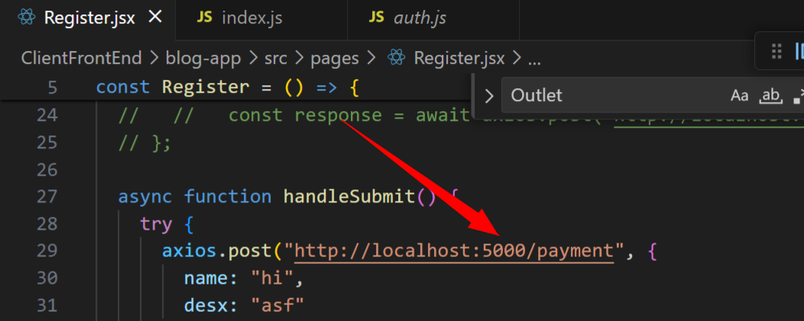

5000 port number I made post request

But 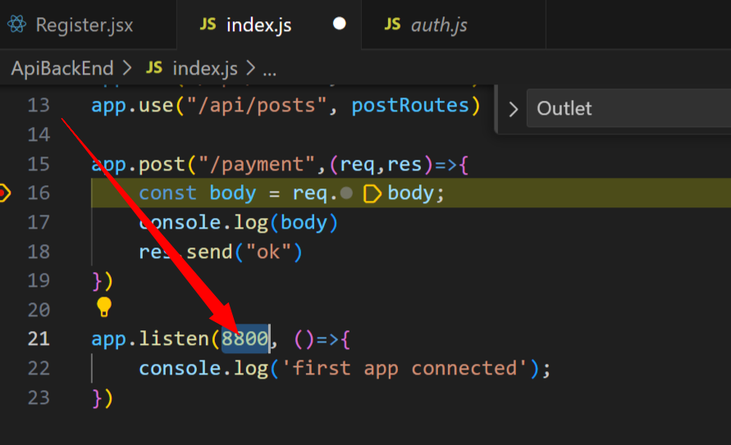

Here I’m listening to different port number I changed it to 5000

It started working fine

#. Debug backend in vs code

First go to **ApiBackEnd ->index.js file**

Top in vscode after **View and Go** you have **Run** in that click on start debugging

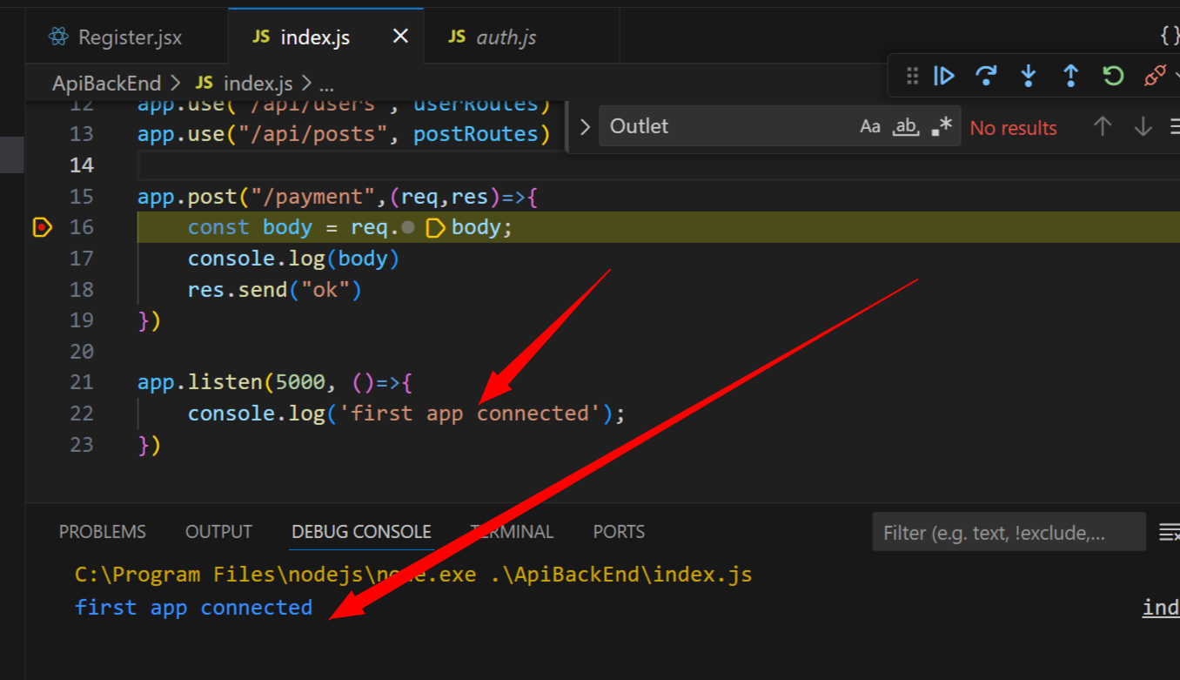if you don’t have any breakpoint in debug console it directly prints “first app connected”

Now post request breakpoint:

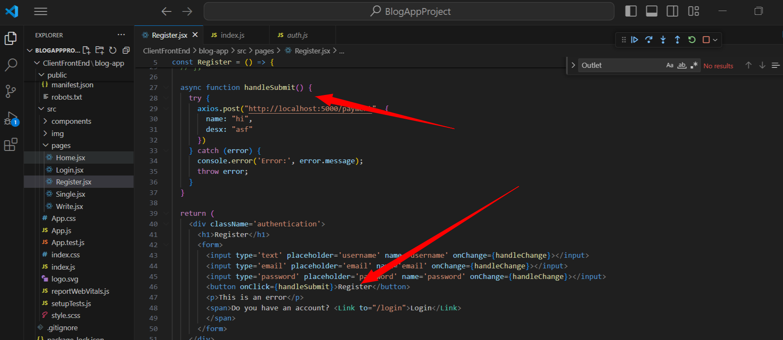

Above is Register.jsx file here I have one button on clicking button I call handlesubmit method

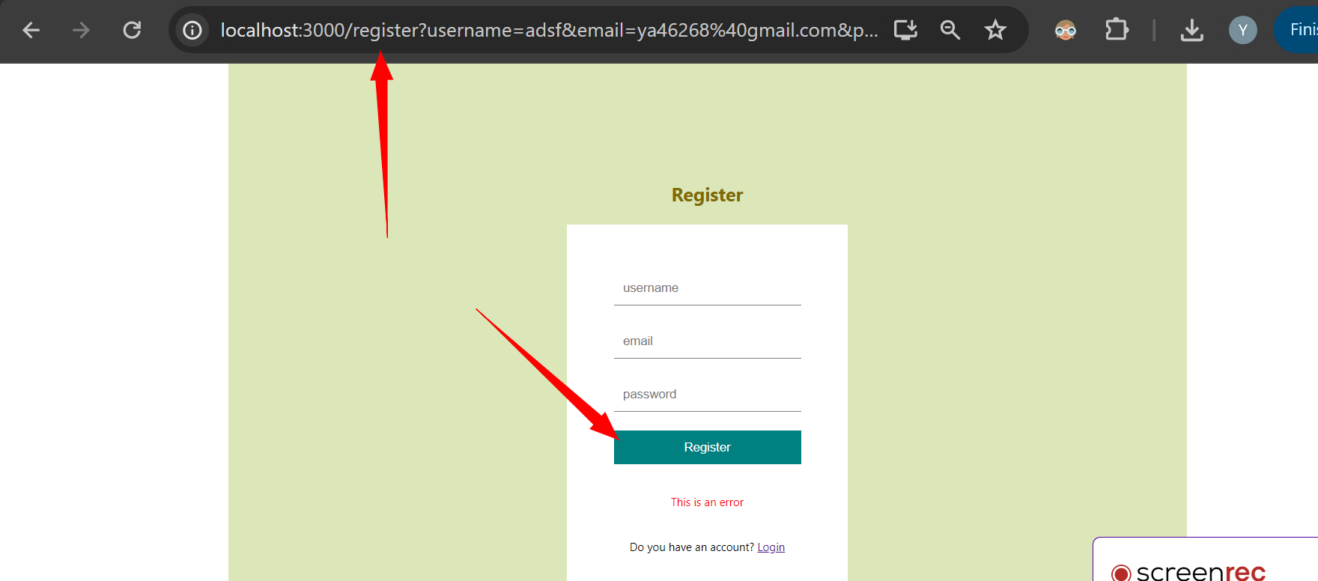

On clicking register button in my register page I make post request

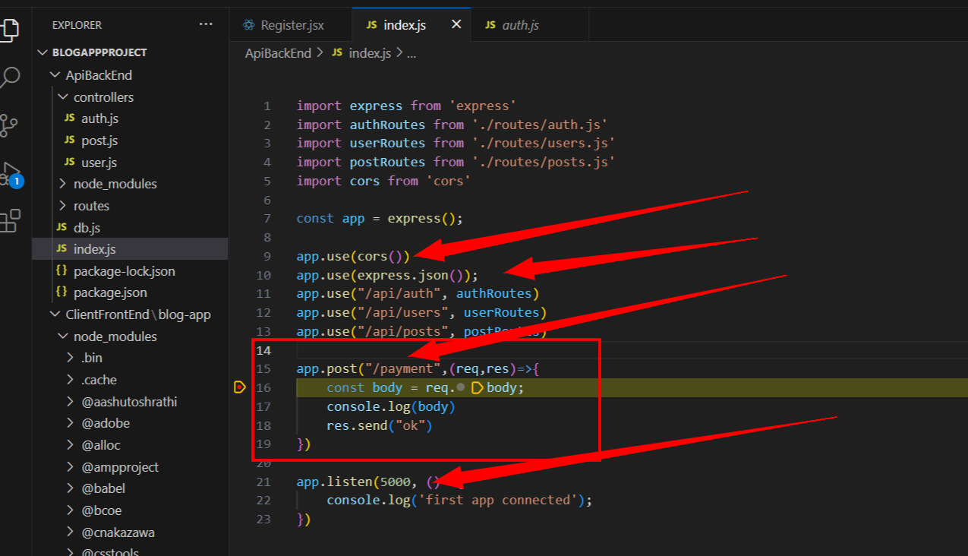

Now to remove cors error we use cors

/payment with express post above our breakpoint will hit when we click on button in front end

#. Continue with blog-app post request passing username mail password

I think in blog-app youtube he made mistake inside index.js file he put some other port number like 5000

But in post request proxy in package.json file he put port number as 8800 that’s why my post request was not listened by my backend app

Port number should be same while sending also while receiving

Chatgpt gave me some code to redirect using api url folder

My query

http://localhost:8800/api/auth/register this is post request url i'm calling from front end of react app now in backend api is folder auth.js is file inside controllers folder where controllers folder is inside src folder and register is method inside auth.js file when i click on button this url i call http://localhost:8800/api/auth/register so breakpoint should hit register method present inside auth.js file when i use vscode

how to make api call method present inside another folder file using nodejs

above

To make an API call to a method present inside another folder/file in a Node.js application, you typically use the **require** or **import** statement to import the module containing the method, and then call the method as needed. Here's a basic example:

Let's say you have a folder structure like this:

project

│ app.js

└───controllers

│ auth.js

And inside **auth.js**, you have a method named **register**.

**auth.js**:

// auth.js

function register(userData) {

// Your register logic here

console.log('User registered:', userData);

}

module.exports = {

register: register

};

Now, to make an API call to the **register** method from **app.js**:

**app.js**:

// app.js

const authController = require('./controllers/auth');

// Assuming you're using Express for your API

const express = require('express');

const app = express();

const port = 8800;

// Define your API route

app.post('/api/auth/register', (req, res) => {

// Assuming req.body contains user data

const userData = req.body;

// Call the register method from the auth controller

authController.register(userData);

// Respond to the client

res.send('User registered successfully');

});

// Start the server

app.listen(port, () => {

console.log(`Server is running on http://localhost:${port}`);

});

In this example, **authController** imports the **auth.js** file, and then you can call the **register** method from within your API route.

Remember, if **auth.js** is inside a different folder, you would need to adjust the relative path in the **require** statement accordingly. For example, if **auth.js** is inside a **controllers** folder, you'd use **require('./controllers/auth')**.

Additionally, ensure that your Node.js application structure and modules are properly set up according to your project's needs.

I used above code but some errors are coming

Time: 1:16

#. I tested youtube blog-app code localhost post request works fine

For api which is backend for index.js file I did run start debugging so in vscode debug console it prints connected

In client frontend I start app and go to register.jsx file there when I click on button post request is hitting exact breakpoint present in auth.js file register method

So referring code directly youtube code and making same folder name every thing

**We have api folder**

**We have client** this react app: created by command **npx create-react-app client**

**I’m using nodejs version: Node.js v16.17.0.**

**#. I uninstalled nodejs 16, installed nodejs20 latest here also axios post working**

**#. Main error could be because of my wrong folder structure**

When I created blog app: for front end I created separate app named **client** after that inside **client** folder I created react-app **blog-app** so when I made post request here it was not at all hitting backend **controller folder->auth file->register** method

So later I uninstalled nodejs 16 version installed nodejs 20 latest version with this executed youtube code of blog app

*. It’s very important how you run your react app: first run back end with port 8800

Using start debugging in debug console It prints “connected”

After that you’ll run front end app with npm run start

With this way breakpoint will will hit back end he didn’t teach this in video

**I referred** youtube code kept all folder structure same for client I created react app like this

Npx create-react-app client so inside client folder itself all node_modules will come app.js src folder will come

When I run this breakpoint hit correctly at backend auth.js file without any issues

It’s not even error with nodejs version

Issue: run backend first where 8800 port should be listening for request

Maintain proper folder structure

One more thing I also tried to correct my older blog-app project folder structure:

Like earlier inside ClientFrontEnd folder I created react app blog-app I tried to cut all contents inside blog-app and pasted to ClientFrontEnd folder deleted blog-app folder

With this when I tried to run post request didn’t work here also

As I think they’ll refer some folder structure initially when you create react app

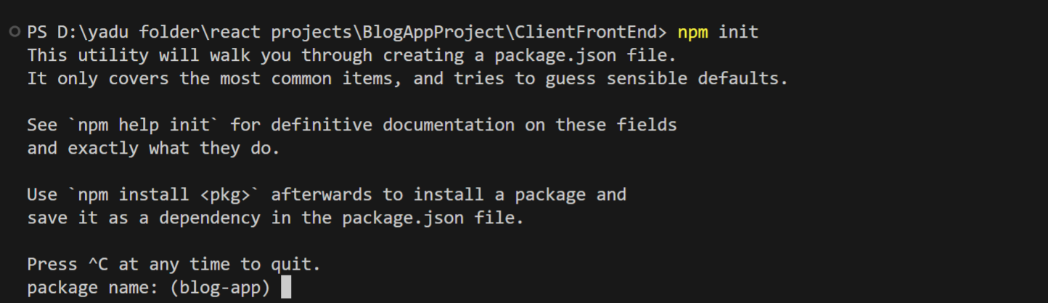

Still it’s telling blog-app

So what I’ll do is:

I refer blog-app frontend and backend code itself but folder structure I’ll create very properly by referring to youtube code that is api folder for backend

And our react app: client will be for front end all codes jsx js file I’ll refer blog app

To debug exact error

Did this

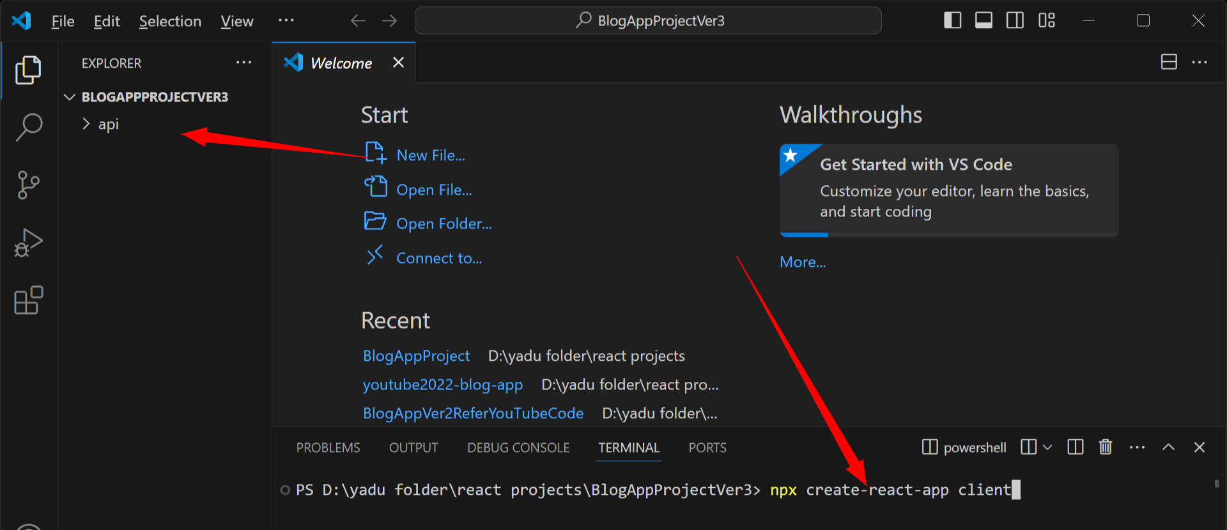new folder api

New react app client

In cmd of vscode: do cd api and do npm init -y which will create package.json file

npm install bcryptjs cookie-parser cors express jsonwebtoken multer mysql nodemon

installed above packages for api backend

next inside package.json file do this: inside api backend

 "type": "module",

  "scripts": {

    "start": "nodemon index.js"

  },

Above

I think there is one exact mistake present in my earlier blog-app because same blog-app code I referred to new version3 blog-app here also while making post request it didn’t hit breakpoint

http://localhost:8800/ApiBackEnd/auth/register

One issue ApiBackEnd folder name

http://localhost:8800/api/auth/register

After correcting above where api folder name

And auth file name and register method name now my breakpoint hits register method inside auth.js file

#. Issues to avoid while making post request

*. Don’t do this: creating react app inside another folder from there making post request

Earlier mistake: blogappproject-> 2 folders

* Api
* Client

->blogapp react app created

Above inside client app I created react app as blogapp there I made post request this might be one issue

Later directly created react app as client and made post request it hit breakpoint

*. Api url’s name should match with correct folder name

<http://localhost:8800/api/auth/register>

instead of api I put ApiBackEnd

also in my backend folder I created folder name as ApiBackEnd this also can create issue

all char should be smaller I think

later as per youtube code kept name as api with this it worked

*. When you make post request your port should be listening at backend

First time I only run front end app, I didn’t run backend server so port was not listening with this breakpoint didn’t hit

Later in api backend: index.js file opened in vscode clicked run and debug inside run and kept breakpoint in auth file register method at app.listen connected Is printed in debug console

After that in front end when I made post request it hit breakpoint

*. I think I need to pass correct api inputs if you pass wrong object to post api it may not respond

*. If I create ApiBackEnd folder and try to access with ApiBackEnd is also not possible I think

*. You need to use app.use(cors()) inside index.js file or else api post doesn’t hit breakpoint

BlogAppProjectVer3 is correct working code

But in package.json file used proxy for common use of api url this didn’t work while making post request I had to use full api url in post request

const handleSubmit = async (e) => {

    e.preventDefault();

    try {

      await axios.post("http://localhost:8800/api/auth/register", inputs);

      navigate("/login");

    } catch (err) {

      setError(err.response.data);

    }

  };

Like above

    db.query(querySelect, [req.body.email,req.body.username],(err,data)=>{

        if(err) return res.json(err);

        if(data.length) return res.status(409).json("User already exists");

    })

Above code started giving error

*. Using mysql for creating connection and for sql select stamt doesn’t work use mysql2

In my blog-app inside db.js file I have used mysql package for making sql connection also for run select insert query

"Client does not support authentication protocol requested by server; consider upgrading MySQL client"

code:'ER_NOT_SUPPORTED_AUTH_MODE

errno:1251

fatal:true

sqlMessage:'Client does not support authentication protocol requested by server; consider upgrading MySQL client'

sqlState:'08004'

message:'ER_NOT_SUPPORTED_AUTH_MODE: Client does not support authentication protocol requested by server; consider upgrading MySQL client'

stack:'Error: ER_NOT_SUPPORTED_AUTH_MODE: Client does not support authentication protocol requested by server; consider upgrading MySQL client\n at Sequence._packetToError (D:\\yadu folder\\react projects\\test projects\\mysqlSelectInsertTest\\node_modules\\mysql\\lib\\protocol\\sequences\\Sequence.js:47:14)\n at Handshake.ErrorPacket (D:\\yadu folder\\react projects\\test projects\\mysqlSelectInsertTest\\node_modules\\mysql\\lib\\protocol\\sequences\\Handshake.js:123:18)\n at Protocol._parsePacket (D:\\yadu folder\\…ules\\mysql\\lib\\Connection.js:454:10)\n at Connection.query (D:\\yadu folder\\react projects\\test projects\\mysqlSelectInsertTest\\node_modules\\mysql\\lib\\Connection.js:196:8)\n at file:///D:/yadu%20folder/react%20projects/test%20projects/mysqlSelectInsertTest/index.js:12:4\n at ModuleJob.run (node:internal/modules/esm/module_job:222:25)\n at async ModuleLoader.import (node:internal/modules/esm/loader:316:24)\n at async asyncRunEntryPointWithESMLoader (node:internal/modules...

[[Prototype]]:Object

But I started getting above erros

<https://stackoverflow.com/questions/50093144/mysql-8-0-client-does-not-support-authentication-protocol-requested-by-server>

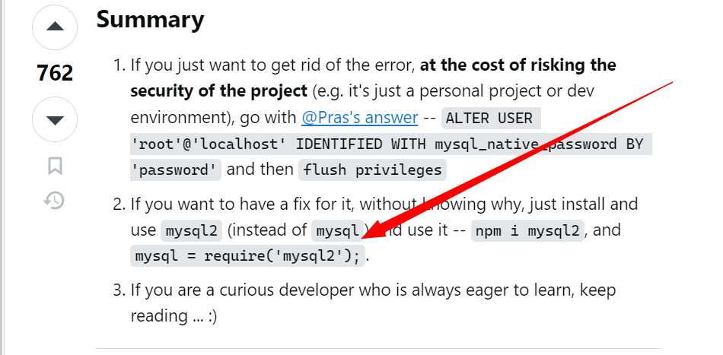

Chatgpt didn’t help much so I started checking stackoverflow

When I got above errors first and best thing I did **I created test nodejs app for testing mysql package**

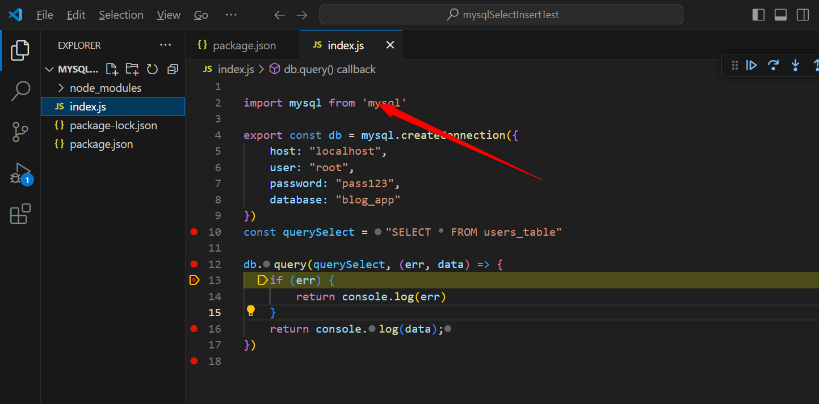

import mysql from 'mysql'

export const db = mysql.createConnection({

    host: "localhost",

    user: "root",

    password: "pass123",

    database: "blog_app"

})

const querySelect = "SELECT * FROM users_table"

db.query(querySelect, (err, data) => {

    if (err) {

        return console.log(err)

    }

    return console.log(data);

})

**Like above**

**First** I got sql password related error with mysql root localhost so I couldn’t remember my mysql root password so I reinstalled mysql with correct password as **pass123**

And created schema tables

After this when I run my test nodejs app I got same error present in my blog-app

So as per stackoverflow I uninstalled mysql installed mysql2

With this when I tried too make createconnection and read sql query in test nodejs app it worked without any error

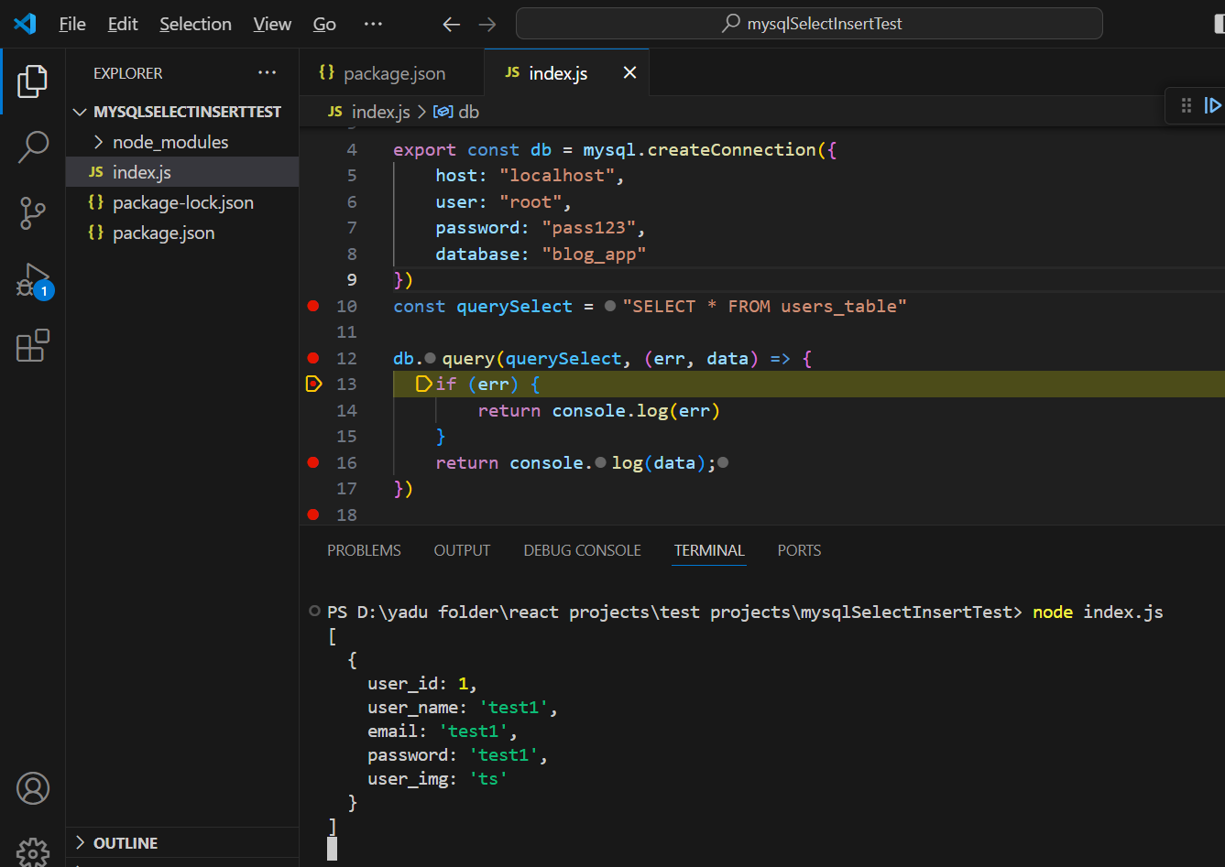

Above we can see proper output in test nodejs without any error

Whenever you get any error create try to create a simple test app for that

import mysql from 'mysql2'

export const db= mysql.createConnection({

    host:"localhost",

    user:"root",

    password:"pass123",

    database:"blog_app"

})

Used mysql2 package

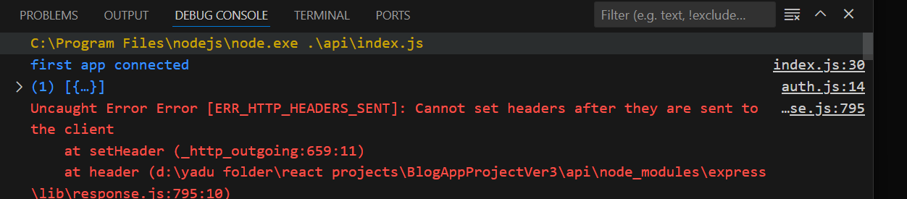

Now in my blog-app my data from sql is printed as object

But due to above code as we’re trying to send response it’s giving error

 db.query(querySelect, [req.body.email,req.body.username],(err,data)=>{

        if(err) return res.json(err);

        if(data.length) return res.status(409).json("User already exists");

    })

Because of above code it’s giving error

if(data.length) return res.status(409).json("User already exists");

So comment above code

Now because of commenting above code code started working properly

code:'ER_PARSE_ERROR'

errno:1064

sql:"INSERT INTO users_table('user_name','email','password')"

sqlMessage:"You have an error in your SQL syntax; check the manual that corresponds to your MySQL server version for the right syntax to use near ''user_name','email','password')' at line 1"

sqlState:'42000'

message:"You have an error in your SQL syntax; check the manual that corresponds to your MySQL server version for the right syntax to use near ''user_name','email','password')' at line 1"

stack:"Error: You have an error in your SQL syntax; check the manual that corresponds to your MySQL server version for the right syntax to use near ''user_name','email','password')' at line 1\n at Packet.asError packets\\packet.js:728:17)\n at Query.execute

(lib\\commands\\command.js:29:26)\n at Connection.handlePacket (D:\\yadu folder\\react projects\\…97:12)\n at PacketParser.executeStart (lib\\packet_parser.js:75:16)\n at Socket.<anonymous> (lib\\connection.js:104:25)\n at Socket.emit (node:events:519:28)\n at addChunk (node:internal/streams/readable:559:12)\n at readableAddChunkPushByteMode (node:internal/streams/readable:510:3)\n at Readable.push (node:internal/st...

[[Prototype]]:Object

Now while inserting I got above error

I think column names while inserting are mismatching

code:'ER_PARSE_ERROR'

errno:1064

sql:"INSERT INTO users_table (user_name, email, password) VALUES ('asdf', 'ya46268@gmail.com', '$2a$10$Nw6MWJSK4g3cjHzuafX1gu2jJGdmUCWa94CM/hz1EFCYpHvCs9MP2', ?, ?)"

sqlMessage:"You have an error in your SQL syntax; check the manual that corresponds to your MySQL server version for the right syntax to use near '?, ?)' at line 1"

sqlState:'42000'

message:"You have an error in your SQL syntax; check the manual that corresponds to your MySQL server version for the right syntax to use near '?, ?)' at line 1"

stack:"Error: You have an error in your SQL syntax; check the manual that corresponds to your MySQL server version for the right syntax to use near '?, ?)' at line 1\n at Packet.

I changed by referring to chatgpt code but still got above erro

        if(err) return res.json(err);

code:'ER_DATA_TOO_LONG'

errno:1406

sql:"INSERT INTO users_table (user_name, email, password) VALUES ('asdf', 'ya46268@gmail.com', '$2a$10$JMpL3AMye.YyAlkWpxBp8OcyRc.GzMIY.lp2Q5sVhbBsUKNe0L4Le')"

sqlMessage:"Data too long for column 'password' at row 1"

sqlState:'22001'

message:"Data too long for column 'password' at row 1"

stack:"Error: Data too long for column 'password' at row 1\n at Packet.asError (D:\\yadu folder\\react projects\\BlogAppProjectVer3\\api\\node_modules\\mysql2\\lib\\packets\\packet.js:728:17)\n at Query.execute (D:\\yadu folder\\react projects\\BlogAppProjectVer3\\api\\node_modules\\mysql2\\lib\\commands\\command.js:29:26)\n at Connection.handlePacket (D:\\yadu folder\\react projects\\BlogAppProjectVer3\\api\\node_modules\\mysql2\\lib\\connection.js:481:34)\n at PacketParser.onPacket (D:\\yadu folder\\react projects\\Blog…97:12)\n at PacketParser.executeStart (D:\\yadu folder\\react projects\\BlogAppProjectVer3\\api\\node_modules\\mysql2\\lib\\packet_parser.js:75:16)\n at Socket.<anonymous> (D:\\yadu folder\\react projects\\BlogAppProjectVer3\\api\\node_modules\\mysql2\\lib\\connection.js:104:25)\n at Socket.emit (node:events:519:28)\n at addChunk (node:internal/streams/readable:559:12)\n at readableAddChunkPushByteMode (node:internal/streams/readable:510:3)\n at Readable.push (node:in...

above is almost near

 const queryInsert = 'INSERT INTO users_table (user_name, email, password) VALUES (?, ?, ?)';

    const values = [req.body.username,

    req.body.email, hash]

    db.query(queryInsert,values,(err,data)=>{

        if(err) return res.json(err);

        // return res.status(200).json("User has been created");

    })

my code is I changed my code by checking chatgpt

In your original code, you're passing **[values]** as a single element array, which is unnecessary. Instead, you should directly pass the **values** array as the second argument to **db.query()**. This way, each element of the **values** array will be treated as a separate parameter for the SQL query,

Above chatgpt prompt in db.query I was passing [values] like this which is wrong

sqlMessage:"Data too long for column 'password' at row 1"

Now error says

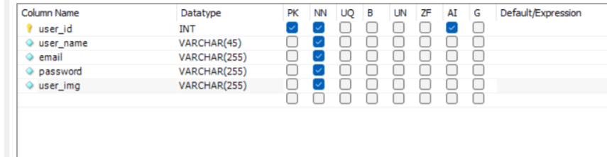

Above users_table

Changed table structure password length kept as 255

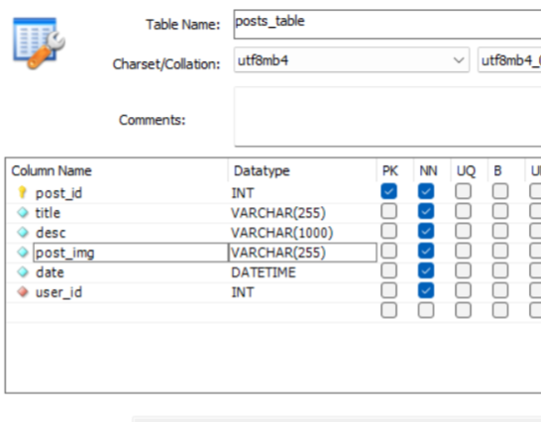

Above post_table

code:'ER_NO_DEFAULT_FOR_FIELD'

errno:1364

sql:"INSERT INTO users_table (user_name, email, password) VALUES ('asdf', 'asd@gmail.com', '$2a$10$QIVRRXXSLP1qQPL8ZiNeW.NLQVNhVC0wuyUqtn7TN1UizUGCL9WWa')"

sqlMessage:"Field 'user_img' doesn't have a default value"

sqlState:'HY000'

message:"Field 'user_img' doesn't have a default value"

stack:"Error: Field 'user_img' doesn't have a default value\n at Packet.asError (D:\\yadu folder\\react

[[Prototype]]:Object

Next error because I kept image as not null

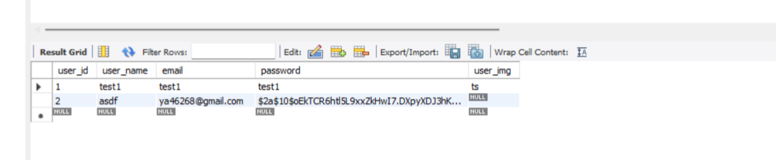

Finally now data got inserted for mysql table

Now if we see password it’s not in text it’s completely encrypted

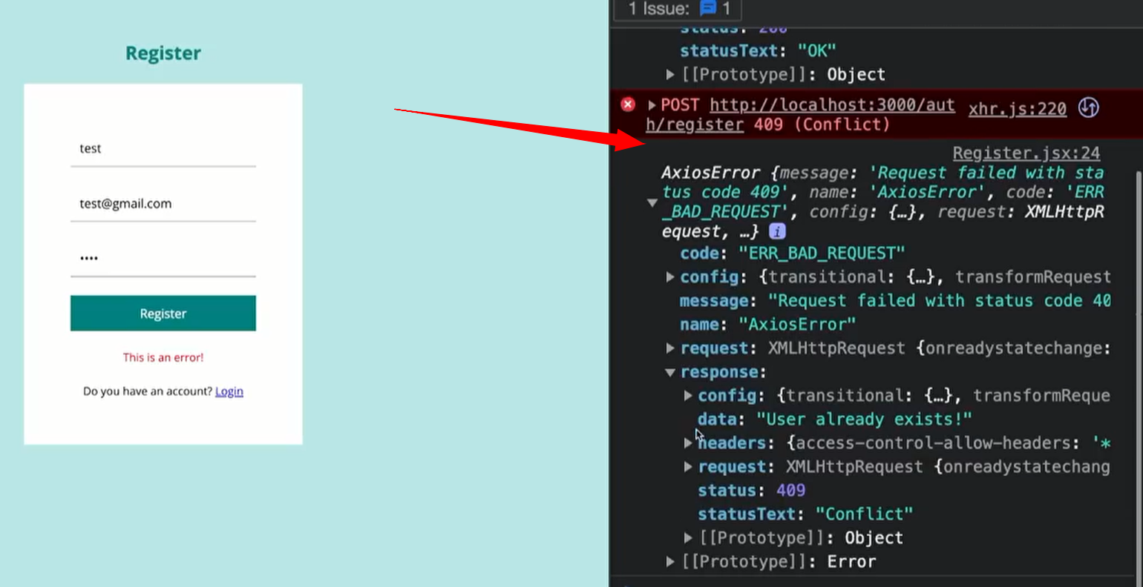

When he tried to add the same user again it returned error like above

In that data says user already exists

But for me I was getting some header error so as of now I have commented that part now

export const register = (req,res) =>{

    // res.send(req.body);

    //check user exists: with mail and name

    const querySelect = "SELECT * FROM users_table"

    // const querySelect = "SELECT * FROM users_table WHERE EMAIL= ? OR USER_NAME=?"

    db.query(querySelect, (err, data) => {

        if (err) {

            return console.log(err)

        }

        return console.log(data);

    })

Above is my register method code for testing whether query works or not

Because res.send res.status were giving error

export const register = (req,res) =>{

    // res.send(req.body);

    //check user exists: with mail and name

    const querySelect = "SELECT * FROM users_table"

    // const querySelect = "SELECT * FROM users_table WHERE EMAIL= ? OR USER_NAME=?"

    db.query(querySelect, (err, data) => {

        if (err) {

            return console.log(err)

        }

        return console.log(data);

    })

    db.query(querySelect, [req.body.email,req.body.username],(err,data)=>{

        if(err) return res.json(err);

        // if(data.length) return res.status(409).json("User already exists");

    })

    //hash the password and create a user

    const salt = bcrypt.genSaltSync(10);

    const hash = bcrypt.hashSync(req.body.password, salt);

    // const queryInsert1 = "INSERT INTO users_table('user_name','email','password')"

    const queryInsert = 'INSERT INTO users_table (user_name, email, password) VALUES (?, ?, ?)';

    const values = [req.body.username,

    req.body.email, hash]

    db.query(queryInsert,values,(err,data)=>{

        if(err) return res.json(err);

        // return res.status(200).json("User has been created");

    })

}

Above Working select query working insert query code without sending response to client or front end

*. Next issue facing is not able to send error response with express to my client

Understood the error properly

export const register = (req,res) =>{

    res.send(req.body);

    //check user exists: with mail and name

    const querySelect = "SELECT * FROM users_table WHERE EMAIL= ? OR USER_NAME=?"

    db.query(querySelect, [req.body.email,req.body.username],(err,data)=>{

        if(err) return res.json(err);

        if(data.length) return res.status(409).json("User already exists");

    })

    //hash the password and create a user

    const salt = bcrypt.genSaltSync(10);

    const hash = bcrypt.hashSync(req.body.password, salt);

    // const queryInsert1 = "INSERT INTO users_table('user_name','email','password')"

    const queryInsert = 'INSERT INTO users_table (user_name, email, password) VALUES (?, ?, ?)';

    const values = [req.body.username,

    req.body.email, hash]

    db.query(queryInsert,values,(err,data)=>{

        if(err) return res.json(err);

        return res.status(200).json("User has been created");

    })

}

If you see above code **first we did res.send**

const handleSubmit = async (e) => {

    e.preventDefault();

    try {

      const response = await axios.post("http://localhost:8800/api/auth/register", inputs);

      // const response =await axios.post("http://localhost:8800/register", inputs);

      navigate("/login");

    } catch (err) {

      setError(err.response.data);

    }

  };

**I made** change in client register.jsx page handlesubmit code like above **axios post will be saved in response**

Now in backend we did res.send(req.body) once so if you go to browser and check with breakpoint hover over response you see 200 ok response because of **res.send(req.body)**

**After** that in backend for select query again we try to make return res.status **this is 2nd time we try to return response which is wrong which can’t send which gives error in debugconsole**

**So what I did I commented**

**Res.send(req.body)**

Below backend code

export const register = (req,res) =>{

    //check user exists: with mail and name

const querySelect = "SELECT * FROM users_table"

    //const querySelect = "SELECT * FROM users_table WHERE EMAIL= ? OR USER_NAME=?"

    db.query(querySelect, [req.body.email,req.body.username],(err,data)=>{

        if(err) return res.json(err);

        if(data.length) return res.status(409).json("User already exists");

    })

    //hash the password and create a user

    const salt = bcrypt.genSaltSync(10);

    const hash = bcrypt.hashSync(req.body.password, salt);

    // const queryInsert1 = "INSERT INTO users_table('user_name','email','password')"

    const queryInsert = 'INSERT INTO users_table (user_name, email, password) VALUES (?, ?, ?)';

    const values = [req.body.username,

    req.body.email, hash]

    db.query(queryInsert,values,(err,data)=>{

        if(err) return res.json(err);

        return res.status(200).json("User has been created");

    })

}

above

**below** frontend code

const handleSubmit = async (e) => {

    e.preventDefault();

    try {

      const response = await axios.post("http://localhost:8800/api/auth/register", inputs);

      // const response =await axios.post("http://localhost:8800/register", inputs);

      navigate("/login");

    } catch (err) {

      setError(err.response.data);

    }

  };

above

now when I hovered over response in browser

it’s error as user already exists some logically wrong select query but still got proper response is sent to front end

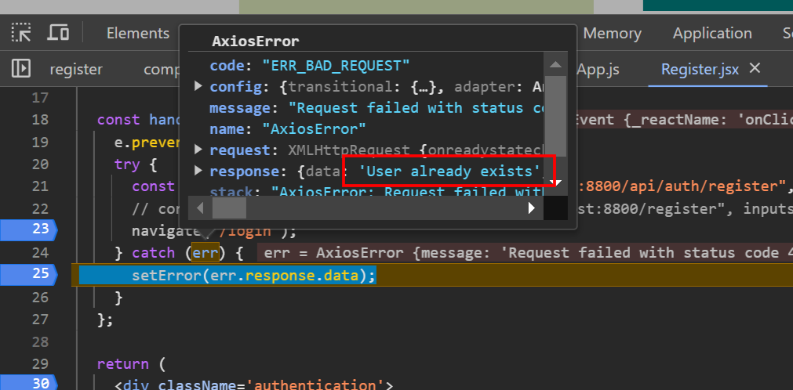

Above response data you can see user already exists

const querySelect = "SELECT * FROM users_table"

It runs above query with that it gets some data when I was testing this issue I didn’t pass username and mailid in select query if data comes return error that user exists this passed to frontned without any issue

**. Another important point: whenever you get an issue try to break into small piece and try to execute this will reduce your time

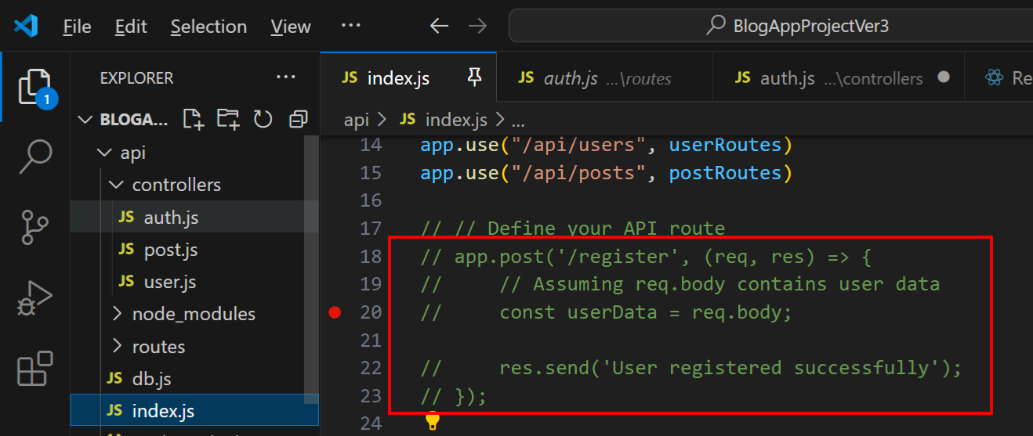

In my backend I uncommented above code kept breakpoint ‘/register’

In front end register page also made post request for only url ‘/register’ so that index.js file app.post will get hit

const handleSubmit = async (e) => {

    e.preventDefault();

    try {

      const response =await axios.post("http://localhost:8800/register", inputs);

      navigate("/login");

    } catch (err) {

      setError(err.response.data);

    }

  };

Like above in browser console for above method kept breakpoint at navigate and

Backend index.js file run and debug: so debug console port will listen to 8800

Now frontend button click make post request it hits index.js /register from there when you send response it directly came to handlesubmit response variable this is how it works

#. Handle user login error client side

In auth.js file register method we receive post req user name and mail there we check in SELECT user already exist if exists we send response to front end

const [err, setError] = useState(null);

above we use useState from react for handling error

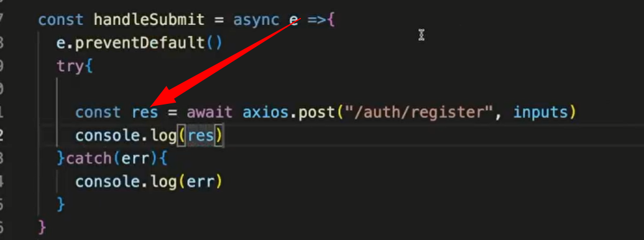

in video also he captures response but I missed it

in our handlesubmit method we use **setError**

<p>This is an error</p>

Now we change above p tag

{err && <p>{err}</p>}

We make like this which will print correct response from backend

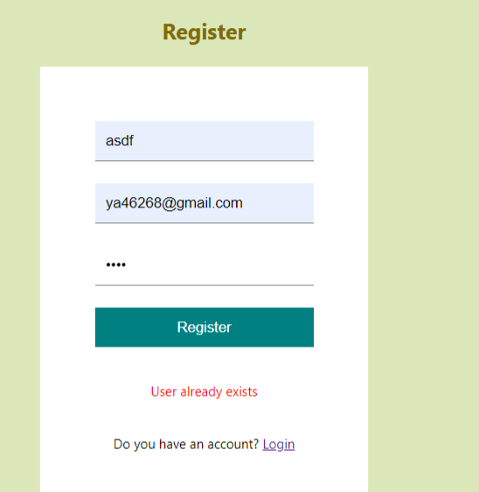

Above is message from backend printed in p tag: **User already exists**

#. User already exists then redirect to login page using react-router-dom usenaviagate hook

const navigate = useNavigate();

above is code for it

const handleSubmit = async (e) => {

    e.preventDefault();

    try {

      const response = await axios.post("http://localhost:8800/api/auth/register", inputs);

      navigate("/login");

    } catch (err) {

      setError(err.response.data);

    }

  };

in handlesubmit code

**navigate("/login");**

we use above which redirects to login

now in above code there is error

**“const response”** this code we added to see response from backend but now if you want to navigate to other page then that time you have to remove **“const response”** or else it’ll block you from going to other page so remove it

But error is not only because of it in my auth.js file I’m running parallely 2 queries SELECT AND INSERT QUERY

If select query returns error means if user does not exist then next insert query will run

But I checked

export const register = (req,res) =>{

    const querySelect = "SELECT * FROM users_table WHERE EMAIL= ? OR USER_NAME=?"

//1//  db.query(querySelect, [req.body.email,req.body.username],(err,data)=>{

//2//     if(err) return res.json(err);

//3//     if(data.length) return res.status(409).json("User already exists");

})

//4// const salt = bcrypt.genSaltSync(10);

//5// const hash = bcrypt.hashSync(req.body.password, salt);

//6// const queryInsert = 'INSERT INTO users_table (user_name, email, password) VALUES (?, ?, ?)';

//7// const values = [req.body.username,req.body.email, hash]

//8//  db.query(queryInsert,values,(err,data)=>{

//9//        if(err) return res.json(err);

//10//        return res.status(200).json("User has been created");

    })

}

Above code I checked with breakpoint **after line1 runs next line4 runs and when line8 runs** after that code goes inside query for SELECT

**MEANS ONCE AFTER RUNNING INSERT QUERY LINE, CODE BREAKPOINT GOES INSIDE SELECT QUERY THAT db.query(querySelect**

ONE MORE ERROR:

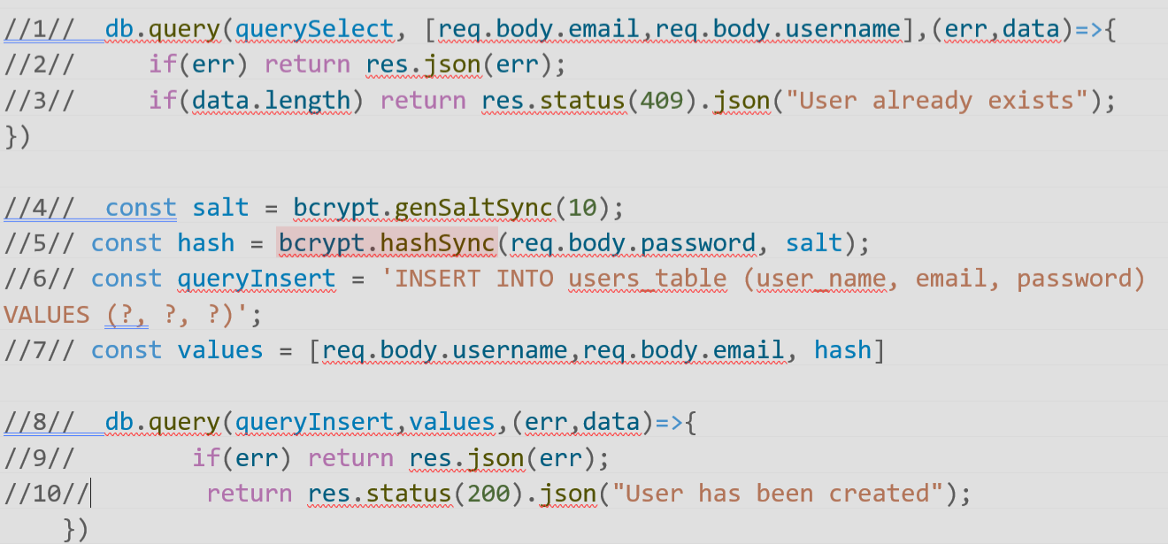

ABOVE image once after **line3** runs breakpoint didn’t stop breakpoint gone to **line9** so when **line9** runs

first app connected

Uncaught Error Error [ERR_HTTP_HEADERS_SENT]: Cannot set headers after they are sent to the client

at setHeader (node:_http_outgoing:659:11)

at header

It throws above error telling correct, once response are sent to client we can’t send response again

That particular error occurs whenever your code attempts to send more than one response to the same request. There are a number of different coding mistakes that can lead to this:

Stackoverflow told above

Means your code is not proper it’s keep trying to send response again and again

Our code should stop in backend once it finds that user already exist it shouldn’t move to insert code

I fixed above error with help of chatgpt:

The issue you're encountering is due to the asynchronous nature of the **db.query** function calls. When you call **db.query**, it initiates a database query, but the code execution continues without waiting for the query to complete. This leads to the subsequent code executing even before the database query finishes.

To address this issue, you can ensure that the insertion code (**db.query** for inserting the user) is executed only when the check for existing users is complete. One way to achieve this is by moving the insertion code inside the callback function of the **db.query** for checking existing users. Here's how you can do it:

It told db.query(SELECT) is async in nature, once it runs it doesn’t wait until SELECT query execution completes, async means without waiting for current it goes for next call db.query(INSERT) with this I was getting header error

So INSERT query method I put inside db.query(SELECT) method this simply solved my issue

export const register = (req, res) => {

    //check user exists: with mail and name

    const querySelect = "SELECT * FROM users_table WHERE EMAIL= ? OR USER_NAME=?"

    db.query(querySelect, [req.body.email, req.body.username], (err, data) => {

        if (err) {

            return res.json(err);

        }

        if (data.length) {

            return res.status(409).json("User already exists");

        }

        //hash the password and create a user

        const salt = bcrypt.genSaltSync(10);

        const hash = bcrypt.hashSync(req.body.password, salt);

        // const queryInsert1 = "INSERT INTO users_table('user_name','email','password')"

        const queryInsert = 'INSERT INTO users_table (user_name, email, password) VALUES (?, ?, ?)';

        const values = [req.body.username,req.body.email, hash]

        db.query(queryInsert, values, (err, data) => {

            if (err) { return res.json(err); }

            return res.status(200).json("User has been created");

        })

    })

}

Code above inside auth.js file

Now if user already exists in front end you’ll see error

If user doesn’t exist already user will be inserted to table also in front end you’ll be **navigated routed to login page**

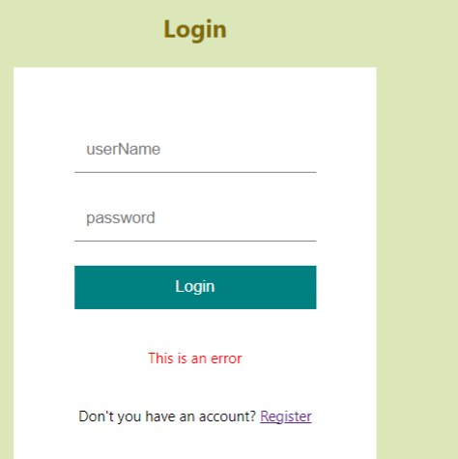

**Above**

**#. Do the same for login page as we did in register page frontend client**

const [inputs, setInputs] = useState({

    username: "",

    email: "",

    password: "",

  });

  const [err, setError] = useState(null);

  const navigate = useNavigate();

  const handleChange = (e) => {

    setInputs((prev) => ({ ...prev, [e.target.name]: e.target.value }));

  };

  const handleSubmit = async (e) => {

    e.preventDefault();

    try {

      await axios.post("http://localhost:8800/api/auth/register", inputs);

      navigate("/login");

    } catch (err) {

      setError(err.response.data);

    }

  };

**Above are** from register.jsx page after that import all other packages

In login page also add p tag for error, add button handlesubmit, also add **onchange**

In login page we don’t need email **name and password** are enough

<div className='authentication'>

      <h1>Login</h1>

      <form>

        <input type='text' placeholder='username' name='username' onChange={handleChange}>

        </input>

        <input type='password' placeholder='password'  name='password' onChange={handleChange}>

        </input>

        <button onClick={handleSubmit}>Login</button>

        {err && <p>{err}</p>}

        <span>Don't you have an account? <Link to="/register">Register</Link>

        </span>

      </form>

    </div>

We updated above html code

Also update axios post request endpoint will be **login**

For post request we’re gonna pass inputs it’s exactly the same

If all are fine with login we’re gonna redirected to **home page**

const handleSubmit = async (e) => {

    e.preventDefault();

    try {

      await axios.post("http://localhost:8800/api/auth/login", inputs);

      navigate("/");

    } catch (err) {

      setError(err.response.data);

    }

  };

Above navigate("/"); means navigate to home page

If you want to receive **response or if you want to see read response in browser add**

Const response = await axios.post…..

**. In auth.js backend which controller we take care about it

Here also first we’re gonna check user exists or not

export const login = (req, res) => {

    //check user

    const querySelect = "SELECT * FROM users_table WHERE USER_NAME=?"

    db.query(querySelect, [req.body.username], (err, data) => {

        if (err)

            return res.json(err);

        if (data.length === 0)

            return res.status(409).json("User not found!");

While checking if data.length is 0 means we don’t have any data with logged in username in our db for that we return an error

Next if we don’t have any error **next we’re going to validate or check password**

Why to check?

**Because in our web app: we’re gonna send plain text password to backend**

And we compare this password with password present in db

**. How to compare password using bcryptjs documentation

<https://www.npmjs.com/package/bcryptjs>

above link if you go little down scroll

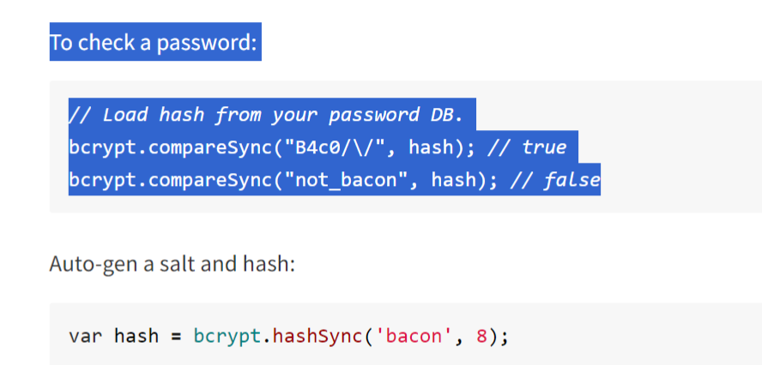

We use comparesync function above in place of “B4c0” we pass our password

Where **hash** is password from db

So we compare front end password with password present in db

//check password

const isPasswordCorrect = bcrypt.compareSync(req.body.password,data[0].password);

        if(!isPasswordCorrect) return res.status(400).json("Wrong username or password");

We do like above using bcrypt package

data[0].password: this is password from db, as data will be in dictionary object format from there we fetch password

**with all above is everything okay we’re logged in**

but he told we’re not gonna send user information, we use **localstorage in browser**

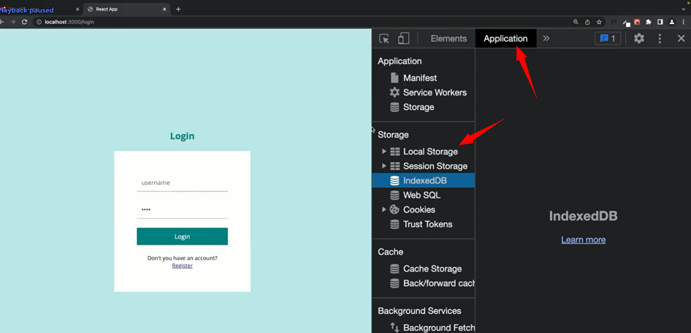

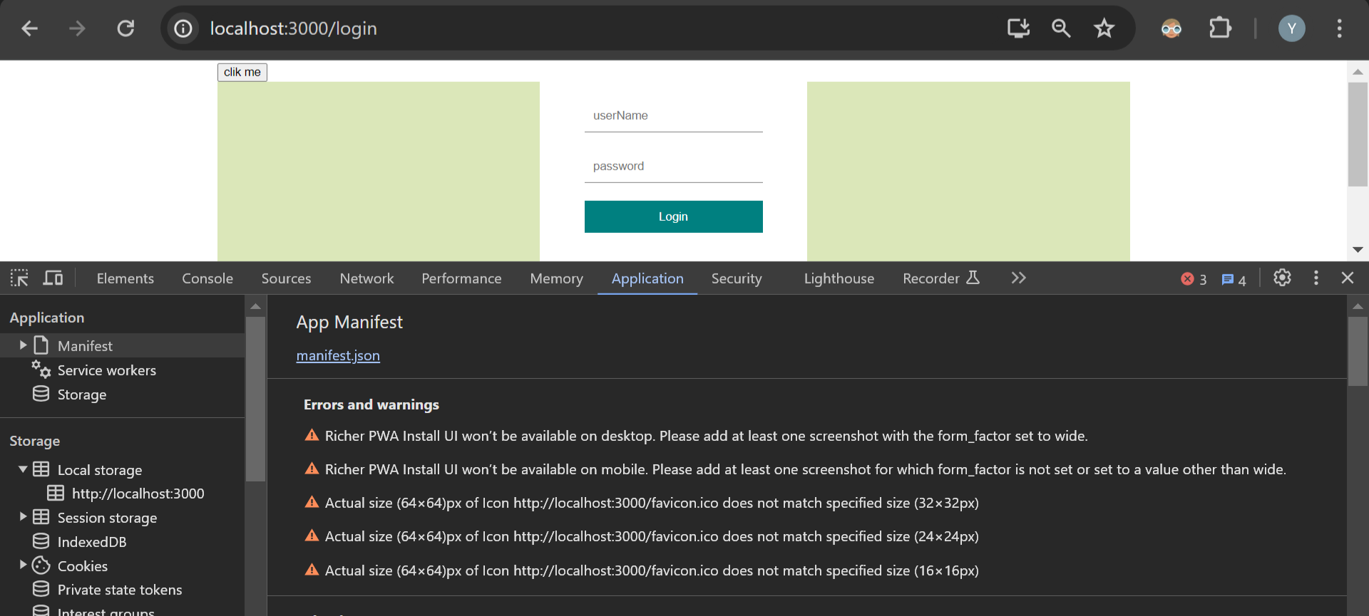

**. **He told why to use jwt json web token he told to watch his video on it**

**Later** in this session he told: we’re gonna update delete posts

But we shouldn’t able to delete or alter other user’s posts to provide that security we use json web token

So now he added package jsonwebtoken

#. Using jwt jsonwebtoken for signin

**Jwt.sign()** for this sign we should send user information that identifies us

In our db users_table our userid **is unique**

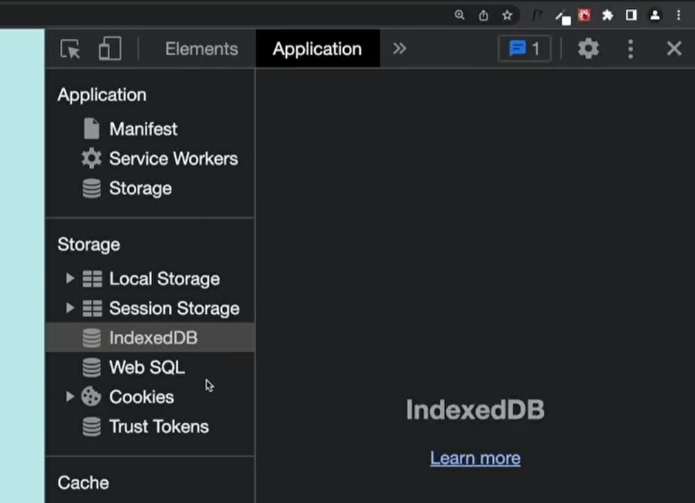

**He told**  const token = jwt.sign({id:data[0].id})

**Above** token we’re gonna store in browser cookie

After having jsonwebtoken now if we want to change any posts

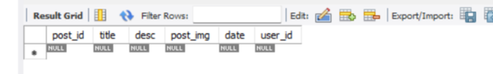

Our posts table has unique user_id our jsonwebtoken will also know which user logged in so logged in user can delete only his post with that

This is how we achieve

He told to provide secret key for jwt token

He told we can generate random key and store it in file

Next we send this **token info to cookie**

**So now we need library cookie-parser** we install it

**#. Our index.js file is like middleware where all request comes first there we use cors etc..**

That’s why in index.js file we use cors,express.json

Now we use also cookie parset in our middleware index.js file

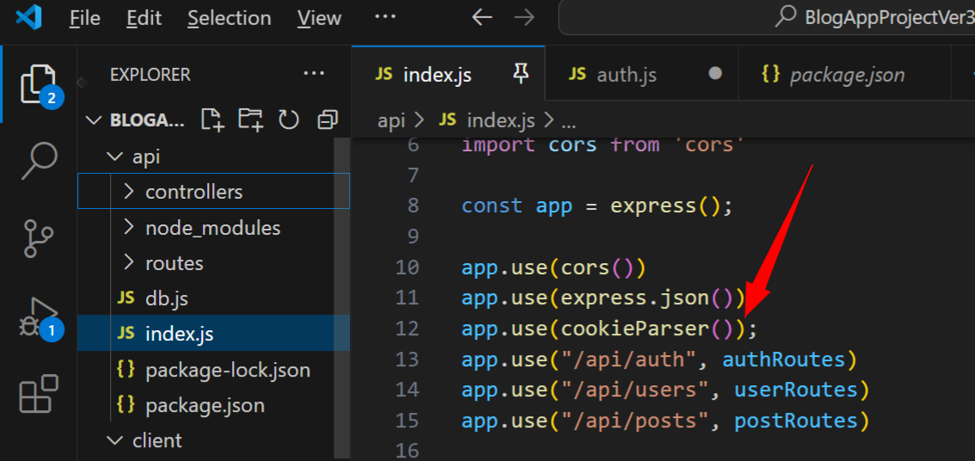

We used above

res.cookie("access_token", token,{

            httpOnly:true

        })

Above access_token name of cookie, token is our token from jsonwebtoken

For more security we add httponly true

**He told any external script in our frontend textboxes in browser or from url cannot reach**

**Or from browser application cannot react our access_token** cookie directly

Only **via api request we can reach our cookie**

 res.cookie("access_token", token,{

            httpOnly:true

        }).status(200).json(data[0])

He told above code will send status 200 and json we are sending entire data to cookie including our encrypted hashed password which is saved in db

We shouldn’t anyways send password to cookie which isn’t good

So what we do: we take only specific info from data

*. Separating password and other data from an object

 const{password, ...other} = data[0];

above he told we separate password and other info from data and we send only other data to json

const{password, ...other} = data[0];

        res.cookie("access_token", token,{

            httpOnly:true

        }).status(200).json(other)

With above we send only other info to json

export const login = (req, res) => {

    //check user

    const querySelect = "SELECT * FROM users_table WHERE USER_NAME=?"

    db.query(querySelect, [req.body.username], (err, data) => {

        if (err)

            return res.json(err);

        if (data.length === 0)

            return res.status(409).json("User not found!");

        //check password

        const isPasswordCorrect = bcrypt.compareSync(req.body.password,data[0].password);

        if(!isPasswordCorrect) return res.status(400).json("Wrong username or password");

        //store it in cookie of browser

        const token = jwt.sign({id:data[0].id})

        const{password, ...other} = data[0];

        res.cookie("access_token", token,{

            httpOnly:true

        }).status(200).json(other)

    })

}

Above is code for login, generating token for logged in user so that he can’t delete other’s posts,

After that sending to browser cookie user info

#. Some credentials test data here: name and passwords

test1 [test1@gmail.com](mailto:test1@gmail.com) password:1234

test2 [test2@gmail.com](mailto:test2@gmail.com) password:test21234

while running login code :

that is tried to login: test1 user

const token = jwt.sign({id:data[0].id})

above line I got this error

C:\Program Files\nodejs\node.exe .\api\index.js

first app connected

Uncaught Error Error: secretOrPrivateKey must have a value

at module.exports (d:\yadu folder\react projects\BlogAppProjectVer3\api\node_modules\jsonwebtoken\sign.js:111:20)

above error

data[0].id

got it is wrong in db it’s user_id

 const token = jwt.sign({id:data[0].user_id},"jwtkey")

above I forgot to pass jwtkey

1:26

email:'test1@gmail.com'

user_id:15

user_img:null

user_name:'test1'

[[Prototype]]:Object

In **other variable we have above info**

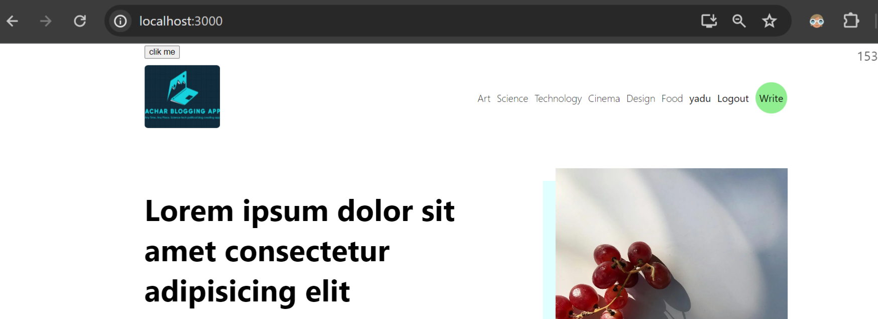

As we can see now we’re naviagated to home page

Now check **cookies**

**Again** issue in browser cookies didn’t come from backend

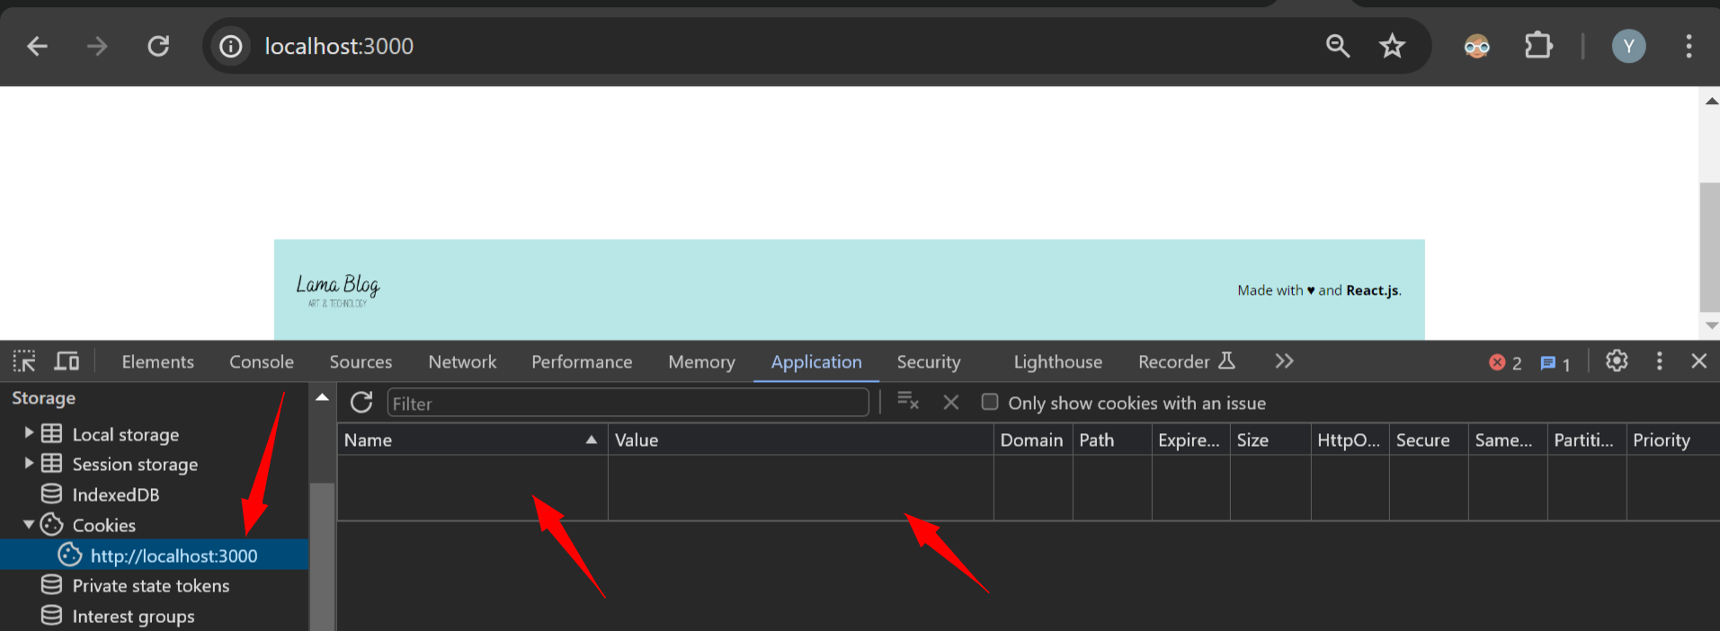

Backend

I run code from youtube code github original code there also cookie didn’t com

**Around time 1:24**

**\*. Tested** post request code for sending cookies working fine in apidog apitester

app.post('/payment', (req, res) => {

    const { username, password } = req.body;

    // Mock authentication logic (replace with your actual authentication logic)

    const user = users.find(u => u.username === username && u.password === password);

    if (!user) {

        return res.status(401).json({ message: 'Invalid username or password' });

    }

    // Generate JWT token

    const token = jwt.sign({ userId: user.id }, JWT_SECRET, { expiresIn: '1h' });

    // Set token as a cookie

    res.cookie('accessToken', token, { httpOnly: true, domain: 'localhost', path: '/' });

    console.log('Cookie set:', token);

    res.json({ message: 'Login successful' });

});

Code from test app run and debug above in backend

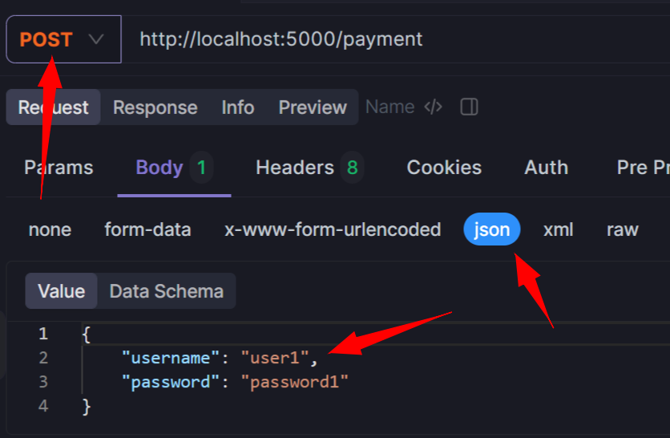

When I do post request here it directly hits my backend post request from backend res.cookies will send cookies

So

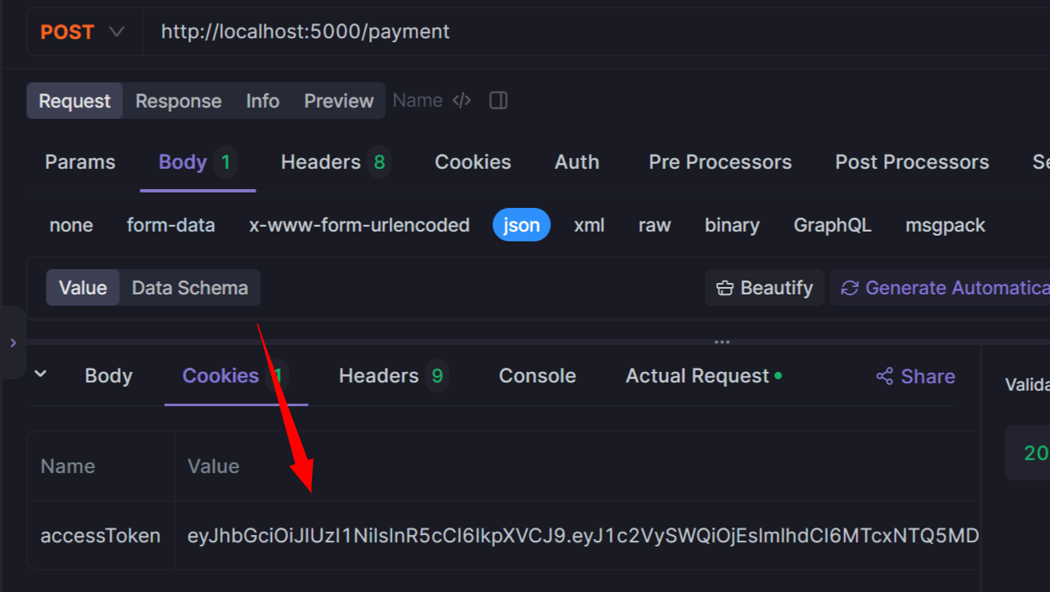

Above I got my accesstoken without any error

#. **Sending cookies to browser issue solved with test application**

send jwt token to browser cookie using cookie parser and express js nodejs give me simple frontend backend example using both post and get request from frontend for login which goes to backend and backend will send cookie to browser and in frontend use axios for making post and get request

I searched above on google

I got stackoverflow link

<https://stackoverflow.com/questions/36824106/express-doesnt-set-a-cookie>

don’t ignore a piece of information

var headers = new Headers();

headers.append('Content-Type', 'application/json');

headers.append('Accept', 'application/json');

return fetch('/your/server_endpoint', {

method: 'POST',

mode: 'same-origin',

redirect: 'follow',

credentials: 'include', // Don't forget to specify this if you need cookies

headers: headers,

body: JSON.stringify({

first_name: 'John',

last_name: 'Doe'

})

})

Above in above stackoverflow link they mentioned or used **fetch for setting cookie**

use fetch in a client-side code. If you do not specify credentials: 'include' in fetch options, cookies are neither sent to server nor saved by a browser, although the server response sets cookies.

Above

I mean that post in stackoverflow was solution for solving cookie issue when using fetch but **same credentials:include solution I tried to set for my express,nodejs,cookieparser,axios app it worked**

Same above link

**24**

Struggling with this for a 3h, and finally realized, with axios, I should set withCredentials to true, even though I am only receiving cookies.

axios.defaults.withCredentials = true;

above post I got from stackoverflow

in that one post told that we need to maintain credentials **while sending cookie**

**this word I** searched in **chatgpt**

**it gave me good code**

credentials: 'include' how to pass this while setting and sending cookies to browser

searched like above in chatgpt

To include credentials (such as cookies) in a cross-origin request made by Axios, you can set the **withCredentials** option to **true**. This option ensures that cookies are included in the request when making cross-origin requests.

Here's how you can modify your Axios request to include credentials:

javascript

Copy code

document.getElementById('loginForm').addEventListener('submit', async function(event) { event.preventDefault(); const formData = new FormData(this); const data = { username: formData.get('username'), password: formData.get('password') }; try { const response = await axios.post('/login', data, { withCredentials: true // Include credentials (cookies) }); alert(response.data.message); window.location.href = '/protected'; } catch (error) { alert(error.response.data.message); } });

By setting **withCredentials: true**, Axios will include cookies in the request headers when making cross-origin requests, allowing your backend to set cookies in the browser.

Additionally, on the server-side, ensure that your CORS configuration allows credentials (cookies) to be included in cross-origin requests. You can set the **credentials** option to **true** in your CORS middleware configuration:

javascript

Copy code

const cors = require('cors'); app.use(cors({ origin: 'http://example.com', // Replace with your frontend URL credentials: true // Allow credentials (cookies) }));

With this setup, both the frontend and backend are configured to allow and include cookies in cross-origin requests, ensuring that cookies are properly set in the browser.

Above is chatgpt prompt

According to it I changed my code in frontend and in backend

function App() {

  const [inputs, setInputs] = useState({

    username: "user1",

    password: "password1",

  });

const handleClick = async (product)=>{

  const response = await axios.post("http://localhost:5000/payment", inputs, {

    withCredentials: true // Include credentials (cookies)

});

  var hi = "";

  alert(response);

}

Above frontend code app.js while making post request

And above backend code receiving post request and sending cookie setting cookie in browser

app.use(cors({

    origin: 'http://localhost:3000',

    credentials: true // Allow credentials (cookies)

}));

Index.js file backend file first I have set credentials

import express from 'express'

import cors from 'cors'

import jwt from 'jsonwebtoken'

import cookieParser  from 'cookie-parser'

const app = express();

// app.use(cors())

app.use(cors({

    origin: 'http://localhost:3000',

    credentials: true // Allow credentials (cookies)

}));

app.use(express.json())

app.use(cookieParser());

const JWT_SECRET = 'your_jwt_secret';

// Mock user data (replace this with your authentication logic)

const users = [

    { id: 1, username: 'user1', password: 'password1' },

    { id: 2, username: 'user2', password: 'password2' }

];

// Login route

app.post('/payment', (req, res) => {

    const { username, password } = req.body;

    // Mock authentication logic (replace with your actual authentication logic)

    const user = users.find(u => u.username === username && u.password === password);

    if (!user) {

        return res.status(401).json({ message: 'Invalid username or password' });

    }

    // Generate JWT token

    const token = jwt.sign({ userId: user.id }, JWT_SECRET, { expiresIn: '1h' });

    // Set token as a cookie

    res.cookie('accessToken', token, { httpOnly: true, domain: 'localhost', path: '/' });

    console.log('Cookie set:', token);

    res.json({ message: 'Login successful' });

});

app.listen(5000, ()=>{

    console.log('first app connected');

})

Later sending cookie code

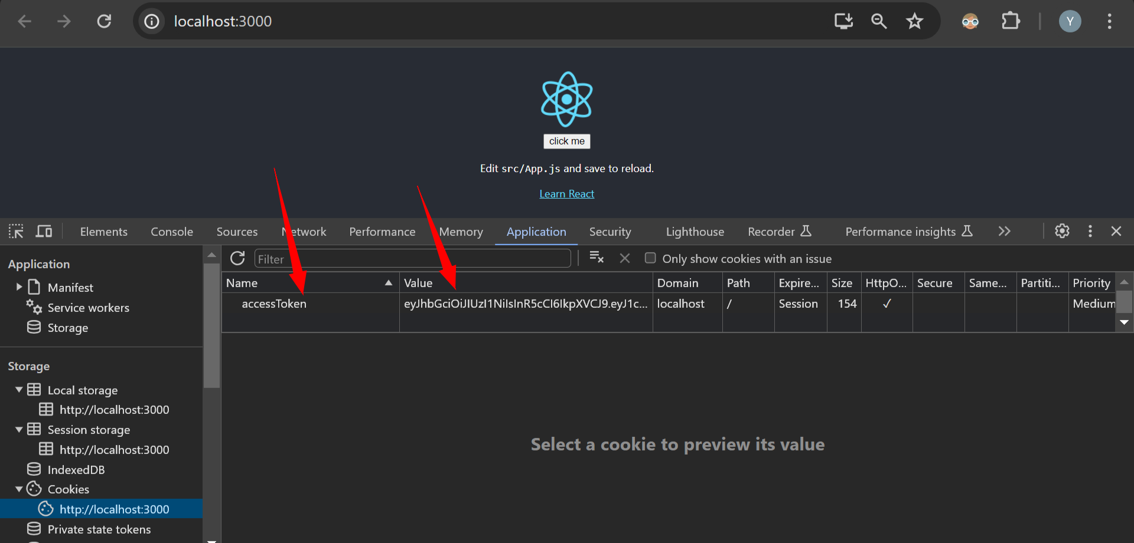

Now when I checked in browser cookies set

#. **I referred youtube code 2 years old code within that if I download and run youtube code for this blog-app from github it doesn’t run there are lot of changes happened mysql2, using credentials for setting cookies. Without loosing patience you have to do Research search in stackoverflow,chatgpt google other blogs try all possible ways without quit**

**Every other ideas also**

**You have to explore:** I’m using cookieparser,jwt,express,nodejs,axios for making post request,sending jwt token,setting cookie

But in stackoverflow they solved issue for fetch library with **credentials include same I tried to apply for axios and cors with help of chatgpt**

Check every blog check all different possible ways to solve issues

Because if you stop trying when you’re stuck not doing research on google you’ll always stuck there itself

Code package version they keep updating so 1 year old code will not work today either check documents or stackoverflow blos

<https://medium.com/@ethantcollins98/setting-and-using-cookies-with-a-node-js-express-server-49479673d043>

in this blog also they mentioned to

"Access-Control-Allow-Credentials": "true"

Use credentials like above

We need to set **credentials both frontend axios and backedn for middleware cors**

**Or else** it doesn’t work

I tested like that in front end removed credentials code

In backend removed cors credentials code

app.post('/payment', (req, res) => {

    const { username, password } = req.body;

    // Mock authentication logic (replace with your actual authentication logic)

    const user = users.find(u => u.username === username && u.password === password);

    if (!user) {

        return res.status(401).json({ message: 'Invalid username or password' });

    }

    // Generate JWT token

    const token = jwt.sign({ userId: user.id }, JWT_SECRET, { expiresIn: '1h' });

    // Set token as a cookie

    res.cookie('accessToken', token, { httpOnly: true, domain: 'localhost', path: '/' });

**res.setHeader('Access-Control-Allow-Credentials', 'true');**

**res.json({ message: 'Login successful' });**

});

But added res.setheader

Now opened 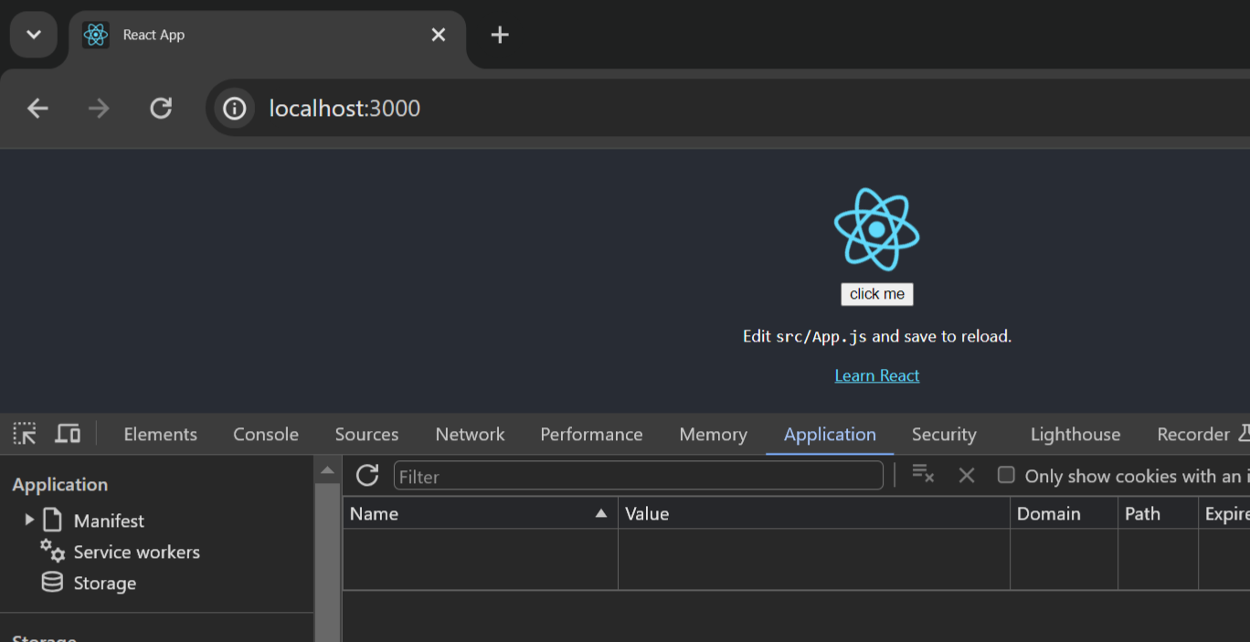

Browser in private window because in normal window I can’t test as you’ve remove older cache storage because of cache even after closing browser I saw same accesstoken but in private window cache will not be saved

So I need to set credentials both in axios frontend and cors in backend

Continue adding code in blog-app project

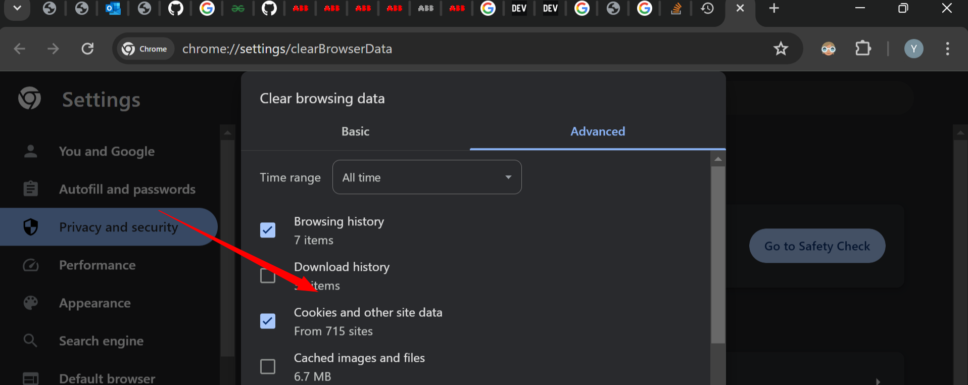

To delete cookies click on above

In login.jsx file

const handleSubmit = async (e) => {

    e.preventDefault();

    try {

      await axios.post("http://localhost:8800/api/auth/login", inputs

      , **{withCredentials: true}////**with this code cookies will be set in browser application->storage->cookies

      );

      navigate("/");

    } catch (err) {

      setError(err.response.data);

    }

  };

Added above code

In index.js file

app.use(cors({

    origin: 'http://localhost:3000',

    credentials: true // Allow credentials (cookies)

}));

Added above code

And in auth.js file changed code

export const login = (req, res) => {

    //check user

    const querySelect = "SELECT * FROM users_table WHERE user_name=?"

    db.query(querySelect, [req.body.username], (err, data) => {

        if (err)

            return res.json(err);

        if (data.length === 0)

            return res.status(409).json("User not found!");

        //check password

        const isPasswordCorrect = bcrypt.compareSync(req.body.password,data[0].password);

        if(!isPasswordCorrect) return res.status(400).json("Wrong username or password");

        //store it in cookie of browser

        const token = jwt.sign({id:data[0].user_id},"jwtkey",{expiresIn:"1h"});

        const{password, ...other} = data[0];

        res.cookie("accessToken", token, { httpOnly: true, domain: 'localhost', path: '/' });

        res.send('Token sent as a cookie!');

        // .status(200).json(other)

    });

}

Like above

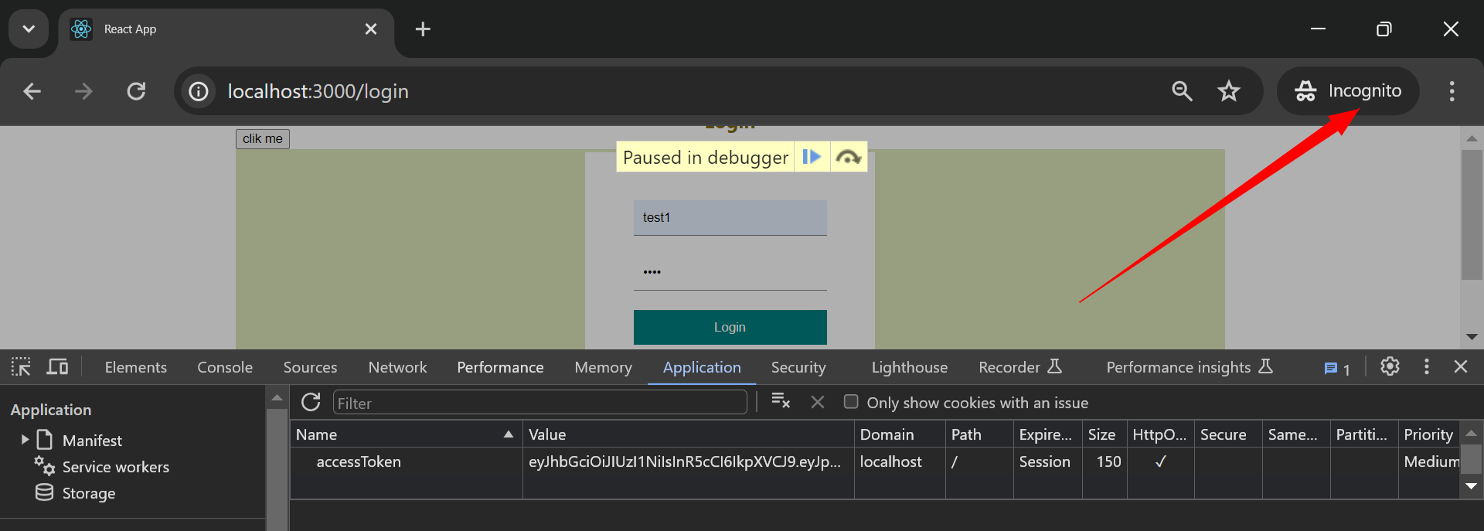

Now in private window I got accesstoken

1:26 time

Value is hashed token which is userid

Now we also have to store userinfo in localstorage we gonna use them in **navbar or in any post**

If we want to create any new post that time also we need **userid**

We need userinfo in any other component so we store userinfo in common place

**#. Store userinfo in localstorage using state manage tools**

we gonna use userinfo in **navbar or in any post**

If we want to create any new post that time also we need userinfo

So many place we need we store them in common place

So we use **react context api**

**Inside** frontend client -> src folder->create context folder inside that create file

**authContext.js**

import { createContext } from "react";

export const AuthContext = createContext();

**after** above code we create contextprovider

why we do above?

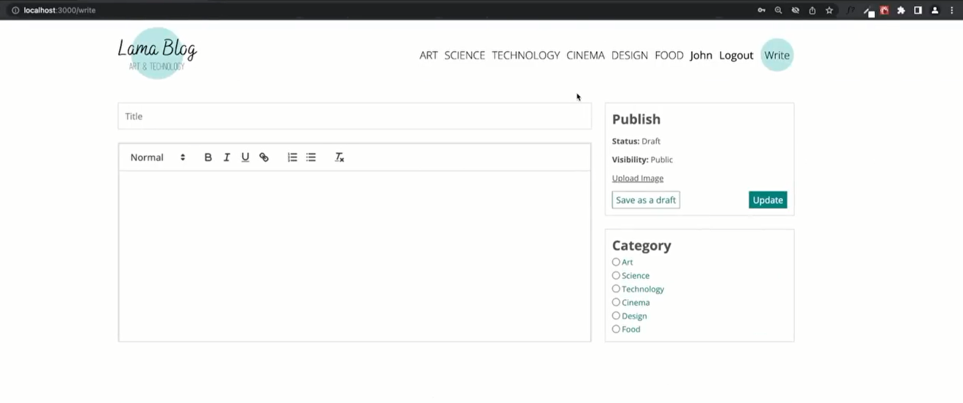

Because we need userinfo in multiple components: while creating new post, inside a post for buttons like to edit delete, for navbar, for write page

So we’re gonna save userinfo **inside AuthContext**

He told like: if we create contextprovider inside authContext.js file

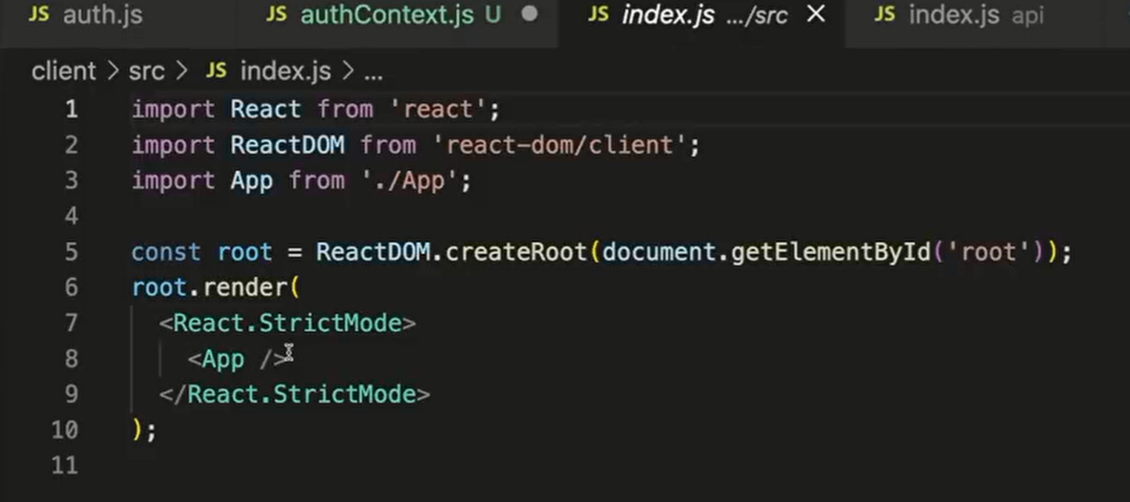

Then he told we can wrap our provide in frontend index.js file

Then we can useour **userState anywhere** in our application

export const AuthContextProvider = ({children})=>{

}

Above we pass children represents our components that we want to wrap with contextprovider

He told in our case 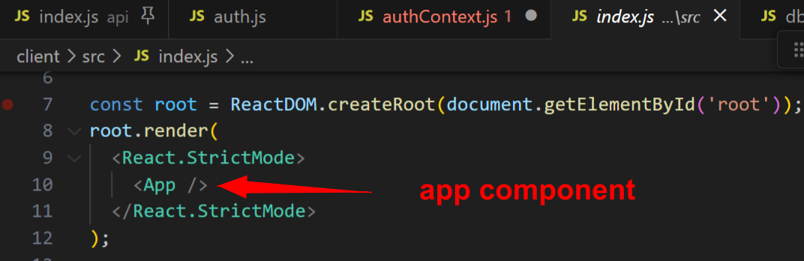

Next inside contextprovider we create usestate hook

const [currentUser, setCurrentUser] = useState()

So next we check: in browser **application ->storage ->localstorage** here if we have any user we’ll use it

If there are no user means we’re not loggedin

To do that we use localhost.getitem

But I want to convert all userinfo into object

const [currentUser, setCurrentUser] = useState(JSON.parse(localStorage.getItem("user") || null))

above code for localstorage

**. Create login function: instead of axios login url in login.jsx page

Login function: inside authContext.js

export const AuthContextProvider = ({ children }) => {

    const [currentUser, setCurrentUser] = useState(JSON.parse(localStorage.getItem("user") || null))

    const login  = async(inputs)=>{

        const response = await axios.post("http://localhost:8800/api/auth/login", inputs

      , {withCredentials: true}////with this code cookies will be set in browser application->storage->cookies

      );

**setCurrentUser(response.data);**

    }

}

Above we can see login method inside login url is there from login response we get back user info current user that we pass setcurrentuser

In backend controller->auth.js file we send userinfo

After login one more method we write for logout

On logout our setcurrentuser as null

**. Now question is inside authcontext we have current user as usestate

But **how to update localstorage each time we change the user**

**For** that we use **useeffect**

Inside useeffect hook we set localstorage we pass user and but this time we transform our object to string

    useEffect(()=>{

        localStorage.setItem("user",JSON.stringify(currentUser));

    },[currentUser])

Above is code

Finally we are gonna return authcontext provider

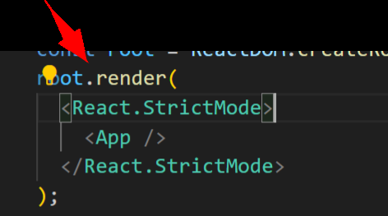

Which looks some thing like above

He told for provider we pass our {**children}** which is app.js

<AuthContext.Provider>{children}</AuthContext.Provider>

above{**children}** is app.js

we can pass any state to provider we pass currentuser state we can also pass function like login or logout

  <AuthContext.Provider value={{currentUser,login,logout}}>

        {children}

        </AuthContext.Provider>

He told we can use this login logout currentuser anywhere in our app

**We have to route our app inside index.js file**

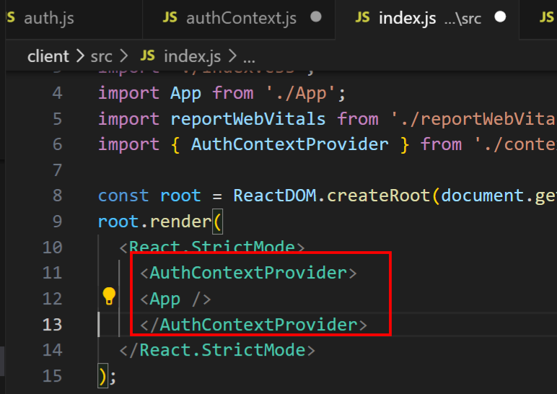

**Like** above we route our app inside index.js file

Now using **AuthContext** we start using **currentUser login,logout in** other place

import { AuthContext } from '../context/authContext';

  const {currentUser} = useContext(AuthContext);

console.log(currentUser);

we

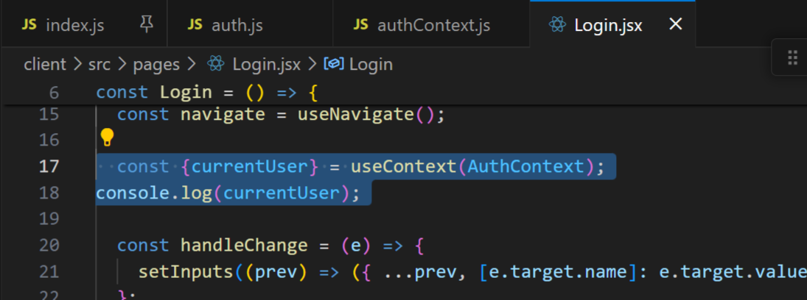

do console log

I think there is again an issue some thing not working: page is looking white or blank

Some of mistakes found while

Didn’t put bracket while returning in authcontext

 return (

    <AuthContext.Provider value={{currentUser,login,logout}}>

        {children}

        </AuthContext.Provider>

    );

Above () I missed after putting it all thing worked

Currentuser we try to console.log print in browser

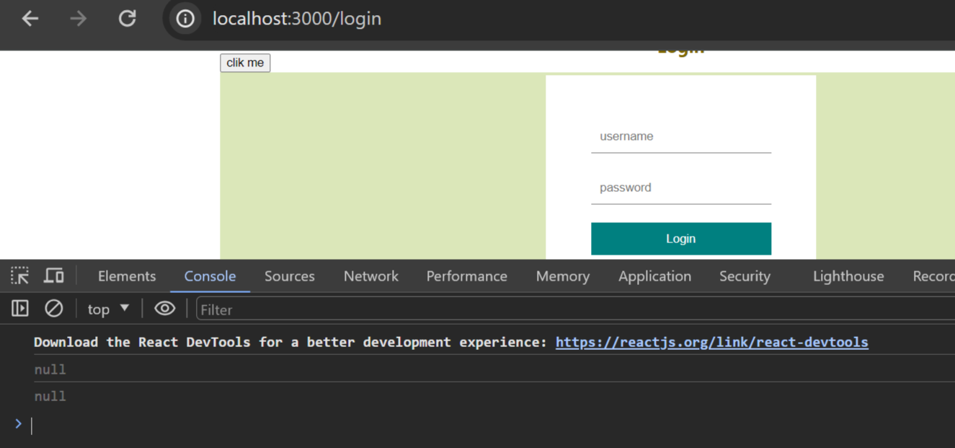

But we got printed null twice

  const {currentUser} = useContext(AuthContext);

console.log(currentUser);

for above code

now as soon as you type in username and password many null will be printed on browser console

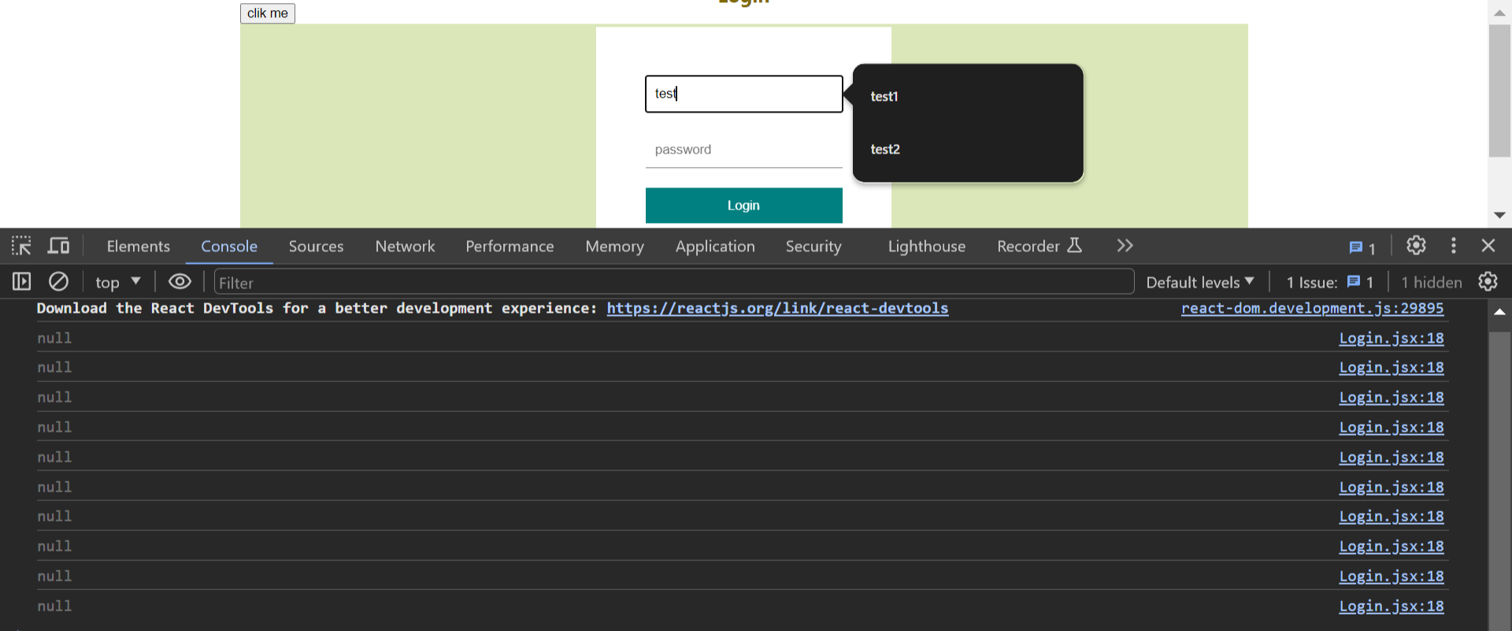

Even if you type password null will be printed

We didn’t call our login function **inside handlesubmit method**

Inside login.jsx handlesubmit method call login method pass inputs

  const {login} = useContext(AuthContext);

We remove currentuser inplace of it we put login

const handleSubmit = async (e) => {

    e.preventDefault();

    try {

      // const response = await axios.post("http://localhost:8800/api/auth/login", inputs

      // , {withCredentials: true}////with this code cookies will be set in browser application->storage->cookies

      // );

      //above login url moved to authcontext.js file below we use login method

**await login(inputs);**

      navigate("/");

    } catch (err) {

      setError(err.response.data);

    }

  };

Call login method like above

Now if you try to login in browser in **browser->application->storage->localstorage we see our userinfo object**

**Like above**

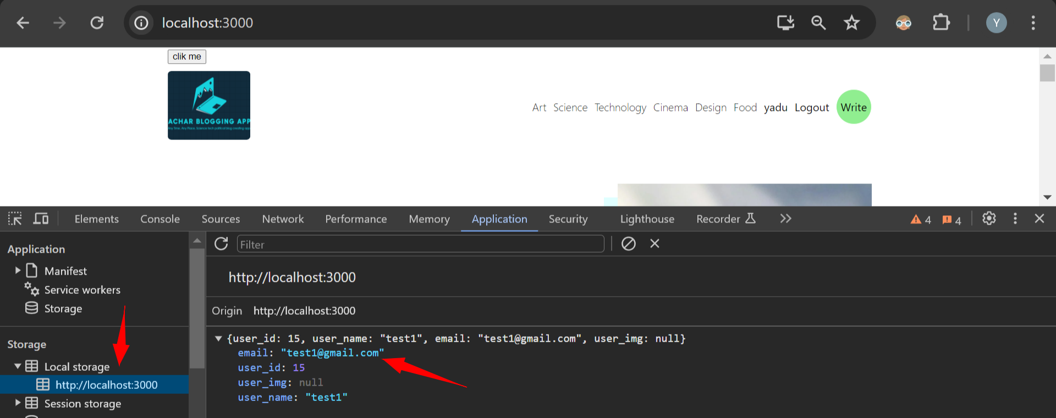

**#. Using currentuser info we update navbar**

Go to navbar

We make use of **AuthContext** every where common

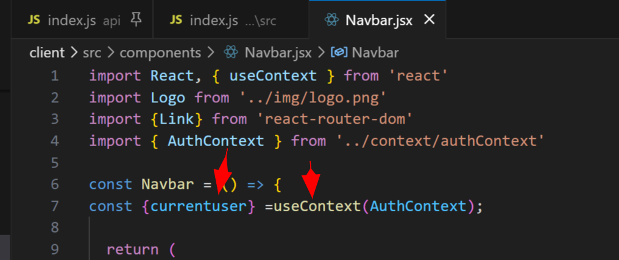

const {currentuser} =useContext(AuthContext);

above

 <span>{currentUser?.user_name}</span>

Above if currentuser exists prints his username

Where user_name is db column name

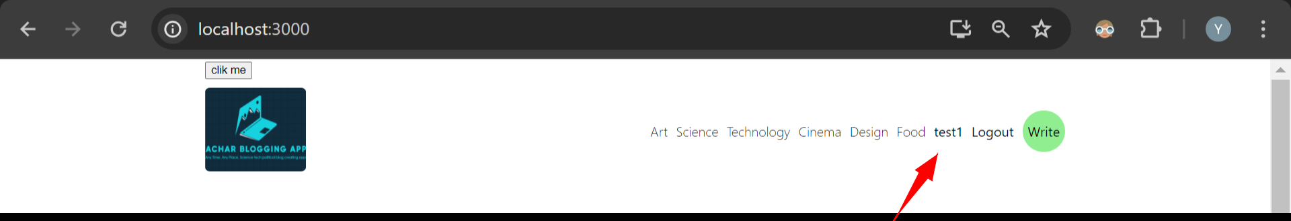

With this my username is coming in navbar

#. **Logout button functionality**

Next we can add condition if user_name is there then we can show **logout button**

And on click on that we can call logout function

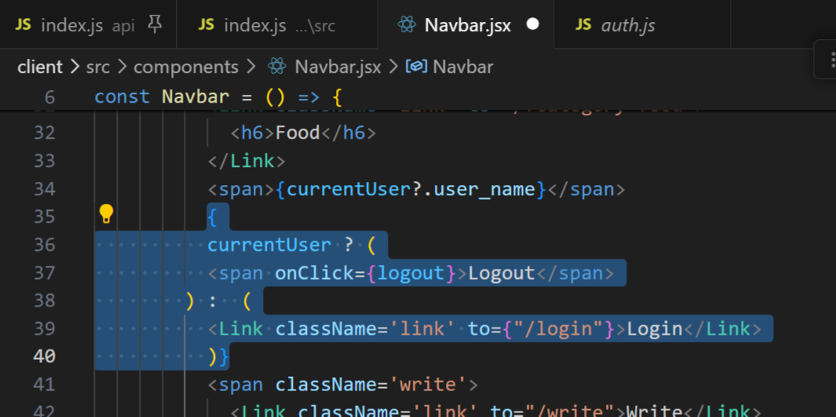

{

          currentUser ? (

          <span onClick={logout}>Logout</span>

        ) :  (

          <Link className='link' to={"/login"}>Login</Link>

          )}

We add logout code like above

Above says: if currentuser is there then show logout button, else currentuser not there means show **login** button

On click **logout button: we make currentuser null in authcontext.js file**

We make currentuser null at **the same time we logout from backend server**

#. **Logout from backend and frontend**

**Go to** controller->auth.js file

Write method for logout

export const logout = (req, res) => {

    res.clearCookie("access_Token",{

        sameSite:"none",

        secure:true

    }).status(200).json("User has been logged out")

}

Above code

Frontend inside **authcontext.js**

const logout = async (inputs) => {

        await axios.post("http://localhost:8800/api/auth/logout");

        setCurrentUser(null);

    }

**We make post request after that** make currentuser as null

Faced issue cookie didn’t removed from browser application->storage->cookies

**While working with cookies always test in private browser window because in normal browser cookies won’t be deleted after closing browser**

**While** doing logout **userinfo is deleted in browser but cookies won't be deleted**

Res.clearcookie doesn’t work

Res.clearcookie is a strange issue

I checked lot of stackoverflow blogs for solving this issue none of them worked

But finally I asked with chatgpt: fetch cookie from browser and send it to backend using axios using post request and delete cookie in backend using express nodejs cookie parser

Axios needs: **{ withCredentials: true }** for sending cookies to backend or else cookies won’t send

const cookie = document.cookie;

// Send cookie to backend

axios.post('/api/cookie', { cookie })

.then(response => {

console.log('Cookie sent to backend successfully');

})

.catch(error => {

console.error('Error sending cookie to backend:', error);

});

Chatgpt gave above code

const cookie = document.cookie;

even above cookie is “” empty because it’s not safe to send cookie from browser

even though is empty I sent it via axios to backend

some miracle happened even while sending this empty cookie from client frontend to backend

now in backend

I hovered over **req.cookies this has cookie exactly.**

**I kept** breakpoint in backend auth.js file for logout

complete:true

connection:ƒ () {\r\n return this.socket;\r\n }

cookies:{access_Token: 'eyJhbGciOiJIUzI1NiIsInR5cCI6IkpXVCJ9.eyJpZ…jAkbgUyXQTtCyIR3uc09MjMxChErh-VWWhih8NBt0'}

When I hovered over req I saw above

await axios.post("http://localhost:8800/api/auth/logout"

           , { withCredentials: true }

        );

When I sent post request for logout with above code with document.cookie I checked breakpoint in auth.js file for req

complete:true

connection:ƒ () {\r\n return this.socket;\r\n }

cookies:{ }

It was like above

await axios.post("http://localhost:8800/api/auth/logout"

            , { cookieValue }, { withCredentials: true }

        );

With above code I sent document.cookie even though it’s empty to backend

Now res.clearcookie worked perfectly fine it even deleted cookie from browser.

Code for delete cookie

const cookieValue = document.cookie.replace(/(?:(?:^|.*;\s*)access_Token\s*\=\s*([^;]*).*$)|^.*$/, "$1");

        await axios.post("http://localhost:8800/api/auth/logout"

            , { cookieValue }, { withCredentials: true }

        );

Front end authcontext.js file post request with logout

Backend auth.js file

export const logout = (req, res) => {

    // const { cookieValue } = req.body;

    res.clearCookie('access_Token', {httpOnly: true});

    res.end().status(200)

    .json("User has been logged out");

Code above for delete a cookie

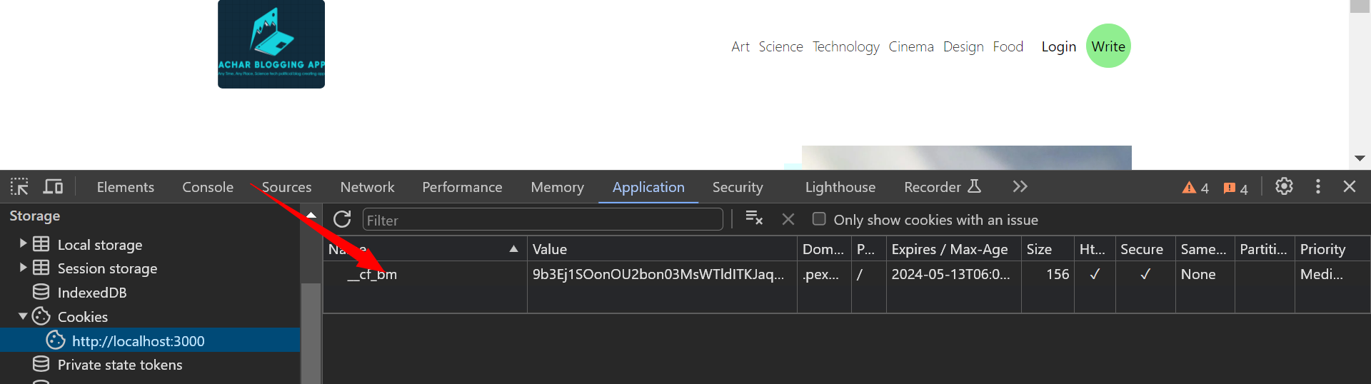

My access_token cookie is deleted above is not my cookie so code worked without error

#. **Handle posts**

Go to api->routes->posts.js file

Whenever you make api call your call will first come to routes->posts.js file

From here call goes to controller->posts.js file we handle api inside controller

Create express router after that we make get api request to get posts

router.get("/",)

router.get("/:id",)

router.post("/",)

router.delete("/:id",)

router.update("/:id",)

we create routes api for all get all posts, get posts with id, for delete for update we create routes inside posts.js file

import express from 'express'

const router = express.Router();

router.get("/",)

router.get("/:id",)

router.post("/",)

router.delete("/:id",)

router.update("/:id",)

export default router

above is posts.js file

next we create controller for posts

controller->posts.js file

export const getPosts = (req,res)=>{

    res.json("from post controller: this is post")

}

export const getPost = (req,res)=>{

    res.json("from post controller: this is post")

}

export const addPost = (req,res)=>{

    res.json("from post controller: this is post")

}

export const deletePost = (req,res)=>{

    res.json("from post controller: this is post")

}

export const updatePost = (req,res)=>{

    res.json("from post controller: this is post")

}

we have above

next above method names we import it to **routes->posts.js file and use them inside route**

import express from 'express'

import { addPost, deletePost, getPost, getPosts, updatePost }

from '../controllers/post';

const router = express.Router();

router.get("/",getPosts)

router.get("/:id",getPost)

router.post("/",addPost)

router.delete("/:id",deletePost)

router.update("/:id",updatePost)

export default router

**like** above we import and use them

**next we go inside controller->post.js and write our query over there**

for getposts: SELECT ALL FROM POSTS

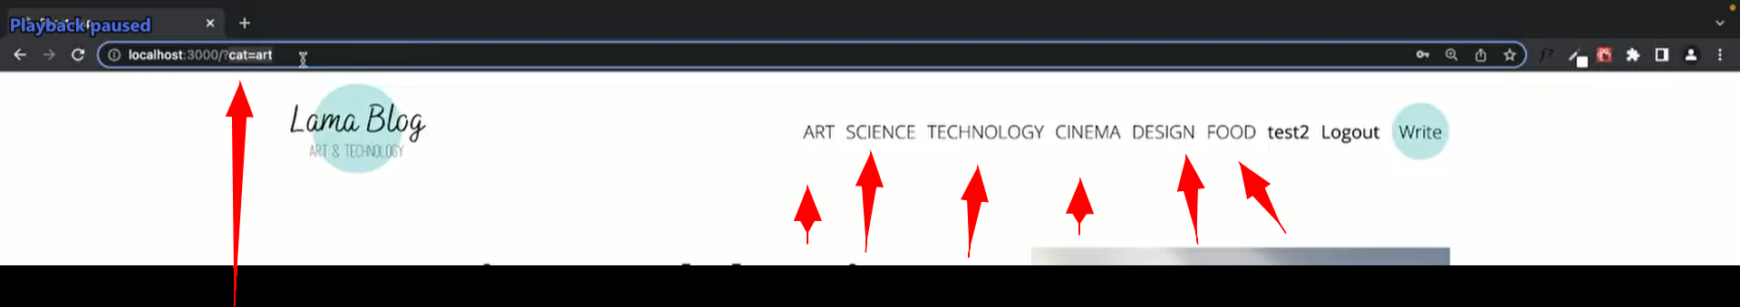

THERE is one more thing in our page we have different categories also in url we’re making **query for category also**

**So** in our code we need to do like: **check first if there is a** category **or not,**

**If there is a** category **then pass that** category **to db and fetch related** category **data**

In db posts_table **we don’t have** category column

So we add it in mysql

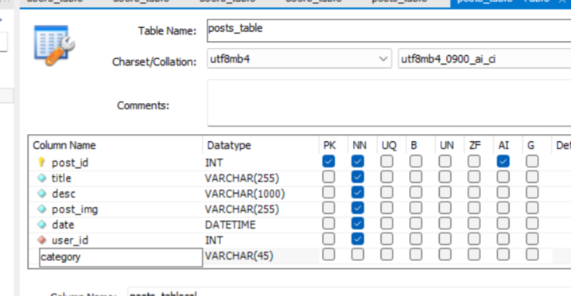

Above

So now how to pass **category** from frontend app to controller->posts.js file

That is **req.query.category**

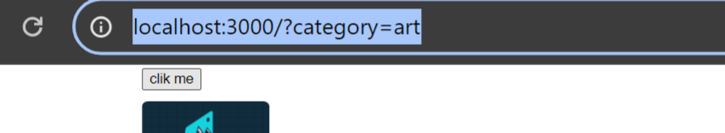

**above**

**req**.query.category will directly take category from our url itself and from there we can take in backend file

***. INSIDE POSTS.JS FILE

 const query = req.query.category

    ? "SELECT * FROM POSTS_TABLE WHERE CATEGORY=?"

    : "SELECT * FROM POSTS_TABLE"

Above is **if else: if we have category then search with that or else** select all posts from table

export const getPosts = (req, res) => {

    const query = req.query.category

        ? "SELECT * FROM POSTS_TABLE WHERE CATEGORY=?"

        : "SELECT * FROM POSTS_TABLE"

    db.query(query, [req.body.category], (err, data) => {

        if (err) {

            return res.json(err);

        }

        return res.status(200).json(data);

    })

}

Above is code for gettingposts

Now we go to **client folder** frontend **home.jsx file**

We know earlier we used dummy data in home

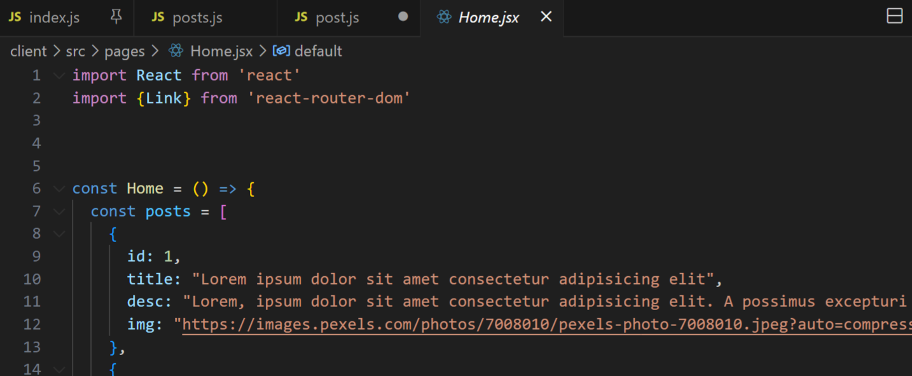

Now

You can comment or remove those posts dummy

Now we create usestate hook

const [posts,setPosts] = useState([])

this usestate hook is something like it keep listening to post if we use them in some textbox as valuewe enter in textbox it’ll be updated in post or setpos you can see and understand with example

above for post we put empty array inside it

next we create async method inside **useEffect**

useEffect(()=>{

    const fetchData = async ()=>{

      try{

      }catch(err){

        console.log(err);

      }

    }

  })

Above as we used inside register.jsx page: we can also use usestate for error inside catch(err)

Inside try: we make axios get request and save that in response

If there is a response we will set our post

  const [posts,setPosts] = useState([])

  useEffect(()=>{

    const fetchData = async ()=>{

      try{

        const response = await axios.get("/posts");

        setPosts(response.data);

      }catch(err){

        console.log(err);

      }

    }

  },[]);

Above if you see we pass our response data to setpost which is a usestate

He told one more thing: **why we create another method inside useeffect that async fetchdata method**

Because we can’t directly use async on **useeffect itself so inside that we created fetchdata method async**

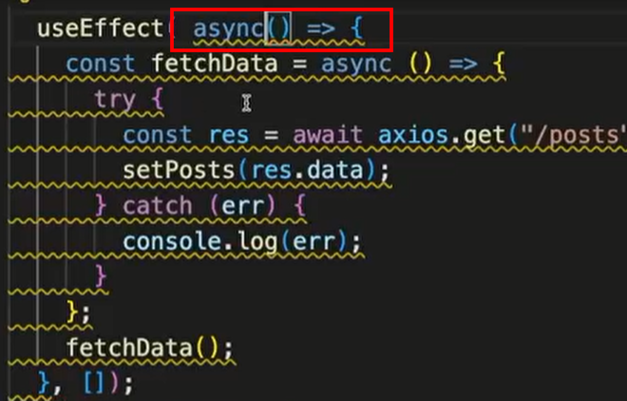

**Whe**n you use useeffect with async it throws error with yellow underline

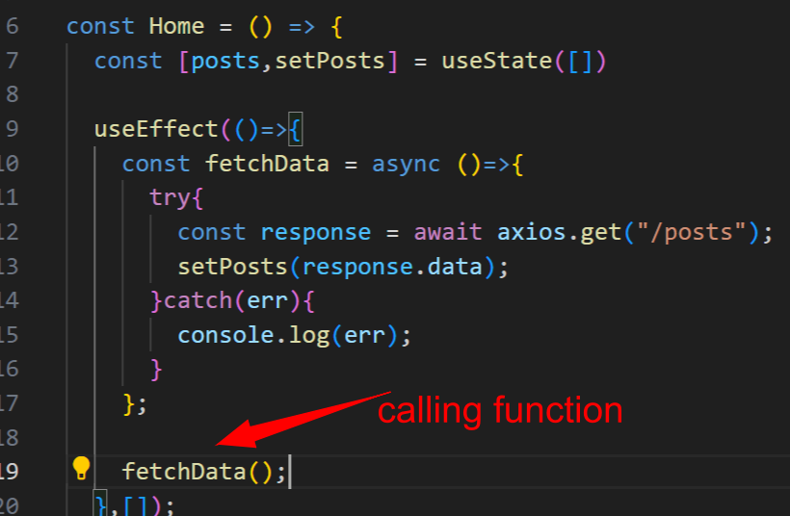

Inside useeffect we call fetchdata method

1:41

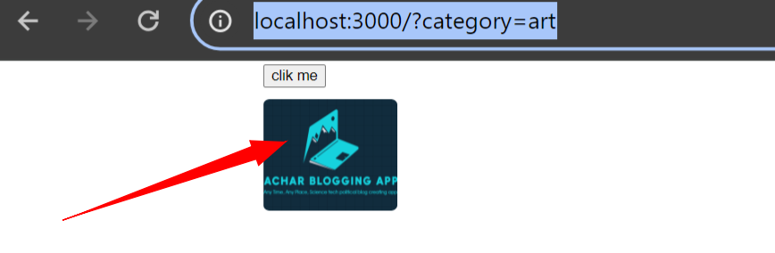

For this logo also we add link to home page using Link attribute we do that inside navbar.jsx file

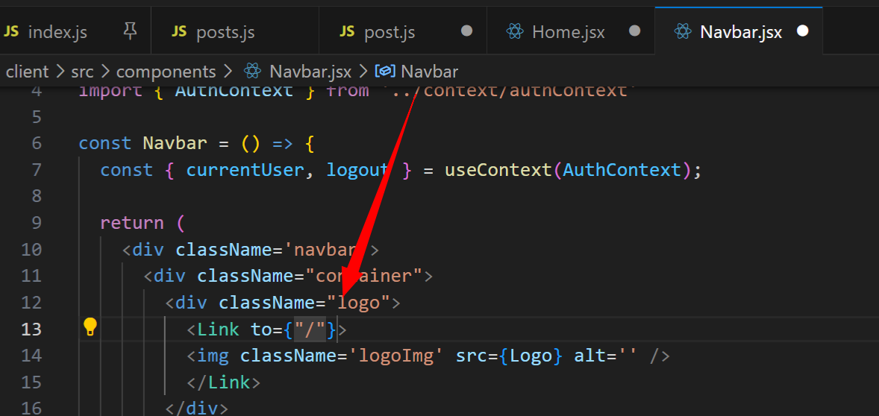

We add like above

In db he removed not-null for datetime column as it’s difficult to write datetime by hand

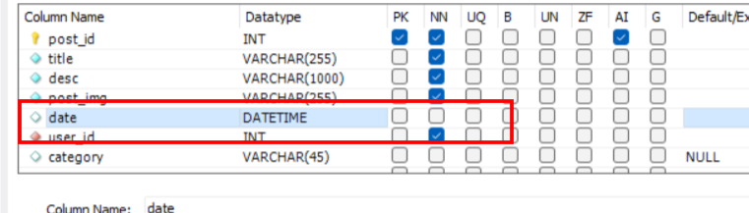

Datetime can be null also

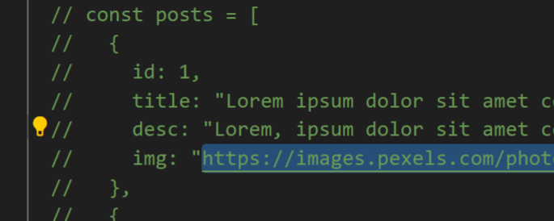

From this commented post img url we copy and insert into post table img column data for insert

<https://images.pexels.com/photos/7008010/pexels-photo-7008010.jpeg?auto=compress&cs=tinysrgb&w=1260&h=750&dpr=2>

above is img

2 issues solved they gave error when running backend:

How did I run backend: keep breakpoint at app.listen in index.js file inside api folder now click on **run->run and debug** breakpoint hits if you continue in debug console “connected” will be printed

Also backend will keep running

Issues:

Inside route->posts.js file

 from '../controllers/post';

I put like above due to it app crashed later coorected it as from '../controllers/post.js';

Another issue:

Express router doesn’t have update method it has put method due to this app crashed inside

Router->posts.js file

router.put("/:id",updatePost)

above is correct

const response = await axios.get("http://localhost:8800/posts");

Inside home.jsx file I changed api rul like this because when I keep <http://localhost:8800> this as proxy in package.json it didn’t work

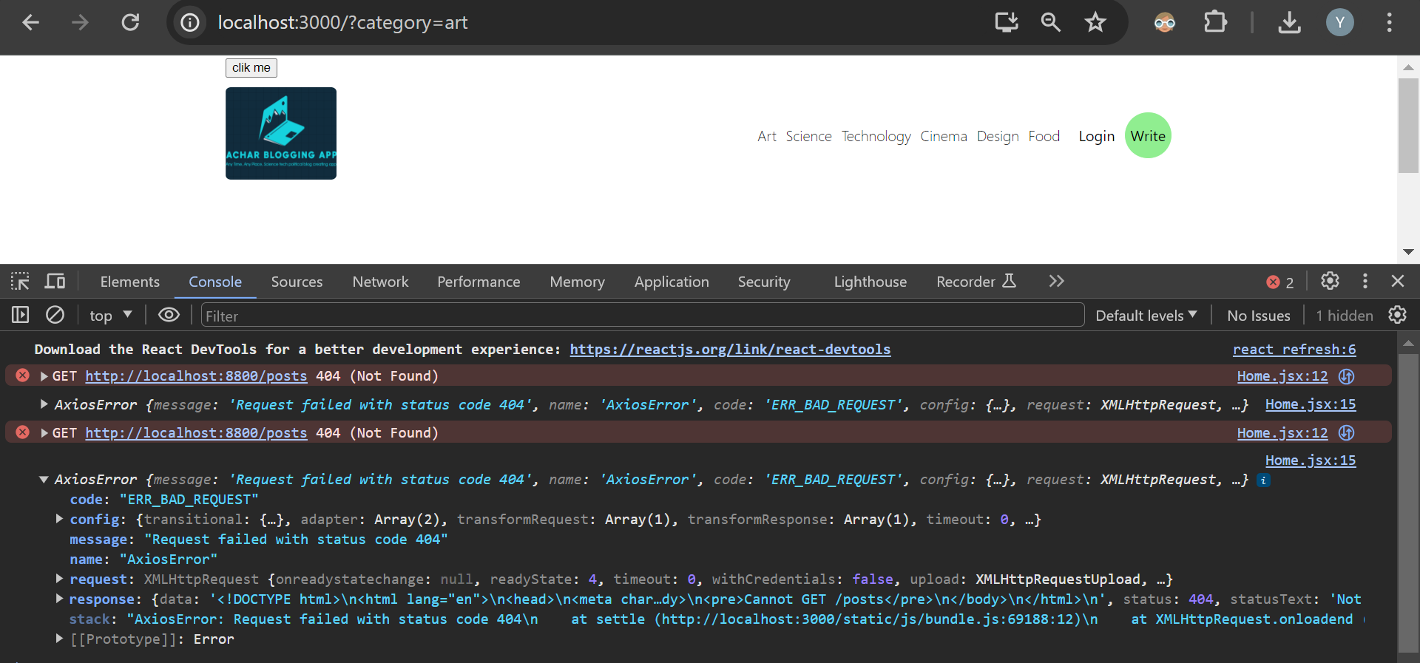

Now when you refresh your page you get axios error

Error says there is no posts

http://localhost:3000/?category=science

There should be some way to reach category from above url

For that he uses: **uselocation** hook from react-router-dom

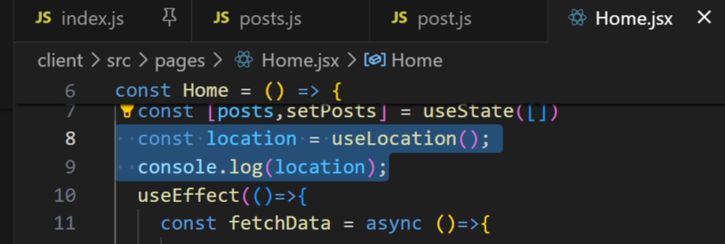

  const location = useLocation();

  console.log(location);

When we print location

When you click on different categories

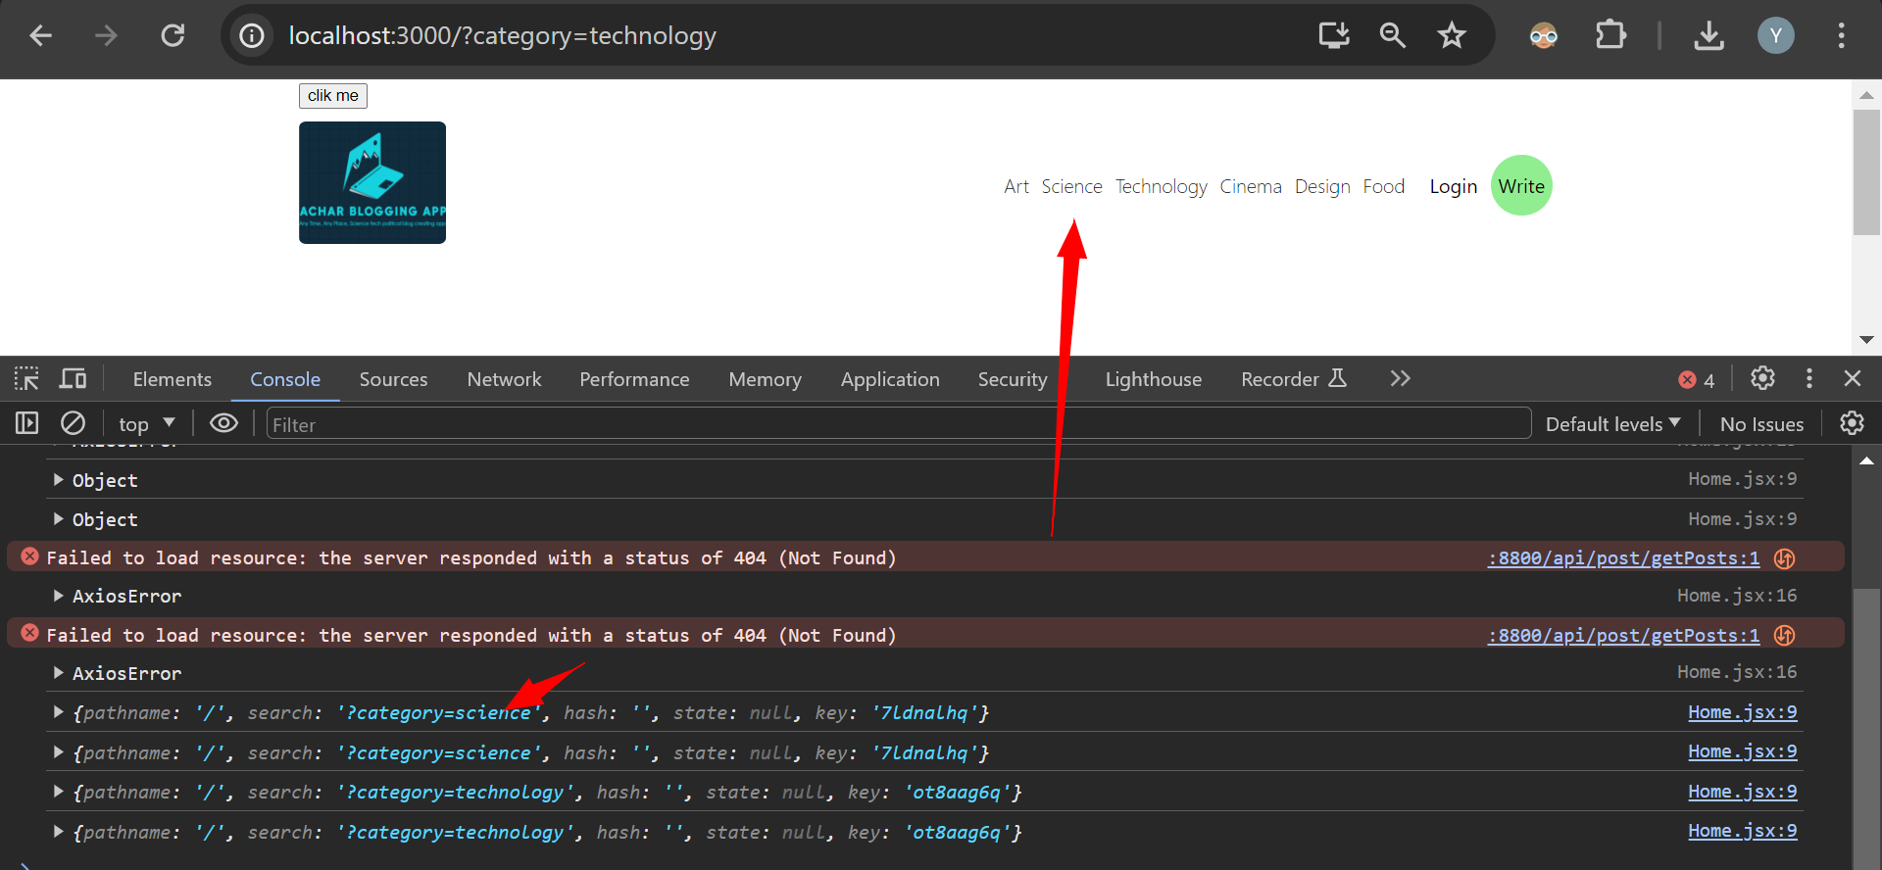

It shows like above pathname, category,key

/ means we’re in home page

Search: it includes our query

So we send **search to our backend**

  const location = useLocation().search;

**now** above will give me exact category query to me

#. Solve api url saving in package.json file as proxy issue

I checked some stackoverflow it doesn’t work like that now, that saving prefix of api url in proxy and only using api enpoint in post request that doesn’t work

I got one issue:

http://localhost:8800/posts

Frontend home.jsx api url I kept like above due to that I got axios bad request error

Because posts file present inside main **api** folder so you have to add api

http://localhost:8800/api/posts

above is correct with above my breakpoint in posts.js file got hit

const [posts,setPosts] = useState([])

  // const location = useLocation(); //gives all location object of navbar category

  const **category** = useLocation().search;

  useEffect(()=>{

    const fetchData = async ()=>{

      try{

        const response = await axios.get(`http://localhost:8800/api/posts**${category}**`);

        setPosts(response.data);

      }catch(err){

        console.log(err);

      }

    };

    fetchData();

  },[**category**]);

Above all red changes he did, we pass category to our api url so that we can fetch data related to that category

Also at the end of useeffect inside empty list also we need to pass **category why?**

**Whenever we change our category it’ll keep calling our function again and again I think it calls fetchdata function**

With above change in my code breakpoint hits: post.js file

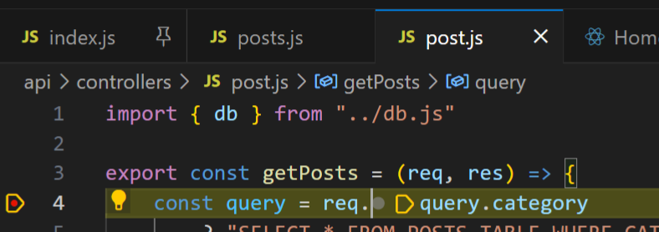

Getposts method

So first time when page loads our url will be only http:localhost/3000 so our category will be empty

So in db that time we fetch all posts

When we click on art category we call fetchdata method and pass art category you can check with breakpoint

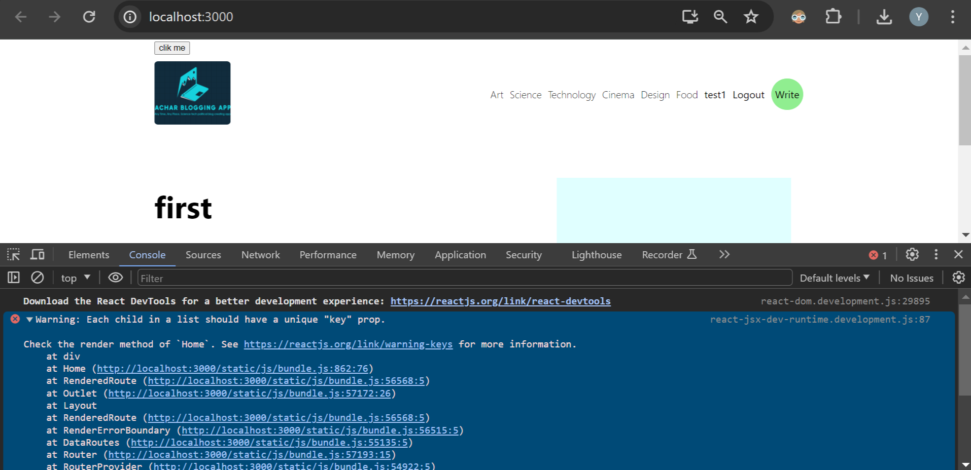

Above error I got in browser

I think database column name doesn’t match with home.jsx variable

category:'art'

date:null

desc:'hello'

post_id:1

post_img:'https://images.pexels.com/photos/7008010/pexels-photo-7008010.jpeg?auto=compress&cs=tinysrgb&w=1260&h=750&dpr=2'

title:'first'

user_id:15

above is db colname

changed: img to post_img

changed: post.id to post.post_id in url you see post id on clicking title with this

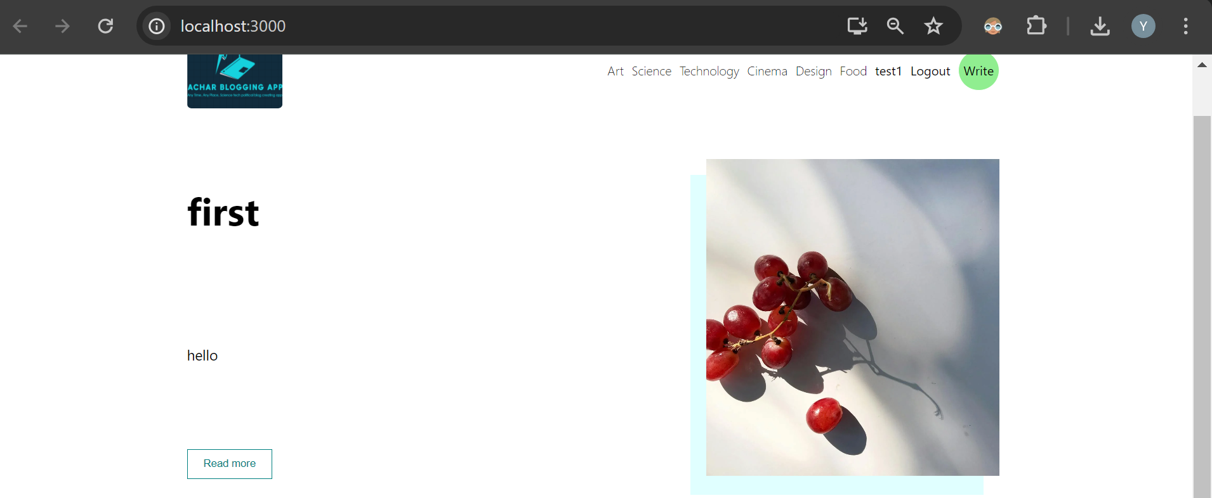

With change to post_img error removed

Now if you click on art then "?category=art" this will be passed to fetchdata method and it’ll get called make get request to backend pass above category to backend

You can check with backend with breakpoint

Getposts method query=art from db we filter only records with category art

Controller->post.js code

export const getPosts = (req, res) => {

    const query = req.query.category

        ? "SELECT * FROM POSTS_TABLE WHERE CATEGORY=?"

        : "SELECT * FROM POSTS_TABLE"

    db.query(query, [req.query.category], (err, data) => {

        if (err) {

            return res.json(err);

        }

        return res.status(200).json(data);

    })

}

Above

**#. Click on post title to see detailed post and recommended post**

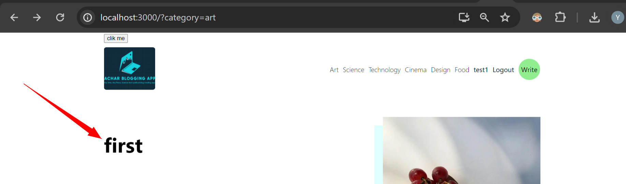

**Click** on first

You should see

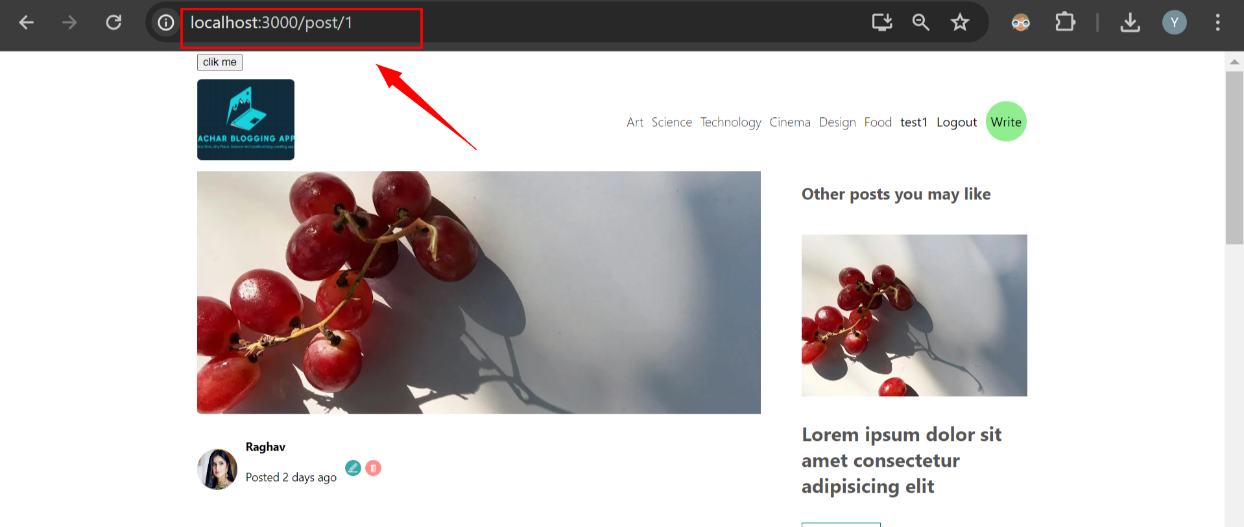

Above we have post detail page with in url we have post id

And on right side recommened posts are there

It should also fetch user name but username is not in posts_table it’s in userstable

For that we use mysql features

const [posts,setPosts] = useState([])

  // const location = useLocation(); //gives all location object of navbar category

  const category = useLocation().search;

  useEffect(()=>{

    const fetchData = async ()=>{

      try{

        const response = await axios.get(`http://localhost:8800/api/posts${category}`);

        setPosts(response.data);

      }catch(err){

        console.log(err);

      }

    };

    fetchData();

  },[category]);

As we did in home.jsx file above we do the same in **our single.jsx file**

But main thing: instead of **sending category to get api request to post file now we send post_id** in fetchData method

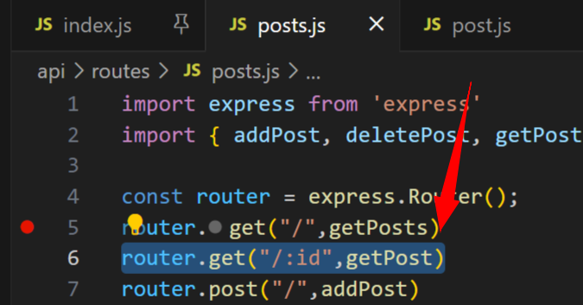

See above by passing single id we can fetch single post detail with method getPost

But now how to get id: for that we use uselocation hook

<http://localhost:3000/post/1>

above is our url: with uselocation

const category = useLocation();

  console.log(category);

I printed uselocation

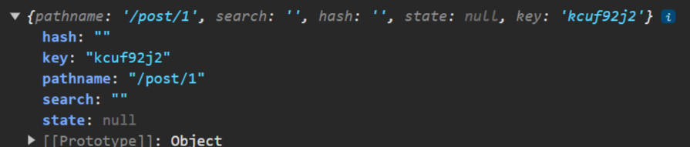

We have our id in pathname so we use uselocation pathname later for getting id we use js split

We have / slash 2 times to after split get 2nd index you’ll get your id

.split('/')[2]

const [post,setPost] = useState([])

  // const location = useLocation(); //gives all location object of navbar category

  const postIdIs= useLocation().pathname.split('/')[2];

  useEffect(()=>{

    const fetchData = async ()=>{

      try{

        const response = await axios.get(`http://localhost:8800/api/posts${**postIdIs**}`);

        setPost(response.data);

      }catch(err){

        console.log(err);

      }

    };

    fetchData();

  },[**postIdIs**]);

With above code as we click on post’s ttile first we get postid using uselocation pathname

We pass id to our axios get request

Also postid we pass inside list of useeffect which is dependency so as id changed it calls fetchdata method

In our single page we have hardcoded data

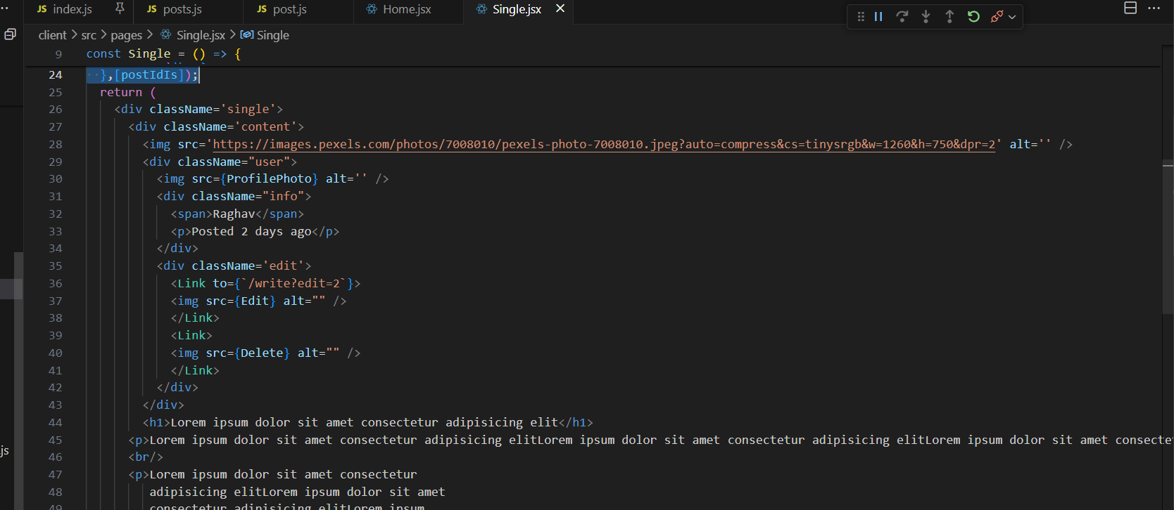

Like above we change them which are hardcoded

<img src={post?.post_img} alt='' />

Why we do above ? means: it’s handling of error properly

If post is not null not undefined then only take post_img from it

 <span>{post.user_name}</span>

Above we don’t have user_name in our post table we join with usertable and we show username

 <p>Posted 2 days ago</p>

Now to show at what time posted

We use moment library

We import and use moment library inside single.jsx file

 <p>Posted {moment(post.date).fromNow()}</p>

Using moment above will show difference b/w post.date and current date

For showing or hiding buttons:

<div className='edit'>

            <Link to={`/write?edit=2`}>

            <img src={Edit} alt="" />

            </Link>

            <Link>

            <img src={Delete} alt="" />

            </Link>

          </div>

We show above buttons only if we’re owner of that post

So we can use our currentuser from authcontext.js file

Using usecontext we initialize currentuser

  const {currentUser} = useContext(AuthContext);

above currentuser

now for showing buttons we write conditions

**{currentUser.user_name === post.user_name &&**

            <div className='edit'>

              <Link to={`/write?edit=2`}>

                <img src={Edit} alt="" />

              </Link>

              <Link>

                <img src={Delete} alt="" />

              </Link>

            </div>

**}**

Like above if username of currentuser matches with post’s username then only show buttons or else hide

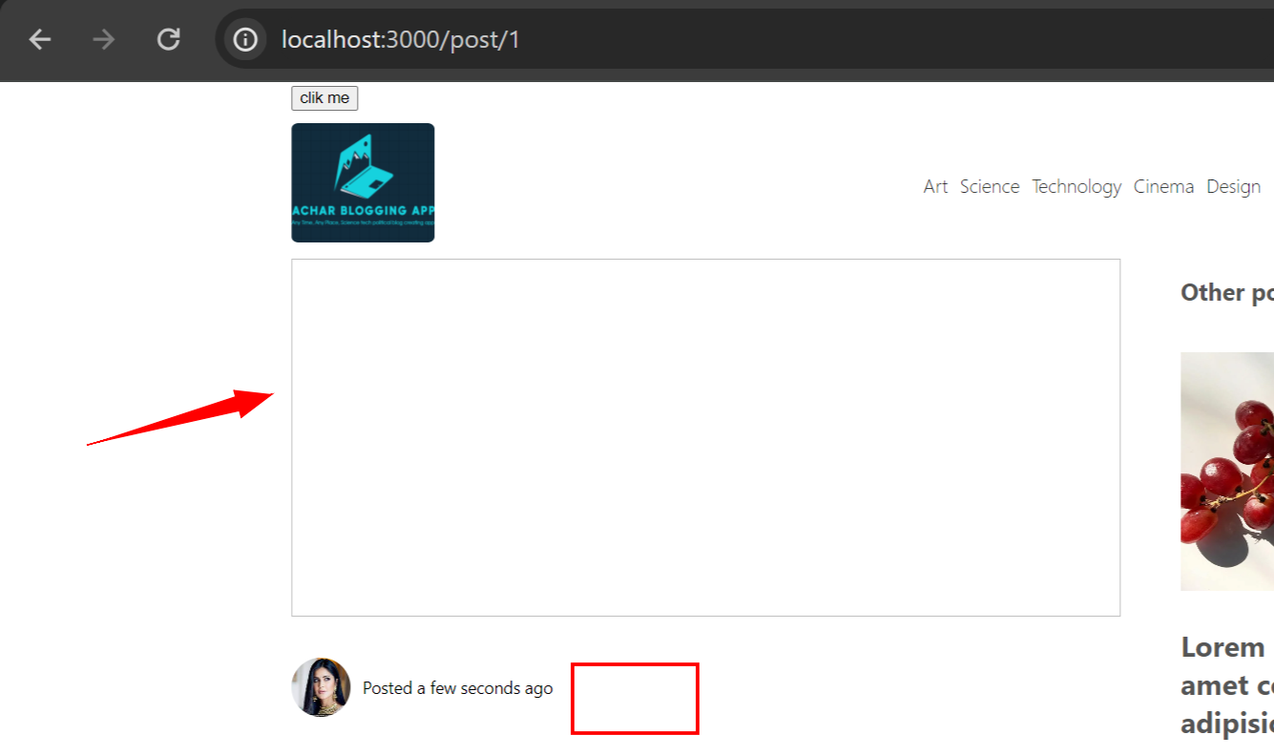

Now we can see button is gone he told it’s because we don’t have any post yet

1:48:34

For hardcoded title we put **post.title**

For hardcoded desc we put post.desc

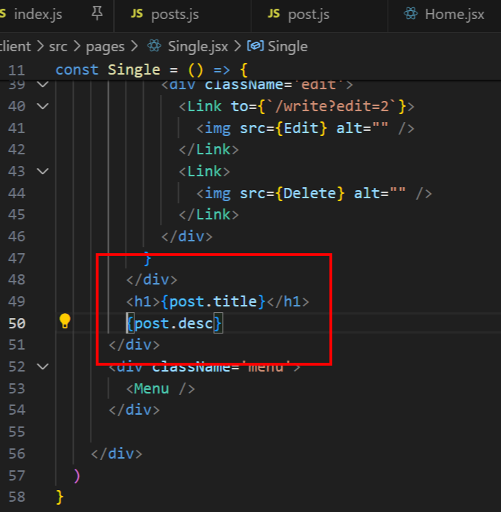

Above

Next we go to backend: post.js file to fetch our data inside controller folder

export const getPost = (req, res) => {

    const query = " SELECT UT.user_name,PT.TITLE,PT.DESC,PT.POST_IMG,PT.DATE,PT.CATEGORY FROM USERS_TABLE AS UT "

    query = query + " JOIN POSTS_TABLE AS PT ON PT.USER_ID=UT.USER_ID "

    query = query + " WHERE PT.POST_ID= ? "

    db.query(query, [req.params.post_id], (err, data) => {

        if (err) {

            return res.json(err);

        }

        return res.status(200).json(data[0]);

    })

}

Above is code, data[0] as it returns list of data in that we need only 0th index data

As data returns array

**. If you make even small mistake your get api request will not work

It’s very strange in home.jsx file for get request while sending inputs before that I didn’t put ‘/’but still it called backend get request without issue

Same thing for passing singleid post id I tried in single.jsx file but here / I missed api didn’t work

After putting / it worked

http://localhost:8800/api/posts${postIdIs}

Above issue ‘/’ is missing after posts

http://localhost:8800/api/posts/${postIdIs}

corrected

**. Another issue: express js you can’t write multiline sql query by concat gives error

const query = " SELECT UT.user_name,UT.user_img,PT.TITLE,PT.DESC,PT.POST_IMG,PT.DATE,PT.CATEGORY FROM USERS_TABLE AS UT JOIN POSTS_TABLE AS PT ON PT.USER_ID=UT.USER_ID WHERE PT.POST_ID= ?"

query = query + " FROM USERS_TABLE AS UT "

query = query + " JOIN POSTS_TABLE AS PT ON PT.USER_ID=UT.USER_ID "

query = query + " WHERE PT.POST_ID= ? "

above I write query by string concatenation in express which gave me error

const queryString = `

SELECT *

FROM your_table

WHERE column1 = ?

AND column2 = ?

`;

chatgpt told we can write like this

 const query = `SELECT UT.user_name,UT.user_img,PT.TITLE,PT.DESC,PT.POST_IMG,PT.DATE,PT.CATEGORY

     FROM USERS_TABLE AS UT

     JOIN POSTS_TABLE AS PT ON PT.USER_ID=UT.USER_ID

     WHERE PT.POST_ID= ?`

so above with `` worked in express

I got even correct data for above query

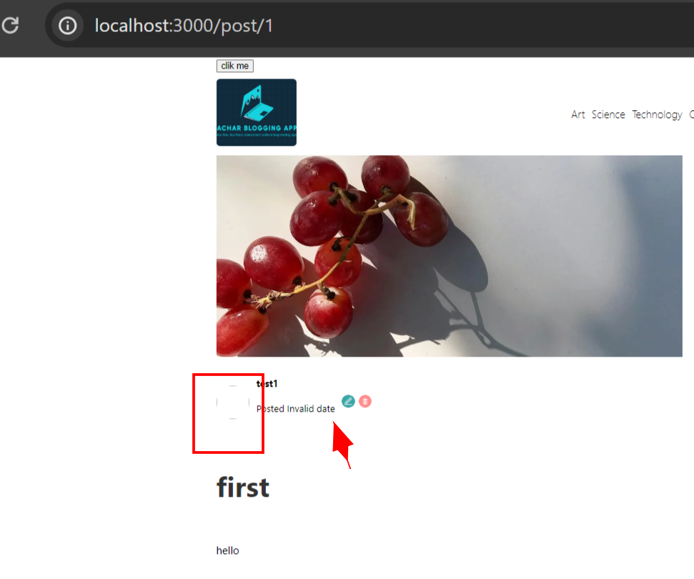

With backend data now frontend post with id1 display like above image of user is null so it looks like above date also null I think

We handle user_img if it’s null

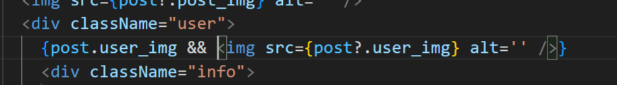

Above if user_img is there then show it or else don’t show it

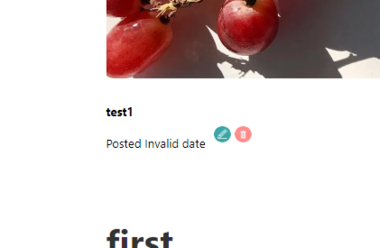

With that empty user image gone

Now we can edit delete our post as we’re the owner of the post

#. **Handle delete for single post, usenaviage for navigate to home page**

 <Link>

                <img onClick={handleDelete} src={Delete} alt="" />

              </Link>

We add above

And create next handleDelete method

For delete method api is delete

Once we delete we naviage to home page

Now we use useNavigate hook

const handleDelete = async () => {

    try {

      await axios.delete(`http://localhost:8800/api/posts/${postIdIs}`);

      navigate("/");

    } catch (err) {

      console.log(err);

    }

  };

Above is handledelete with apicall

Next we work on controller->post.js file delete method for db

**. Now again jsonwebtoken comes into picture

If we **don’t** have jwt in our browser application->storage->cookies then we’re not authenticated

Not logged in so we can’t delete

We can delete only if we have webtoken in browser

As you know in logout page api request frontend you’ve followed some steps to send cookies like credentials true with api or else cookies won’t be sent to backend if you don’t follow steps

 const logout = async (inputs) => {

        const cookieValue = document.cookie.replace(/(?:(?:^|.*;\s*)access_Token\s*\=\s*([^;]*).*$)|^.*$/, "$1");

        await axios.post("http://localhost:8800/api/auth/logout"

            , { cookieValue }, { withCredentials: true }

        );

        deleteCookie('access_Token');

        setCurrentUser(null);

    }

Above is logout method present inside **authContext.js file in frontend**

Now in backend post.js file we fetch cookie we verify whether it’s valid cookie

const postIdIs = useLocation().pathname.split('/')[2];

const handleDelete = async () => {

    try {

        const cookieValue = document.cookie.replace(/(?:(?:^|.*;\s*)access_Token\s*\=\s*([^;]*).*$)|^.*$/, "$1");

        await axios.delete(`http://localhost:8800/api/posts/${postIdIs}`

            , { cookieValue }, { withCredentials: true });

        navigate("/");

    } catch (err) {

        console.log(err);

    }

};

Above **code is wrong which doesn’t send cookie to backedn so I asked chatgpt to give correct code**

const cookieValue = document.cookie.replace(/(?:(?:^|.*;\s*)access_Token\s*\=\s*([^;]*).*$)|^.*$/, "$1");

      await axios.delete(`http://localhost:8800/api/posts/${postIdIs}`, {

            headers: {

                Cookie: `access_Token=${cookieValue}`

            },

            withCredentials: true

        });

So chatgpt **gave one code which is working** with **delete request passing cookies**

**Us**ing jwt we verify whether access_token valid or not

As you remember while creating jwt token

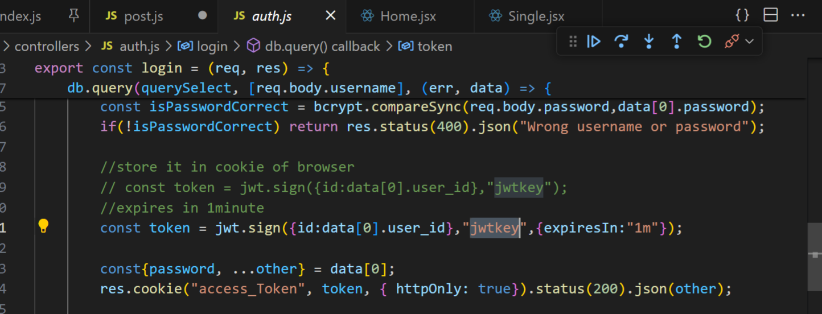

Above token: we converted user_id into jwt token with securitykey

Means we sent userid as jwttoken

**But now we do reverse**: from jwt token got from browser cookie we try to recover our userid that’s why

jwt.verify(token,jwtkey,(err, userInfo)=>{

        })

We write like this, from token fetch userinfo like id

After that inside verify above we write our query and db call to delete userid

Time:1:55

const postId =req.params.id;

            const query = "DELETE FROM POSTS_TABLE WHERE post_id=? AND user_id=?"

ABOVE user_id we pass from jwt token and if user_id inside posts_table doesn’t match with user_id fetched by jwt token then we’re not allowed to delete

export const deletePost = (req, res) => {

    const token = req.cookies.access_token

    if(!token) return res.status(401).json("Not authenticated")

        jwt.verify(token,jwtkey,(err, userInfo)=>{

            if (err) {

                return res.status(500).json("Token is not valid");

            }

            const postId =req.params.id;

            const query = "DELETE FROM POSTS_TABLE WHERE post_id=? AND user_id=?"

            db.query(query, [postId, userInfo.id], (err, data) => {

                if (err) {

                    return res.status(500).json("You can delete only your post");

                }

                return res.status(200).json("Post has been deleted");

            })

        })

}

You can hover with breakpoint on userinfo it is object type which has all userinfo from that we get id

expiredAt:Tue May 14 2024 22:26:33 GMT+0530 (India Standard Time)

message:'jwt expired'

name:'TokenExpiredError'

I got above error token expired

const token = jwt.sign({id:data[0].user_id},"jwtkey",{expiresIn:"1m"});

because I kept 1minute change it to 30min

1:56:57

DELETE WORKED BUT I changed delete query added status column in posts table or else every time I have to go and insert to avoid it

Instead of delete I’m doing update

export const deletePost = (req, res) => {

    const token = req.cookies.access_token

    if (!token) return res.status(401).json("Not authenticated")

    jwt.verify(token, "jwtkey", (err, userInfo) => {

        if (err) {

            return res.status(500).json("Token is not valid");

        }

        const postId = req.params.id;

        const query = "UPDATE POSTS_TABLE SET STATUS='INACTIVE' WHERE post_id=? AND user_id=?"

        db.query(query, [postId, userInfo.id], (err, data) => {

            if (err) {

                return res.status(500).json("You can delete only your post");

            }

            return res.status(200).json("Post has been deleted");

        })

    })

}

Code above inside post.js file for delete

const handleDelete = async () => {

    try {

      const cookieValue = document.cookie.replace(/(?:(?:^|.*;\s*)access_token\s*\=\s*([^;]*).*$)|^.*$/, "$1");

      await axios.delete(`http://localhost:8800/api/posts/${postIdIs}`, {

            headers: {

                Cookie: `access_token=${cookieValue}`

            },

            withCredentials: true

        });

      navigate("/");

    } catch (err) {

      console.log(err);

    }

  };

Frontend code for delete inside single.jsx file

#. **Single.jsx page: show recommended post according to main page category**

We have Menu tag inside single.jsx file

 <Menu category={post.category}/>

For that we add category

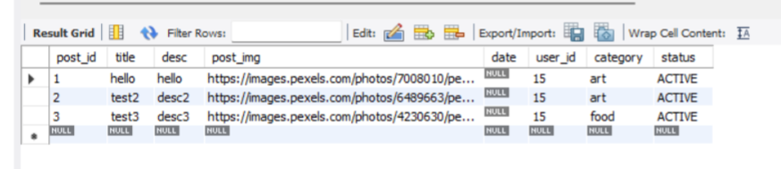

FOR post table manually added above data with same and different categories

Even when I checked browser I found same changes 2 items in art and 1 in food

Menu tag is from **Menu.jsx file**

We commented harcoded posts inside menu.jsx file

We do exact same thing : in our home.jsx we have usestate,uselocation,useeffect hook with method

Before that in flower bracket he put category why because in

 <Menu category={post.category}/>

Single.jsx file for **for Menu tag: category we passed post.category**

So

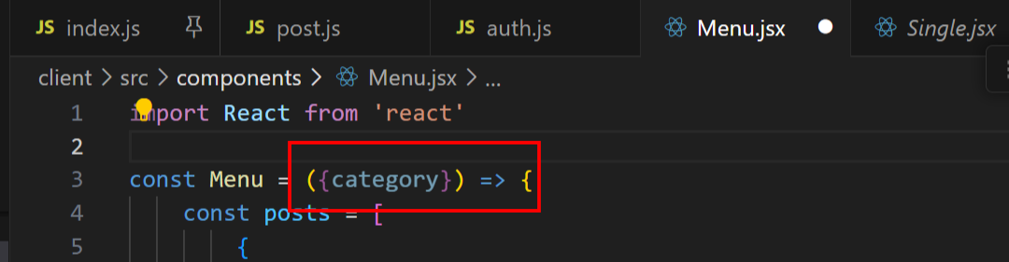

We pass **category** as input to our Menu

We don’t need location as we already have **category**

const [posts,setPosts] = useState([])

  useEffect(()=>{

    const fetchData = async ()=>{

      try{

        const response = await axios.get**(`http://localhost:8800/api/posts/?category=${category}`);**

        setPosts(response.data);

      }catch(err){

        console.log(err);

      }

    };

    fetchData();

  },[category]);

We did change in our api url

It works correctly

Above api will call **getposts** method inside post.js file and according to category it fetches posts

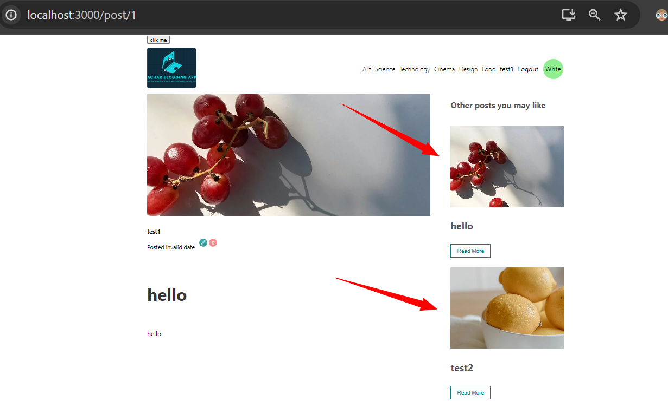

On right side we can see all recommended post they’re now coming from posts_table

#. **Next we take care of write page**

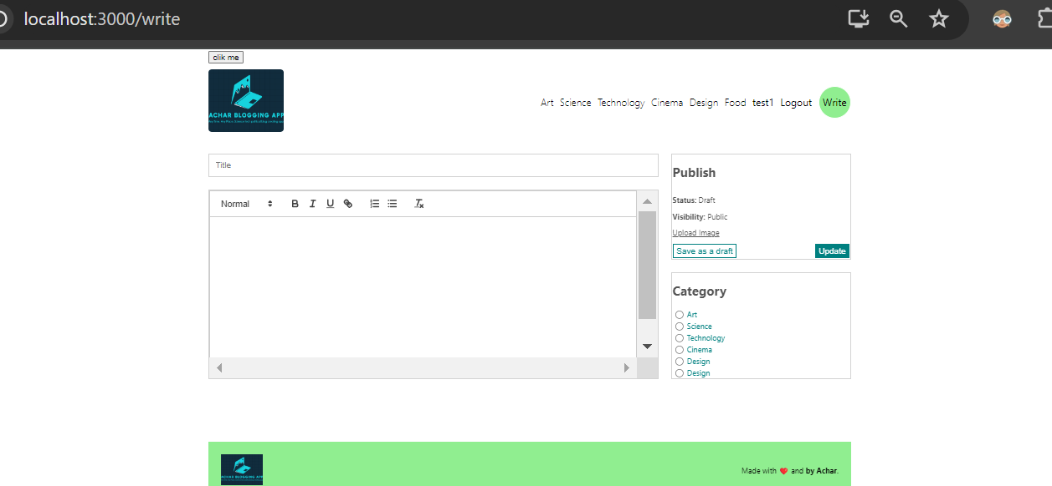

We’re gonna create new posts on write page

We create different usestate hook

const [value, setValue] = useState('');

  const [title, setTitle] = useState('');

  const [img, setImg] = useState(null);

  const [category, setCategory] = useState('');

these are all different hooks created inside write page

 <input type='text' placeholder='Title' onChange={e=>setTitle(e.target.value)}/>

we added onchange method like above

same we add for file also

<input style={{ display: "none" }} type='file' name="" id="file"

           onChange={e=>setFile(e.target.files[0])}></input>

out of all files we’re gonna upload one file that is first file

he told: for categories: we can create different components bodies for them

we have kept categories as radio buttons

we can create different components bodies for categories because we want to prevent creating different different onchange again and again for each of those categories.

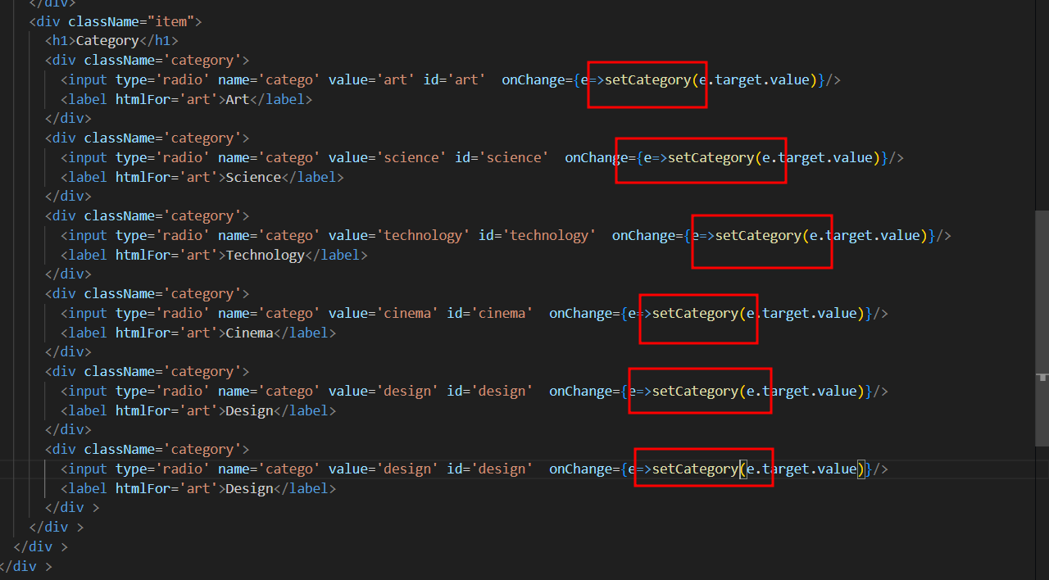

But he told add categories like above

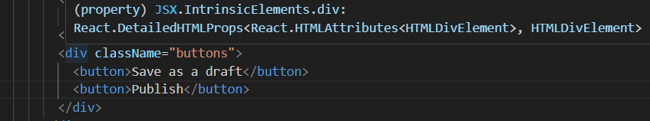

He told he’ll write condition for publish button or **update** button

When we **try to update any post like edit** button will be **update**

But when we write new post that will be publish button

He told he writes it later

Works on onclick method now

Now he told: file uploading or img uploading

#. **File uploading:**

He told to do this: we can use file storage

But currently we store file inside our server

Inside index.js file **we create one more route for uploading file**

We use **multer package for that**

[**https://www.npmjs.com/package/multer**](https://www.npmjs.com/package/multer)

**above** is documentation link

const upload = multer({ dest: 'uploads/' })

as we can see above it creates **destination uploads** folder

inside our **api folder** it creates **uploads** folder

our all files will be uploaded inside that folder

after that we add our app point for uploads

const upload = multer({dest:'uploads/'})

app.post('/upload', upload.single('file'), function (req, res, next) {

    res.status(200).json("Image has been uploaded")

  })

We add above code inside index.js file

Now we go to write.jsx file and create upload async function

const upload = async ()=>{

    try{

      const formData = new FormData();

formData.append("file", file);

    }

    catch(err){

      console.log(err)

    }

  }

On frontend we create FormData inside formdata we upload our file

formData.append("file", file);

here file name should be same as backend index.js upload.single(‘file’)

next we make post request for uploading file

const upload = multer({dest:'uploads/'})

above is wrong with above you get error in debug console that uploads folder not found

const upload = multer({dest:'./uploads/'})

change

2:06:41 I think there are some errors with uploading image

Debug it.

*. AGAIN I’VE MADE SOME MISTAKE ON API

While making post request for upload not hitting for backend

I checked with youtube github code there it’s hitting backend when uploading image file

Using beyond compare for comparing mine and github codes

Couldn’t get exact issue but after correcting ‘/api/upload’ it started working

Below are working code both in backend and frontend

Inside index.js file

const upload = multer({dest:'./uploads/'})

app.post('/api/upload', upload.single('file'), function (req, res) {

    res.status(200).json("Image has been uploaded")

  })

We keep above code

Write.jsx file is

const upload = async () => {

    try {

      const formData = new FormData();

      formData.append("file", file);

      const res = await axios.post("http://localhost:8800/api/upload", formData);

      console.log(res.data);

    }

    catch (err) {

      console.log(err)

    }

  }

  const handleClick = async e => {

    e.preventDefault();

    upload();

  }

Above code for : first uploading image after that publish to backend using post request

Above code file is hook, when uploaded image it keeps that image file info later we append that file to form, later we make post request for backend we send formdata containing image

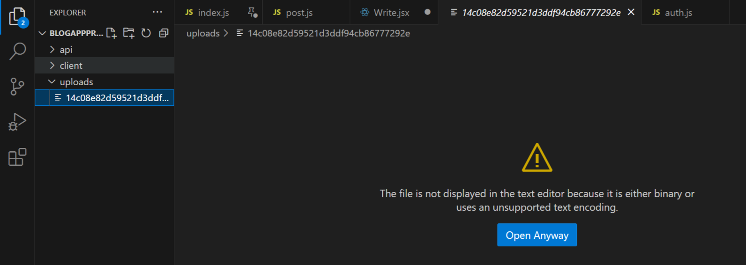

We can see above multer package created **uploads** folder inside that we have image or some thing

If you change it’s extension to jpg then you’ll see proper image

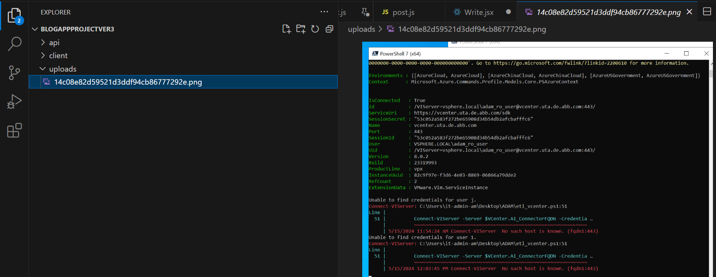

Like above

**In video he told: how we’re gonna add image name**

He told for that we don’t use : multer **with dest**

**He told we use multer with storage**

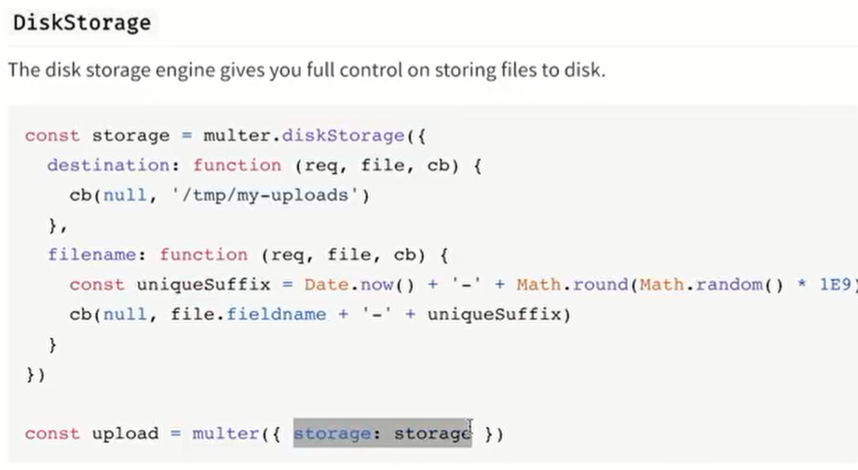

In document of multer he showed above to make use of storage

const storage = multer.diskStorage({

  destination: function (req, file, cb) {

    cb(null, '/tmp/my-uploads')

  },

  filename: function (req, file, cb) {

    const uniqueSuffix = Date.now() + '-' + Math.round(Math.random() * 1E9)

    cb(null, file.fieldname + '-' + uniqueSuffix)

  }

})

const upload = multer({ storage: storage })

From here <https://www.npmjs.com/package/multer> copy pasted

He modified code from above code itself

Upload variable: we keep single storage as both variable names are same

const upload = multer({ storage: storage })

We keep like above

uniqueSuffix it tries to give uniqye date but we remove that code

we give name of file like this: date after that original filename

and what will be our foler structure where image should stored

folder structure: go to client side/ go to public folder/ inside there create uploads folder there save your images

he told we’re not gonna send message like this “image has been uploaded”

instead we’ve to send image url to front end

that is we send **file.filename**

const file=req.file will take file in index.js file inside app.post(‘/api/upload’

**. **But this time upload folder we create manually in this folder: client->public->upload**

const storage = multer.diskStorage({

    destination: function (req, file, cb) {

      console.log("Destination function called");

      cb(null, '../client/public/upload')

    },

    filename: function (req, file, cb) {

      console.log("Filename function called");

      cb(null, Date.now() + file.originalname)

    }

  })

  const upload = multer({ storage:storage })

app.post('/api/upload', upload.single('file'), function (req, res) {

    const file = req.file;

    res.status(200).json(file.filename)

  })

But above code didn’t work

Error: ENOENT: no such file or directory, open 'D:\yadu folder\react projects\client\public\upload\1715834010621image.png'

Gave error like this

It should check for ../client/public/upload' this folder and 1715834010621image.png' this named image file it should drop

2:09:28

If your code is configured to save uploaded files to the **../client/public/upload** directory, but the files are not being generated there, there are several potential issues to consider:

1. **Check Directory Existence and Permissions:** Ensure that the destination directory (**../client/public/upload**) exists and is writable by the server process. If the directory doesn't exist, create it manually, and ensure that the server process has the necessary permissions to write to it.

Chatgpt told if my api Is backend folder and client is frontend folder and from backend you want to upload to front end you may need to have permission for that

So I changed ../client/public/upload' this to ./uploads with this file generated and uploaded to this folder

const storage = multer.diskStorage({

    destination: function (req, file, cb) {

      console.log("Destination function called");

      // cb(null, '../client/public/upload')

      cb(null, './uploads')

    },

    filename: function (req, file, cb) {

      console.log("Filename function called");

      cb(null, Date.now() + file.originalname)

    }

  })

Above code itself I’ll follow

With above code file properly uploads with .png extension

Next we add our url of img to db

Next: we take title description and category and send them to db

We do frontend changes

<http://localhost:3000/write?edit=2>

whenever we click on edit button that time also you go to write page with post_id

so with above url itself I can know whether I’m writing a new post or editing

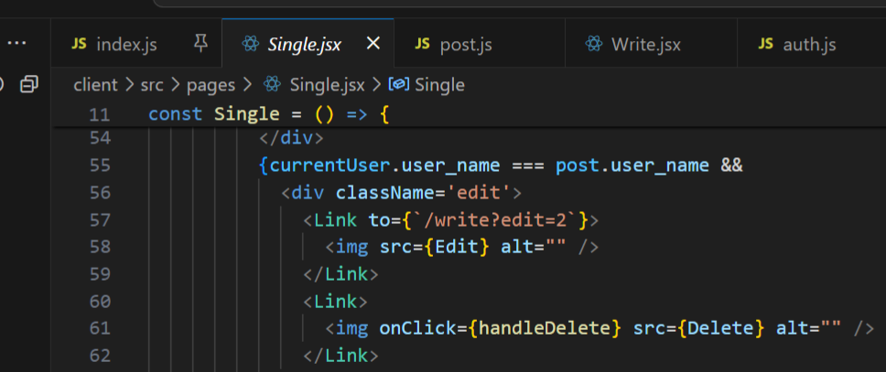

As you can see above currently we hardcoded redirecting from single detailed post from there click edit button we should move to write page

**It’s important to add: state to our Edit Link: or else it doesn’t work**

**State={post} add this in edit Link**

Code after adding state={post} to our edit button link

{currentUser.user_name === post.user_name &&

            <div className='edit'>

**<Link to={`/write?edit=2`} state={post}>**

                <img src={Edit} alt="" />

              </Link>

              <Link>

                <img onClick={handleDelete} src={Delete} alt="" />

              </Link>

            </div>

          }

Our code

So what we do: if we’re editing a post we auto populate post’s title and desc in our write page

Also category and image we auto populate if we edit a post

For doing it: we add conitions in our **usestate hook** if we have already title from state

State we get from uselocation object state inside state if title is there then populate it

Inside state desc is there then populate it

We do above changes in write.jsx because we come from single.jsx page

 const state = useLocation().state;

  const [value, setValue] = useState(state?.title || "");

  const [title, setTitle] = useState(state?.desc || "");

  const [file, setFile] = useState(null);

  const [category, setCategory] = useState(state?.category || "");

we add like above we don’t do anything for file as it’s file

next we do add above usestate in our html codes

<input type='text' value={title} placeholder='Title' onChange={e => setTitle(e.target.value)} />

for this input text box add value

2:10

Next for categories with radio button

checked={category==='science'}

for all our radio button input we added checked property

based on their category

I faced one issue after watching video again it solved

In home page you click on **art** page

In art page you click on one blog

That single blog detail opens in single.jsx page

In single.jsx file you’ll have edit button on click on edit button in write.jsx page you’ll auto populate blog details like title desc and category

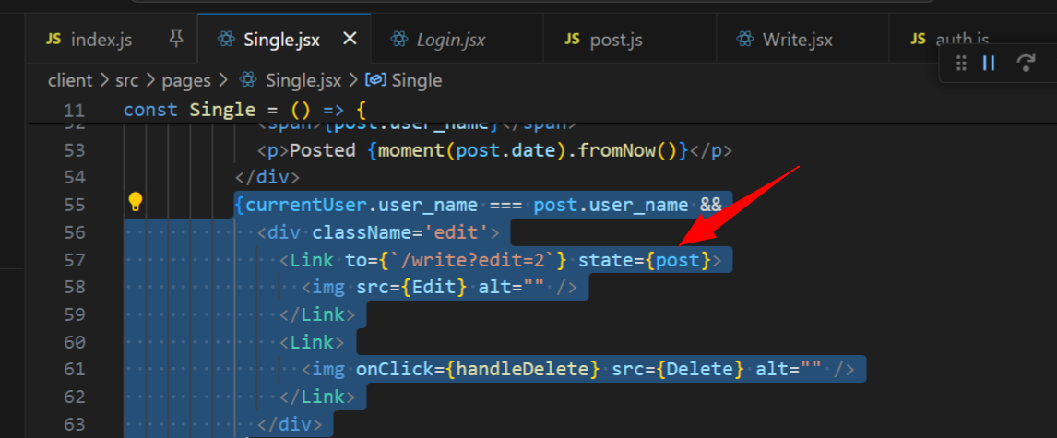

Edit Link it’s important to set state

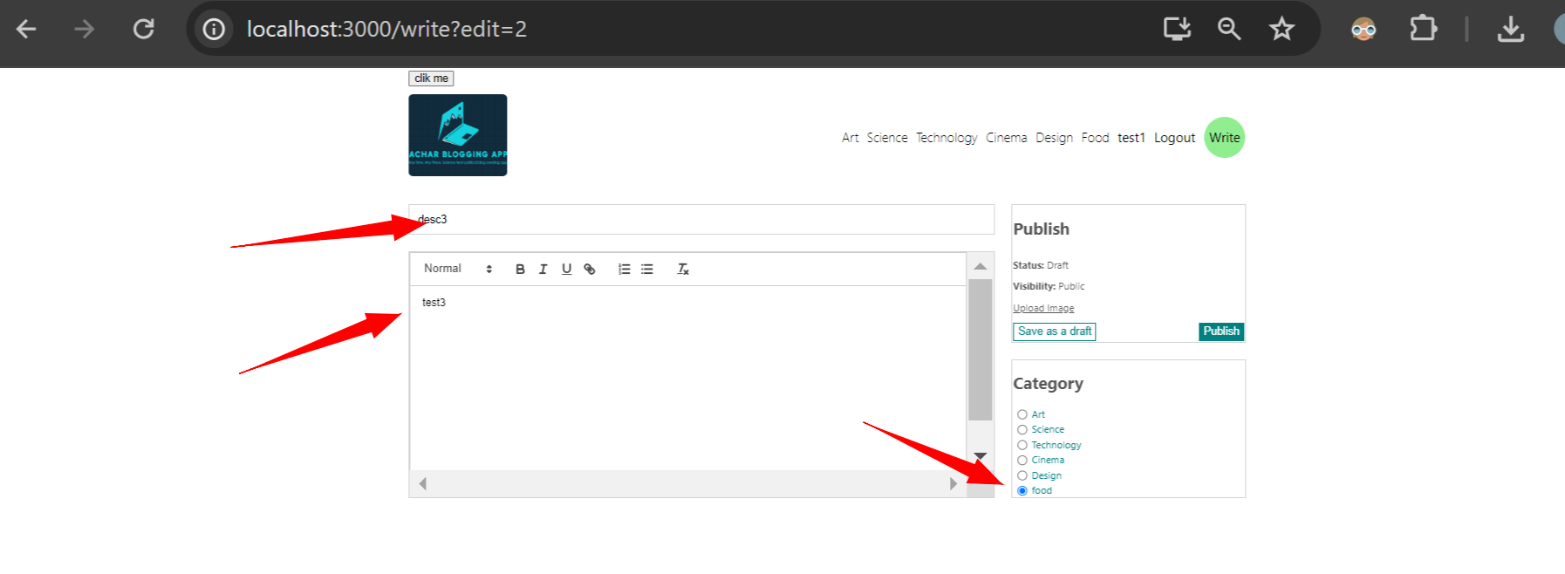

Check above

I clicked on food category at top

Next clicked on desc3 blog

Next clicked on edit icon I got above

But if you try to write new post all will be empty: title,desc,category will be empty

Next we write condition: inside **handleclick method**

If we’ve state then it means: we’re editing a post

If state is null means it’s a new post

So while editing: for axios put request we send post.id

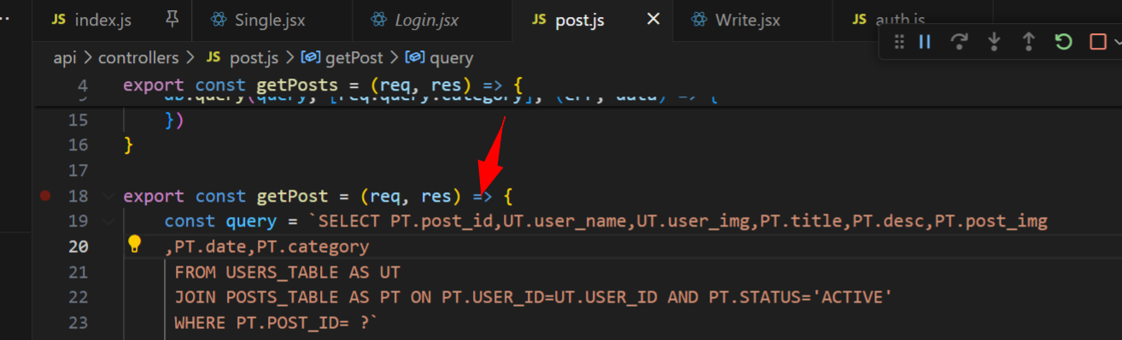

WE should have post_id from getpost method

Or else in write page for axios put request we won’t be able to send post_id

state ? await axios.put(`http://localhost:8800/api/posts/${state.post_id}`,{

      })

Above means if state is there then put or we do edit of existing data

Or else new data we insert

const handleClick = async e => {

    e.preventDefault();

    const imgUrl = upload();

    try {

      state ? await axios.put(`http://localhost:8800/api/posts/${state.post_id}`, {

        title

        , desc: value

        , category

        , img: file ? imgUrl : ""

      }) :

        await axios.post(`http://localhost:8800/api/posts/`, {

          title

          , desc: value

          , category

          , img: file ? imgUrl : ""

          , date: moment(Date.now()).format("YYYY-MM-DD HH:mm:ss")

        })

 navigate("/") //navigate to home page

    } catch (err) {

      console.log(err);

    }

  }

We change our handleclick like above

If state is there then edit, if state is not there then add new post we don’t pass post id there

Title kept single: because title parameter input and saved title state both are same

Img: if file is there then pass imgurl or else “”

We pass date using moment in that format

Next inside post.js file we add putpost method

Inside addPost method we do change

If we’re not logged in we can’t add post

We use jwt.verify for verify token here also

const query = "INSERT INTO POSTS_TABLE(`title`,`desc`,`post_img`,`date`,`category`,`user_id`) VALUES(?)"

            const values = [

                req.body.title,

                req.body.desc,

                req.body.post_img,

                req.body.date,

                req.body.category,

                userInfo.id,

            ]

Our query and we pass input of list

Updatepost method we do similar to addpost: that is get token,verify token, write query pass input run query

Again facing issue with adding new post and edit post I think some column names mismatch in frontend

const imgUrl = await upload();

Didn’t put await for upload

const handleClick = **async (e)** => {

for e didn’t cover brackets

http://localhost:8800/api/posts/

put / after posts

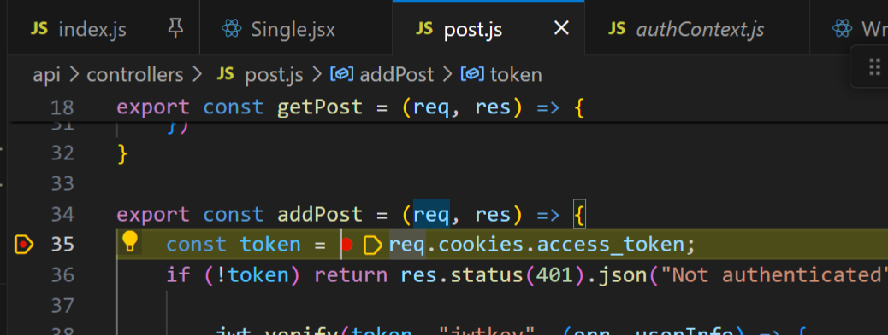

Breakpoint now hit here

code:'ER_WRONG_VALUE_COUNT_ON_ROW'

errno:1136

sql:"INSERT INTO POSTS_TABLE(`title`,`desc`,`post_img`,`date`,`category`,`user_id`) VALUES('apple')"

sqlMessage:"Column count doesn't match value count at row 1"

sqlState:'21S01'

got error while inserting

code:'ER_PARSE_ERROR'

errno:1064

sql:"INSERT INTO POSTS_TABLE(`title`,`desc`,`post_img`,`date`,`category`,`user_id`) VALUES('apple', '<p>apple good for healt</p>', '1715909512166apple.jpg', '2024-05-17 07:01:53', 'food', 15, ?, ?, ?, ?, ?)"

sqlMessage:"You have an error in your SQL syntax; check the manual that corresponds to your MySQL server version for the right syntax to use near '?, ?, ?, ?, ?)' at line 1"

sqlState:'42000'

m

export const addPost = (req, res) => {

    const token = req.cookies.access_token;

    if (!token) return res.status(401).json("Not authenticated")

        jwt.verify(token, "jwtkey", (err, userInfo) => {

            if (err) {

                return res.status(500).json("Token is not valid");

            }

            const postId = req.params.id;

            const query = "INSERT INTO POSTS_TABLE(`title`,`desc`,`post_img`,`date`,`category`,`user_id`) VALUES(?, ?, ?, ?, ?, ?)"

            const values = [

                req.body.title,

                req.body.desc,

                req.body.img,

                req.body.date,

                req.body.category,

                userInfo.id,

            ]

            db.query(query, values, (err, data) => {

                if (err) {

                    return res.status(500).json(err);

                }

                return res.status(200).json("Post has been created");

            })

        })

}

Above method inserted data correctly without any error

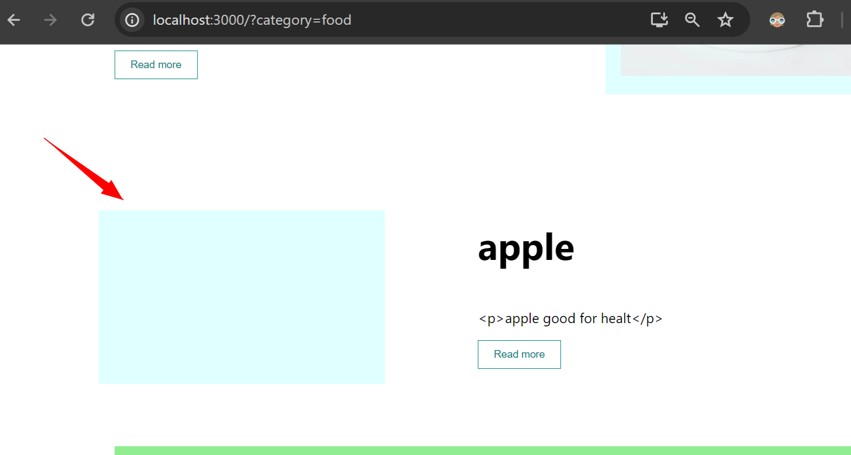

If we go food page we don’t see image

For that he told to go to home page

He told some thing because of multer storage but that didn’t work for me so I used chatgpt code

**Which worked like charm:what I do: basically from server side itself get path of folder where images are dropped. And use that entire url for showing image**

import path from 'path';

import { fileURLToPath } from 'url';

above packages used

const __filename = fileURLToPath(import.meta.url);

const __dirname = path.dirname(__filename);

what above code does

The code you've provided is a common approach in Node.js for obtaining the **__dirname** variable in an ES module.

In ES modules, **__dirname** isn't directly available like in CommonJS modules. So, to emulate the behavior of **__dirname** in an ES module, you can use the **import.meta.url** property along with the **fileURLToPath** function from the Node.js **url** module and the **path.dirname** function from the Node.js **path** module.

Above

const __filename = fileURLToPath(import.meta.url);

const __dirname = path.dirname(__filename);

print __filename D:\yadu folder\react projects\BlogAppProjectVer3\api\index.js

index.js:23

print __dirname D:\yadu folder\react projects\BlogAppProjectVer3\api

We can see filename is of index.js it’s path, dirname is of index.js directory backend server running

What this code

app.use('/uploads', express.static(path.join(__dirname, '../uploads')));

will do

This line of code sets up a middleware in your Express application to serve static files from a directory named "uploads". Let's break it down:

1. **app.use('/uploads', ...)**:
   * **app.use()** mounts middleware functions at a specified path. In this case, it mounts the middleware for serving static files at the "/uploads" path.
2. **express.static(...)**:
   * This is the middleware function provided by Express to serve static files such as images, CSS files, JavaScript files, etc.
   * It takes a root directory as an argument and returns a middleware function that serves static files from that directory.
3. **path.join(__dirname, '../uploads')**:
   * **__dirname** is the directory name of the current module file. It's being used here to construct an absolute path to the "uploads" directory relative to the current module's directory.
   * **path.join()** is a method from the Node.js **path** module that joins multiple path segments into a single path.
   * **../uploads** is appended to **__dirname**, which means it goes up one level from the current directory and then looks for the "uploads" directory.

So, when a request is made to the "/uploads" URL path, Express will serve the static files located in the "uploads" directory relative to the directory of the current module file.

according to chatgpt

after above code in frontend client **home.jsx file**

<div className='img'>

                <img src={`http://localhost:8800/uploads/${post.post_img}`} alt='' />

              </div>

**I used backend server listening port and** it’ll look for filename inside uploads folder

Anyways post_img name is coming from db

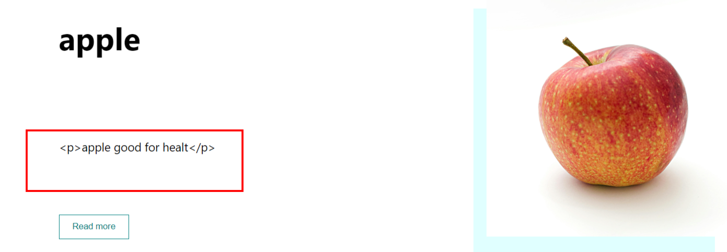

One thing we see p tag I saw in write.jsx file while publishing desc was having p tag

He told in home.jsx file he creates one method for removing p tag

  const getTextFromHtml = (html)=>{

    const doc = new DOMParser().parseFromString(html,"text/html");

    return doc.body.textContent;

  }

Above will convert those p tag text and returns only text

<p>{getTextFromHtml(post.desc)}</p>

And I called that method passed desc which has p tag in it

Now we have another issue: in single.jsx that post’s detail page when we go to post’s detail page we don’t see our image that is path issue

So inside single.jsx pass url of uploads folder from backend port similar to what you did In home.jsx page

 <img src={`http://localhost:8800/uploads/${post?.post_img}`} alt='' />

In single.jsx file used image like above

If you have some old images which are not present in uploads folder then they won’t be displayed it’s better you delete and re-add them

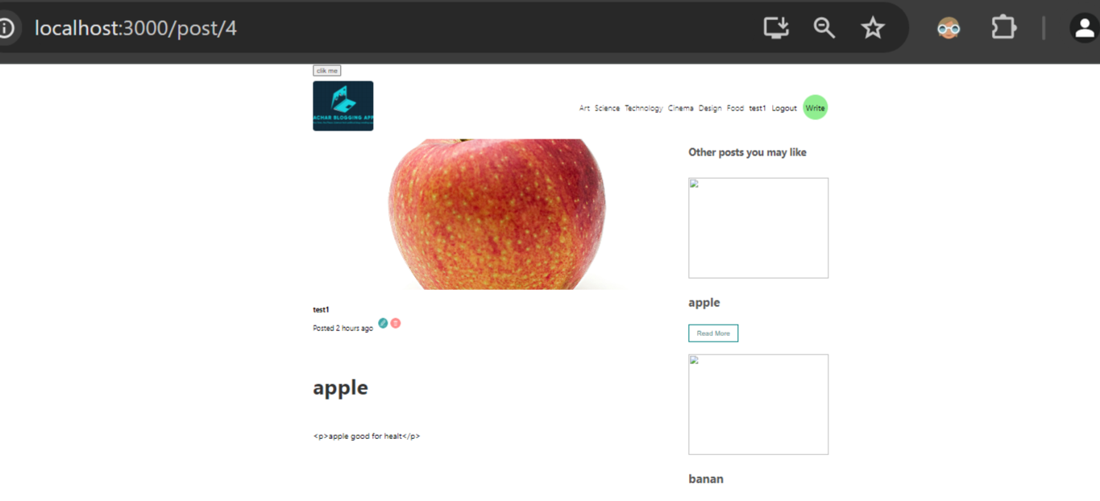

Single.jsx post details page image is coming

And for other posts you may like i.e. recommended posts

Change image url in menu.jsx page

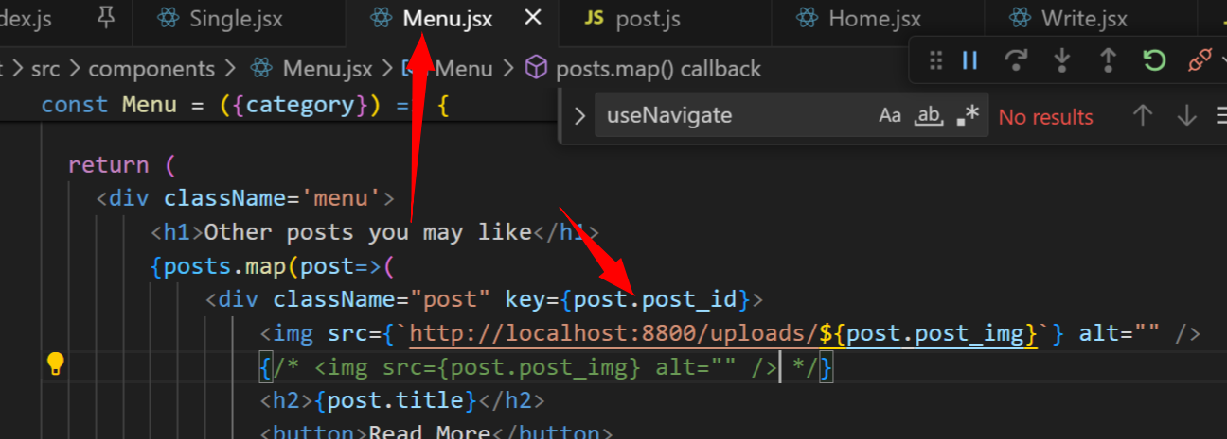

After change in menu.jsx file right side looks like below

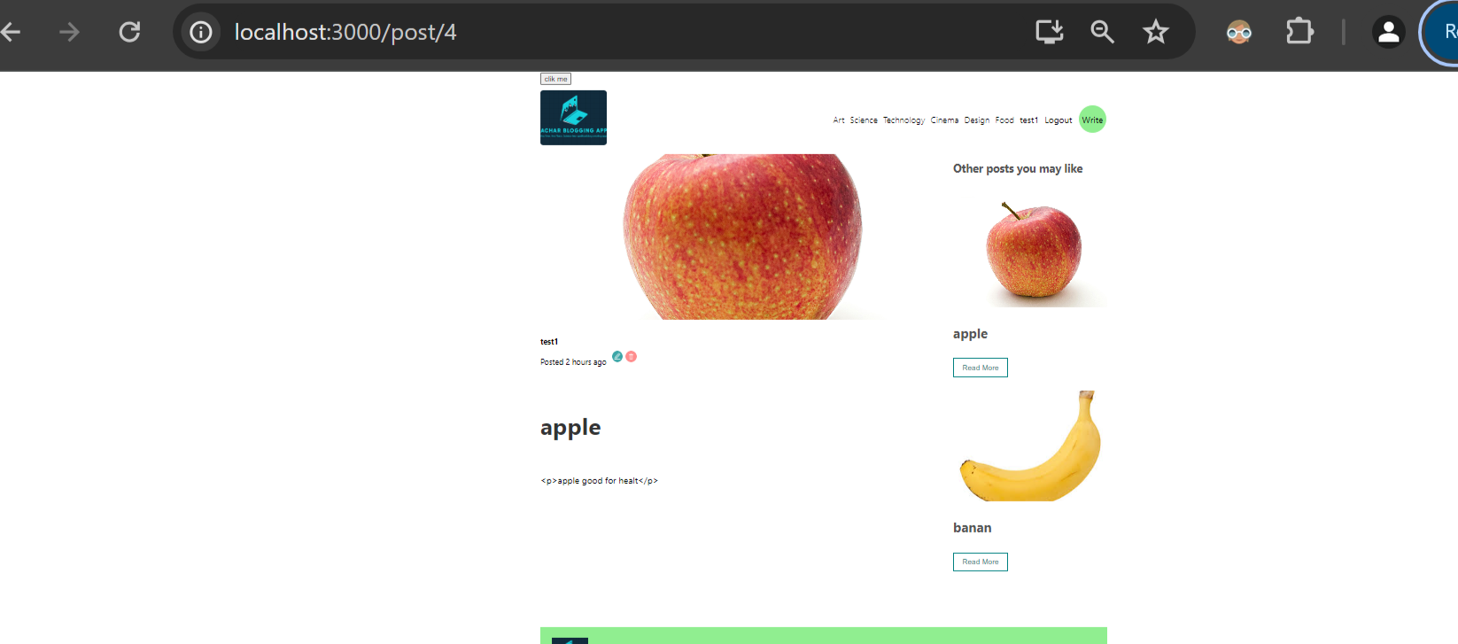

Above

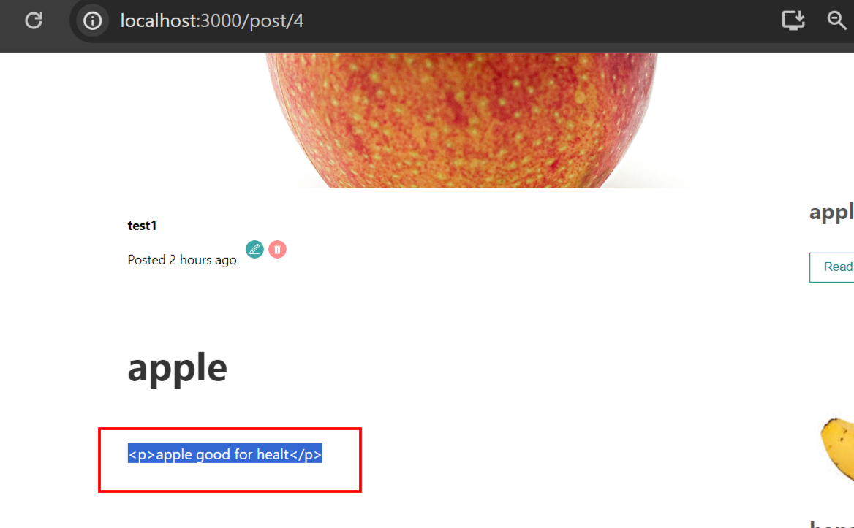

Posts detail page we see above p tag for that as we did in home.jsx

  const getTextFromHtml = (html)=>{

    const doc = new DOMParser().parseFromString(html,"text/html");

    return doc.body.textContent;

  }

Above metod paste in single.jsx file and call it and pass desc

{getTextFromHtml(post.desc)}

We do above in single.jsx for removing that error

Edit is also working

Finally he told we can enhance some features if we want

The end

**#. After 3 years if you want to run this project use npm ci command**

**npm ci** is a command provided by npm (Node Package Manager) that is used to install dependencies from a project's **package-lock.json** file or **npm-shrinkwrap.json** file. It's designed to be used in continuous integration environments or other automated workflows where you want to ensure that dependencies are installed exactly as specified without doing any updates or resolution of dependencies.

Here's how to use **npm ci**:

1. Navigate to your project directory using your terminal or command prompt.
2. Ensure that you have a **package-lock.json** file or **npm-shrinkwrap.json** file in your project. These files contain information about the exact versions of dependencies used in your project.
3. Run the following command:

Above from chatgpt

Because after 3 years if you try to run that time packages might be delegated that package may not work so if you run this command it’ll install same package so you don’t get any error

1. **Include dependencies in your project:** You can include the **node_modules** directory in your version control system (like Git). This ensures that anyone who downloads your project will have all the dependencies available locally. However, this approach increases the size of your repository significantly and might not be recommended for larger projects.

Another way upload your entire project including node_modules to github

**#. While pushing code to github don’t push node_modules folder add it to gitignore**

If you delete it becomes problem instead add node_modules folder to gitignore this way it won’t be pushed to github

https://stackoverflow.com/questions/69864790/how-to-push-entire-react-folder-to-github